BEFORE THE PUBLIC SERVICE COMMISSION
OF THE STATE OF MISSOURI

In the Matter of the Application of Kansas City Power ) Case No. ER-2006-0314
& Light Company for Approval to Make Certain Changes ) Tariff No. YE-2006-0594
in its Charges for Electric Service to Begin the )
Implementation of its regulatory Plan )

ANSWER TO KCPL’S MOTION IN OPPOSITION FOR LEAVE TO DEPART FROM LIST OF WITNESS

COMES NOW, W. Bill Dias and W. Bill Dias D/B/A 1.Paystation.com (“Dias”), submits these answers to KCPL’s Motion in Opposition for Leave to Depart From List of Witness (the “Motion”) to the Public Service Commission of the State of Missouri (the “Commission”). In support of the Motion, Dias states as follows:

On October 6, 2006, W Bill Dias did deliver to Kevin Thompson his issues which will be covered in the topic named “Customer Programs”:

Dias’ Energy Conservation Program is centered on a mixture of customer programs such as On-Time Bill Payment using a debit/credit card, level payment plan, pay agent/pay stations and credit agency reporting i.e. Alternative Credit Scores. Weatherization is only one component of the Energy Conservation Program.

In the Motion in Opposition filed by KCPL my point is proven. Sue Nathan’s surrebuttal testimony she states “Presuming Mr. Dias is referring to the programs envisioned by KCPL in Case No. EO-2005-0329; i.e. affordability, energy efficiency and demand for low-income customers”. Her entire surrebuttal testimony deals with this bad presumption therefore the testimony is wholly irrelevant; her value as a witness is very limited at best; if there is any value at all.
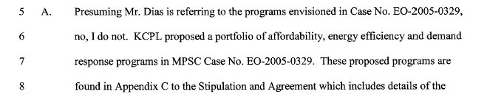

The “Energy Conservation Program” that Mr. Dias envisions which is detailed in the Memorandum of Understanding dated June 5, 2006, is one that is a total package for the customer dealing with the real world costs that a KCPL customer has to pay on a monthly base. The “Energy Conservation Program envisioned by Mr. Dias address the fact that KCPL does not report “positive on-time payments” however they do report anything negative on a customers bill paying habits through a network of collection agencies that buy the unpaid accounts and then report their collection activity to the four (4) major credit reporting agency; this is negative credit.

The “Energy Conservation Program” envisioned by Mr. Dias establishes a financial management roadmap for the customer and provides the tools to achieve on-time bill payment, positive credit reporting, level payments and a home/apartment that has been weatherized to such a degree that there will be no unexpected increase in the level payment due to poor weatherization.

The weatherization of the home/apartment establishes a cost platform from which to build all other household costs facing a KCPL customer. The KCPL customer will know what their monthly costs are and can plan to meet these costs on-time each month. Pursuant to 4 CSR 240-2.130(14) “The presiding officer may require the production of further evidence upon any issue”.

KCPL’s Motion In Opposition deals with Sue Nathan’s incorrect presumption contained in her surrebuttal testimony that Mr. Dias’ “Energy Conservation Program” is the same as the programs offered by KCPL in Case No. EO-2005-0329 and through KCPL’s Motion establishes that Sue Nathan will not be able to address the issues contained in “Energy Conservation Program” as envisioned by Mr. Dias.

The requested witnesses Cory Sullivan (KCPL) and Lori Shaffer (KCPL) are the witness needed to cover the issues which are strategic to the “Energy Conservation Program”. Mr. Dias further states that in a meeting hosted by KCPL on July 20, 2006, KCPL did offer Cory Sullivan and Lori Shaffer to the Executive Committee of the Baptist Ministers Union of Kansas City Missouri as the proper individuals to discuss these issues. They were offered as having day-to-day responsibility for Customer Relations, Payment Plans, Pay Agent/ Pay Station, Call Center Activities and Credit Agency Reporting.

Once again when are you to believe KCPL; they say one thing when meeting with the community and another thing when they are in front of the Commission.

KCPL’s Motion in Opposition, offers up Sue Nathan, a witness that is ill equipped to produce the evidence and answers asked by the Commission on Community Relations.
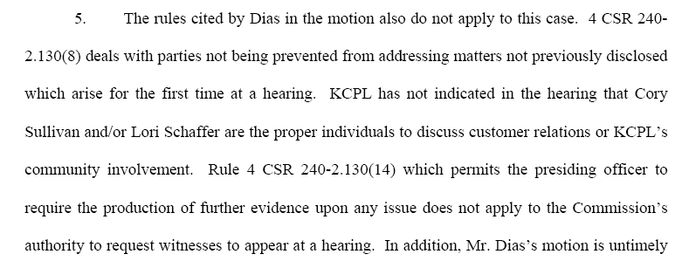
Not to restate the arguments in Mr. Dias Motion for Leave to Depart from the Witnesses list “The requested witnesses to appear for cross-examination on October 27, 2006 will provide direct testimony on KCPL’s out reach to the community that no other KCPL witnesses can provide. The questions directed to Bill Downey by the Commission can only be answered from the persons that have the day to day responsibility on dealing with the Churches, local organization and so on”. “If the Commission wants to get a true picture of what is really going on between KCPL and the Community; these witnesses must be required to testify on October 27, 2006. Pursuant to 4 CSR 240-2.130(8) “A party shall not be precluded from having a reasonable opportunity to address matters not previously disclosed which arise at the hearing. “ These issues were disclosed at the hearing by Mr. Dias cross-examination of Bill Downey and his opening statement.

Finally there is some question as to whether Cory Sullivan is employed at KCPL are not, however, Cory Sullivan should be directed to appear before the Commission.
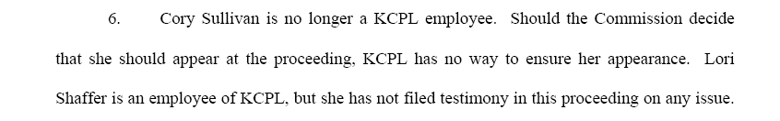

CONCLUSION:

For good cause, it is requested that the Commission deny KCPL Motion in Opposition and grant W. Bill Dias a resident of Kansas City Missouri and W. Bill Dias d.b.a. 1.PayStation.com Motion for Leave to Depart From The List of Witness should direct Cory Sullivan and Lori Shaffer to appear personally before the Commission on October 27, 2006 as new witness to provide direct testimony no other KCPL witness can provide to the Commission and for that reason Dias’ Motion should be granted.

Respectfully Submitted

W Bill Dias
8358 Drury Circle
Kansas City, Missouri 64132
816-523-6614
816-554-7400 X 112 wbilldias@kc.rr.com, wbilldias@hotmail.com

CERTIFICATE OF SERVICE

I do herby certify that on this 18 day of October, 2006, a copy of the above and foregoing was sent via U.S. Mail, postage prepaid, to

General Counsel’s Office US Department of Energy NNSA Lewis R. Mills, Jr.
P.O. Box 360 Kansas City Plant P.O Box 2230
200 Madison Street, Paul Phillips 200 Madison Street
Jefferson City, Mo 65102 1000 Independence Ave. S.W. Jefferson City, Mo 65102
Washington, DC 20585

AARP Aquila, Inc City of Kansas City, Missouri
John Coffman Diana Carter Mark Comley
871 Tuxedo Blvd 312 E. Capital Ave. 601 Monroe St. Suite 301
St. Louis, Mo 63119 P.O. Box 456 P.O. Box 537
Jefferson City, Mo.65102 Jefferson City, Mo 65102

Missouri Department of Empire District Electric Ford Motor Company
Natural Resources Company Diana Vuylstek
Shelley Woods Dean Cooper 211 N. Broadway
P.O. Box 899 P.O. Box 456 St. Louis, Mo 63102
Jefferson City, Mo Jefferson City, Mo 65102
65102-0899

Trigen-Kansas City Missouri Gas Energy Kansas City Power & Light
Energy Corporation Diana Carter Company
Jeffrey Keevil 312 E. Capital Ave. James Fischer
Charles Stewart P.O. Box 456 101 Madison-Suite 400
4603 John Garry Drive, Jefferson City, Mo 65102 Jefferson City, Mo. 65101
Columbia, Mo 65203

Missouri Industrial Energy County of Jackson, Missouri Praxair, Inc.
Consumers Jeremiah Finnegan Stu Conrad
Diana Vuylsteke 1209 Penntower Office David Woodsmall
211 N. Broadway 3100 Broadway 3100 Broadway, Suite 1209
St. Louis, Mo. 63102 Kansas City, Mo. 64111 Kansas City, Mo. 64111

Kansas City Power & Light US Department of Energy
Company NNSA
William Riggins Kansas City Plant
1201 Walnut Stephanie Bogart
Kansas City, Mo 64141 P.O. Box 410202, Kansas City, Mo
64111

BY: W Bill Dias
8358 Drury Circle
Kansas City, Missouri 64132
816-523-6614
816-554-7400 X 112 wbilldias@kc.rr.com, wbilldias@hotmail.com

