BEFORE THE PUBLIC SERVICE COMMISSION
OF THE STATE OF MISSOURI

In the Matter of the Application of Kansas )
City Power & Light Company for Approval )
to Make Certain Changes in its Charges for ) Case No. ER-2006-0314
Electric Service to Begin the Implementation )
of its Regulatory Plan )

MOTION OF MISSOURI JOINT MUNICIPAL ELECTRIC UTILITY COMMISSION FOR LEAVE TO WITHDRAW FROM PROCEEDING

Comes now the Missouri Joint Municipal Electric Utility Commission (MJMEUC) and requests leave to withdraw from this proceeding. The MJMEUC was made a party to the instant case because of its participation in related prior proceedings, but it will take no position on matters at issue in this docket and therefore respectfully withdraws from this case, subject to leave being granted to do so. In view of the current status of and other participation in the case, the public interest will not be adversely affected by withdrawal of the MJMEUC.

WHEREFORE, having stated grounds for its request, the MJMEUC requests the Commission to enter its Order granting leave to withdraw and dismissing the MJMEUC as a party in this case.

Respectfully submitted,
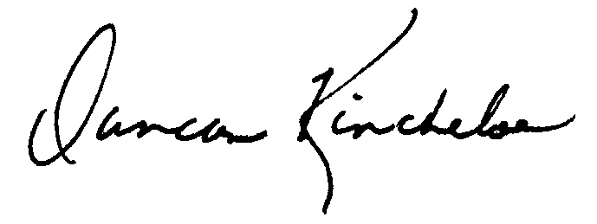
________________________
Duncan E. Kincheloe
Missouri Bar No. 25497
2407 West Ash Street
Columbia, Missouri 65203
(573) 445-3279
(573) 445-0680 (FAX)
dkincheloe@mpua.org
Attorney for the Missouri Joint Municipal Electric Utility Commission

Certificate of Service

I hereby certify that copies of the foregoing have been mailed, hand-delivered, or transmitted by facsimile or electronic mail to all counsel of record this 4th day of April 2006.

________________

