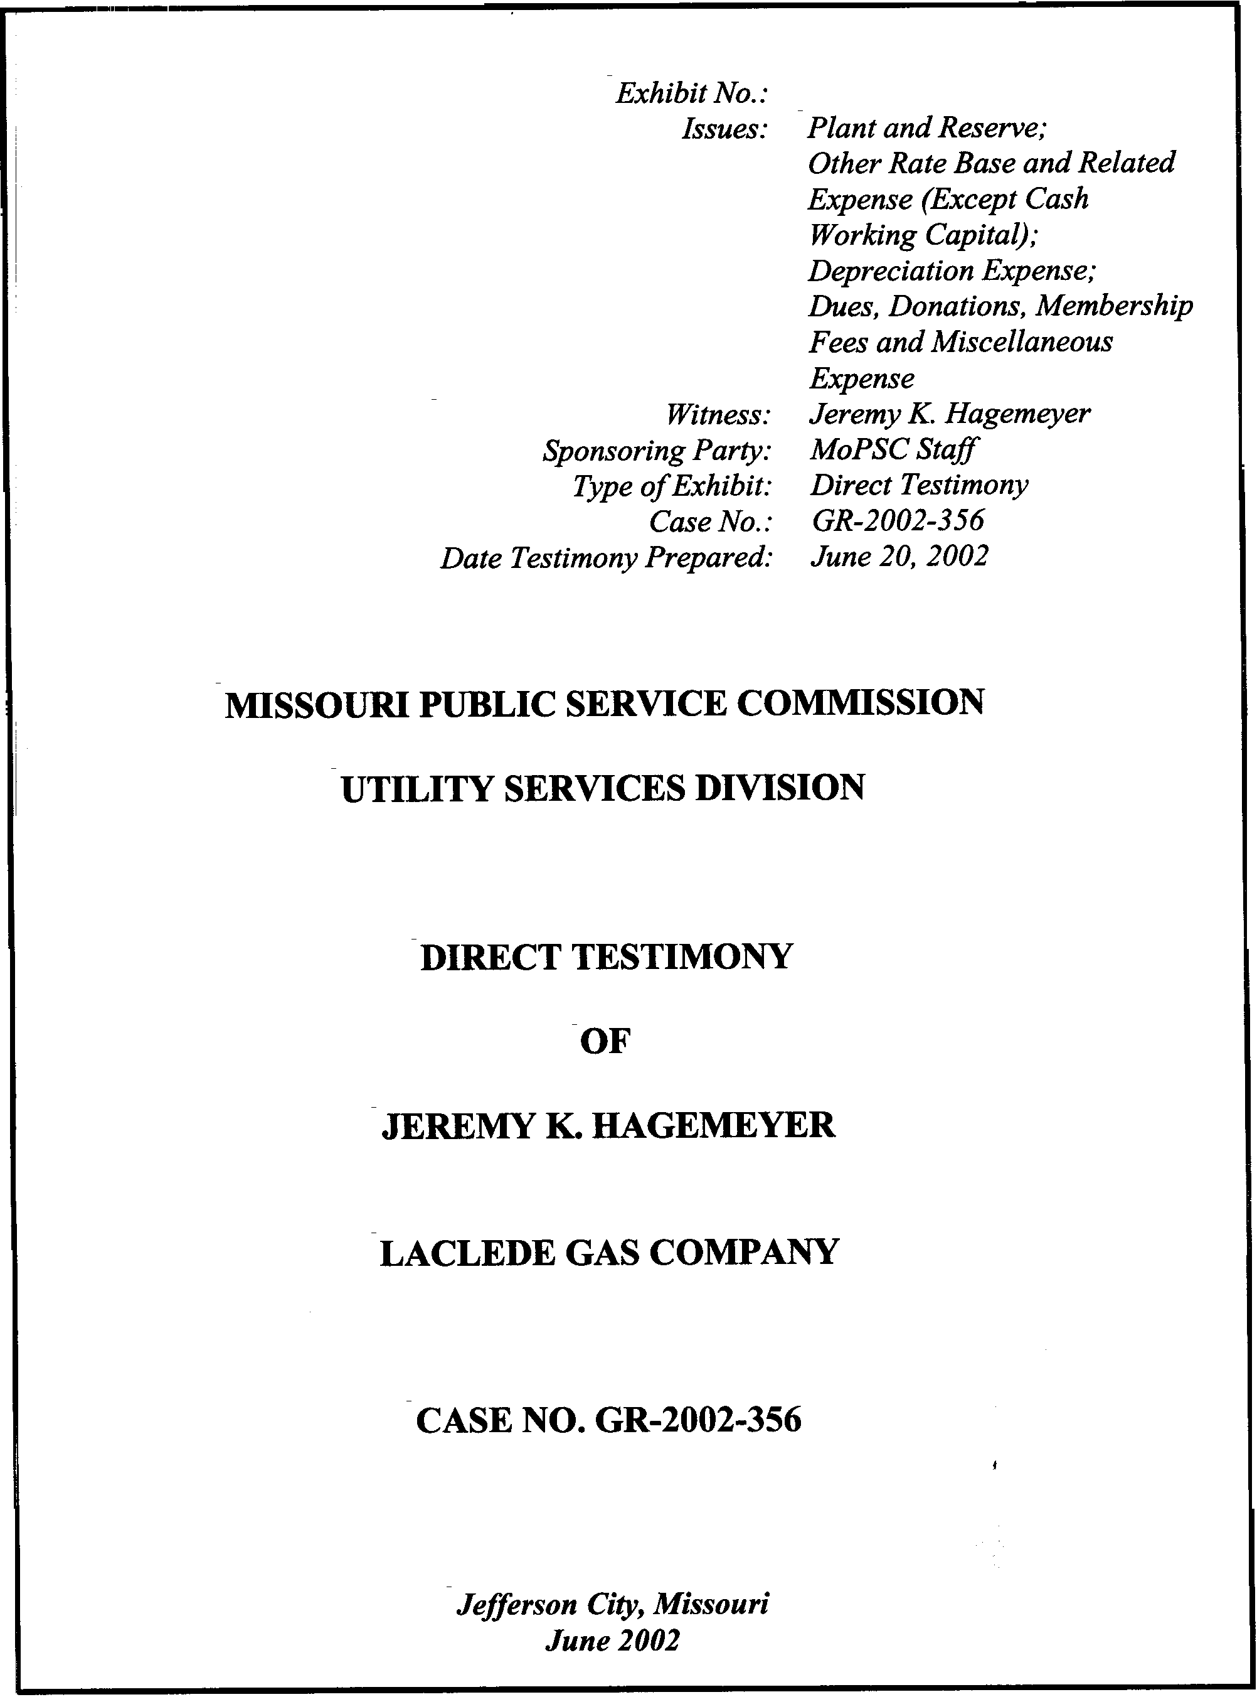
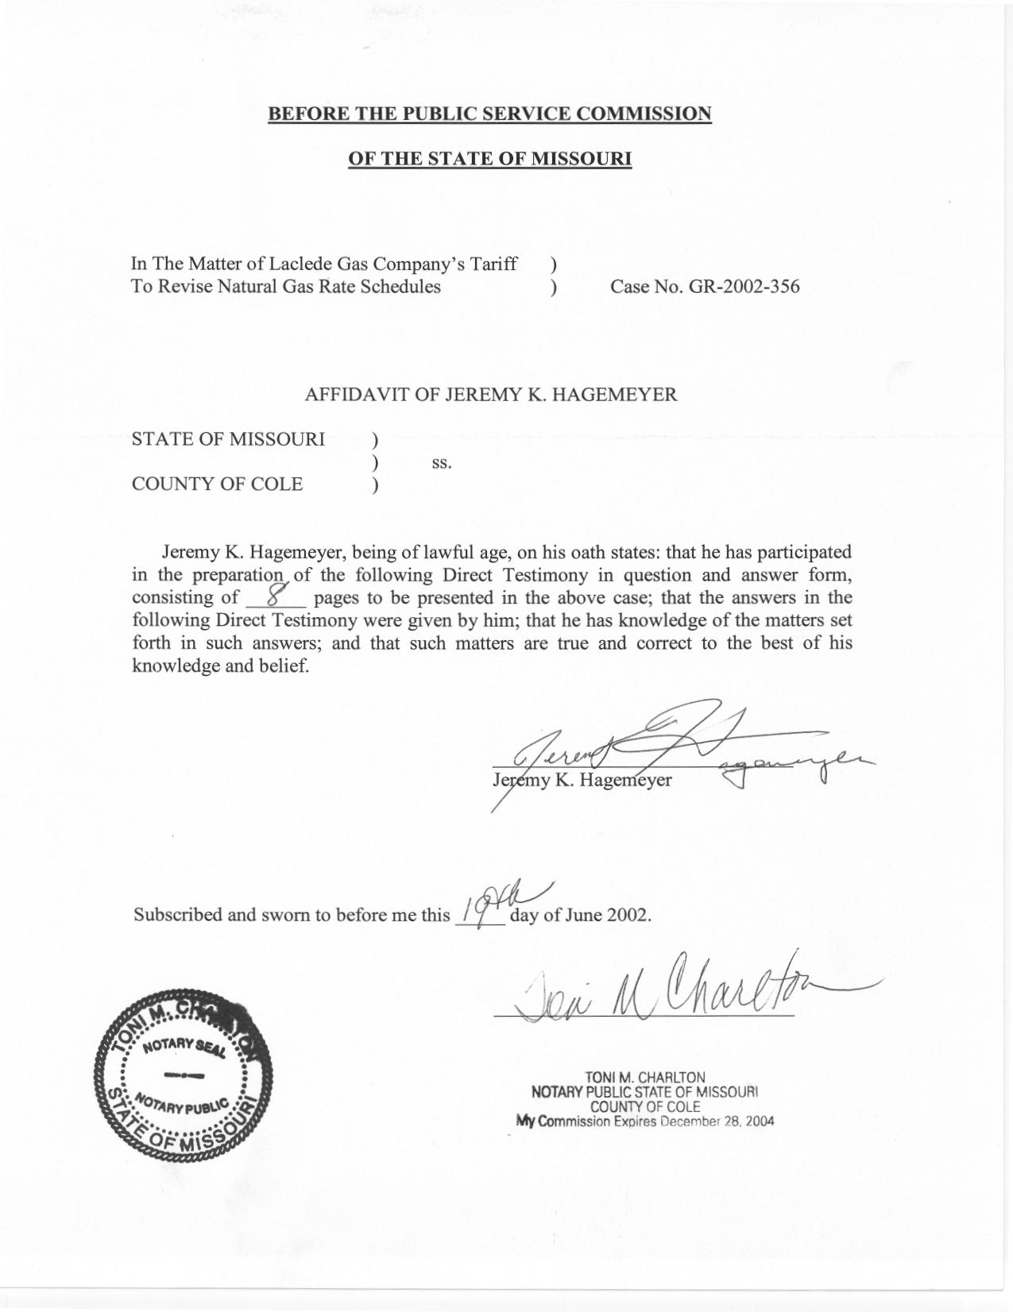

TABLE OF CONTENTS
DIRECT TESTIMONY OF
JEREMY K. HAGEMEYER
LACLEDE GAS COMPANY

CASE NO. GR-2002-356
RATE BASE 3
PLANT IN SERVICE 4
DEPRECIATION RESERVE 4
DEPRECIATION EXPENSE 5
DUES, DONATIONS, MEMBERSHIPS AND MISCELLANIOUS EXPENSE 5
INTEREST REVENUE FOR LOAN PROGRAMS 6
INTEREST ON CUSTOMER DEPOSITS 7
DEPRECIATION AND AMORTIZATION 7

DIRECT TESTIMONY
OF

JEREMY K. HAGEMEYER
LACLEDE GAS COMPANY
CASE NO. GR-2002-356

Please state your name and business address.
Jeremy K. Hagemeyer, 815 Charter Commons Drive, Suite 100B, Chesterfield, MO 63017.
By whom are you employed and in what capacity?
I am a Regulatory Auditor for the Missouri Public Service Commission (PSC).
Please describe your educational background.
- I graduated from Southwest Missouri State University, Springfield, Missouri, in May 2001 with a Bachelor of Science in Accounting and a Bachelor of Science in German.
What are your duties with the Commission?
I assist other Commission Staff (Staff) in the audits and examinations of the books and records of utility companies operating within the state of Missouri.
In reference to Case No. GR-2002-356, have you examined the books and records of Laclede Gas Company (Laclede or Company) in relation to the Company’s request to increase its rates?
Yes, along with other members of the Staff.
Have you previously filed testimony before this Commission?
No, this is my first opportunity.
On what areas will you be testifying?
My primary responsibilities in this case were Plant and Reserve, Other Rate Base Items other than Cash Working Capital (CWC), which includes Prepayments, Materials & Supplies, Insulation Financing Program Loans, Energy Wise, Customer Advances for Construction and Customer Deposits. I was also responsible for Depreciation Expense, and Dues, Donations, Memberships and Miscellaneous Expenses.
What Accounting Schedules are you sponsoring?
I am sponsoring the following Accounting Schedules:
Accounting Schedule 2 – Rate Base
Accounting Schedule 3 – Total Plant in Service
Accounting Schedule 4 – Adjustments to Plant in Service
Accounting Schedule 5 – Depreciation Reserve
Accounting Schedule 6 – Adjustments to Depreciation Reserve
Accounting Schedule 7 – Depreciation Expense
What Income Statement adjustments are you sponsoring?
I am sponsoring the following adjustments:
Staff Adjustment Number Adjustment Area
S-14.2 and S-15.13 Dues, Donations, Memberships and Miscellaneous Expense
S-6.1 Insulation Financing Income
S-6.2 Energy Wise Financing Income
S-12.3 Interest on Customer Deposits
S-16.1 Depreciation Expense
S-16.2 Capitalized Depreciation Expense
S-17.1 Amortization Expense

RATE BASE
Please discuss Accounting Schedule 2.
Accounting Schedule 2, Rate Base, delineates the net capital investment recommended by the Staff to determine the Company’s revenue requirement. Net Plant In Service, shown on line 9, is the summary of March 31, 2002, balances for the plant and reserve components listed on lines 2 through 8. Utility Plant In Service on line 2 and the related depreciation reserve on line 6 are supported by Accounting Schedules 3 and 5, Plant In Service and Depreciation Reserve, respectively, and are discussed later in this testimony. Laclede Pipeline Plant (line 4) and Laclede Pipeline Reserve (line 8) are also components of Net Plant In Service (line 9). This investment was included because Laclede Pipeline Company net income is a component of the Staff’s cost of service calculation. Please refer to the direct testimony of Staff Accounting witness Leasha Teel for the Staff’s position in this area.
In addition to Net Plant In Service, Customer Advances For Construction (line 26) and Customer Deposits (line 27) represent the balances at March 31, 2002. Materials and Supplies (line 12) and propane gas inventory (line 15) reflect 13 month averages of recorded balances for the 12 months ending March 31, 2002, the end of the update period.
Insulation Financing Program Loans (line 18) and Energy Wise (line 19) reflect ending balances as of March 31, 2002.
Prepayments, listed on line 13, reflect an adjusted 13 month average for the 12 months ending March 31, 2002. The balances of prepayments recorded on the Company’s books have been adjusted to exclude the PSC assessment and payments to professional sport franchises. The PSC assessment is excluded from the average prepayment balance because its impact on rate base is specifically measured in the context of CWC. CWC, line 11 on the rate base schedule, is discussed in the testimony of Staff Accounting witness Lisa Hanneken. The prepayment balances attributable to professional sport franchises have been removed to reflect the Staff’s disallowance of these types of expenditures, as discussed later in this testimony.
Gas inventories, included in lines 16 and 17 of Accounting Schedule 2, are discussed in the testimony of Staff witness David M. Sommerer of the Commission’s Procurement Analysis Department. The Prepaid Pension Asset (line 14) and Deferred Income Taxes (line 28) are discussed in the testimony of Staff Accounting witnesses Janis Fischer and John Cassidy, respectively. Interest Offset (line 22), Federal Income Tax Offset (line 23), and State Income Tax Offset (line 24) represent the CWC requirement associated with these items and are discussed in the testimony of Staff Accounting witness Hanneken.

PLANT IN SERVICE
Please discuss Accounting Schedule 3, Plant In Service, and Accounting Schedule 4, Adjustments to Plant In Service.
Accounting Schedule 3, Plant In Service, provides the detail for the Staff’s rate base component of utility gas plant in service, stated at original cost, recorded as of March 31, 2002. As stated on Accounting Schedule 4, Adjustments To Plant In Service, no adjustments were necessary to the Plant Balances presented on Accounting Schedule 3.

DEPRECIATION RESERVE
Please discuss the accounting schedules supporting depreciation reserve.
Accounting Schedule 5, Depreciation Reserve provides the detail of the accumulated depreciation related to the plant balances on Accounting Schedule 3. The purpose of Accounting Schedule 6, Adjustments To Depreciation Reserve, is to provide the detail of any adjustments made to the depreciation reserve.
Please discuss adjustments R-17 and R-38 to the Depreciation Reserve.
These adjustments transfer $5 million from the reserve for distribution mains to the reserve for gas holders. This adjustment is discussed in the testimony of Staff witness Rosella Schad of the Commission’s Engineering and Management Services Department.

DEPRECIATION EXPENSE
Please explain Accounting Schedule 7, Depreciation Expense.
This schedule calculates the annual depreciation expense on the Company’s utility plant in service. Column C shows the plant in service balances from Accounting Schedule 3, Plant In Service. Column D contains the depreciation rates recommended by Staff witness Schad. The rates in Column D are applied to the plant balances in Column C to determine the annual depreciation expense that appears in Column E.

DUES, DONATIONS, MEMBERSHIPS AND MISCELLANIOUS EXPENSE
Please describe adjustments S-14.2 and S-15.13.
These adjustments remove those test year operating expenses that have no apparent demonstrable benefit to the ratepayer. This adjustment included costs for sports arena luxury suites, professional athletic teams’ season tickets, country club costs, theater and symphony performances admissions, sponsorship of community sporting/social events and various charitable donations, etc. Home show expenses were disallowed, as these expenses are more appropriately assigned as below-the-line merchandising activities. Professional, and local business and community service memberships were broadly allowed as valid cost of service expenses.
What was the basis used by the Staff to make these adjustments?
The Staff applied judgment in determining whether the activities or services performed by the organizations to which the Company made payments were necessary for the utility to provide safe and adequate service and were non–duplicative of the services performed by other organizations to which the Company belongs. This criterion for recoverable expenses is consistent with Commission precedence. Further, the Staff has attempted to derive the adjustments in a manner consistent with the adjustments proposed in the Company’s previous rate cases.

INTEREST REVENUE FOR LOAN PROGRAMS
Please explain adjustments S-6.1 and S-6.2.
Adjustments S-6.1 and S-6.2 impute interest revenue for the Company’s Insulation Financing and Energy Wise programs. The Insulation Financing program permits a residential customer to borrow up to $2,000 from the Company at a 3% annual rate for the purpose of insulating their home.
Energy Wise is a program similar to Insulation Financing except that its focus is the financing of gas heating/cooling systems and appliances and is available to commercial customers in addition to residential customers. Energy Wise financing terms are up to five years at interest rates ranging from 7.5% to 8.5% depending on the equipment package purchased.
The Staff adjustments reflect a 3% rate for Insulation Financing and 7.5% for Energy Wise. Since the balances for these programs are included in Rate Base, the associated interest income is appropriately included in the cost of service.

INTEREST ON CUSTOMER DEPOSITS
Please explain adjustment S-12.3.
This adjustment includes the Interest on Customer Deposits in expense. Since Customer Deposits are an offset to rate base, the associated interest expense is appropriately included in the cost of service.

DEPRECIATION AND AMORTIZATION
Please explain adjustment to depreciation expense.
As discussed previously, with regards to Accounting Schedule 7, Deprecation Expense, Adjustment S-16.1 adjusts depreciation expense to reflect an annual level of depreciation expense based on the Staff’s proposed depreciation rates and the March 31, 2002, plant balances.
Please explain adjustment S-16.2 to depreciation expense.
Adjustment S-16.2 capitalizes a portion of the annualized depreciation expense calculated on Accounting Schedule 7 related to vehicles and power-operated equipment. The actual test year percentage of depreciation capitalized was applied to the annualized depreciation for vehicles and power-operated equipment to calculate adjustment S-16.2.
Please explain the adjustment to amortization expense you are sponsoring.
Adjustment S-17.1 annualizes amortization expense related to plant balances as of March 31, 2002.
Does this conclude your direct testimony?
Yes, it does.

