BEFORE THE MISSOURI PUBLIC SERVICE COMMISSION
In the Matter of the Application of )
)
Big River Telephone Company, LLC )
)
to Expand Its Certificate of Basic Local ) Case No. LA-2003-0551
Service Authority to include provision of )
Basic Local Exchange Telecommunications )
Service in CenturyTel and Spectra )
Exchanges and to Continue to Classify the )
Company and its Services as Competitive. )

AMENDED APPLICATION OF BIG RIVER TELEPHONE COMPANY, LLC
TO EXPAND CERTIFICATE OF BASIC LOCAL SERVICE AUTHORITY

COMES NOW Big River Telephone Company, LLC ("Big River"), by its undersigned counsel, and pursuant to the Federal Telecommunications Act of 1996 ("Act"), Sections 392.361, 392.410, 392.420, 392.430, 392.440, 392.450, and 392.455 RSMo, and 4 CSR 240-2.060, 4 CSR 240-3.510 and 4 CSR 240-2.080(20) hereby applies to expand its certificate of basic local service authority to include provision of basic local exchange telecommunications service in the service territories of CenturyTel of Missouri, LLC ("CenturyTel") and Spectra Communications Group, LLC (“Spectra”). Big River already has obtained authority from the Commission to provide facilities-based and resold basic local telecommunications service in the service territory of Southwestern Bell Telephone Company ("SWBT"), as well as interexchange telecommunications services and non-switched local exchange telecommunications services (limited to providing dedicated, non-switched local exchange private line services) throughout the state of Missouri. Big River and its services have been classified as competitive. In this Application, Big River seeks the additional authority to provide facilities-based and resold basic local exchange telecommunications service in the exchanges comprising the service territories of CenturyTel and Spectra. Additionally, pursuant to Sections 392.361 and 392.420 RSMo, Big River requests that its basic local service as offered in these additional territories be classified as competitive, that the company and its services remain classified as competitive, and that certain statutes and regulations be waived as to its basic local service as offered in these additional territories.
In support of its application Big River states to the Commission as follows:

I. QUALIFICATIONS
1. Name and Address: Applicant's legal name is Big River Telephone Company, LLC. Big River maintains its principal place of business at:

24 S. Minnesota
Cape Girardeau, Missouri 63073
Telephone Number: (573) 651-3373
Fax Number: (573) 651-3605
E-Mail: jhowe@bigrivertelephone.com

2. Contact Persons: All inquiries, correspondence, communications, pleadings, notices, orders and decisions relating to this Application should be directed to:

Carl J. Lumley
Leland B. Curtis

Curtis, Oetting, Heinz, Garrett & O’Keefe, PC

130 S. Bemiston, Suite 200

Clayton, Missouri 63105

Telephone: (314) 725-8788

Facsimile: (314) 725-8789

Email: clumley@cohgs.com
lcurtis@cohgs.com

3. Corporate Liaison: Questions concerning the ongoing operation of Big River following certification should be addressed to:

Gerard J. Howe, CEO

Big River Telephone Company, LLC
24 S. Minnesota
Cape Girardeau, Missouri 63073
Telephone: (573) 651-5298
Fax: 636-530-7850
E-Mail: jhowe@bigrivertelephone.com

4. Toll-Free Customer Service Number: Big River's toll-free customer service telephone number is:
(800) 455-1608
5. Corporate Structure: Big River Telephone Company, LLC is a foreign limited liability company organized and existing under Delaware law. Big River is qualified to do business in the state of Missouri. A Certificate of Authority from the Missouri Secretary of State is attached hereto as Exhibit 1.
6. Managerial and Technical Qualifications: Big River remains managerially and technically qualified to provide basic local telecommunications services in the state of Missouri, as found in Case No. TA-2001-699. It has been successfully providing basic local service since it commenced operations in 2001.
7. Financial Qualifications: Big River remains financially qualified to provide telecommunications services in the state of Missouri, as found in Case No. TA-2001-699. It has been successfully providing basic local service since it commenced operations in 2001. Current confidential financial information is attached hereto as Proprietary Exhibit 3 pursuant to the Protective Order that has issued in this case.

II. PROPOSED SERVICES
8. Description of Proposed Services: Big River is currently authorized to, and does, provide basic local exchange telecommunications service within the service territory of SWBT pursuant to approved tariffs. Big River requests that the Commission take notice of its local exchange service tariffs, which are incorporated herein by reference. Big River seeks additional authorization to provide basic local service in the exchanges served by CenturyTel and Spectra. The specific exchanges are identified in Exhibit 2, attached hereto. Big River’s new exchanges will follow the boundaries of CenturyTel’s and Spectra’s respective exchanges and will not be smaller than CenturyTel’s and Spectra’s respective exchanges. Big River’s services meet established Commission standards. Big River will continue to offer basic local service as a separate and distinct service, including in CenturyTel and Spectra exchanges.
9. Description of Proposed Facilities: Big River intends to use its existing facilities and to interconnect with CenturyTel and Spectra and resell their services.
10. Tariff Requirement: Big River requests a temporary waiver of 4 CSR 240-3.510(1)(c), which requires that an application for a certificate of service authority to provide basic local exchange service shall include a proposed tariff with a 45-day effective date. Big River needs to complete the process of obtaining approved interconnection agreements with CenturyTel and Spectra before formally submitting proposed tariff changes with an effective date. Big River will file tariffs in a manner consistent with the Commission’s practices in similar cases before providing basic local service in the expanded service area.
III. CLASSIFICATION AS A COMPETITIVE TELECOMMUNICATIONS COMPANY AND WAIVER OF CERTAIN REGULATORY REQUIREMENTS

11. Classification of Services as Competitive: Big River seeks continued classification as a competitive company, including classification of its basic local exchange telecommunications service in the new service area as competitive, pursuant to Section 392.361 and Section 392.420 RSMo and 4 CSR 240-3.510(1)(A). Big River also seeks the reduced regulation that routinely accompanies such classification. In the Commission's previous order granting Big River certificates of service authority, the Commission classified Big River and its services as competitive.
12. Waiver of Rules: Big River will comply with all applicable Commission rules, except those that are waived by the Commission, in providing basic local service in the new service area. Specifically, Big River will file and maintain tariffs and meet minimum service standards, including quality of service and billing standards, as the Commission requires of CenturyTel and Spectra. Consistent with the Commission’s current treatment of Big River and other certificated competitive local exchange telecommunications companies, Big River requests that the following statutes and regulations be waived regarding Big River’s basic local exchange telecommunications service in the new service area:
Statutes Missouri Public Service Commission Rules
392.210.2 4 CSR 240-10.020
392.240 (1) 4 CSR 240-3.545(2)(C)
392.270 4 CSR 240-30.040
392.280 4 CSR 240-3.550(5)(C)
392.290 4 CSR 240-33.030
392.300.2
392.310
392.320
392.330
392.340

The Commission has previously determined that there is good cause and reason for waiving these statutes and regulations for competitive companies and basic local service and such determination remains sound. No public utility will be affected by the requested waiver of these statutes and regulations.
13. Switched Access Rates: Notwithstanding the provisions of Sections 392.500 and 392.510 R.S.Mo., as a condition of the requested certification and competitive classification, Big River agrees that, unless otherwise ordered by the Commission, Big River originating and terminating switched exchange access rates in the new service area will be no greater than the lowest Commission-approved corresponding access rates in effect for CenturyTel and Spectra in their respective service areas. Additionally, pursuant to the Commission’s Report and Order in Case No. TO-99-596, Big River agrees that if CenturyTel or Spectra decreases its current originating and/or terminating access service rates, Big River shall file an appropriate tariff amendment to reduce its corresponding originating and/or terminating access rates within thirty (30) days of CenturyTel's or Spectra’s reduction of its originating and/or terminating access rates in order to maintain aforesaid cap on switched exchange access rates. Big River agrees that, absent contrary legal authority, any increase in switched access rates above the aforesaid maximum shall be subject to Section 392.200 RSMo and cost-justified pursuant to Sections 392.220 and 392.230 RSMo.
14. Pending Actions: Big River does not have any pending action or final unsatisfied judgments or decisions against it from any state or federal agency or court which involve customer service or customer rates, which action, judgment, or decision has occurred within three years of the date of this Application.
15. Compliance with Orders and Regulations: Big River will comply with all orders and regulations of the Commission applicable to competitive local exchange telecommunications service providers.
16. Annual Reports and Fees: Big River does not have any overdue annual reports or assessment fees.

IV. PUBLIC INTEREST CONSIDERATIONS
17. The Commission granted Big River its current certificates of service authority, based in part upon finding that such action was in the public interest. The grant of this Application will also further the public interest by increasing equitable access for Missourians, regardless of where they live or their income, to affordable telecommunications services. Big River's proposed services will create and enhance competition and expand customer service options consistent with the legislative goals set forth in the Federal Telecommunications Act of 1996 and Chapter 392 RSMo. In particular, the public will benefit directly through the use of the competitive basic local exchange service to be offered by Big River. The public will also benefit indirectly because the competitive presence of Big River will increase the incentives for the incumbents and others to operate more efficiently, offer more innovative services, reduce prices, and improve the quality and coverage of services.
18. Granting this Application will promote the availability of quality services and increased consumer choice. Big River's expertise in telecommunications will allow it to provide economic and efficient services in the new service area, thereby affording more customers with an optimal combination of price, quality, and customer service. Big River anticipates that expansion of its basic local service territory will increase consumer choice for innovative, diversified, and reliable service offerings and otherwise further the public interest.
WHEREFORE, Big River Telephone Company, LLC respectfully requests that the Commission grant it the requested expansion of its certificate of service authority to include provision of basic local telecommunications service in the service territories of CenturyTel and Spectra, classify its basic local service in the new territory as competitive, continue to classify the company as competitive, and grant waiver of the identified statutes and regulations as to the provision of basic local service in the new territory.

Respectfully submitted,
/s/ Carl J. Lumley
____________________________

Carl J. Lumley, #32869
Leland B. Curtis, #20550
Curtis, Oetting, Heinz, Garrett & O’Keefe, PC
130 S. Bemiston, Suite 200
Clayton, Missouri 63105
Telephone: (314) 725-8788
Facsimile: (314) 725-8789
Email: clumley@cohgs.com
lcurtis@cohgs.com

ATTORNEYS FOR BIG RIVER TELEPHONE
COMPANY, LLC

CERTIFICATE OF SERVICE

I hereby certify that a true and correct copy of this document was served upon the parties listed below on this 23d day of June, 2003 by placing same in the U.S. Mail, postage prepaid.

/s/ Carl J. Lumley
________________________________
Carl J. Lumley

Office of the Public Counsel
PO Box 7800
Jefferson City, Missouri 65102

Office of General Counsel
Missouri Public Service Commission
PO Box 360
Jefferson City, Missouri 65102

James M. Fischer and
Larry Dority
Fischer & Dority, P.C.
101 Madison, Suite 400
Jefferson City, MO 65101

EXHIBIT 1

CERTIFICATE OF GOOD STANDING

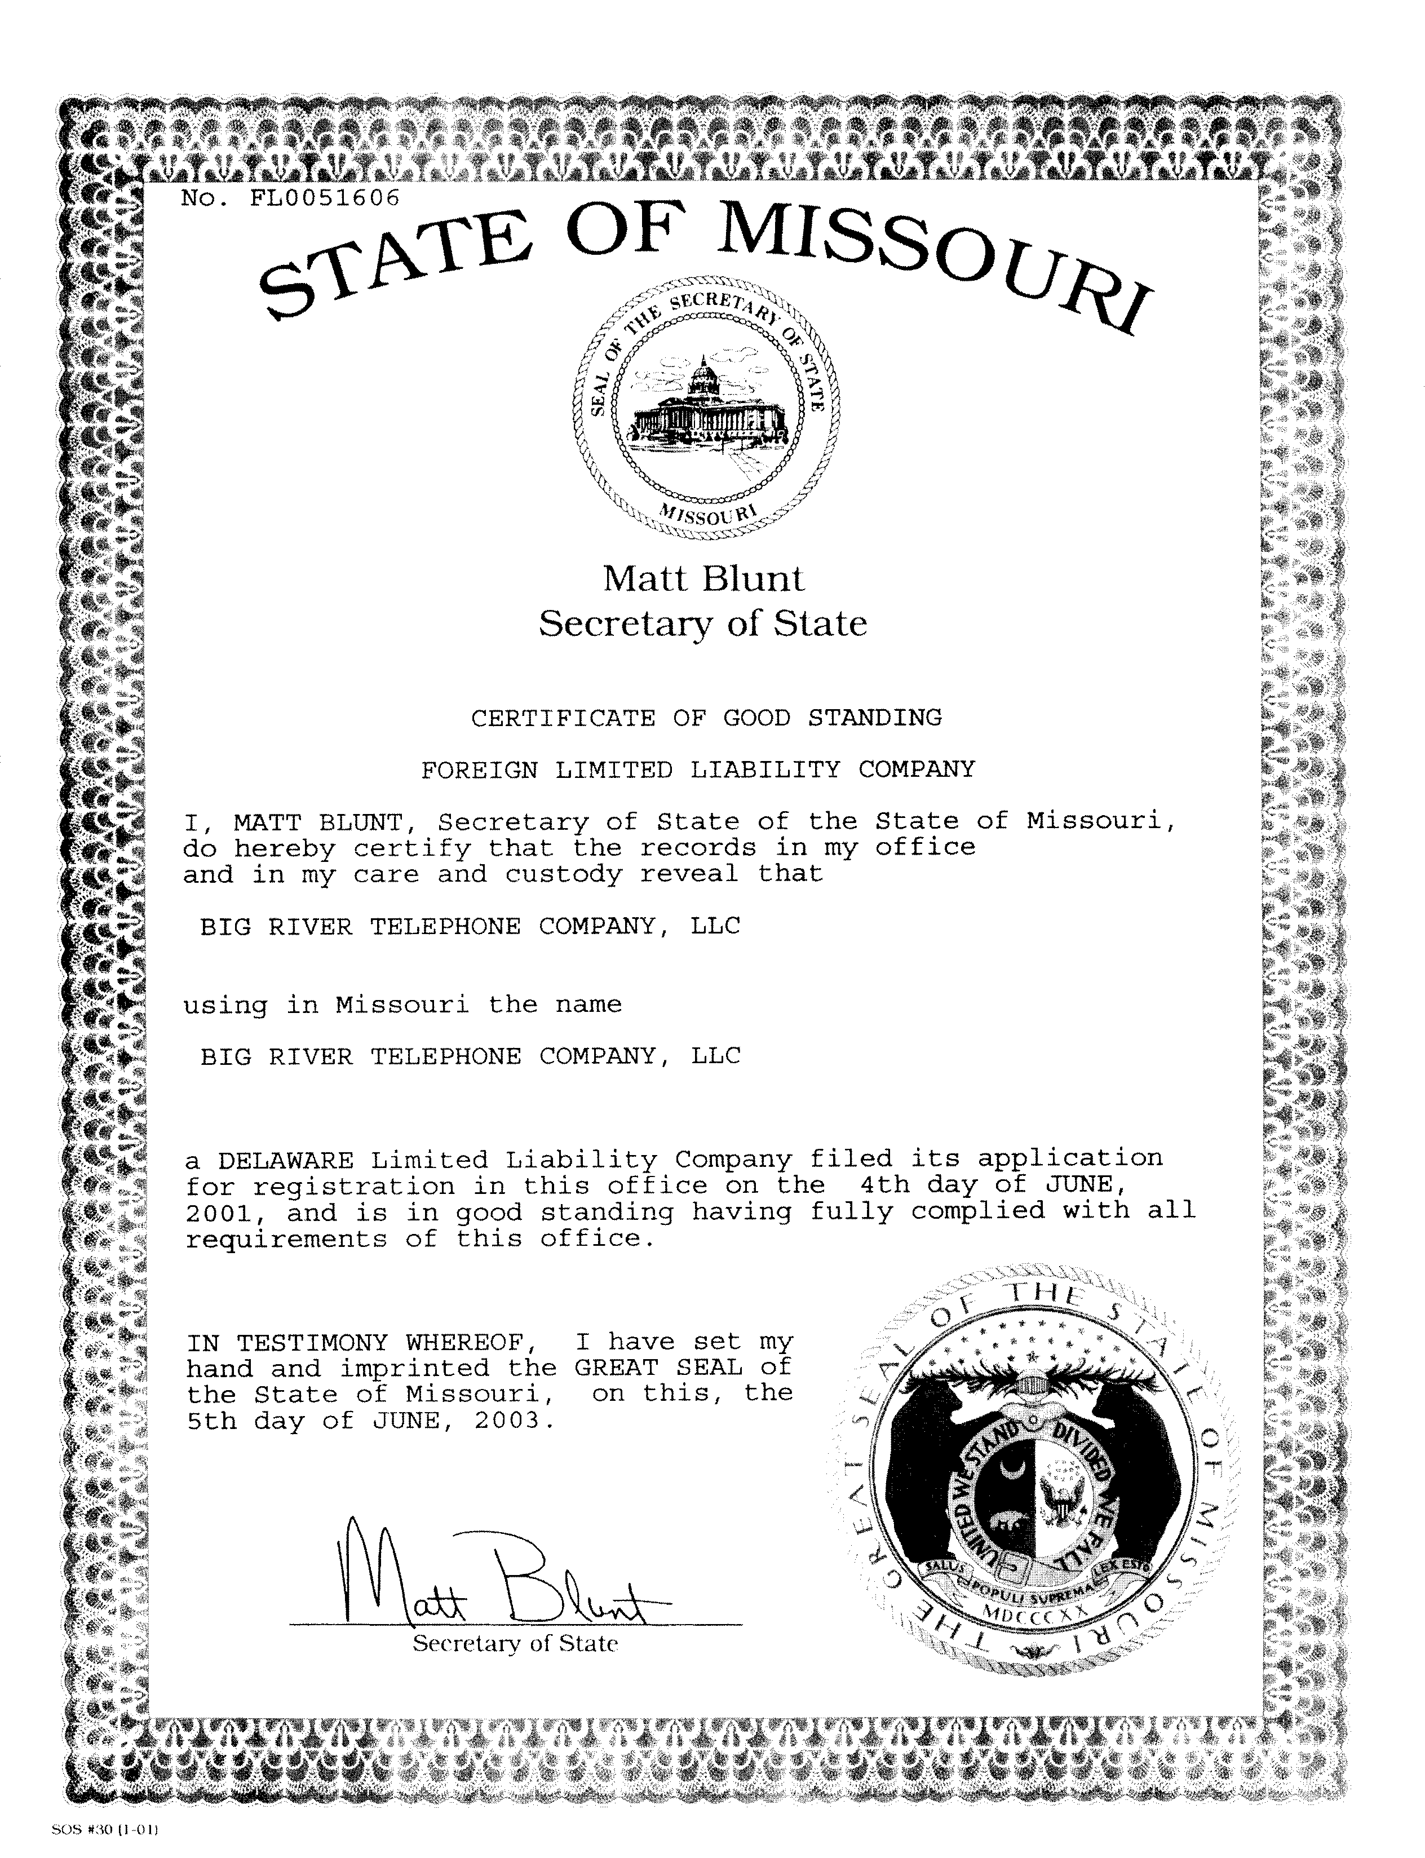
EXHIBIT 2
CENTURYTEL AND SPECTRA EXCHANGES

Exchanges served by CenturvTel

Alton Holstein Vichy
Ashland Hurley Warrenton
Augusta Jamestown Washburn
Ava Jenkins Wasola
Belle Jonesburg Wentzville
Bland Kimberling City West Plains
Blue Eye Koshkonong Wheatland
Bourbon Leasburg Willow Springs
Bradleyville Louisburg Winfield
Branson Mano Wooldridge
Branson West Mansfield Wright City
Buffalo Marshfield
Cabool Marthasville
Cape Fair Morrison
Cassville Moscow Mills
Caulfield Mount Sterling
Cedar Creek Mtn. View
Centralia New Melle
Chamois Niangua
Clark O'Fallon
Columbia Old Monroe
Conway Ozark
Crane Pittsburg
Cross Timbers Prairie Home
Cuba Preston
Dardenne/Lake St. Protem
Louis Reeds Spring
Defiance Rocheport
Dora Rockaway Beach
Elkland St. James
Exeter St. Peters
Foley Safe
Fordland Seymour
Foristell Shell Knob
Forsyth Sparta
Gainesville Sturgeon
Galena Summersville
Hallsville Thayer
Hawk Point Theodosia
Hermann Thomasville
Hermitage Troy
High Hill Truxton
Highlandville Urbana

Exchanges served by Spectra

Amazonia Hamilton Roby
Annapolis Hartville Rockville
Arcola Helena Rosendale
Aurora Houston Santa Fe
Avenue City Humansville Sarcoxie
Avilla Hunnewell Savannah
Belgrade Irondale Schell City
Belleview Ironton Shelbina
Birch Tree Jerico Springs Shelbyville
Bolckow Kahoka Sheldon
Boss Keytesville Stewartsville
Braymer Kidder Stoutsville
Bronaugh- Kingston Timber
Moundville LaBelle Trimble
Brunswick Laddonia Turney
(Triplett) LaGrange Van Buren
Bunker La Plata Vanzant
Caledonia Lawson Walker
Cameron Lesterville Wayland
Canton Lewistown (includes
Centerville Licking customers in
Clarence Lowry City base rate area
Clarksdale Macon Alexandria)
Collins Manes Weaubleau
Concordia Maysville West Quincy
Cosby Milo Whitesville
Dadeville Monroe City Winona
Dalton Montauk Park
Easton Monticello
Edgar Springs Mt. Vernon
Eldorado Springs Mtn. Grove
Ellsinore Nebo
Elmer Norwood
Eminence Oates
Everton Osborn
Ewing Osceola
Fillmore Palmyra
Fremont Paris
Golden City Perry
Gorin Plattsburg
Gower Potosi
Greenfield Raymondville
Grovespring Revere

EXHIBIT 3

Big River Financials

Exhibit 3 is Designated as Propriety and is filed under seal

See Application of Big River Telephone Company, LLC for Certificates of Service Authority to Provide Basic Local, Local Exchange, Exchange Access, and Interexchange Telecommunications Services in the State of Missouri and to Classify Said Services and the Company as Competitive, Case No. TA-2001-699 (Order Granting Certificates effective August 13, 2001).
Id.

