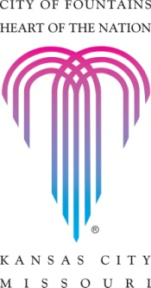
Quinton D. Lucas
Mayor

August 11, 2021
Federal Energy Regulatory Commission
888 First Street, N.E.
Washington, D.C. 20426

The Honorable Richard Glick, Chairman
The Honorable Neil Chatterjee, Commissioner
The Honorable James Danly, Commissioner
The Honorable Allison Clements, Commissioner
The Honorable Mark C. Christie, Commissioner

Re: Spire STL Pipeline LLC Temporary Certificate Application in Emergency
Docket No. CP17-40-000

Dear Chairman Glick and Commissioners,

Thank you for your continued leadership in furthering the development of safe and reliable U.S. energy infrastructure. I write in support of Spire STL Pipeline, LLC’s (STL Pipeline) July 26, 2021, temporary certificate application at the Federal Energy Regulatory Commission (FERC).

Until recently, more than 650,000 residents and businesses in the St. Louis region lacked direct access to reliable, affordable, and abundant natural gas supplies from diverse domestic sources. The STL Pipeline changed this by tapping into gas supply from the Rockies and Appalachian Basins, providing resilience and supply diversity both year-round and when St. Louis needs are most critical.

I support STL Pipeline’s application so that the St. Louis region can avoid potentially dire gas shortages in the months ahead and throughout the winter. I look forward to the FERC’s prompt consideration and response on the temporary certificate application for this crucial energy infrastructure. Please do not hesitate to reach out if I can be of further assistance.

Very truly yours,
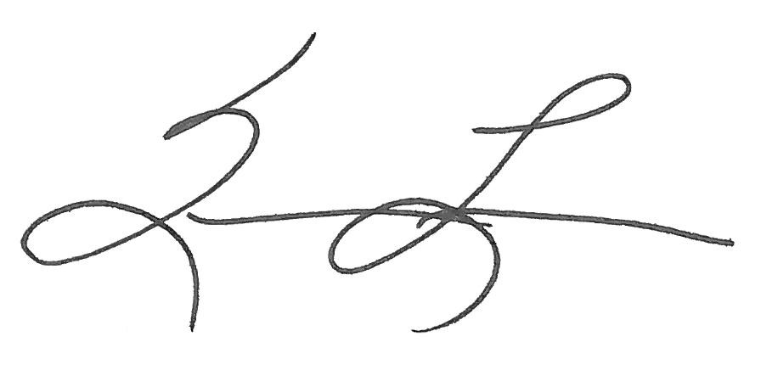

Quinton D. Lucas

cc:
Frank Quagraine, Director of Rental Production
Gus Metz, Chief Underwriter

