Exhibit Number: | ________
Issues: | Condition of Plant Facilities
 | General Operation
Witness Name: | Martin L. Hummel
Type of Exhibit: | Direct Testimony
Sponsoring Party: | MoPSC Staff
Case Number: | ST-2003-0562 and  WT-2003-0563  (Consolidated)
Date Testimony Prepared: | December 19, 2003

Missouri Public Service Commission

Utility Operations Division

Water & Sewer Department

Direct Testimony

of

Martin L. Hummel

Case No. ST-2003-0562 and WT-2003-0563
(Consolidated)

Osage Water Company

Jefferson City, Missouri
December 2003

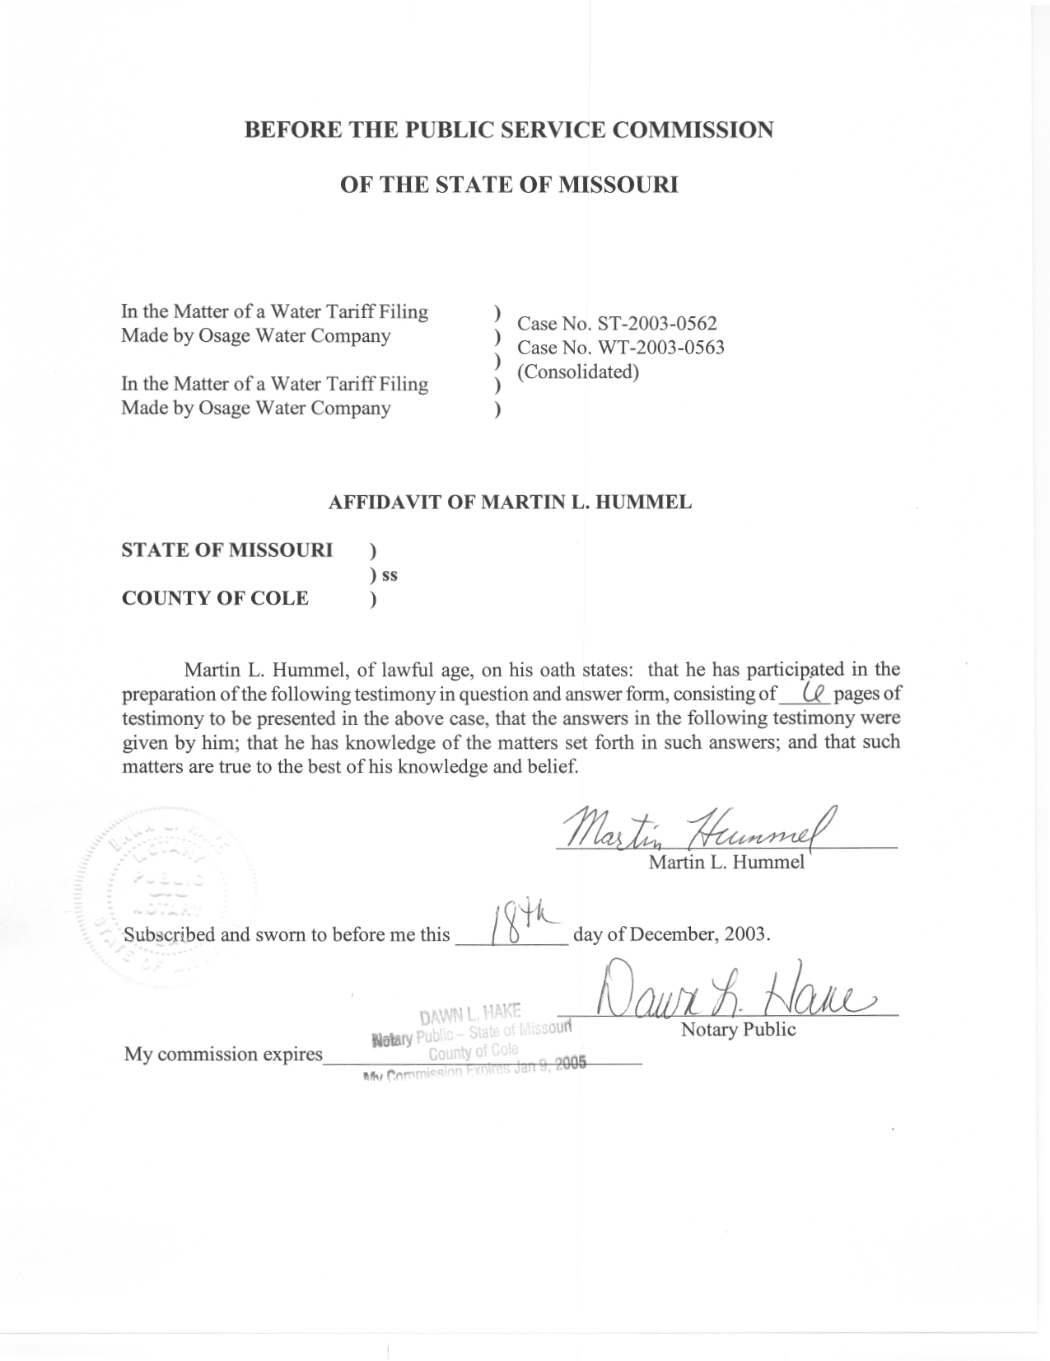

Direct Testimony

of

Martin L. Hummel

Case No. ST-2003-0562 and WT-2003-0563

(Consolidated)

Osage Water Company

Q. Please state your name and business address.
A. My name is Martin L. Hummel, and my business address is P.O. Box 360, Jefferson City, Missouri 65102.
Q. By whom are you employed and in what capacity?
A. I am employed by the Missouri Public Service Commission (Commission) as an Engineer in the Water & Sewer Department (W/S Dept) of the Utility Operations Division.
Q. How long have you been employed by the Commission?
A. I have been employed by the Commission since February 1989.
Q. What is your educational background?
A. I received a Bachelor of Science degree in Education-Science and a Bachelor of Science degree in Engineering from the University of Missouri-Columbia.
Q. What is your employment experience?
A. Prior to my employment at the Commission, I worked with the Missouri Department of Natural Resources (DNR) in the Water Pollution Control Program for two years; I worked as a Research Associate on water-related projects with Louisiana State University-Baton Rouge for two years; and I was employed by a consulting engineering firm as Project Engineer primarily on wastewater treatment projects for three years.
Q. What is the purpose of your testimony?
A. The purpose of this testimony is to comment on the condition of Osage Water Company’s (OWC’s or “the Company’s) facilities and general operation.
Q. Are you familiar with the facilities and the company’s operation?
A. Yes. I have visited the facilities, have had discussions with Company personnel and, have investigated customer complaints and inquiries on numerous occasions.
Q. Have you or others from the PSC Staff made any recent observations of the systems?
A. Our last field review of some of their facilities was in June and July of 2003. PSC Staff has also talked to DNR Staff who made field observations in August of 2003. There are current circumstances that affect the Staff’s approach to the review of OWC’s operation and maintenance, most notably the Commission’s receivership case against OWC, PSC Case No. WC-2003-0134 and Camden County Case No.
CV102-965CC. The Staff, customers, developers and DNR Staff have been anticipating a possible change of management and ownership of these facilities if OWC is placed in receivership.
Q. Even though you have not made recent observations, do you believe you are familiar with the conditions of the Company’s facilities?
A. Yes. I consider myself to be very familiar with the facilities. I presented live testimony in PSC Case No. WC-2003-0134 in October of 2002 regarding problems associated with OWC’s facilities. I have no reason to believe that conditions have significantly changed since then.
Q. Are you aware of any significant improvements or completed construction by the company?
A. No, and OWC has not informed the Staff of any significant improvements or completed construction. The Staff has no reason to believe that facilities have significantly improved over what they were during the receivership case in 2002.
Q. In general, how would you describe the condition of OWC’s facilities?
A. While there are several different service areas with various types of facilities, the facilities as a whole are in poor condition due to poor quality and incomplete construction. As stated, much of this is addressed in the Staff’s testimony in Case No. WC-2003-0134. I also recently learned that DNR issued Notices of Violation (NOV) in August for two of the facilities. (See Schedules 1 and 2)
Q. In your opinion, should any permanent rate increase be granted at this time?
A. Definitely not until several issues have been addressed, including the following.
  - The rate base has been established. This is also the primary issue needing resolution in order to transfer the assets to a new owner, as has been addressed in Camden County Case No. CV102-965CC which would resolve and conclude the receivership case.
  - The facility deficiencies have been corrected, by additional capital expenditure if necessary.
  - With the above two items complete, a review of the cost of service shows that a rate increase is warranted.
- Can you briefly explain what facility deficiencies need correction?
A. Yes, I can provide an overview of items of which the Staff is aware. There could be additional items that should be added to make the list complete and up to date. These include incomplete construction, defective components, and unresolved complaint issues as follows:
  - Cimarron Bay service area: Incomplete wastewater treatment facility, poorly operating lift station, unresolved complaints regarding a suspected sewage leak as well as other sewer related complaints at a condominium development, larger hydropneumatic tank not yet in service as planned more than three years ago, and items contained in the August 25, 2003 DNR inspection report and NOV. (See Schedule 1)
  - Rte KK (Golden Glade and Eagle Woods) service area: Although the wastewater treatment facility is operating, construction is incomplete for long term use and hazardous defective site conditions exist, defective lift station, iron in the drinking water (water is supplied to OWC wholesale by Environmental Utilities, LLC) and an unresolved dispute with the developer resulting in service unavailability to certain lot owners.
  - Cedar Glen service area: Uncertain ownership of the facilities, incomplete facility upgrades as per a contract with the developer, defective wiring to a lift station.
  - Chelsea Rose service area: Hydropneumatic tank not yet in service, only one motor/blower available at the Sewage Treatment Plant, and items contained in the August 25, 2003 DNR inspection report and NOV. (See Schedule 2)
  - Osage Beach North service area: Main well no longer capable of normal flowrate, the hydropneumatic tank leaks, and there are occasional pressure problems.
  - Osage Beach South service area: history of leakage and system outage with the company unwilling to perform repairs without some type of outside funding.
  - In general there may be deficiencies in operational records. The Staff has not evaluated any such records since the Broadwater Bay water outage in August of 2002.
It is possible that OWC has addressed some of these, or other operational issues by expending relatively small amounts of money and/or employee labor. However, as stated, I believe that the major issues remain unresolved.
Q. Does the Commission Staff actually know what plant (property) OWC actually owns?
A. No, and the plant that OWC uses to provide service is not necessarily owned by OWC.
Q. Does this conclude your pre-filed direct testimony?
A. Yes, it does.

