BEFORE THE PUBLIC SERVICE COMMISSION
OF THE STATE OF MISSOURI

In the Matter of the Application of )
)

IBFA Acquisition Company, LLC )
)
For a Certificate of Service Authority to ) Case No. ______________
Provide Basic Local Telecommunications )
Services in Portions of the State of Missouri )
and for Competitive Classification )

APPLICATION FOR CERTIFICATE OF SERVICE AUTHORITY
AND FOR COMPETITIVE CLASSIFICATION

COMES NOW IBFA Acquisition Company, LLC ("IBFA” or “Applicant"), by and through its undersigned counsel, and pursuant to sections 392.361, 392.410, 392.420, 392.430 and 392.450, RSMo, the Federal Telecommunications Act of 1996, and 4 CSR 240-2.060 and 4 CSR 240-3.510, files this verified Application requesting that the Missouri Public Service Commission (hereinafter, “the Commission”) issue an order that:
- grants Applicant certificate of service authority to provide basic local exchange telecommunications services, pursuant to Chapter 392 RSMo;

- grants competitive status to Applicant and Applicant's requested services; and

- waives certain Commission rules and statutory provisions pursuant to Sections 392.420 and 392.361 RSMo, consistent with the Commission's past treatment of other certificated providers of competitive interexchange telecommunications services.

In support of its Application, Applicant states as follows:

1. Applicant IBFA Acquisition Company, LLC is a corporation duly organized and existing under and by virtue of the laws of the State of Michigan and is duly authorized to transact business in the State of Missouri. The character of business performed by Applicant is telecommunications services. A copy of Applicant’s Certificate of Authority from the Missouri Secretary of State, as required by 4 CSR 240-2.060(1)(C), is attached to this Application as Appendix A. Applicant's principal place of business is:
1850 Howard Street, Unit C
Elk Grove Village, IL 60007
Telephone: (847)-685-8600
Fax Number: (847)-685-8687
800-number for customer inquiries or complaints: (800)-362-3276

2. An officer’s verification is attached hereto.
3. All communications, notices, orders and decisions respecting this Application and proceeding should be addressed to:
William D. Steinmeier
Mary Ann (Garr) Young Patrick D. Crocker
William D. Steinmeier, P.C. Early, Lennon, Crocker & Bartosiewicz, P.L.C.
2031 Tower Drive 900 Comerica Building
Jefferson City, Missouri 65109 Kalamazoo, Michigan 49007-4752
Tel: (573) 659-8672 Tel: (269) 381-8844
Fax: (573) 636-2305 Fax: (269) 381-8822
Email: wds@wdspc.com Email: pcrocker@earlylennon.com
myoung0654@aol.com

4. Questions concerning Applicant's ongoing operations should be directed to Mr. Crocker at the above address and phone number. Questions regarding Applicant’s proposed tariff should be directed to Ms. Young.
5. By this Application, Applicant seeks authority to offer and provide basic local telecommunications service on a facilities-based and resold basis to customers throughout all the exchanges currently served by: (a) Southwestern Bell Telephone, L.P., d/b/a SBC Missouri (SBC), formerly known as Southwestern Bell Telephone Company (SWBT); (b) Sprint Missouri, Inc., (Sprint); (c) CenturyTel of Missouri, LLC (CenturyTel); and (d) Spectra Communications Group, LLC d/b/a CenturyTel (Spectra). The specific SWBT, Sprint, CenturyTel and Spectra exchanges within which Applicant proposes to offer service are listed in the local exchange tariffs of the respective incumbent local exchange providers, and will be listed in Applicant’s initial proposed tariff. Applicant’s proposed service areas will follow the respective exchange boundaries of the stated incumbent LECs and shall be no smaller than an exchange as required by Section 392.455(3) RSMo. Applicant may seek authorization to provide service in exchanges served by other incumbent LECs in a subsequent proceeding.
6. Applicant proposes to offer and provide all forms of basic local telecommunications service, including (but not limited to): (a) Basic Exchange Services, including local exchange flat rate, measured rate service, pre-paid local exchange, operator services, etc.; (b) Custom and Class Features, including call waiting, caller ID, call forwarding, etc.; and (c) Ancillary Services such as 911, directory listing, and directory assistance.
7. Applicant possesses the technical and managerial resources and abilities necessary to provide the services it proposes as required by Section 392.455(1) RSMo. The background and experience of Applicant's management is attached hereto as Appendix B.
8. Applicant possesses the necessary financial resources and abilities to provide the services it proposes as required by Section 392.455(1) RSMo Supp. 1997 and has the necessary capital to conduct its proposed operations in Missouri. Applicant will late-file its recent financial statements Appendix C. Applicant is seeking a Protective Order from the Commission to enable it to file such statements under seal.
9. Pursuant to this Application, Applicant also seeks classification of itself and its new basic local telecommunications service offerings as competitive, with accompanying reduced regulation pursuant to Sections 392.361 RSMo and 4 CSR 240-3.510(1)(A). Applicant believes that its proposed services will be subject to sufficient competition to justify a lesser degree of regulation and that granting this request will allow greater price and service options for telephone users.
10. Applicant will offer basic local telecommunications service as a separate and distinct service in accordance with Section 392.455 RSMo. Applicant will give consideration to equitable access for all customers in Missouri, without regard to their income or where they might reside, to affordable telecommunications services in Applicant's proposed service areas in accordance with Section 392.455(5) RSMo.
11. Applicant is willing to comply with all applicable Commission rules and is willing to meet all relevant service standards including, but not limited to, quality of service, billing, and tariff filing and maintenance. Consistent with the Commission's treatment of other certificated competitive local exchange telecommunications companies, Applicant requests that, at minimum, the following statutes and regulations for Applicant and its proposed basic local exchange service offerings be waived at this time:

STATUTES
392.210.2 Uniform System of Accounts
392.240.1 Just & Reasonable Rates
392.270 Ascertain Property Values
392.280 Depreciation Accounts
392.290 Issuance of Securities
392.300.2 Acquisition of Stock
392.310 Issuance of stock and debt
392.320 Stock dividend payment
392.330 Issuance of securities, debts & notes
392.340 Reorganizations
REGULATIONS
4 CSR 240-3.550(5)(C) File exchange boundary maps with PSC
4 CSR 240-10.020 Depreciation fund income
4 CSR 240-30.040 Uniform system of accounts

12. Applicant requests a temporary waiver of 4 CSR 240-3.510(1)(C), which requires that an application for a certificate of service authority to provide interexchange, local exchange or basic local exchange service shall include a proposed tariff with a forty-five (45) day effective date. Applicant will promptly file a tariff with a 45-day effective date as soon as possible.
13. Applicant herein states that there are no pending actions or final unsatisfied judgments or decisions against it in any state, federal agency, or court which involve customer service or rates for which action, judgment, or decision has occurred within three (3) years of the date of this Application.
14. Applicant hereby affirms that the Company does not have any overdue annual reports or fees owed to the Missouri Public Service Commission.
15. Applicant submits that the public interest will be served by Commission approval of this Application because Applicant's proposed services will create and enhance competition and expand customer service options, consistent with the legislative goals set forth in the Telecommunications Act of 1996 and Chapter 392 RSMo. Prompt approval of this Application also will expand the availability of innovative, high-quality and reliable telecommunications services within the State of Missouri.
WHEREFORE, Applicant IBFA Acquisition Company, LLC respectfully requests that the Commission grant it a certificate of service authority to provide basic local telecommunications service as herein requested, classify Applicant and its proposed services as competitive, and grant waivers of the aforesaid statutes and regulations.
Respectfully submitted,

/s/ William D. Steinmeier

William D. Steinmeier, MoBar #25689
Mary Ann (Garr) Young, MoBar #27951
WILLIAM D. STEINMEIER, P.C.
2031 Tower Drive
P.O. Box 104595 Jefferson City, MO 65110-4595
(573) 659-8672 (phone)
(573) 636-2305 (fax)
wds@wdspc.com
myoung0654@aol.com

ATTORNEYS FOR IBFA ACQUISITION COMPANY, LLC

May 31, 2005

CERTIFICATE OF SERVICE

I hereby certify that a copy of the foregoing Verified Application has been served electronically on the General Counsel’s Office and the Office of the Public Counsel this 31st day of May 2005.

/s/ William D. Steinmeier

William D. Steinmeier

APPENDIX A

Secretary of State Certificate

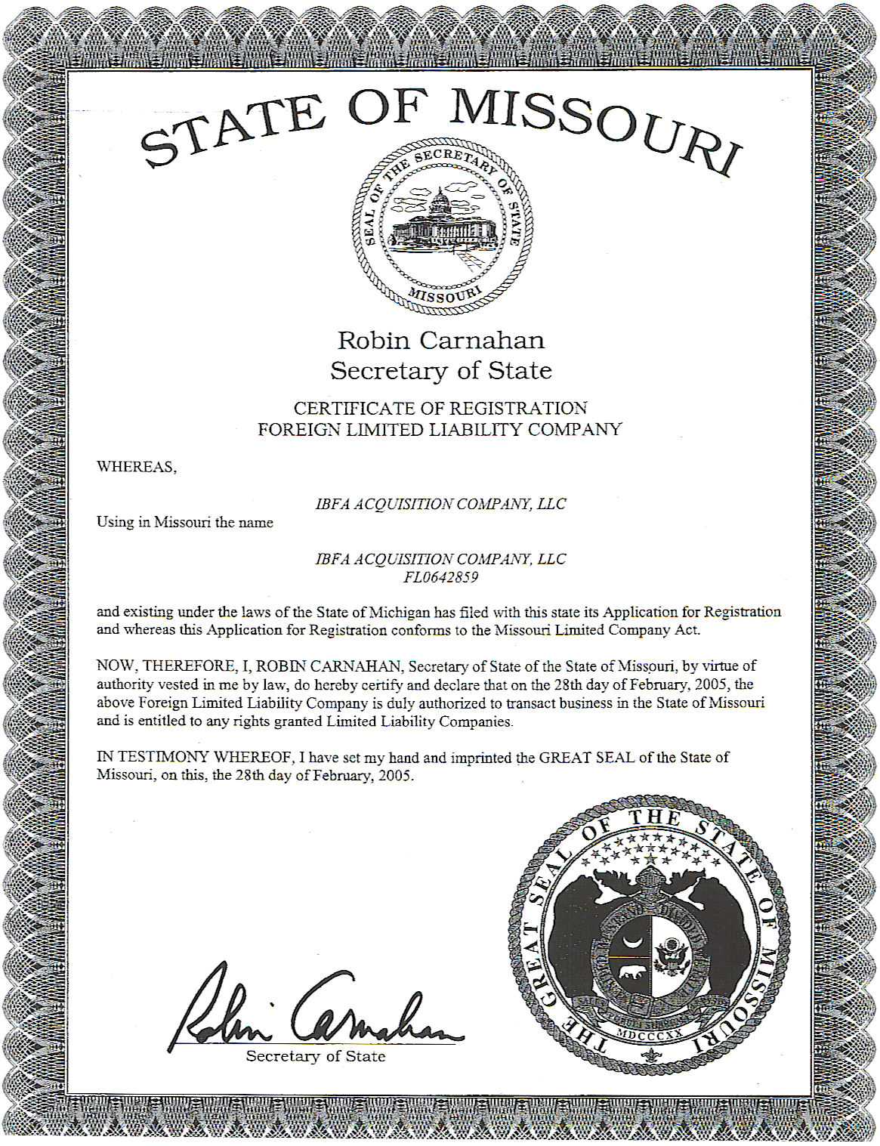

APPENDIX B

Background and Experience of Key Management

Casey Wojciechowski, President, IBFA Acquisition Company, LLC

Casey Wojciechowski’s penchant for communications began in the United States Marine Corps more than 30 years ago where he served in aircraft communications managing one of the largest communications and navigation repair facilities in the Marines. After the service, Casey furthered his telecommunications expertise in the sales, marketing and management of the industry by focusing on Internet, data and voice applications for small to multi-million dollar businesses for both AT&T and MCI. As General Manager of American Farm Bureau Incorporated, Casey personally envisioned and launched Farm Bureau Connection®, a national long distance program. As a founding member and President of Applicant, Casey is responsible for all program operations, a national call center and customer service, compliance issues and contract negotiations regarding vendors, billing, taxes and product offering.

James Grabowski, Vice President, IBFA Acquisition Company, LLC

Jan 2005 – present Vice President of IBFA Acquisition Company, LLC
Sep 1996 – Dec 2004 Owner of JG Core Group, a telecommunications consultant
1991 – Sep 1996 Vice President of Great Lakes Telecommunications, a long distance reseller
1985 – 1991 Vice President of Promotional Services Group, a sale promotion agency

Patrick D. Crocker, Secretary, IBFA Acquisition Company, LLC

Professional experience includes 15 years experience as a practicing attorney specializing in the area of telecommunications and technology.

May 1989 — Early, Lennon, Crocker & Bartosiewicz, P.L.C.
Present Vice-President
Vice Chairman, Telecommunications and Technology Department

- Provide regulatory, strategic and transactional legal services to over 100 public and private telecommunication and technology clients nationwide. Such services include:

  - State and federal certification
  - Contract negotiations with underlying carriers
  - Business transactions
  - Formal and informal regulatory complaints
  - All stages of arbitration and litigation
  - Corporate Reorganization
  - Sale or acquisition of company assets, including customer base
  - Corporate mergers and acquisitions
  - Computer system contracts
  - Trademark licensing and registration
  - Entry into the electric resale market
  - Nationwide carrier compliance

EDUCATION: University of Michigan, BA 1986
University of Detroit, School of Law, JD 1989

APPENDIX C

Pro Forma Financial Statements

To be late-filed under seal

Verification

