BEFORE THE PUBLIC SERVICE COMMISSION
STATE OF MISSOURI

In the Matter of the Joint Application of )
IBFA Acquisition Company, LLC and )
American Farm Bureau, Inc. d/b/a )
The Farm Bureau® ConnectionSM ) Case No. __________________
for Approval of the Acquisition of )
Certain Assets of The Farm Bureau® )
ConnectionSM by IBFA Acquisition )
Company and for a Waiver )

JOINT APPLICATION FOR APPROVAL OF TRANSFER OF ASSETS

COME NOW IBFA Acquisition Company, LLC (“IBFA”) and American Farm Bureau, Inc. d/b/a The Farm Bureau® ConnectionSM (“FB CONNECTION” or “Seller”), (referred to collectively hereinafter as “Joint Applicants”), by and through counsel, pursuant to Sections 392.290 and 392.300 RSMo., and 4 CSR 240-2.060 and 4 CSR 240-3.520, and hereby jointly request Commission approval of a transaction whereby IBFA will acquire certain Missouri assets of FB CONNECTION, described more fully below, pursuant to an Asset Purchase Agreement dated January 31, 2005 (the "Agreement"). Joint Applicants also request a waiver of the subscriber authorization and verification requirements for the change of customers’ interexchange carrier in 4 CSR 240-33.150. Joint Applicants further request cancellation of FB CONNECTION’s Missouri certificates of service authority and tariffs after consummation of the transfer of assets.
In support of their request, Joint Applicants state the following:
- The Parties
  - IBFA Acquisition Company, LLC
1. IBFA is a limited liability company organized under the laws of the State of Michigan with principal offices located at Elk Grove Village, Illinois. The nature of IBFA’s business is telecommunications. A copy of Applicant’s Certificate of Authority from the Missouri Secretary of State, as required by 4 CSR 240-2.060(1)(C), is attached to this Application as Appendix A.
2. IBFA is authorized to provide intrastate, interexchange service in 12 jurisdictions and is filing nationwide for authority to provide basic local exchange and/or interexchange telecommunications services. An Application for a Certificate of Service Authority to Provide Basic Local Telecommunications Services in the State of Missouri is being filed by IBFA contemporaneously with this filing. An Application for a Certificate of Service Authority to Provide Interexchange and Non-Switched Local Exchange Telecommunications Services in the State of Missouri was filed by IBFA on May 27, 2005 in Case No. TA-2005-0451.
3. The principal office of IBFA is located at:
1850 Howard Street, Unit C
Elk Grove Village, IL 60007
Telephone: (847)-685-8600
Fax Number: (847)-685-8687
800-number for customer inquiries or complaints: (800)-362-3276

4. IBFA states that it does not have any outstanding Annual Reports or assessment fees owed to the Missouri Public Service Commission and it does not have any pending action or final unsatisfied judgments or decisions against it from any state or federal agency or court which involve customer service or customer rates, which action, judgment, or decision has occurred within three years of the date of this application.
  - American Farm Bureau, Inc. d/b/a The Farm Bureau® CONNECTIONSM
5. FB CONNECTION is a corporation organized under the laws of the State of Illinois whose principal offices are located at Park Ridge, Illinois. FB CONNECTION is authorized under Section 214 of the Communications Act of 1934, as amended, to provide domestic interstate and international telecommunications service, and has authority to provide intrastate, interexchange service in 49 states with CLEC authority in 13 of those states, including the State of Missouri.
6. FB CONNECTION is authorized to provide interexchange telecommunications services in Missouri pursuant to a certificate of service authority granted by this Commission in Case No. TA-97-99 (dated 10/28/96).
7. Documentation from the Missouri Secretary of State was filed in Case No. TA-97-99, and is incorporated herein by reference pursuant to 4 CSR 240-2.060(1)(G).
8. FB CONNECTION is authorized to provide basic local telecommunications services in Missouri pursuant to a certificate of service authority granted by this Commission in Case No. CA-2004-0131 (dated 01/22/2004). 9. FB CONNECTION states that it does not have any outstanding Annual Reports or assessment fees owed to the Missouri Public Service Commission and it does not have any pending action or final unsatisfied judgments or decisions against it from any state or federal agency or court which involve customer service or customer rates, which action, judgment, or decision has occurred within three years of the date of this application.
10. The principal office of FB CONNECTION is located at:
225 Touhy Avenue
Park Ridge, IL 60068

II. DESIGNATED CONTACTS
- All communications, notices, orders and decisions respecting this Application and proceeding should be addressed to:
William D. Steinmeier
Mary Ann (Garr) Young Patrick D. Crocker
William D. Steinmeier, P.C. Early, Lennon, Crocker & Bartosiewicz, P.L.C.
2031 Tower Drive 900 Comerica Building
Jefferson City, Missouri 65109 Kalamazoo, Michigan 49007-4752
Tel: (573) 659-8672 Tel: (269) 381-8844
Fax: (573) 636-2305 Fax: (269) 381-8822
Email: wds@wdspc.com Email: pcrocker@earlylennon.com
myoung0654@aol.com

12. Questions concerning the Parties (Joint Applicants) and the Transaction should be addressed directly to Mr. Crocker at the above address, telephone number and/or email address.

III. The Transaction
13. Pursuant to an Asset Purchase Agreement executed January 31, 2005, FB CONNECTION has agreed to sell to IBFA, and IBFA has agreed to purchase the assets, including but not limited to: (1) all PUC/PSC/FCC licenses, CPCNs and tariffs authorizing Seller to do business in all relevant states to the extent assignable or transferable; and (2) the customer base as of the Closing Date.

IV. Public Interest Considerations
14. The transaction contemplated by the Asset Purchase Agreement will serve the public interest by enabling IBFA to achieve increased economies of scale and compete more effectively in the telecommunications marketplace. More effective competition will ultimately lead to lower prices and the availability of more products and services to the public. The acquisition of the FB CONNECTION customer base by IBFA will enable these subscribers to continue to receive high-quality telecommunications service at affordable rates without interruption.
15. Upon approval of this transaction, IBFA will provide notice to the FB CONNECTION Customers, and assure them of IBFA’s commitment to continue the provision of high quality, affordable services pursuant to the company’s filed tariff. Specifically, customers will continue to receive the high quality, affordable telecommunications services that they presently receive. IBFA is not requesting permission to adopt FB CONNECTION’s existing tariff. Rather, IBFA has filed its own interexchange and non-switched local exchange tariffs with its Application in Case No. TA-2005-0451, and will file its own CLEC tariff, to establish rates, terms, and conditions identical to those in the Seller’s tariffs, thus providing a seamless transition for existing customers of FB CONNECTION. As a result, the proposed acquisition will be virtually transparent to FB CONNECTION’s customers. As such, the transaction will not cause inconvenience or confusion to FB CONNECTION customers. Indeed, the transaction will be virtually transparent to FB CONNECTION customers in terms of the services that they receive. A copy of the sample notice of the transfer appears as Appendix B attached hereto.
16. IBFA certifies that it has the necessary managerial and financial resources to provide the public with quality telecommunications service throughout the state. After the consummation of the transaction, IBFA will be lead by a team of well-qualified managers comprised of its existing personnel – including the creator and manager of the Farm Bureau Connection Program. IBFA expects that the ample managerial, technical and financial expertise of this managerial team will enable IBFA to provide high quality service to FB CONNECTION customers as well as to expand its customer base. The proposed acquisition will therefore promote competition in the Missouri telecommunications services market and serve the public interest.
17. The transfer will have no impact on the tax revenues of any political subdivision in the state of Missouri.

V. WAIVER OF 4 CSR 240-33.150
18. IBFA and FB CONNECTION seek waiver of 4 CSR 240-33.150, which contains subscriber authorization and verification requirements for the change of customers’ interexchange carrier. This waiver is appropriate and in the public interest because this is not the type of transfer to which the “anti-slamming” rule was intended to apply. In addition, Applicants submit that the notice to be provided to customers will reasonably and adequately advise them of both the change in their telecommunications services provider and their opportunity to choose another provider.

VI. CANCELLATION OF CERTIFICATE AND TARIFF
19. Because IBFA will acquire substantially all of the assets of FB CONNECTION and FB CONNECTION will thereafter cease operations in this state, FB CONNECTION will no longer require authority to provide service in this state. Joint Applicants therefore respectfully request that through this proceeding the Commission grant any authority necessary to permit FB CONNECTION to discontinue service upon consummation of the Transaction and permit FB CONNECTION to relinquish its certification in this state, simultaneously with the effective date of the Acquisition.
20. FB CONNECTION requests that its Missouri Certificate and tariffs be cancelled, upon completion of the instant transaction.

VI. CONCLUSION
WHEREFORE, IBFA Acquisition Company, LLC (IBFA) and American Farm Bureau, Inc. d/b/a The Farm Bureau® ConnectionSM (FB CONNECTION) respectfully and jointly request that the Commission authorize the sale of assets from FB CONNECTION to IBFA.
Respectfully submitted,
/s/ William D. Steinmeier
William D. Steinmeier, Mo. Bar #25689
Mary Ann (Garr) Young, Mo.Bar #27951
WILLIAM D. STEINMEIER, P.C.
2031 Tower Drive
P.O. Box 104595
Jefferson City, MO 65110-4595
Tel.: (573) 659-8672
Fax: (573) 636-2305
Email: wds@wdspc.com
Myoung0654@aol.com

ATTORNEYS FOR THE PARTIES:
IBFA Acquisition Company, LLC and
American Farm Bureau, Inc.
d/b/a The Farm Bureau® ConnectionSM

May 31, 2005

Certificate of Service
I hereby certify that a copy of the foregoing document has been served electronically on the Office of the General Counsel of the Missouri Public Service Commission and the Office of Public Counsel, on this 31st day of May 2005.

/s/ William D. Steinmeier

Appendix A

IBFA Acquisition Company, LLC:

Missouri Certificate of Registration as a

Foreign Limited Liability Company
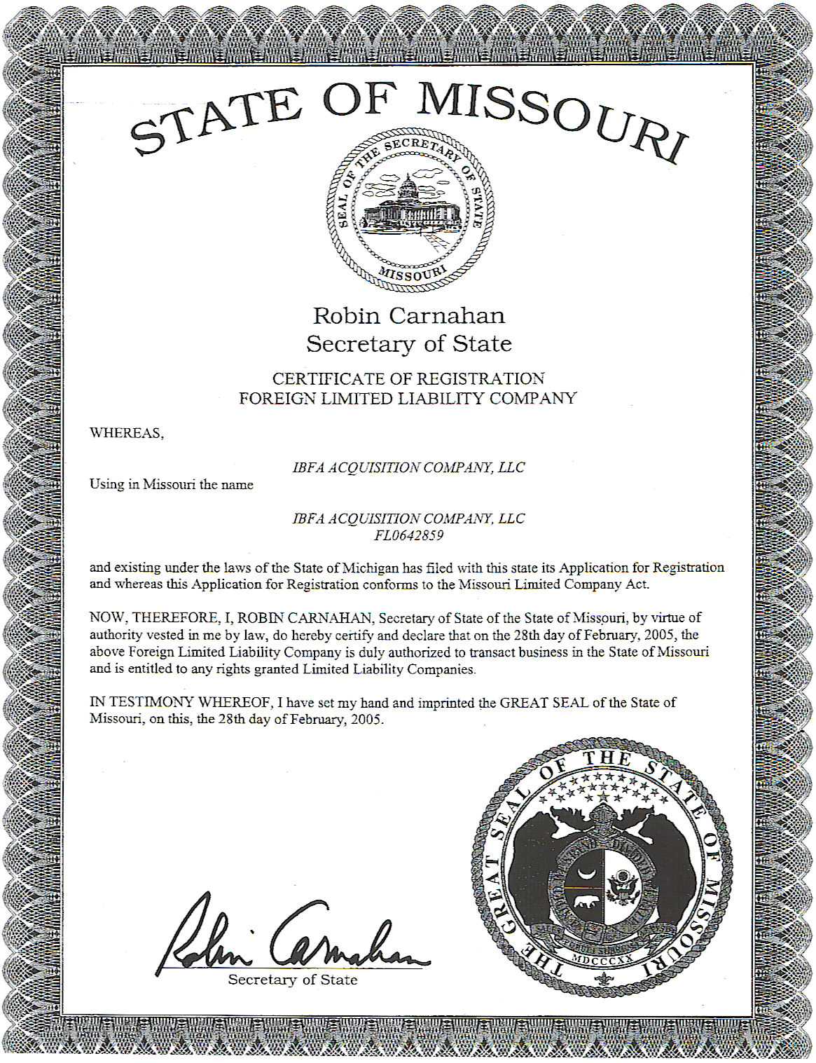

Appendix B

Sample Notice to Customers

IBFA FB Connection

(Customer Name)
(Address)

Dear Customer:

American Farm Bureau, Inc. d/b/a The Farm Bureau Connection (“FB Connection”) and IBFA Acquisition Company, LLC (“IBFA") have entered into an Asset Purchase Agreement, whereby the telecommunications assets of FB Connection will be acquired by IBFA, and IBFA will become your new provider of communications service provider. IBFA anticipates becoming your telecommunications provider on or before July 31, 2005.

There will be no change to the rates, terms or conditions of service currently provided to you. We will provide appropriate notice should the terms or conditions change subject to this transfer.

IBFA will be responsible for any carrier change charges associated with this transfer.

You may select an alternative preferred carrier for your telecommunications services.

If you have a preferred carrier freeze, you must contact the appropriate local exchange company to arrange a new freeze.

Please direct all questions, complaints, or concerns to the following toll free number: (800) 362-3276.

We at IBFA are pleased to welcome you to our team and would like to express our appreciation for allowing us the opportunity of being your telecommunications service provider. We are confident that you will be pleased with the high quality of our service.

Sincerely,

IBFA

Casimir Wojciechowski, President

Verifications

(FB CONNECTION Verification to be late-filed)

