Exhibit No.:

Issues: Tariffs
Witness: James A. Gray
Sponsoring Party: MoPSC Staff
Type of Exhibit: Rebuttal Testimony
Case No.: GA-2002-429
Date Testimony Prepared: June 28, 2002

MISSOURI PUBLIC SERVICE COMMISSION

Utility Operations DIVISION

rebuttal TESTIMONY

OF

James A. Gray

LACLEDE GAS COMPANY

CASE NO. GA-2002-429

Jefferson City, Missouri
June, 2002

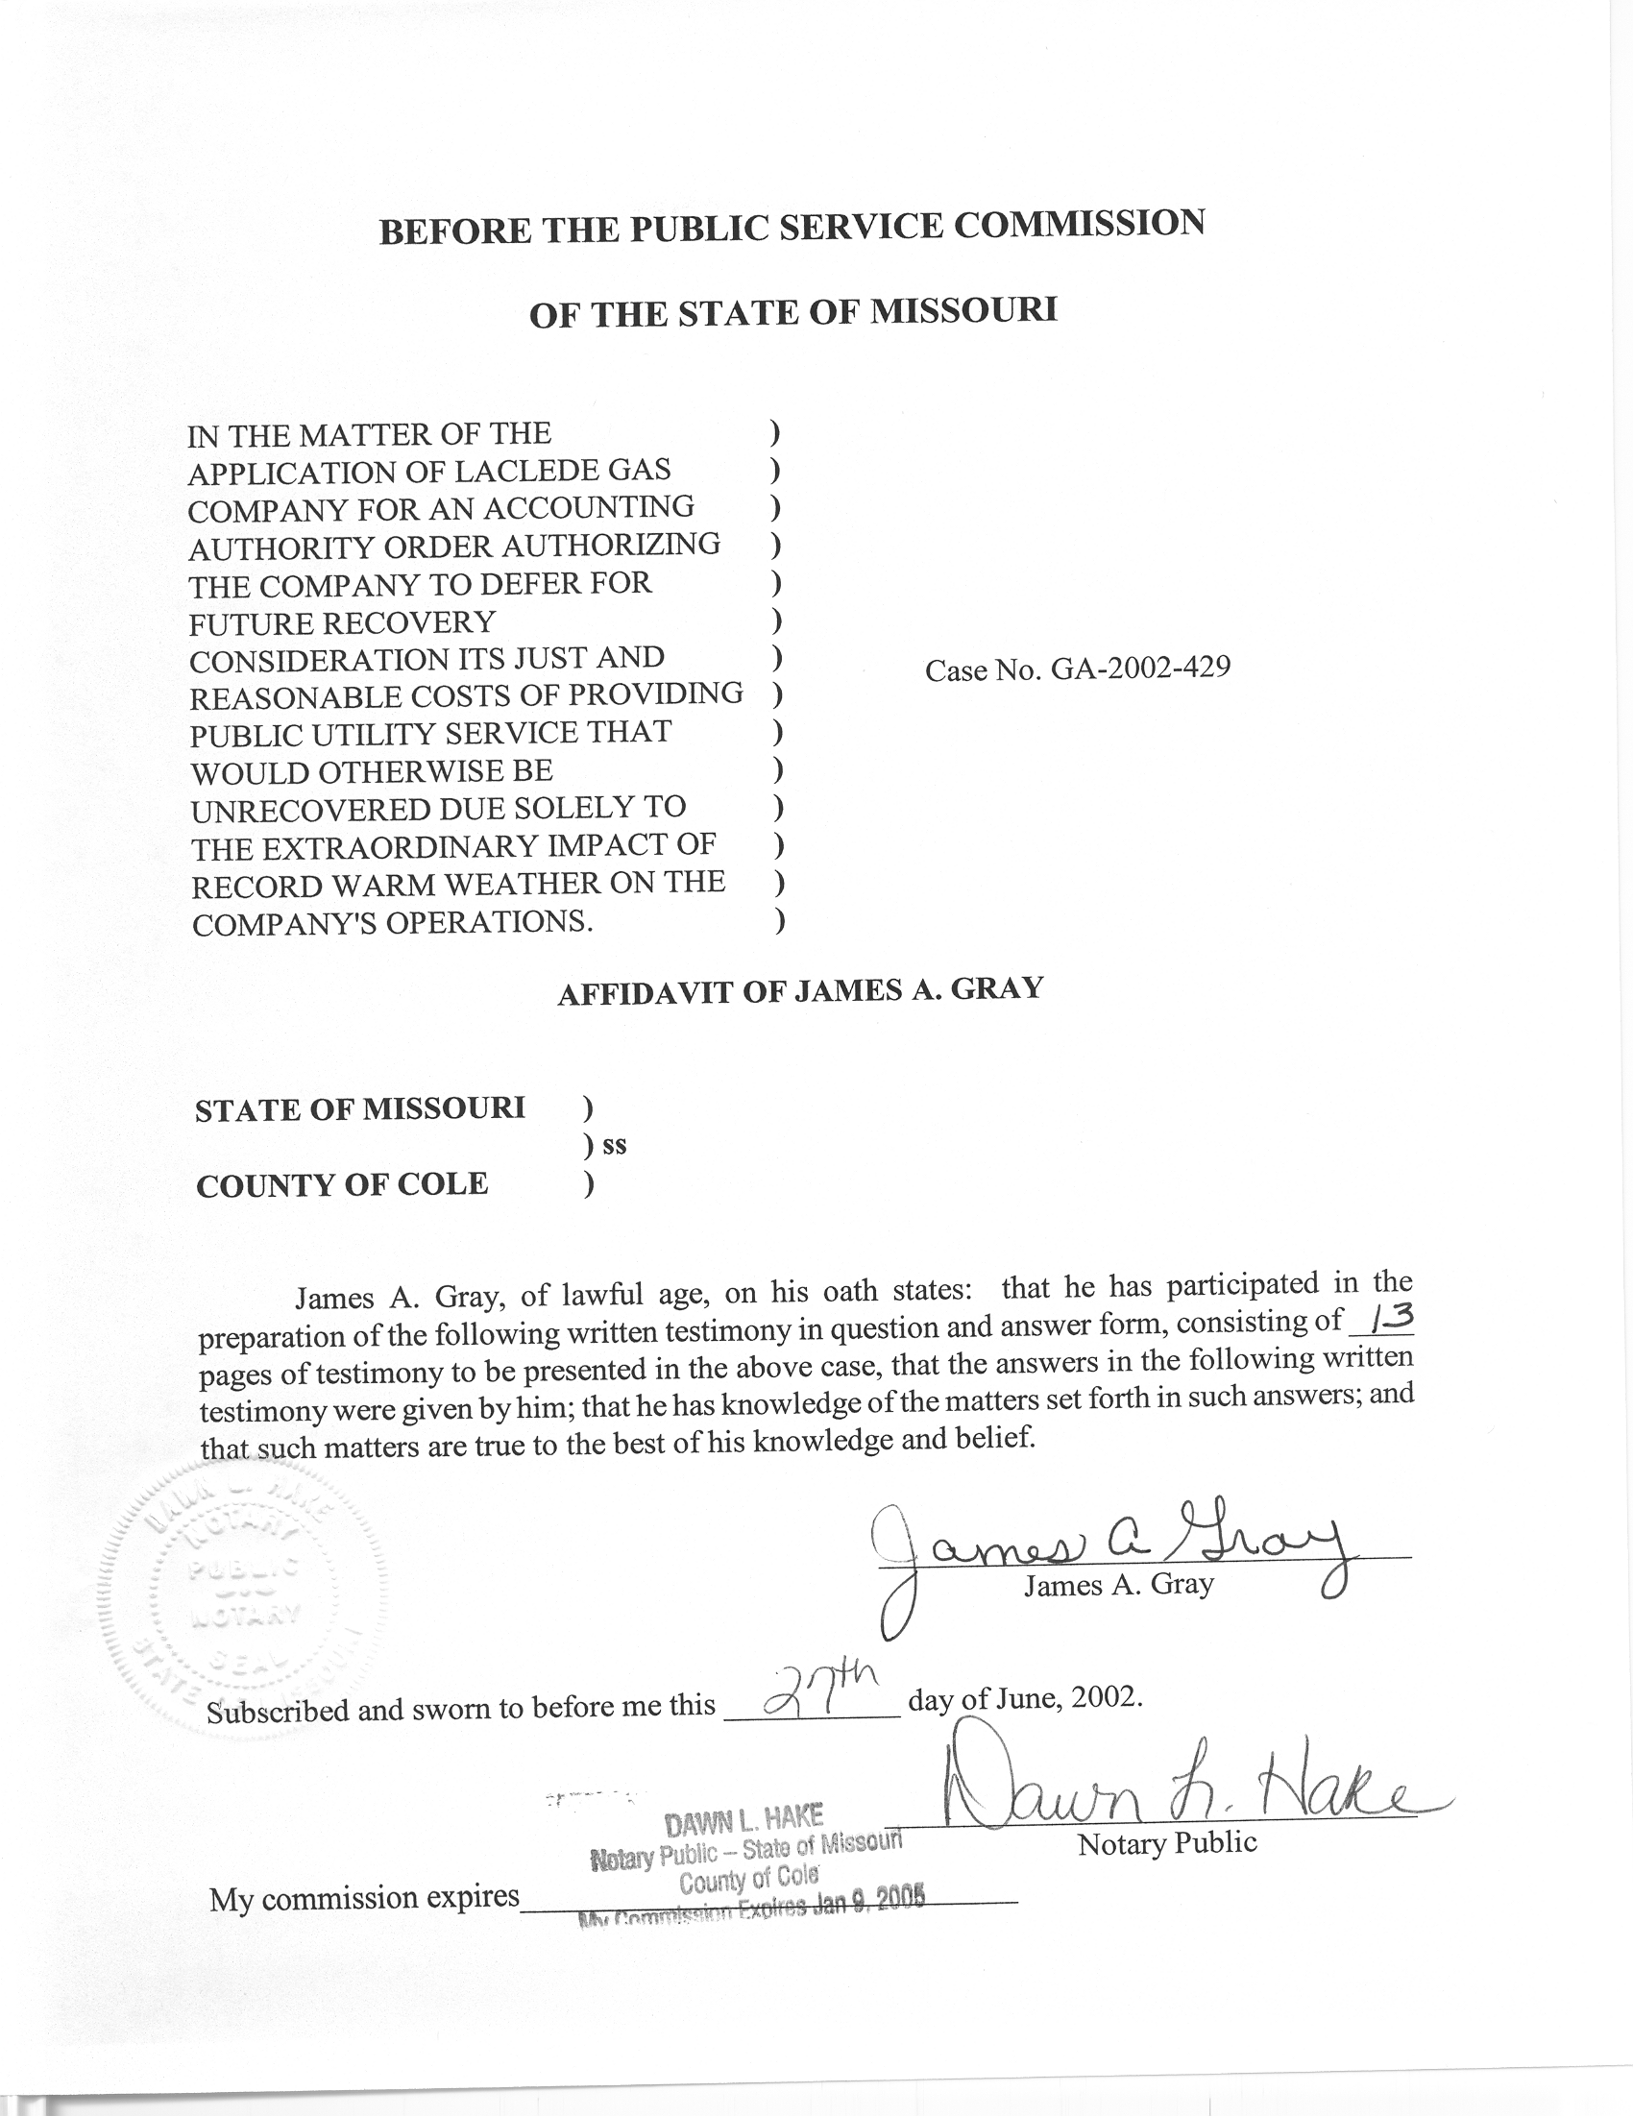

TABLE OF CONTENTS

RATIONALE FOR ADJUSTING GAS SALES TO NORMAL WEATHER 3
DIFFERENCES IN METHODOLOGY 5
RECOMMENDATION 13

REBUTTAL TESTIMONY
OF
JAMES A. GRAY

LACLEDE GAS COMPANY

CASE NO. GA-2002-429

Q. Please state your name and business address.
A. My name is James A. Gray. My business address is P. O. Box 360, Jefferson City, Missouri 65102.
Q. By whom are you employed and in what capacity?
A. I am employed by the Missouri Public Service Commission (Commission) as a Regulatory Economist in the Tariffs/Rate Design Section of the Commission's Energy Department.
Q. How long have been employed by the Commission?
A. I have been employed with the Commission for approximately twenty-two years.
Q. Please state your educational background.
A. I received a degree of Bachelor of Science in Psychology as well as one in General Studies from Louisiana State University, and I received a degree of Master of Science in Special Education from the University of Tennessee. Additionally, I completed several courses in research and statistics at the University of Missouri - Columbia.
Q. Please state your professional qualifications.
A. Prior to being employed by the Commission, I was a Research Analyst for two and a half years with the Missouri Department of Mental Health where I conducted statistical analyses. In 1980, I began my employment with the Commission as a Statistician in the Depreciation Department where I submitted testimony regarding depreciation rates, trended-original cost, and trended-original cost less depreciation.
Beginning in 1989 as a member of the Economic Analysis Department, I submitted testimony on weather-normalized sales for natural gas, water, and electric utilities. I reviewed residential-electric-load forecasts with the associated detailed end-use studies and the marketing surveys in electric resource plans.
From December of 1997 through June of 2001, I was in the Tariffs/Rate Design Section of the Commission's Gas Department. Since July of 2001, I have been in the Tariffs/Rate Design Section of the Commission’s Energy Department. I have reviewed tariffs and applications of natural gas utilities. I have submitted testimony concerning weather-normalized sales, complaints, certificates of convenience and necessity, and recommended minimum-statistical-sample sizes for natural gas residential-customer-billing reviews.
Q. Please list all the cases in which you have submitted prepared written testimony before this Commission.
A. The cases in which I have submitted prepared, written testimony are enumerated in Schedule 1, attached to my testimony.
Q. What issue are you addressing in your rebuttal testimony?
A. I am addressing Laclede Gas Company (Laclede or Company) witness Michael R. Spotanski’s methodology to adjust natural gas sales for weather. Staff is recommending that this Accounting Authority Order (AAO) be rejected. If the Commission accepts Laclede’s AAO request, then my recommendations on weather normalization methods should be used to quantify the amount deferred.

RATIONALE FOR ADJUSTING GAS SALES TO NORMAL WEATHER
Q. Have you previously weather-adjusted the natural gas sales of Laclede to normal weather?
A. Yes, I have weather-adjusted the natural gas sales in six Laclede rate cases. Schedule 1-2, attached to this testimony, shows all the cases in which I have primarily presented testimony on weather-normalization. Those cases are marked with asterisks.
Q. Please summarize the type of source data or inputs required for your weather-normalization studies.
A. In a rate case, the weather adjustment is based on an historical test year, ordered by the Commission, with verified actual weather, audited customer numbers and audited natural gas usage. I use these input data to do detailed analyses to perform my weather-normalization studies for a test year.
Q. Why is it important to adjust natural-gas sales to normal weather in a rate case?
A. Since rates are based on natural gas usage during a test year, it is important to remove the influence of abnormal weather. Otherwise, the rates will be distorted by the deviations from normal weather conditions during the test year. Adjustments to test-year sales set the test-year-natural-gas volumes at the levels that would be experienced under normal-weather conditions.
Q. Why are natural gas sales dependent upon weather conditions?
A. The predominant use of natural gas in Missouri is for space heating. Space heating refers to the use of mechanical equipment to heat all or part of a building. As the weather becomes colder, natural gas sales increase because of space-heating requirements.
Q. What indicator of space-heating requirements do Staff and Laclede use?
A. Both parties use heating degree days (HDD) as a weather measure. HDD are defined by the U.S. National Oceanic and Atmospheric Administration (NOAA). HDD are calculated as the difference between 65 degrees and the mean daily temperature (the average of the high and low daily temperature), when the mean daily temperature is below 65ºF. On days warmer than a mean daily temperature of 65ºF, the HDD are equal to zero. For example, if a day had a mean daily temperature of twenty degrees (20º F), then that day would have 45 HDD (65 – 20 = 45). But if a day had a mean daily temperature of eighty degrees (80º F), the HDD would be zero.
Q. How are test-year-natural-gas sales adjusted if the test year is warmer than normal?
A. Natural gas sales for a test year would be increased to reflect a normal year, because the Company would be expected to sell more natural gas volumes under normal weather conditions than it sells during a warmer than normal test year.
Q. How are test-year-natural-gas sales adjusted if the test year is colder than normal?
A. Natural gas sales for a test year would be decreased to reflect a normal year, because the Company would be expected to sell less natural gas volumes under normal weather conditions than it sells during a colder than normal test year.
Q. Are weather-adjusted volumes dependant upon the methodology used?
A. Yes, the results depend upon the methodology utilized to arrive at an adjustment.

DIFFERENCES IN METHODOLOGY
Q. Does Mr. Spotanski imply that Staff agrees with Mr. Spotanski’s methodology?
A. Yes, Mr. Spotanski states:
Accordingly, there should be no issue regarding the Company's quantification of the cost recovery shortfall that it has experienced as a result of the extraordinary weather event of this past winter. (Spotanski Direct, Page 6, Lines 15 – 17) (emphasis added)

Q. Do you agree with Mr. Spotanski when he says, “... there should be no issue regarding the Company’s quantification …”?
A. No, I do not. Mr. Spotanski refers to the “quantification of the cost recovery” as if it were only one set of calculations. Actually, the “quantification of the cost recovery” encompasses several distinct steps or areas. Setting aside the issue of whether Laclede can recover any “shortfall,” the Company methodology differs from Staff’s methodology in the following seven, general areas:
(1) The choice of a proper weather normal or benchmark. This is the main reason for the quantitative differences between Staff and Laclede. (In Case No. GR-2002-356, Staff used thirty (30) years of data to calculate its normal weather variables while Laclede used only ten (10) years of data.)
- The quantification of the relationship between a weather measure (heating degree days (HDD)) and natural gas usage for space heating, during the colder months.
(3) The quantification of natural gas usage for water heating.
(4) The methodologies used to adjust natural gas volumes, for space heating and water heating, to normal weather.
(5) Additional adjustments pertaining to the large customer classes. (These adjustments can be for interruptible service and price responses.)
(6) Billing determinants. (Billing determinants are measured or calculated values used to determine a bill. These include applicable usage values, fixed charges, and any minimums.)
(7) Pricing the billing determinants.
All of these steps have been discussed, at various times, in Laclede’s previous rate cases. My testimonies in the past six Laclede rate cases have concerned the second, third, and fourth steps.
Q. Then, is Laclede’s weather-normalization methodology an issue?
A. Yes, it is.
Q. Has Staff previously presented its methodology in testimony?
A Yes, I have presented my methodology on numerous occasions. I have presented the same methodology in the last six Laclede rate cases shown on Schedule 1-2 concerning weather-adjustments of Laclede’s natural gas sales.
Q. Does Mr. Spotanski use Staff’s methodology to adjust natural gas sales to normal weather?
A. No, Mr. Spotanski states that he uses the methodology filed by Laclede in its previous rate cases.
The calculation, as set forth in Schedule 1 to my direct testimony, is based on the general weather normalization principles that were employed in Laclede's last rate case, Case No. GR-2001-629, and in previous cases, for measuring the cost of service recovery impact of deviations from the heating degree day normal. (Spotanski Direct, Page 5, Lines 9 -12) (emphasis added)

Q. Have you reviewed Laclede’s weather-normalization methodology?
A. Yes, I have in the previous six Laclede rate cases. As Mr. Spotanski previously stated, Laclede has essentially used the same methodology in those cases.
Q. How does Mr. Spotanski’s methodology differ from Laclede’s methodology in Case No. GR-2002-356?
A. Mr. Spotanski calculated a simple average (point-estimator) across all General Service rate classes and Laclede’s four divisions. In Case No. GR-2002-356, Laclede developed twelve (12) point-estimates, one point-estimator for the residential, commercial, and small industrial general service customers for each of Laclede’s four divisions.
Q. Have Staff and Company agreed to use the same weather-normalization methodology?
A. No, there have been no agreements to change either Laclede’s or Staff’s weather-normalization methodology. Mr. Spotanski implies that Staff and Company have made an agreement in Case No. GR-2001-629 when he states:
Derive the heating degree day deviation from normal for the period October 1, 2001 to March 31, 2002, by subtracting the actual heating degree days for each month from the heating degree day normal that the Company believes underlies the rates and billing determinants agreed upon in Case No. GR-2001-629. (Spotanski Direct, Page 5, Lines 14 – 18) (emphasis added)
In the last six rate cases, in which I have participated, the agreed revenues resulting from weather-normalization have been total dollar amount settlements. The parties in those previous six rate cases have not agreed to use any weather-normalization methodologies to calculate revenues in future rate cases. In prior cases, there have been joint study agreements that have not resulted in any changes in methodology.
Q. In those six Laclede rate cases, have any differences in weather-normalization methodology been resolved?
A. No, there has been no resolution in the last six Laclede rate cases. However, there was an attempt to resolve one step of the weather-normalization methodology, the quantification of the adjustment for water-heating volumes. In Case No. GR-92-165, Item 4(b) of the Stipulation and Agreement required Staff and Company to participate in a study to possibly arrive at a methodology to normalize natural gas sales for water heating. Item No. 4(b) of the Stipulation and Agreement states:
(b) To provide data on water heating usage by random sampling from extreme winter and summer years. Staff will gather water temperature data for the same sample period as measured at the Olive and Ballas Street office of St. Louis County Water Company. Laclede agrees to work with Staff to determine appropriate procedures for estimating and normalizing monthly water heating usage. (Stipulation and Agreement in Case No.
GR-92-165, Item 4(b)) (emphasis added)
A copy of Item 4(b) of the Stipulation and Agreement is attached to this testimony as Schedule 2.
Q. Were any methodological issues concerning “estimating and normalizing monthly water heating usage” resolved?
A. No, Laclede and Staff are still using two different methodologies to weather-normalize hot water heating. Neither Laclede nor Staff has changed its methodology in “estimating and normalizing monthly water heating usage” as a result of Case No. GR-92-165.
Q. Is there any other evidence in any of the previous rate cases that Staff and Laclede disagree with each other’s weather-normalization methodologies?
A. Yes, in Laclede Case No. GR-99-315, Staff and Laclede filed rebuttal and surrebuttal testimony on weather normalization. Also, in that case, Laclede deposed three Staff witnesses on weather normalization.
In that case, the weather-normalization issue was stipulated to a dollar amount, and any differences in weather-normalization methodology in Case No.
GR-99-315 were not resolved.
Q. In quantifying the relationship between space-heating natural gas usage and weather, what is the main methodological difference?
A. It is Laclede’s reliance upon simple arithmetic averages to estimate complex relationships.
- Does Mr. Spotanski rely on simple averages?
A. Yes, Mr. Spotanski states:
Multiply the heating degree day deviation from normal by the average actual usage per heating degree day experienced during the period by the Company's general service rate customers to determine the decrease in therm usage. (Spotanski Direct, Page 5, Lines 19 – 22) (emphasis added)

Q. What estimates does Laclede calculate?
A. Laclede primarily relies on two seasonal usage averages. One is a simple ratio calculated by dividing total natural gas usage by total Heating Degree Days (HDD). This ratio estimates usage response to colder weather (non-summer months). The other ratio is calculated the same way, but it encompasses only two summer months. Such seasonal averages, one average of ten months (non-summer months) and one of two months (summer months), are not good estimators of relationships.
Then Laclede multiplies the ten-month (non-summer) seasonal ratio by the monthly deviation in weather for each non-summer month of the test year.
Q. Does Staff calculate simple ratios of total natural gas space heating usage to total actual HDD for a test year?
A. No, Staff does not. The goal of adjusting test year natural gas sales to normal weather is to accurately quantify the relationship between weather and natural gas usage. Staff, in contrast to Laclede, uses statistical regression to quantify the relationship between space-heating usage and weather over the twelve billing months of a test year. Staff’s methodology is a monthly model that matches monthly natural gas usage and weather. In Staff’s regression analyses, the regression equations describe the relationship between daily-space-heating sales-per-customer (in therms) to the daily HDD. That is, it estimates how natural gas usage and weather, during the test year, are related.
One of the benefits of statistical regression is that the regression equation calculates a straight line that best fits or describes the relationship. For example, the slope of the best fitting straight line estimates a change in the daily natural gas usage-per-customer whenever the daily average HDD change by one HDD.
Another benefit of statistical regression is that the regression equations estimate a measure of the goodness or quality of fit. The measure is an r squared (r²). The r² value ranges from 0.00 to 1.00, with 1.00 being a perfect fit. Staff’s statistical regression produces better estimates than simple averages. Essentially, Laclede’s simple averages are point estimates.
Q. Would Mr. Spotanski’s results be different results if he had used Staff’s weather-normalization methodology?
A. Yes, the results would be different. Although, I did not have time to conduct detailed analyses with the billing months February 28, 2001 through March 31, 2002; in my direct testimony in Laclede Case No. GR-2002-236, I did conduct my analyses on a Commission ordered test year of December 1, 2000 through November 30, 2001. The results of my analyses differed from Laclede’s analyses, even though Company and Staff used the Commission ordered test year.
Q. Please compare the effect of Staff’s weather adjustments on revenue requirements with that of Laclede’s proposed adjustments.
A. Staff’s proposed adjustments in Case No. GR-2002-356 would result in a lower revenue requirement than the adjustment resulting from the weather-normalization methodology utilized by Laclede.
Q. Where does Mr. Spotanski present his methodology to adjust natural gas sales to normal weather?
A. Mr. Spotanski summarizes his weather adjustment on Schedule 1, attached to his testimony.
Mr. Spotanski uses this methodology to calculate his revenue adjustment due to weather. Mr. Spotanski’s adjustments are shown in the column labeled “Margin Adj.” on Schedule 1, attached to Mr. Spotanski’s testimony.
Q. Does adoption of this (AAO) as filed by Laclede imply de facto rejection of Staff’s methodology?
A. Yes, it means accepting Laclede’s methodology.
Q. In your opinion, is it important to reach agreement on methodology?
A. Yes, to implement this type of AAO, it is important to reach agreement on all inputs and calculations to be used.
Q. If methodology were resolved, do you see any other potential problems with the implementation of this AAO?
A. Yes, in my opinion, the customer numbers and natural gas usage should be audited by Staff, as is customarily done in a rate case.
Q. Please summarize all the potential methodological problems with the AAO.
A. I have regrouped my seven steps into five major categories. First, there are problems with verifying the inputs to the calculations. The inputs should be audited natural gas usage and audited customer levels. The other major input is the selection of appropriate weather variables.
Second, there are methodological differences associated with estimating the relationship between weather and natural gas usage for both space heating and water heating. Third, there are methodological differences involving the calculations to adjust the natural gas volumes to normal. Fourth, there are differences in the selection of the proper billing determinants. Fifth, there are methodological differences in the pricing of the billing determinants.

RECOMMENDATION
- What are your recommendations?
A. Staff witnesses Mark L. Oligschlaeger and James M. Russo are recommending that the AAO be rejected. However, if the Commission approves Laclede’s AAO, then the Commission should recommend Staff’s weather-normalization methodology over Laclede’s methodology to estimate any under- or over-recovery. Also, I recommend that the Commission use audited customer numbers and audited natural gas usage to compute any under-recovery.
Q. Does this conclude your Rebuttal Testimony?
A. Yes, it does.

Laclede Gas Company
Case No. GR-2002-356
Testimonies Submitted by James A. Gray

COMPANY CASE NO.

Missouri Public Service Company GR-81-312
Missouri Public Service Company ER-82-39
Missouri Public Service Company GR-82-194
Laclede Gas Company GR-82-200
St. Louis County Water Company WR-82-249
Missouri Public Service Company ER-83-40
Kansas City Power & Light Company ER-83-49
Osage Natural Gas Company GR-83-156
Missouri Public Service Company GR-83-186
The Gas Service Company GR-83-225
Laclede Gas Company GR-83-233
Missouri Water Company WR-83-352
Missouri Cities Water Company WR-84-51
Le-Ru Telephone Company TR-84-132
Union Electric Company ER-84-168
Union Electric Company EO-85-17
Kansas City Power & Light Company ER-85-128
Great River Gas Company GR-85-136
Missouri Cities Water Company WR-85-157
Missouri Cities Water Company SR-85-158
United Telephone Company of Missouri TR-85-179
Osage Natural Gas Company GR-85-183
Kansas City Power & Light Company EO-85-185
ALLTEL Missouri, Inc. TR-86-14
Sho-Me Power Corporation ER-86-27
COMPANY CASE NO.

Missouri-American Water Company, Inc. WR-89-265 **
The Empire District Electric Company ER-90-138 **
Associated Natural Gas Company GR-90-152
Missouri-American Water Company, Inc. WR-91-211 **
United Cities Gas Company GR-91-249 **
Laclede Gas Company GR-92-165 **
St. Joseph Light & Power Company GR-93-42 **
United Cities Gas Company GR-93-47 **
Missouri Public Service Company GR-93-172 **
Western Resources, Inc. GR-93-240 **
Laclede Gas Company GR-94-220 **
United Cities Gas Company GR-95-160 **
The Empire District Electric Company ER-95-279 **
Laclede Gas Company GR-96-193 **
Missouri Gas Energy GR-96-285 **
Associated Natural Gas Company GR-97-272 **
Union Electric Company GR-97-393 **
Missouri Gas Energy GR-98-140 **
Laclede Gas Company GR-98-374 **
AmerenUE GA-99-107
Laclede Gas Company GA-99-236
St. Joseph Light & Power Company GR-99-42 **
Laclede Gas Company GR-99-315 **
AmerenUE GR-2000-512 **
Missouri Gas Energy GR-2001-292 **
Gateway Pipeline Company, Inc., et al. GM-2001-585
Missouri Gas Energy, et al GC-2001-593
