Exhibit No.:
Issues: Weather-Normalization

Witness: James A. Gray
Sponsoring Party: MO PSC Staff
Type of Exhibit: Rebuttal Testimony
Case No.: GR-2002-356
Date Testimony Prepared: August 2, 2002

MISSOURI PUBLIC SERVICE COMMISSION

Utility Operations DIVISION

Rebuttal testimony

of

James A. Gray

Laclede gas company

CASE NO. GR-2002-356

Jefferson City, Missouri
August, 2002

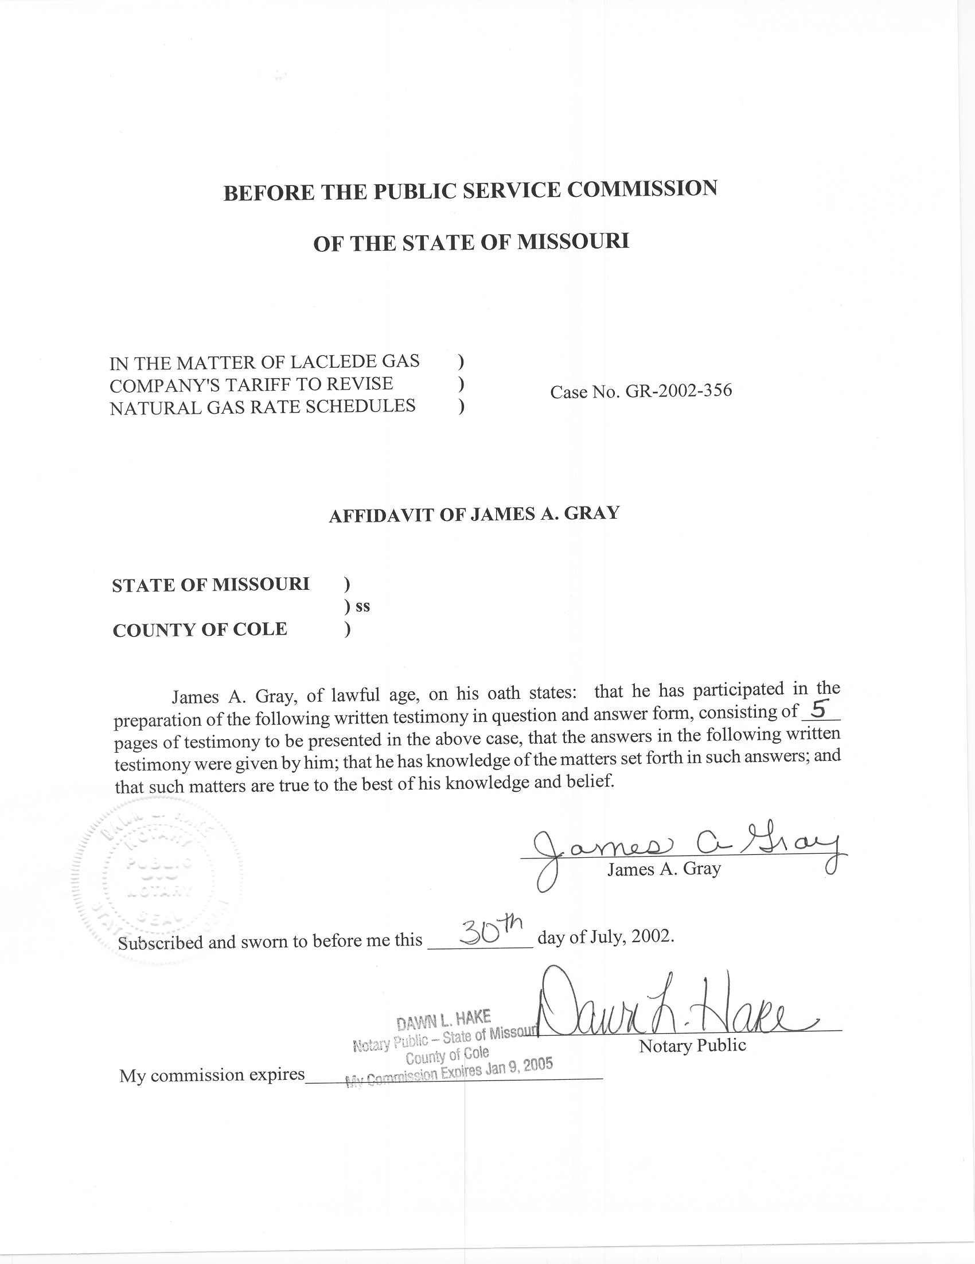

REBUTTAL TESTIMONY
OF
JAMES A. GRAY

LACLEDE GAS COMPANY

CASE NO. GR-2002-356

Q. Please state your name and business address.
A. My name is James A. Gray. My business address is P. O. Box 360, Jefferson City, Missouri 65102.
Q. Are you the same James A. Gray who filed Direct Testimony in this case?
A. Yes, I am.
Q. What issue are you addressing in your Rebuttal Testimony?
A. Laclede Gas Company’s (Laclede or Company) witness Patricia A. Krieger’s Direct Testimony concerning weather-normalization.
Q. Do you agree with the Company’s methodology to adjust natural gas sales to normal weather?
A. No. I have several concerns with Laclede’s methodology.
Q. Briefly summarize the main differences between Staff’s and Laclede’s methodology in weather-adjusting the volumes of Laclede’s general service classes.
A. The Company’s methodology differs from Staff’s methodology in four, broad general areas or steps:
- The choice of a proper weather normal or benchmark. This is the
major component of the quantitative differences between Staff and Laclede. In this case, Staff has used thirty (30) years of data to calculate its normal weather variables while Laclede only used ten (10) years of data. This difference will be addressed by Staff witness Dennis Patterson in his Rebuttal Testimony.
- The quantification of the relationship between a weather measure (heating degree days (HDD)) and natural gas usage for space heating, during the colder months.
- The quantification of natural gas usage for water heating. This difference will be addressed by Staff witness Henry E. Warren, PhD, in his Rebuttal Testimony.
- The methodologies to adjust natural gas volumes, for space heating and water heating, to normal weather.
My Rebuttal Testimony addresses the second (2) and fourth (4) differences between the Staff’s and the Company’s methodologies identified above. Staff’s methodology, concerning the second and fourth differences, was described in my Direct Testimony in this case.
Q. How does Laclede differ from Staff in quantifying the relationship between space-heating natural gas usage and weather?
A. Laclede uses simple, arithmetic averages to estimate complex relationships when there are better methods to determine relationships. Essentially, Laclede’s simple averages are point estimates. The Company uses a simple arithmetic method based on an average annual use per customer by general service class and division. However, the Staff uses a customer weighted averaging process to account for varying customer numbers among the cycles within a billing month.
Q. Where does Ms. Krieger present her methodology to adjust natural gas sales to normal weather?
A. Ms. Krieger discusses weather-normalization on pages 8 through 20 of her Direct Testimony in this case. Then Ms. Krieger summarizes her results in Schedule 3.
- Does Ms. Krieger rely on simple averages?
A. Yes, Ms. Krieger states:
In each case, the average annual use per customer is the starting point, and the customer use that does not vary with degree days is subtracted to yield the use per customer per degree day. (Krieger Direct, Page 18, Lines 13 – 16) (emphasis added)

Q. Which Laclede estimates are simple averages?
A. Laclede primarily relies on “Average annual use per customer,” as shown on Ms. Krieger’s Schedule 3. The other simple average is a summer seasonal average shown as “Use not varying with degree days,” on Ms. Krieger’s Schedule 3. The summer seasonal average is an average of two summer months’ (July and August) usage. These two averages are the basis of Laclede’s weather-normalization methodology.
In Laclede’s calculations, the summer seasonal averages are an average natural gas usage over only two summer months, and the annual average is an average of the twelve months of the test year. A seasonal estimate based on only two summer months does not accurately quantify the relationship between weather and natural gas usage.
Laclede’s method assumes a fixed relationship between Laclede’s summer customers versus the winter customers, which is not demonstrated. There may be seasonal customers, which only use natural gas in the winter. There may also be growth in the number of the customers throughout the test year. In my opinion, the customers with newer natural gas appliances may have quite different natural gas consumption patterns than the customers with older natural gas appliances.
Q. Does Staff rely on annual or seasonal averages?
A. No, the goal of adjusting test year natural gas sales to normal weather is to accurately quantify the relationship between weather and natural gas usage. Simple averages of many months of data are not good estimators of relationships.
Staff, in contrast, uses statistical regression to quantify the relationship between space-heating usage and weather over each of the twelve billing months of a test year. Therefore, Staff’s methodology is a monthly model that matches monthly natural gas usage and weather. That is, it estimates how natural gas usage and weather, during the test year, are related.
One of the benefits of statistical regression is that the regression equation calculates a straight line that best fits or describes the relationship between daily-space-heating sales-per-customer in therms to the daily HDD. For example, as described in my Direct Testimony, the slope of the best fitting straight line estimates the daily natural gas usage-per-customer per HDD.
Another benefit of statistical regression is that the regression equations estimate a measure of the goodness or quality of fit. The measure is an r squared (r²). The r² ranges from 0.00 to 1.00, with 1.00 being a perfect fit. Staff’s statistical regression produces better estimates than Laclede’s simple averages.
Q. What are your recommendations?
A. I recommend that the Commission approve the Staff’s regression methodology versus Laclede’s ratio method of adjusting test year natural gas sales to normal weather.
Q. Does this conclude your rebuttal testimony?
A. Yes, it does.

