Exhibit No.:
Issues: Alternative Regulation Plan AmerenUE’s Low Income Assistance Program; DNR’s Low Income Weatheriza-tion Program; and Energy Efficiency Services for Residential and Commercial Customers
Witness: Wess A. Henderson
Sponsoring Party: MO PSC Staff
Type of Exhibit: Surrebuttal Testimony
Case No.: EC-2002-1
Date Testimony Prepared: June 24, 2002

MISSOURI PUBLIC SERVICE COMMISSION

Utility Operations DIVISION

SURREBUTTAL TESTIMONY

OF

WESS A. HENDERSON

UNION ELECTRIC COMPANY d/b/a

AMERENUE

CASE NO. EC-2002-1

Jefferson City, Missouri
June, 2002
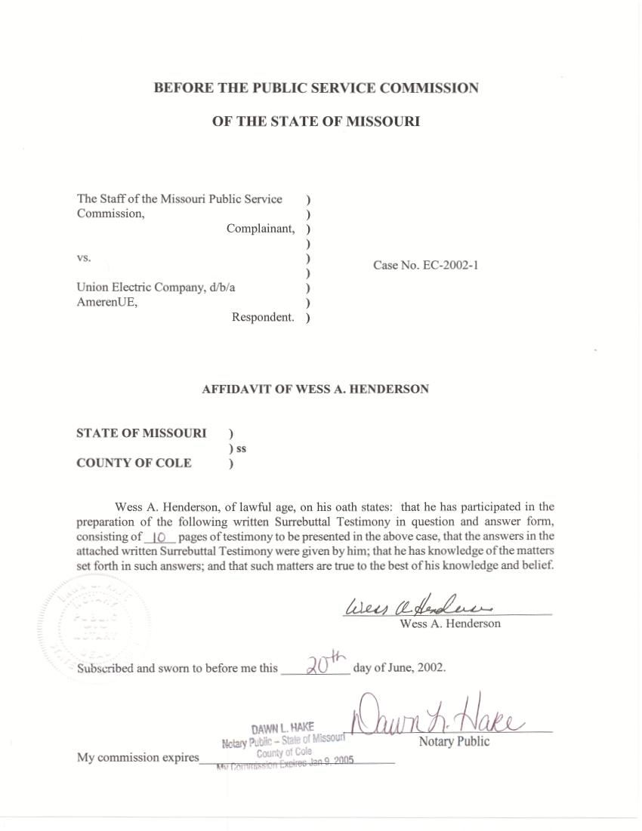

SURREBUTTAL TESTIMONY
OF
WESS A. HENDERSON
UNION ELECTRIC COMPANY
d/b/a/ AMERENUE

CASE NO. EC-2002-1

Q. Please state your name and address.
A. Wess A. Henderson, P. O. Box 360, Jefferson City, Missouri, 65102.
Q. By whom are you employed and in what capacity?
A. I am employed by the Missouri Public Service Commission (Commission) as the Director of the Utility Operations Division. I have held this position since October 1, 1997.
Q. How long have you been employed by the Commission?
A. I began work at the Commission in April 16, 1979 as a Staff Accountant. On August 1, 1981, I was promoted to Assistant Manager in the Water and Sewer Department. I held that position until I was appointed to my current position.
Q. Please describe your educational background.
A. I received a Bachelor’s Degree in Business Administration, majoring in Accounting, from Columbia College in February 1975. I also received a Master’s Degree in Public Administration in November 1985 from the University of Missouri-Columbia. I became a certified Government Financial Manager in December 1996.
Q. What is the purpose of your surrebuttal testimony?
A. As one of the senior contact persons for the Commission Staff with Union Electric Company (Company or AmerenUE) in this case, and prior to this case, I am responding to comments found in the rebuttal testimony of Dr. Peter S. Fox-Penner starting on page 25, lines 16 to 25 and continuing on page 26 line 1 where he states:
Q. Does Staff’s case consider or propose alternative or incentive ratemaking for AmerenUE?

A. No. Staff does not even consider, much less recommend, alternative or incentive ratemaking for AmerenUE. The failure to even consider alternative or incentive ratemaking is an important deficiency in the Staff’s case given the changes occurring in the electric industry. I find this omission even more puzzling given the fact that from July 1, 1995 through June 30, 2001, AmerenUE was regulated under a form of incentive regulation know as the Experimental Alternative Regulation Plan (EARP).

Q. Do you agree with Dr. Fox-Penner’s statement on page 25, lines
18 and 19?
A. Only in part. Staff did not propose an alternative or incentive regulation plan in its excess earnings complaint case filed July 2, 2001 and March 1, 2002. However, during the period before the Staff filed its complaint, the Staff did consider and discuss alternative or incentive regulation options with AmerenUE. Staff was unable to develop an approach acceptable to the Company prior to the filing of the complaint.
Q. Why did Staff not recommend or propose an alternative or incentive regulation plan in its excess earnings complaint case?
A. It is my understanding that alternative regulation approaches or experiments cannot be imposed on utilities under the Commission’s jurisdiction without their consent. In the Staff’s excess earnings complaint filing on July 2, 2001, Staff recommended to the Commission that AmerenUE’s Missouri rates be reduced using the traditional cost of service methodology. The EARP expired on June 30, 2001 when no agreement was reached among the Company, Staff, the Office of the Public Counsel (OPC) and other parties to extend the EARP or come to terms on a new or restructured EARP. Staff had started an earnings investigation in the fall of 2000 for the purpose of the report that was required to be filed on February 1, 2001 and also in order to be in a position to carry on discussions with the Company regarding what might follow the conclusion of the second EARP on June 30, 2001. As of the close of the second EARP, the Staff believed the Company would be in an excess earnings position.
Q. Do you agree with Dr. Fox-Penner’s statements on pages 25 lines 19 to 23 and page 26 line 1 regarding the failure to consider alternative or incentive regulation being an important deficiency in Staff’s case?
A. No, I do not.
Q. Please explain.
A. Staff has been discussing with AmerenUE’s senior management an additional EARP since October 2000 in an effort to reach a mutual agreement on the terms and conditions of a third EARP. These discussions continued until just shortly before Staff’s excess earnings complaint was first filed. AmerenUE representatives and the Commission’s Executive Director and General Counsel had several meetings between November 2001 and April 1, 2002 that included discussion of general concepts that an EARP might address. There were no further substantive discussions between Company and Staff regarding an EARP until after the Company filed its rebuttal testimony on May 10, 2002.
Q. What correspondence have you had with the Company as it relates to an alternative or incentive regulation methodology plan for AmerenUE?
A. Since October 18, 2000 through March 28, 2001, I have communicated through six different letters to the Company senior management responding to Company questions and concerns, and outlining what, for settlement purposes, Staff would consider being a reasonable rebasing of rates and other terms and conditions such as a sharing grid for a new alternative or incentive regulation methodology. Staff, OPC, the non-utility interveners and the Company in Case No. EC-2002-1 have continued discussions until recently respecting an appropriate rebasing of the company’s rates and what might be terms of an acceptable experimental alternative regulation methodology.
Q. Please explain.
A. The EARP that was in effect at the time of the correspondence was due to expire by its own terms on June 30, 2001. If all parties could not negotiate a new experimental alternative regulation methodology, AmerenUE would be required to return to traditional rate regulation as of July 1, 2001. Once the EARP expired, Staff filed an earnings complaint case based upon traditional cost of service regulation methodology.
My letters set out many of the specifics that Staff views as important parts of any future alternative form of regulation. These details try to ensure, among other things, that there is an appropriate sharing of earnings among all stakeholders. The correspondence also sets out the fact that Staff believes that there should be specific operational and customer service goals and measurements included in a new alternative regulation plan. A deficiency with the last two EARPs was that there were no specific customer service goals or operational measurements determined at the outset of the EARPs to measure the success of the EARPs. The topics that were discussed include: customer service concerns; the term for a third EARP; sharing grid; moratorium on staff excess earnings (rate decrease) cases and rate increase moratorium; jurisdictional allocation factors; individual adjustments to derive UE’s ROE for purposes of the sharing grid; regulatory out provisions; reports to be provided to the staff; discovery; crediting of undisputed sharing amounts and provisions for treatment of interest on disputed amounts; permanent rate reduction at the start of a third EARP; disputes concerning compliance with a third EARP stipulation and agreement; nuclear decommissioning; effect of legislation; and other pending cases.
Although there was a rate reduction and credits provided to customers, the Staff believes that there is no way to measure if customers would have received the same or additional benefits under traditional ratemaking.
Staff believes that there should be a rebasing of rates that would be reflective of traditional cost of service regulation methodology. By rebasing rates to traditional cost of service rates and setting appropriate benchmarks for customer service and operational performance standards, at the end of the EARP there would be measurements to determine if a new alternative regulation plan had been successful.
The Staff proposal included a sharing grid that if the EARP was successful and there were earnings within certain bands, there would be a sharing of the earnings among the stakeholders. Staff’s proposed grid reversed the sharing from the first and second EARPs so that customers, not shareholders, would receive a larger percent of earnings in the lower bands and the shareholders, not the customers, would receive a larger percentage of earnings in the higher bands. This proposal was structured to ensure that the Company would have no reason not to be as efficient as possible in its operations. Increased sharing at the higher bands would be an incentive for AmerenUE to continue to achieve the maximum efficiency possible, without compromising quality of service, in order to increase its overall earnings.
Staff proposed that the term of a new experiment would be three years. Due to a need to revisit these experiments on a regular basis due to the dynamic nature of events in the electric industry and regulation in general, Staff would recommend that any future experiment have a three-year term. This time frame allows the experiment to have an adequate period to be effectuated and evaluated while not leaving the plan in place an inordinate amount of time if there are problems occurring that had not been anticipated.
Q. Is there any component of the AmerenUE alternative regulation plan (ARP) proposed in the AmerenUE rebuttal testimony that Staff believes should be adopted in this case?
A. Yes. Staff would support the establishment of the low income assistance funding and programs as discussed in the rebuttal testimony of two AmerenUE witnesses with two modifications:
Mr. Richard J. Mark discusses the low income assistance program in his rebuttal testimony on page 2, lines 22 through page 6, line 4. Mr. Warner L. Baxter discusses the low income assistance program in his rebuttal testimony on page 73, lines 7 through 17 and Schedule 1-6, line 7 through page 1-7, line 2.
Q. Are there any modifications that Staff would suggest to the program proposed by the Company?
A. Yes. Staff would propose that the initial funding of $5 million would be independent of AmerenUE’s ARP proposal. After the first year of this program, $1 million will be annually added to the low-income fund. This is an extremely important modification since AmerenUE’s earnings can be significantly influenced by, among other things, affiliate transactions. Currently, the Company is not operating under the Commission’s affiliate transaction rule or a formal interaffiliate code of conduct adopted by the Commission. The $1 million funding would be continued until such time as the Commission decides to cancel the program. The initial $5 million funding amount would be amortized over a three-year period or $1.6 million for each of the first three years. The amount of $2.6 million should be recorded as a regulatory expense in the Company’s books.
Q. Did the Staff suggest a low-income assistance program in its discussions with the Company regarding the third EARP?
A. Yes. Staff believes that this concept originated with Staff. In the last two EARPs, there were no provisions for funding of a low-income weather assistance program or a “price stabilization fund.” Staff proposed this concept in its discussions with AmerenUE regarding a new EARP.
Q. Please explain what the Staff means by a price stabilization fund.
A. Staff had seen the impact of the extraordinarily high gas prices on the ability of low-income gas customers to pay their gas bills during the abnormally cold winter of 2000-2001. The Staff proposed in its discussions with the Company a price stabilization fund which was designed to provide $5 million for each sharing credit period to be used to mitigate electric prices for low-income customers due to events such as abnormally cold or abnormally hot weather.
Q. Have you read the testimony of Anita C. Randolph from the Department of Natural Resources (DNR) regarding the establishment in this case of a low income weatherization assistance program and a program for utility-based energy efficiency services for residential and commercial customers?
A. Yes. I have.
Q. Is the Staff supportive of DNR’s proposals?.
A. Yes. Ms. Randolph states as follows at page 2, lines 8 to 10 of her rebuttal testimony:
The Energy Center [of DNR] is seeking commitment by AmerenUE to provide additional funding for weatherization assistance for their low-income residential customers and utility-based energy efficiency services and programs for residential and commercial customers.

As previously stated in this testimony, after the extremely cold winter of 2000-2001 and the effect it had on low-income households across the state, it became evident that there was a greater need to assist low-income customers respecting the abnormally high cost of heating their homes during extreme cold weather. This program would help people that otherwise would have little or no heat during the winter to have the means to continue to stay in their homes and pay their heating bills.
Weatherization assistance, as proposed by DNR, thus would benefit low-income customers. Since many low-income customers live in older, energy inefficient homes, this program would provide funding to help with such items as insulation, new energy efficient appliances, and new energy efficient heating and cooling equipment.
Regarding DNR’s proposal for utility-based energy efficiency services and programs for residential and commercial customers, DNR identified utility-based energy efficiency services and programs available today such as residential and commercial energy audits, consumer education, and rebates or low-interest loans for the purchase of new products such as efficient water heaters, lights, showerheads, air conditioners and heat pumps.
In the Unanimous Stipulation and Agreement filed on November 12, 1997 and approved in the Commission’s Order Approving Stipulation and Agreements issued December 10, 1997, AmerenUE agreed to study a low-income weatherization grant pilot program. The program was to be designed in a collaborative effort by representatives of AmerenUE, the Staff, and OPC. As stated by the Commmission in Case No. GR-97-393, Order Re-Opening Case, Establishing Prehearing Conference, and Directing Filing of Procedural Schedule, the purpose of the program was to provide weatherization grants averaging approximately $1,750.00 to approximately 150 of AmerenUE’s low-income customers over a period of two years. The program was to be funded from utility revenue received by AmerenUE in an annual funding amount of $150,000 per year for each year of the program. Following the conclusion of the program, AmerenUE was required to submit a report accounting for program expenditures. A new weatherization program was adopted in the Company’s last gas rate case GR-2000-512 to be funded by the Company at the annual rate of $125,000. Ms. Randolph notes in her testimony that the Company has approximately 123,000 natural gas customers in Missouri.
Q. Do you agree with the funding levels proposed by Ms. Randolph?
A. Yes.
Q. Please Explain.
A. Ms. Randolph notes that the Company has approximately 1.2 million electric customers and proposes an annual funding level of $1.2 million for each of the programs recommended by DNR. She proposes on behalf of DNR, that each program be designed through a collaborative effort among AmerenUE, Staff, OPC and DNR, consistent with federal guidelines. Staff proposes that if the Commission approves these programs, then there should be a ninety (90) day period immediately following the Commission’s Report and Order for these parties to meet and determine the most effective way to spend these monies. If the parties cannot agree, then disagreements must be brought to the Commission for a decision.
Q. Does this conclude your surrebuttal testimony?
A. Yes.

