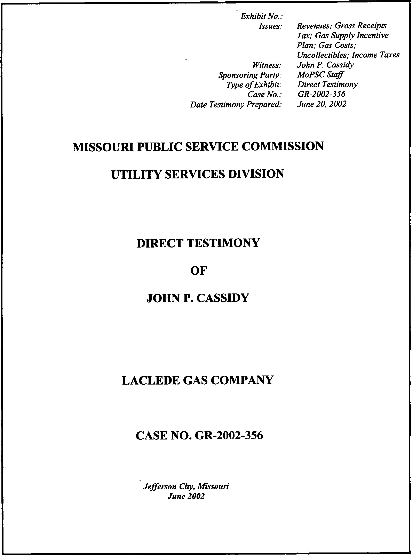

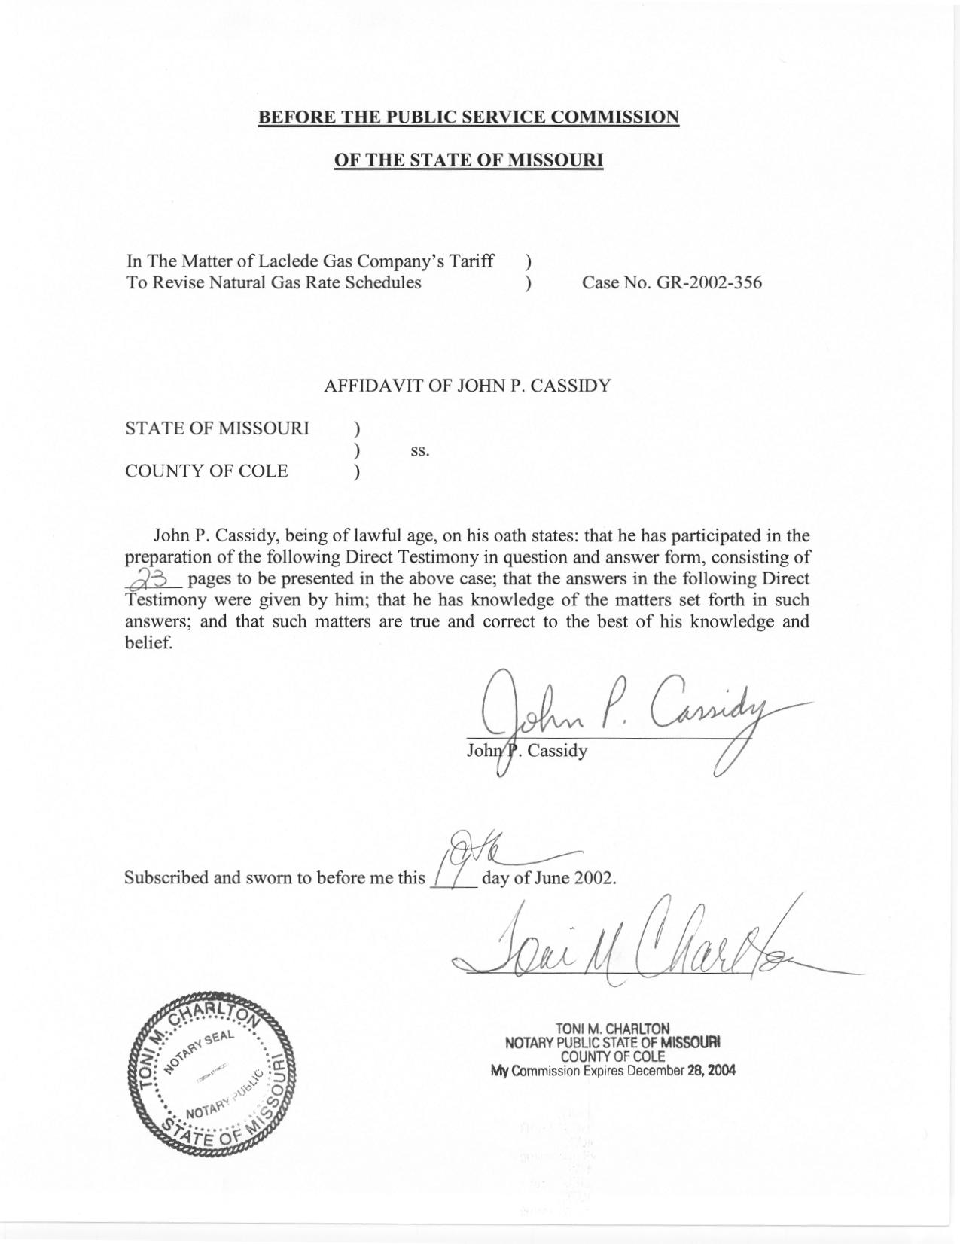

TABLE OF CONTENTS OF
DIRECT TESTIMONY OF

JOHN P. CASSIDY
LACLEDE GAS COMPANY
CASE NO. GR–2002–356
REVENUES 3
GROSS RECEIPTS TAXES 13
GAS SUPPLY INCENTIVE PLAN 14
GAS COSTS 14
UNCOLLECTIBLES 15
POSTAGE EXPENSE 16
CURRENT INCOME TAX 16
DEFERRED INCOME TAX 23

DIRECT TESTIMONY
OF

JOHN P. CASSIDY
LACLEDE GAS COMPANY
CASE NO. GR–2002–356
Please state your name and business address.
John P. Cassidy, 815 Charter Commons, Suite 100B, Chesterfield, Missouri 63017.
By whom are you employed and in what capacity?
I am employed by the Missouri Public Service Commission (Commission) as a Regulatory Auditor.
Please describe your educational background.
I graduated from Southeast Missouri State University, receiving a Bachelor of Science degree in Business Administration, with a double major in Marketing and Accounting in 1989 and 1990, respectively.
What has been the nature of your duties while in the employ of this Commission?
Since joining the Commission Staff in 1990, I have assisted with and directed audits and examinations of the books and records of utility companies operating within the state of Missouri. I have also conducted numerous audits of small water and sewer companies in conjunction with the Commission’s informal rate proceedings.
Have you previously filed testimony before this Commission?
Yes, I have. Please refer to Schedule 1, which is attached to my direct testimony, for a list of cases in which I have previously filed testimony.
With reference to Case No. GR-2002-356, have you made an examination of the books and records of Laclede Gas Company (Laclede or Company)?
Yes, in conjunction with other members of the Commission Staff (Staff).
What are your areas of responsibility in this case?
My areas of responsibility in this case include the revenues, unbilled revenues, PGA revenues and gas costs, gross receipts taxes, uncollectibles, postage expense, and current and deferred income taxes.
Please identify the Accounting Schedule you are sponsoring.
I am sponsoring the Staff’s calculation of Income Tax, which appears on Accounting Schedule 11. Accounting Schedule 11, Income Tax, is the calculation of current income tax expense for the test year ending November 30, 2001, as updated through March 31, 2002, and the current income tax requirements for the range of equity returns sponsored by Staff witness Roberta A. McKiddy.
What Accounting Adjustments are you sponsoring?
I am sponsoring the following adjustments, which appear on the Adjustments to Income Statement, Accounting Schedule 10:
Revenues S-1.1, S-1.2, S-1.4, S-1.6, S-2.1,
S-2.2, S-2.3, S-2.4, S-2.5, S-2.8,
S-2.9, S-2.10, S-3.1, S-3.2, S-3.3,
S-3.5, S-3.6, S-4.1, S-4.2, S-4.4,
S-4.5, S-4.6, S-4.7, S-4.8 and S-6.4.
Gross Receipts Tax S-1.5, S-2.7, S-3.4, S-4.3, S-18.4
and S-18.5
Unbilled Revenues S-1.3 and S-2.6
Natural Gas Supply Expense S-7.1, S-7.2 and S-7.3
Manufactured Gas Production S-8.2
Uncollectibles Expense S-12.2
Postage Expense S-12.4
Current Income Taxes S-21.1
Deferred Income Taxes S-22.1 and S-23.1

REVENUES
Please provide a general format outlining your discussion of revenues.
Company’s test year revenues, like its expenses, must be annualized and normalized in order to develop a cost of service that is representative of the Company’s operations. Generally, my discussion of revenues will be developed in five stages. First, I will discuss the general operations of the Company as they relate to the area of revenues. Second, I will describe the types of adjustments the Staff is proposing in this case. Third, I will discuss some of the specific adjustments and reference the Staff members who developed the revenue analysis and adjustments. Fourth, I will describe the approach I performed regarding the determination of customer levels for purposes of revenue annualizations. Lastly, I will describe the specific general service adjustments by district and customer class.
Please describe Laclede’s operations.
For purposes of recording revenues and levels of customers (counts), Laclede has five districts. The five districts are:
- Laclede
- St. Charles
- Midwest
- Missouri Natural (MoNat)
- Franklin County
Within each district, customers and revenues are divided into the customer classes of residential, commercial and industrial. Finally, customers are further divided within customer classes based on general consumption habits.
The following classifications can be found in the residential customer class:
- General Service
- Heat Pump
- Seasonal
- Propane
Likewise, within the commercial and industrial classes, the following classifications can be found:
- General Service
- Large Volume
- Basic Transportation
- Firm Transportation
- Interruptible
- Propane
What is the basis for pricing the revenue adjustments?
All revenue adjustments in the Staff’s cost of service were priced on the margin (the total rate excluding gas cost) included in the Company’s tariffs.
Please describe and discuss the types of adjustments the Staff developed to determine annualized revenues.
In general, the Staff’s annualized revenues reflect the effects of the following conditions:
- Normalized Weather
- Customers switching customer classes (rate switching)
- Customer load changes
- Non typical usage
- Normalized periods of service interruptions
6. Tariff rate changes
- Customer growth or loss
Why is it appropriate to adjust revenues for normalized weather?
Temperature levels experienced during any twelve-month period could have a significant impact on the Company’s revenues. If the overall temperature was very cold during the period, the Company’s revenues would be overstated in relation to normal weather. Conversely, if the overall temperature was warm during the period, the Company’s revenues would be understated in relation to normal weather. Therefore, the Staff normalized revenues for weather to eliminate the effects of below normal temperature during the test year.
What methodology did the Staff use to normalize for weather?
The methodology and weather station data used by the Staff to develop actual and normal weather is discussed in the direct testimony of Staff witness Dennis Patterson of the Commission’s Energy Department. This data was used to develop weather normalized sales and usage per customer, as discussed in the direct testimony of Staff witnesses James A. Gray and Kim J. Elvington of the Commission’s Energy Department. Staff witness Elvington was responsible for weather normalized sales and usage per customer for general service residential customers, while Staff witness Gray developed weather normalized sales and usage per customer for general service commercial and industrial customer classes. The results of Mr. Gray’s and Ms. Elvington’s weather normalized sales volumes were provided to Staff witness Henry E. Warren of the Commission’s Energy Department who allocated the weather normalized sales to the appropriate rate blocks. The methodologies used to develop weather normalized revenues for Large Volume, Interruptible and Transportation customers is discussed in the direct testimony of Staff witness Daniel I. Beck of the Commission’s Energy Department. Based on these analyses, the Staff has adjusted revenue in adjustments S-2.5, S-3.1 and S-4.2 to reflect the normalization of weather for Large Volume, Interruptible and Transportation customers.
Please describe the Staff’s adjustments relating to weather normalization for the general service residential, commercial and industrial customers.
Staff witnesses Elvington and Gray developed the monthly weather normalized therm sales per customer for the weather sensitive customer classes during the Staff’s test year. Generally, these classes consisted of the general service residential, commercial and small industrial heating customers.
Mr. Gray and Ms. Elvington adjusted the actual monthly therm sales from the test year to reflect normalized weather. Mr. Warren distributed these test year therm sales and normalized therm sales by season; summer (May-October) and winter (November-April). Mr. Warren then further distributed the test year and normalized therm sales by usage rate blocks. The totals by season and usage rate block were then priced on the margin to develop the Staff’s weather normalized adjustments S-1.2 for residential customers and S-2.2 for commercial and industrial customers.
Please explain adjustments S-1.6, S-2.9, S-3.6 and S-4.6 related to the Company’s last general rate increase.
The Stipulation and Agreement in Case No. GR-2001-629 provided for new customer rate schedules to be effective December 1, 2001. Natural gas sales to customers during the test year ending November 30, 2001 were billed entirely based on rate schedules that were in effect prior to December 1, 2001. Staff Adjustments S-1.6,
S-2.9, S-3.6 and S-4.6 adjusts revenues to the level that would have been realized during the test year if the new rate schedules had been in effect. The Staff did not specifically calculate these amounts rather the Staff used the Company’s calculation of these amounts as a reasonable reflection of the value of annualizing the new rates resulting from the last case.
Please describe the effects of customers switching between customer classes (rate switching) and customer load changes.
Customers switching customer classes or rate switching can occur for several reasons. The nature of a customer’s operations may have changed and now another customer class is more appropriate. The customer may find it more economical to switch to another customer class. Finally, the customer may decide to procure its own gas and thus, a rate switch would be necessary.
Customers also experience load changes. The operations of the customer production facilities may have changed, thereby causing a change in the demand of gas for that customer.
Staff witness Anne Ross of the Staff’s Energy Department addresses these two conditions within her analysis. Ms. Ross analyzed the Company’s interruptible, firm transportation, basic transportation and large volume customers on a customer by customer basis during the Staff’s test year ending November 30, 2001 and update period ending March 31, 2002. Adjustments S-2.3, S-2.8, S-3.2, and S-4.1 reflect the results of her analysis.
Please explain adjustments S-2.10, S-4.7 and S-4.8.
Staff Adjustments S-2.10 and S-4.7 are completed in order to annualize commercial and industrial revenues and transportation revenues for demand charges. Staff Adjustment S-4.8 represents an adjustment to restate transportation revenues to reflect test year billing units. For a complete discussion of all of these adjustments, please refer to the direct testimony of Staff witness Ross.
Please explain adjustments S-3.5, S-4.4 and S-4.5.
Staff adjustment S-4.4 adjusts basic transportation revenue for non-typical usage due to high gas prices that occurred during the test year. Staff adjustments S-3.5 and S-4.5 adjust interruptible and transportation sales to reflect normal periods of service interruption. For a complete discussion of all of these adjustments, please refer to the direct testimony of Staff witness Beck.
Why is it appropriate to adjust revenues for customer growth or loss?
This adjustment is appropriate in order to reflect the ongoing level of revenues based on an analysis of customer counts through the end of the Staff’s test year ending November 30, 2001 and update period ending March 31, 2002.
Please explain your analysis related to customer growth/loss for the general service customer class.
The Staff analyzed customer growth for each of the five districts of the Company. The analysis was further divided into specific customer classes within those districts. The customer growth adjustments are comprised of two components. The first component annualizes the customer charge based on the annualized level of customers. The second component relates to pricing of normalized therm sales per customer for the annualized level of customers.
Please explain how the Staff determined the annualized level of customers.
The Staff analyzed each customer class by district as described earlier in this testimony. Based upon that analysis, the Staff determined that using a single method would not provide the best picture of customer levels. Instead the Staff used three different methods to determine annualized customer levels by using the method best suited to provide the most accurate annualization for each division and customer class. The following discussion will explain the different methods for the specific customer classes and why each method was utilized.
For residential customers in the St. Charles district, the Staff used the March 31, 2002, level of customers. Since the St. Charles residential customer class has experienced constant growth throughout the years, the most recent month provides the most appropriate level for annualization.
Customer analyses in the Laclede and MoNat residential, commercial and industrial customer classes as well as the St. Charles commercial and the Franklin County and Midwest residential and commercial classes revealed that these customer classes exhibited patterns of seasonality. Seasonality refers to the situation where customer levels tend to decrease in the late winter months (March-April) when demand for gas space heating declines and continues to decline through many of the summer months. Customer levels then begin to increase in anticipation of the beginning of the gas heating season and continue to increase as the need for space heating increases.
A monthly, ongoing level of customers was determined by dividing the March 31, 2002 level of customers by the five-year average percentage of March 31 customers to the succeeding year ending February 28th average customer levels. The monthly level of customers were then distributed over twelve months in order to develop annualized level of customers. This methodology enables the Staff to annualize customer growth and losses for these customer classes while giving consideration for the fluctuation of customer levels caused by seasonality. Through the Staff’s analysis of these customer classes, it was observed that seasonality of customers occurred annually and with a high degree of certainty. The Staff analyzed these customers for seasonality over several years.
The Staff used the test period (twelve months ending November 30, 2001) actual customer levels for the Midwest, St. Charles and Franklin County industrial customer class. Midwest industrial customer levels have remained the same for several years, therefore no change in customer levels needs to be addressed. In the past, St. Charles and Franklin County industrial customers had grown at a fairly constant rate, however during the test period this growth did not continue and the class actually experienced slightly lower customer levels than the year before. For purposes of this case, the Staff has adopted the test year level of customers for these classes. By using the test year level of customers, the Staff is effectively reflecting no level of customer growth for these customer classes.
The Staff will re-examine all the customer levels as part of its planned true-up audit when this information becomes available. Attached as Schedule 2 to this direct testimony are graphs that track the historical customer levels for each of the five districts’ residential and commercial customer classes. These graphs provide support for the Staff’s methods used to annualize customer levels.
How were customer charges annualized?
To develop the customer charge portion of the customer growth adjustment, the Staff multiplied total annualized customer levels by the appropriate monthly customer charge to derive annualized customer charges by customer class.
How were the annualized levels of therms and commodity revenues developed?
For each residential, commercial and industrial class, the Staff developed an annualized usage per block. Total annualized customers were multiplied by normalized usage per customer, by month, as supplied by Staff witnesses Elvington and Gray. This resulted in an overall normalized usage. The Staff then distributed this overall normalized usage to the appropriate usage rate blocks based on test year normalized therms and then priced these blocks using the appropriate current seasonal (winter and summer) usage tariffed rates. The Company’s tariffs currently have two different rates for gas usage during the summer and winter months within the two seasons. For example, the residential class has a usage block set at 65 therms. For usage below 65 therms per month, one rate is charged while another rate is applied to customer usage greater than 65 therms in a given month. By pricing these rate blocks using the appropriate seasonal and usage rates this produced the Staff’s annualized commodity revenues for each revenue class.
Finally, all annualized customer charge revenues and annualized commodity revenues were summed by customer class and this amount was subtracted from the Company’s per book revenues already adjusted for Staff’s weather adjustment and the unrealized rate increase as were previously described in this direct testimony. These differences represent the Staff’s adjustments S-1.1 and S-2.1 for customer growth.
Please describe Staff adjustments S-1.3 and S-2.6.
Staff’s adjustments S-1.3 and S-2.6 eliminate unbilled revenue from the Staff’s test year. For purposes of a rate case, unbilled revenues must be eliminated from the test year to reflect revenues during the test year on an as-billed basis.
Please discuss Staff adjustments S-1.4, S-2.4 and S-3.3.
These adjustments remove the cost of natural gas from revenues. The total test year cost of natural gas was removed from the various revenue classes based on actual test year activity. By eliminating test year gas costs from revenue and expense, the Staff has put its direct filing on a margin basis.

GROSS RECEIPTS TAXES
Please explain Staff adjustments S-1.5, S-2.7, S-3.4 and S.4.3 that were made to test year ending November 30, 2001 per book revenues.
Staff adjustments S-1.5, S-2.7, S-3.4 and S-4.3 remove the test year per book gross receipt taxes from the Company’s operating revenues. Gross receipts taxes are not operating revenues for the Company. The Company merely acts as a collecting agent and remits the taxes to the appropriate taxing entities. Gross receipts taxes are reported as both a revenue and expense item on the Company’s books. Therefore, both revenue and expense adjustments are necessary.
Please explain Staff adjustments S-18.4 and S-18.5 to Taxes Other Than Income Taxes.
The Staff made adjustment S-18.4 to remove gross receipts taxes from the Taxes Other Than Income Taxes line item of the expense portion of the income statement. Adjustment S-18.5 removes an uncollectible allowance related to gross receipts taxes to recognize that a portion of these gross receipts taxes are not normally collected. Some municipalities allow the Company to pay an amount of gross receipts taxes, that is less than the amount that is actually included on customer bills, to allow for the event that some of the gross receipts taxes will be uncollectible. By removing this portion of the gross receipts expense, the Staff acknowledges that it has not recognized the possibility that these taxes may become uncollectible in this area of the case. However, if these taxes are determined to be uncollectible, the amount of gross receipts taxes that are uncollectible are included in the Company’s books as uncollectible expense. Therefore, the Staff has included those gross receipts taxes that are uncollectible as a component of the Staff’s uncollectibles adjustment and does not need to be included in this area of the Staff’s case.
Why is the adjustment for revenues higher than the adjustment for expense?
A timing difference of $792,405 results from the Company’s method of recording gross receipts taxes as an expense in a different period from the revenue billing that includes the gross receipts taxes. The time period difference depends on how a community’s applicable statute is written. For example, the gross receipts taxes included on some customers’ bills are not recorded as an expense until the second month following the revenue month that contains the billed gross receipts taxes.

GAS SUPPLY INCENTIVE PLAN
Please describe the Gas Supply Incentive Plan (GSIP).
Under the Gas Supply Incentive Plan, the Company and its customers shared in income from off-system sales, capacity release and certain gains and losses, as measured against benchmark prices for gas costs, related to the acquisition of the Company’s natural gas supply. As part of the plan, the Company sold gas supply and pipeline capacity in markets outside of its normal service territory.
Please describe Staff adjustment S-6.4.
Staff adjustment S-6.4 removes from Other Revenues the revenues associated with the GSIP. The Staff has also made a corresponding adjustment to gas costs as discussed in the next section of this direct testimony.

GAS COSTS
Please explain Staff’s adjustments S-7.1, S-7.2, S-7.3 and S-8.2.
Staff adjustments S-7.1 and S-8.2 remove the test year cost of natural and manufactured gas from expense. Staff adjustment S-7.3 eliminates natural gas costs associated with unbilled revenues. Staff adjustment S-7.2 eliminates the gas expense associated with the GSIP. These gas cost adjustments and the corresponding gas revenue adjustments are necessary to restate the Staff’s cost of service calculation on a margin basis.

UNCOLLECTIBLES
Please explain Staff adjustment S-12.2.
Staff adjustment S-12.2 annualizes uncollectible expense. The Staff utilized a five-year average of actual net write-offs for the years ending March 31, 1998 – 2002. Over the last five years actual net write-offs have varied greatly, as the table shown below demonstrates:
Year Actual Net-Writeoffs
March 31, 1998 $8,118,999
March 31, 1999 $6,223,463
March 31, 2000 $4,556,075
March 31, 2001 $3,961,227
March 31, 2002 $11,434,267
Five Year Average $6,858,806
The Staff’s use of a five-year average of uncollectibles expense, which is $6,858,806, includes a normal level of expense in the cost of service associated with this expense item. Actual net write-offs have been used by the Staff in previous rate cases before this Commission to determine uncollectible expense. The Staff is currently evaluating the uncollectible costs associated with the emergency cold weather rule, which took effect on November 18, 2001 and will address this item as part of its true-up audit. Since the actual net write-offs through March 31, 2002 are included in the Staff’s five-year average for determining permanent rates in this case, none of the write-offs prior to April 1, 2002 should be included in the emergency cold weather rule AAO.

POSTAGE EXPENSE
Please explain Staff adjustment S-12.4.
Staff adjustment S-12.4 annualizes the Company’s level of postage expense to include amounts to be consistent with its customer growth annualization through March 31, 2002.

CURRENT INCOME TAX
Please discuss the adjustment you are sponsoring to current income tax expense.
The adjustment to current income tax expense is identified as adjustment S-21.1 on Accounting Schedule 10. Adjustment S-21.1 adjusts current income tax to reflect the difference between the test year adjusted income tax computed on Accounting Schedule 11, Income Tax, and the current income tax expense recorded during the test year.
Please explain how the current income tax expense is calculated on Accounting Schedule 11, Income Tax.
Net operating income (NOI), as calculated on Accounting Schedule 9, Income Statement, is the starting point of the test year income tax calculation (column B) on Accounting Schedule 11. The NOI for each rate of return (Line 1, columns C, D and E) was calculated on Accounting Schedule 1, Revenue Requirement. The applicable current and deferred income taxes are added back to NOI to determine the net operating income before income taxes (NOIBT). NOIBT is then adjusted for various tax-timing differences to determine the amount of taxable income. The Federal and State income taxes are calculated based on statutory rates applied to the taxable income after allowances for applicable income tax deductions and credits. State income taxes are deductible in the determination of Federal taxable income. One-half of Federal current income taxes are deductible for State taxable income.
What is the justification for the additions and subtractions that were used to adjust NOIBT?
The Internal Revenue Code (Code) dictates what is appropriately included, or deducted, in the determination of taxable income. The adjustments made to NOIBT are necessary to reconcile the income reported on the income statement with the taxable income determined in compliance with the Code. These adjustments are commonly referred to as tax-timing differences or Schedule M items. Schedule M is the Federal tax form on which the Company reconciles the difference between book income and taxable income. The Staff has added or subtracted the timing differences from NOIBT that are necessary for ratemaking purposes.
Please discuss the adjustments to NOIBT.
The adjustments to NOIBT related to depreciation are reflected in three separate line items on Accounting Schedule 11. Line number 10 is an addition to taxable income for the annualized depreciation and amortization included in book income. Line numbers 18 and 19, tax straight line depreciation and excess tax depreciation, respectively, reduce taxable income to reflect the depreciation and amortization that is deductible for tax purposes.
Why have three separate adjustments been used to adjust taxable income for depreciation?
Depreciation could have been presented as a single net adjustment to taxable income. However, presenting the adjustment for depreciation using three components provides a clearer illustration of how taxable income is developed and the impact these components have on tax expense.
As previously indicated, the Code is the basis for determining what is deductible for tax purposes. Therefore, to properly state taxable income, book depreciation is added back and tax depreciation is deducted from NOIBT. Tax depreciation is presented as two separate components because each of these components has a distinct impact on income tax expense. Straight-line tax depreciation is the equivalent of book depreciation, restated to reflect the tax basis of plant in service, and is provided “flow-through” treatment. The difference between total tax depreciation and tax straight-line depreciation, identified as excess tax depreciation, is required by the Code to be “normalized.”
Why does a depreciable basis difference exist between the depreciable book basis and tax basis?
A difference exists between the depreciable book basis and the tax basis because the Code has allowed expenditures to be expensed in the year incurred for tax purposes that have been historically capitalized for book purposes. As a result, the tax basis is typically lower than the basis used to calculate book depreciation.
What is the explanation for the difference between total tax depreciation and tax straight-line depreciation that you have identified as excess tax depreciation?
The Code provides for a quicker recovery of the tax basis plant investment through the use of accelerated depreciation methods. This will normally generate a larger depreciation deduction for tax purposes than depreciation calculated on a straight-line basis. As stated previously, there is a requirement that the tax depreciation in excess of tax-straight line be normalized.
What is meant by the terms “flow-through” and “normalized?”
The term flow-through refers to the tax treatment that equates the amount provided by the ratepayer for income tax expense with the amount paid to the taxing authority. Under flow-through no deferred tax is created to offset the impact of the timing difference on current income tax expense. However, with normalization, the impact of a tax timing difference on current income tax expense is offset by deferred income tax expense. Under normalization treatment, the ratepayer provides the funds to the Company as if the tax-timing difference did not exist.
How were the two components of tax depreciation determined?
The Company provided the Staff with the tax basis of the plant for each class of property by vintage year and the applicable accelerated and straight-line depreciation rates were applied. The tax straight-line depreciation was calculated using the open-ended method, which calculates tax straight-line depreciation by property account without regard to its vintage until the book rate is set to zero.
Please continue with your discussion of the other adjustments that have been made to NOIBT on Accounting Schedule 11.
Additions to NOIBT include contributions in aid of construction (CIAC), miscellaneous nondeductible expenses, inventory overheads capitalized and Accounting Authority Order (AAO) amortization. The adjustments to NOIBT that reduce current taxable income are interest expense, administrative and general (A&G) expense capitalized, transfer of services, net salvage expense, pensions and Laclede Pipeline income. A description of these adjustments and their development, follows:
- Contributions in Aid of Construction - For tax purposes, when the Company receives CIAC from customers, the Company is required to report the CIAC as revenue. For book purposes, CIAC received is recorded as a credit to plant, which reduces the level of plant investment included in rate base. The Staff adjustment included on Accounting Schedule 11 is the test year ending November 30, 2001 level of CIAC.
- Miscellaneous Non-Deductible Expenses - This category includes such items as travel, meals, dues, gifts and lobbying expenses and are only 50% deductible for tax purposes. Therefore, one-half of the expenditures included in operating expense must be added back to NOIBT to reflect the limitation imposed by the IRS. The Staff adjustment to NOIBT reflects only the applicable addition of those expenses that have been allowed as an operating expense for ratemaking.
- Inventory Overheads Capitalized - Some costs related to storage gas are treated differently for book purposes than for tax purposes.
- AAO Amortization - This reflects the expense included in the income statement related to prior period expenditures that were deferred and now being amortized to expense. Although the expenditures were deferred on the books when occurred, they were recognized in the year incurred for tax purposes. The AAO amortization needs to be added back to NOIBT to appropriately state the level of current taxable income.
- Interest Expense - Interest is a deduction for tax purposes that is not reflected as an operating expense (before income taxes) in the Staff’s Income Statement, Accounting Schedule 9. Interest expense is calculated by multiplying rate base by the Staff’s weighted cost of debt included in the overall rate of return sponsored by Staff witness McKiddy. This method of determining interest expense is referred to as interest synchronization because the interest used in the calculation of income tax expense is matched with the interest expense the ratepayers are required to provide to the Company in rates. Interest synchronization has been consistently used by the Staff and adopted by the Commission in past orders.
- Administrative and General (A&G) Costs Capitalized - The Company is allowed to expense a portion of A&G costs for tax purposes which are capitalized on the books. The Staff’s deduction in the tax calculation reflects the test year A&G expenses capitalized on the books that are deductible for income tax purposes, adjusted for the changes reflected in the Staff’s A&G expense adjustment.
- Transfer of Services - The cost of certain main replacements are capitalized on the books but expensed for tax purposes. The deduction reflects the test year amount capitalized on the books that is deductible for tax purposes.
- Cost of Removal - These costs have been historically included in depreciation expense over the life of the depreciable property on the books but are deductible on the tax return in the year incurred. The Staff used the actual test year level of tax deductible net salvage expense.
- Pensions - For tax purposes, pension expense is reported on a cash basis. Since the Staff is recommending a zero minimum ERISA expense level, no recognition of a timing difference for pensions is necessary.
- Laclede Pipeline Income - The Staff has subtracted from taxable income the markup related to the Laclede Pipeline operations because the amount that has been reflected in the Staff’s cost of service calculation is already net of tax.
Regarding the adjustments to arrive at taxable income, which items does the Staff propose be provided flow-through treatment?
In addition to tax straight-line depreciation, the Staff has provided flow through treatment for miscellaneous non-deductible expenses, inventory overheads capitalized, interest, A&G expense capitalized, transfer of services and net salvage expense. The Staff has normalized the remaining adjustments consisting of CIAC, AAO amortization, excess tax depreciation and pensions.

DEFERRED INCOME TAX
Please discuss your adjustments to deferred income tax expense.
Adjustments S-22.1 and S-23.1 adjust deferred income tax expense to reflect the impact on total tax expense for the tax timing differences that are being normalized, as previously discussed with regard to the development of current taxable income. In general, a deferred income tax-debit reflects the normalization of tax timing differences that decrease current taxable income and, inversely, a deferred income tax-credit represents the normalization of tax timing differences that increase current taxable income. The accumulated deferred tax balances related to the tax timing differences that have been normalized were included in the determination of rate base.
The Staff has made no adjustment to the test year level of Investment Tax Credit (ITC) amortization. The deferred income tax balance in rate base includes the unamortized pre-1971 ITC balance. Code restrictions prevent the use of post 1971 ITC balances to reduce rate base.
Does this conclude your direct testimony at this time?
Yes.
RATE CASE PROCEEDING PARTICIPATION

JOHN P. CASSIDY

COMPANY CASE NO.
Missouri Cities Water Company WR-91-172
Missouri Cities Water Company SR-91-174
St. Louis County Water Company WR-91-361
Southwestern Bell Telephone Company TC-93-224
Laclede Gas Company GR-94-220
Empire District Electric Company ER-95-279
Imperial Utility Corporation SC-96-247
St. Louis County Water Company WR-97-382
Laclede Gas Company GR-98-374
United Water Missouri, Inc. WR-99-326
Union Electric Company EC-2000-795
Union Electric Company GR-2000-512
Laclede Gas Company GR-2001-629
Union Electric Company, d/b/a AmerenUE EC-2002-01
Union Electric Company, d/b/a AmerenUE EC-2002-1025

