Exhibit Number: | ________
Issue: | Response to Direct Testimony of OWC Witness William P. Mitchell
Witness Name: | Dale W. Johansen
Type of Exhibit: | Rebuttal Testimony
Sponsoring Party: | MoPSC Staff
Case Number: | ST-2003-0562 and WT-2003-0563  (Consolidated)
Date Testimony Prepared: | January 9, 2004

Missouri Public Service Commission

Utility Operations Division

Water & Sewer Department

Rebuttal Testimony

of

Dale W. Johansen

Case Nos. ST-2003-0562 and WT-2003-0563
(Consolidated)

Osage Water Company

Jefferson City, Missouri
January 2004

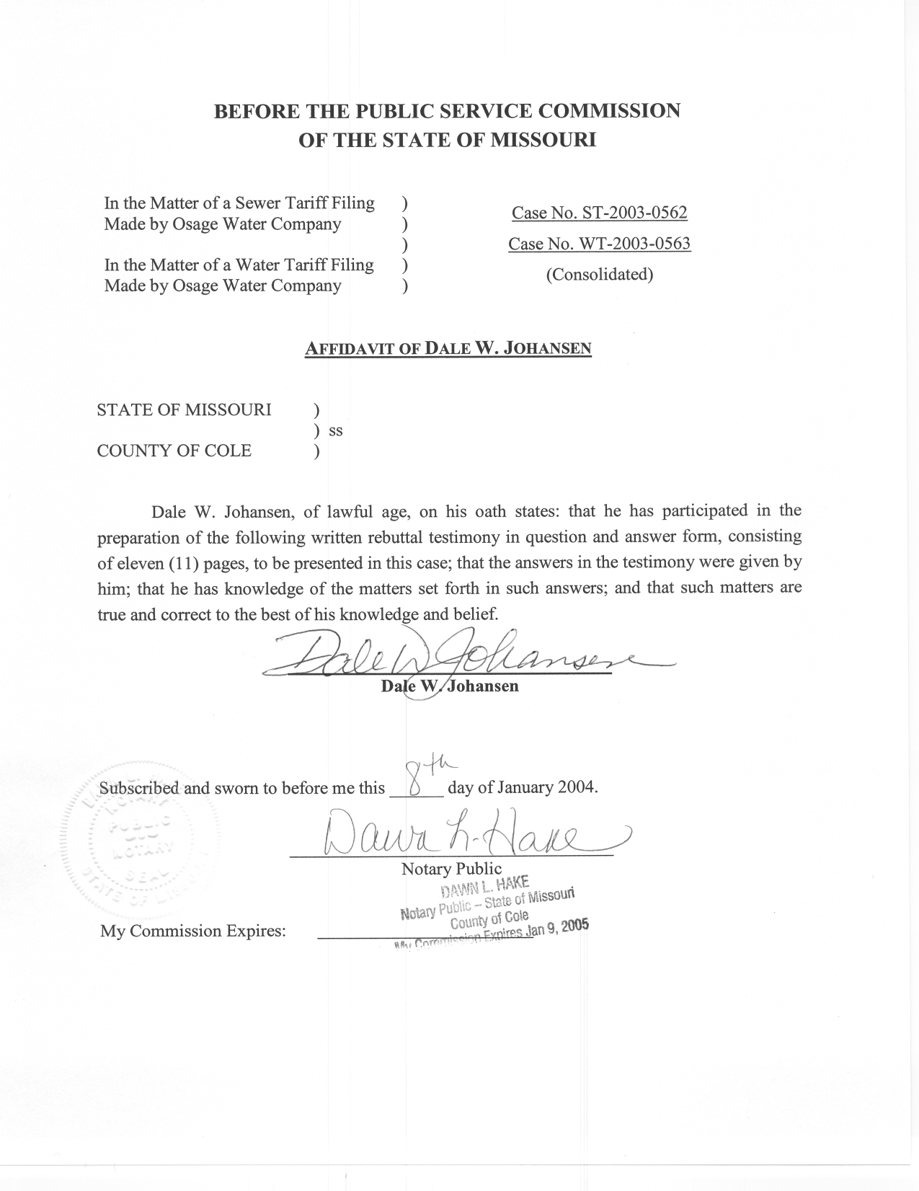
Table of Contents for the Rebuttal
Testimony of Dale W. Johansen

Case Nos. ST-2003-0562 and WT-2003-0563
(Consolidated)
Osage Water Company

Introduction 1
"Reasonable rates, cost of operation" 2
"current rates and tariffs" 6
"rates" 7
"Conclusion" 10
Proposed sewer tariff provisions 11

Introduction
Q. Please state your name and business mailing address.
A. Dale W. Johansen, P.O. Box 360, Jefferson City, Missouri 65102.
Q. Are you the same Dale Johansen that previously filed direct and supplemental direct testimony on behalf of the Commission Staff?
A. Yes, I am.
Q. What is the purpose of the pre-filed rebuttal testimony you are presenting?
A. To respond to certain portions of the direct testimony of Osage Water Company (OWC or Company) witness William P. Mitchell. (For the purpose of this testimony, but with the exception of my last section, I am using the same section titles as Mr. Mitchell used in his direct testimony.)
Q. Are any other Staff members filing rebuttal testimony?
A. Yes. Janis Fischer of the Auditing Department and David Murray of the Financial Analysis Department are also filing rebuttal testimony addressing various aspects of Mr. Mitchell's direct testimony. Where appropriate, I am including references to their testimony in this testimony.

"Reasonable rates, cost of operation"
Q. On page 7 of his direct testimony, lines 1-3, Mr. Mitchell refers to an attached schedule of revenues and expenditures for the past twelve months. Is such a schedule actually attached to his testimony?
A. Monthly billing summaries for the months of June 2002 through August 2003 are attached to his direct testimony. However, there is no summary of OWC's actual test year expenditures attached to the testimony. As noted in the rebuttal testimony of Staff witness Janis Fischer, while it appears the first two columns of WPM Schedule 8 represent such information that is not the case. As a result, the Company has not presented any evidence to the Commission regarding its actual test year expenditures.
Q. Beginning on page 7, line 13 and continuing through page 8, line 13 of his direct testimony, Mr. Mitchell discusses the need for an additional operator for OWC's systems. Please respond to his comments regarding this matter.
A. My basic response to this is that it is simply not known if a second operator is really needed, since the current operator responsible for the systems does not spend his full time on work related only to OWC's systems. For example, this operator performs duties not only for OWC under the terms of the management agreement between OWC and Environmental Utilities (E.U.), but also performs work for E.U. and for the owners of E.U. personally.
Q. On page 9 of his direct testimony, lines 6-16, Mr. Mitchell discusses "cash flow deficiencies" related to purchased water expenses and wastewater treatment plant lease expenses for the Company's Eagle Woods service area. Please respond to his comments regarding these matters.
A. First of all, the choice to purchase water for the Eagle Woods system was the Company's choice, and the rates related to the water purchases were set out in the water purchase contract that Mr. Mitchell signed on behalf of the Company. Presumably, this option was the most cost effective manner in which to provide the needed water supply for the Eagles Woods system or the Company would not have entered into the water purchase agreement. Additionally, as noted in the rebuttal testimony of Staff witness Janis Fischer, many of the customers in the Eagle Woods system are not metered. Because of the manner in which OWC's rates are structured, this situation almost certainly contributes to any revenue shortfalls that may exist between the cost of purchased water and the customer revenues received from OWC's customers.
Secondly, as with the water purchase agreement, the decision to utilize a leased wastewater treatment plant rather than a company-owned treatment plant was a management decision, and this option is presumably the most cost effective approach to providing sewer treatment services for OWC's customers.
I also believe it is interesting to note here that OWC purchases its water for the Eagle Woods system from Environmental Utilities, which is owned by Greg and Debra Williams, and that the wastewater treatment plant that it leases for the Eagle Woods system is owned by Greg and Debra Williams as the developers of the adjacent Golden Glade subdivision. Additionally, OWC is currently managed by Debra Williams through a management agreement between OWC and Environmental Utilities.
Q. On page 10 of his direct testimony, lines 18-19, Mr. Mitchell states that spreadsheet analyses reflecting current customer counts, income and expenses by service area are attached to his testimony. Are these analyses actually attached to his testimony?
A. No, they are not, which yet again means that the Company has not presented any evidence to the Commission regarding the actual expenses and revenues related to the operations of its sewer and water systems.
Q. Beginning on page 10, line 22 and continuing through page 11, line 2 of his direct testimony, Mr. Mitchell references several "statutory requirements" that he believes exist with regard to matters that the Commission is required to do. Please respond to his comments regarding these matters.
A. First, I note that Mr. Mitchell does not provide any citations for the statutory requirements to which he refers.
Second, I note that to my knowledge the Commission has never considered either operating or emergency "reserves" in its determination of a company's overall cost-of-service that is to be recovered through customer rates. Additionally, I am not aware of any statutory requirement pertaining to this matter.
Third, I note that the Commission does consider a company's cost of capital, which includes a reasonable return on investments in utility plant used to provide service, in determining a company's overall cost-of-service that is to be recovered through customer rates.
And fourth, I note that the Commission does include recovery of depreciation expenses on utility plant in which a company has invested in determining a company's overall cost-of-service that is to be recovered through customer rates.
Q. On page 11 of his direct testimony, lines 3-19, Mr. Mitchell cites the Broadwater Bay outage as an example of why OWC needs operating reserves. What is your response to his comments regarding this matter?
A. I find that this is an interesting example for Mr. Mitchell to use in an attempt to justify an operating reserve, when it is generally accepted that the Company's inadequate attention to and operation of the Broadwater Bay system and the well that supplies the system were at least in part the reason why the outage occurred in the first place.
Q. Beginning on page 11, line 20 and continuing through page 12, line 9 of his direct testimony, Mr. Mitchell discusses the level of emergency and operating reserves that he believes are necessary. Please respond to Mr. Mitchell's comments regarding these matters.
A. First, Mr. Mitchell provides no basis whatsoever for the $50,000 funding level "needed" for an emergency reserve fund. And second, the "TMF rule" that Mr. Mitchell cites in his testimony as requiring an operating reserve fund doesn't even to apply to OWC. I will discuss the referenced "TMF rule" in greater detail later in this testimony.
Q. On page 12 of his direct testimony, lines 10-16, Mr. Mitchell discusses depreciation expenses, and his reasoning as to the level of depreciation expense that OWC should be recovering. Do you have a response to his comments regarding this matter?
A. I will limit my response to again say that the "TMF rule" that Mr. Mitchell references does not even apply to OWC and that I will discuss the referenced rule in greater detail later in this testimony. I do, however, note that Staff witness Janis Fischer addresses this issue in her rebuttal testimony.

"current rates and tariffs"
Q. On page 13 of his direct testimony, lines 10-22, Mr. Mitchell discusses the rates that other utilities in areas surrounding OWC's service areas are charging. Do you have a response to his comments regarding this matter?
A. Yes. The rates charged by other service providers are in no way relevant in determining what OWC's rates should be.
Q. On page 14 of his direct testimony, lines 1-6, Mr. Mitchell discusses the matter of why OWC could not charge rates comparable to the rates charged by other area service providers. Please respond to Mr. Mitchell's comments regarding this matter.
A. OWC's rates are based on its cost-of-service and that is why it can't charge what other service providers charge. This is also why, as I noted in my answer to the previous question, that the rates charged by other service providers are not relevant in determining what OWC's rates should be.

"rates"
Q. On page 15 of his direct testimony, line 20, Mr. Mitchell indicates that he has prepared a rate analysis for OWC and that it is attached as WPM Schedule – 8 Budget. Do you have any comments regarding this matter?
A. Yes, I do. The schedule that Mr. Mitchell references is not a rate analysis at all, but rather is simply a "budget" of what he apparently believes should be recognized as the Company's cost-of-service.
Q. On page 16 of his direct testimony, lines 3-11, Mr. Mitchell discusses the "TMF minimums" that have been put into effect by the Missouri Department of Natural Resources (DNR). Would you please discuss this subject matter and Mr. Mitchell's comments regarding it?
A. Certainly. The DNR's "TMF minimums" to which Mr. Mitchell refers set out certain technical, managerial and financial "capacity" requirements (thus the acronym of "TMF") that apply to certain water systems (they do not apply to any sewer systems). Three particular aspects of the DNR's TMF rule
(10 CSR 60.3.030) are important to the case at hand.
Q. Please discuss the three important aspects of the TMF rule that you just mentioned.
A. The first important aspect of the TMF rule that is pertinent to the case at hand is that the rule only applies to new water systems that commenced operation after October 10, 1999. With the possible exception of the Eagle Woods system, all of OWC's systems commenced operation prior to this date.
The second important aspect of the TMF rule that is pertinent to the case at hand is that the provisions of the rule do not address the issue of depreciation at all, much less do they require that depreciation be collected on utility plant contributed to a utility.
The third important aspect of the TMF rule that is pertinent to the case at hand, and in my opinion the most important, is that the financial capacity requirements related to the establishment and funding of operating reserves, equipment replacement reserves and debt service reserves are specifically not applicable to water systems that are subject to state regulation of rates for water service. This exception to the rule was specifically placed in the rule because of the Commission's statutorily granted jurisdiction over certain water systems, and the DNR's recognition that the Commission's regulatory policies and practices govern these three areas.
Q. On page 16 of his direct testimony, lines 12-20, Mr. Mitchell discusses his proposal for all of the requested rate increase to be recovered through increases in the Company's base monthly charges. Please respond to his comments regarding this matter.
A. Regarding the Company's water rates, I first note that the Company's current water rates include the recovery of 2,000 gallons of water in the monthly minimum charge, which is included to address the seasonal nature of customer usage patterns that exist in the Company's service areas. Also, I note that the Staff is not proposing to change this rate design, but also does not see a need to increase the monthly minimum further in relation to the Company's commodity rate. Additionally, the Company's proposed 25% increase in its monthly minimum water charge is the equivalent to the recovery of just over 3,300 gallons in that charge at current rates (over a 50% increase in the 2,000 gallons now recovered). Finally, better management of Company funds collected during the high usage season could offset the revenue collection reductions in lower usage season (the Company could, in essence, create its own operating reserve fund).
Regarding the Company's sewer rates, both the current and proposed sewer rates are monthly flat rates and revenue collections are thus not subject to fluctuations caused by seasonal water usage patterns.

"Conclusion"
Q. Do you have a response to Mr. Mitchell's comments regarding termination of the receivership litigation against OWC, which are found on page 19, lines 2-6 of his direct testimony.
A. Yes, I do. I believe it is important to note here that the receivership litigation is only occurring in the first place because of the condition of the Company that its owners allowed it to get into and because its owners effectively abandoned it. To suggest that the Company's customers, which have been determined to not be receiving safe and adequate service, should suffer a rate increase and yet not receive service enhancements because of litigation expenses certainly does not make sense to me.
Q. Do you have a response to Mr. Mitchell's comments "that the Commission has essentially ignored its obligation to insure that OWC's rates are adequate to provide a fair return to OWC's investors", which are found on page 19, lines 8-12 of his direct testimony?
A. Yes, I do. The Commission's charge is to balance the interests of a regulated utility with the interests of the utility's customers. Its obligation to the utility's investors is to give them the opportunity to earn a reasonable rate of return on the investment they have in the utility's rate base that is used to provide service. The Commission is not obligated to ensure any level of return to the investors, and the return that the investor has the opportunity to earn is limited only to those facilities for which the utility has an investment of its funds.

Proposed sewer tariff provisions
Q. Do you have any comments regarding the Company's proposal to collect its DNR sewer plant permit fees from its customers as a separate tariffed rate item, as set out on the sewer tariff sheet attached to Mr. Mitchell's direct testimony?
A. Yes. The collection of an isolated component of the overall cost-of-service through a separate tariffed billing item is generally not allowed, except as may be provided by special Commission policies, Commission rules or statutory authority.
Q. Does this conclude your pre-filed rebuttal testimony?
A. Yes, it does.

