Exhibit Number: | ________
Issue: | Rate Design Schedules
Witness Name: | Dale W. Johansen
Type of Exhibit: | Supplemental Direct Testimony
Sponsoring Party: | MoPSC Staff
Case Number: | ST-2003-0562 and WT-2003-0563 (Consolidated)
Date Testimony Prepared: | December 30, 2003

Missouri Public Service Commission

Utility Operations Division

Water & Sewer Department

Supplemental Direct Testimony

of

Dale W. Johansen

Case Nos. ST-2003-0562 and WT-2003-0563
(Consolidated)

Osage Water Company

Jefferson City, Missouri
December 2003
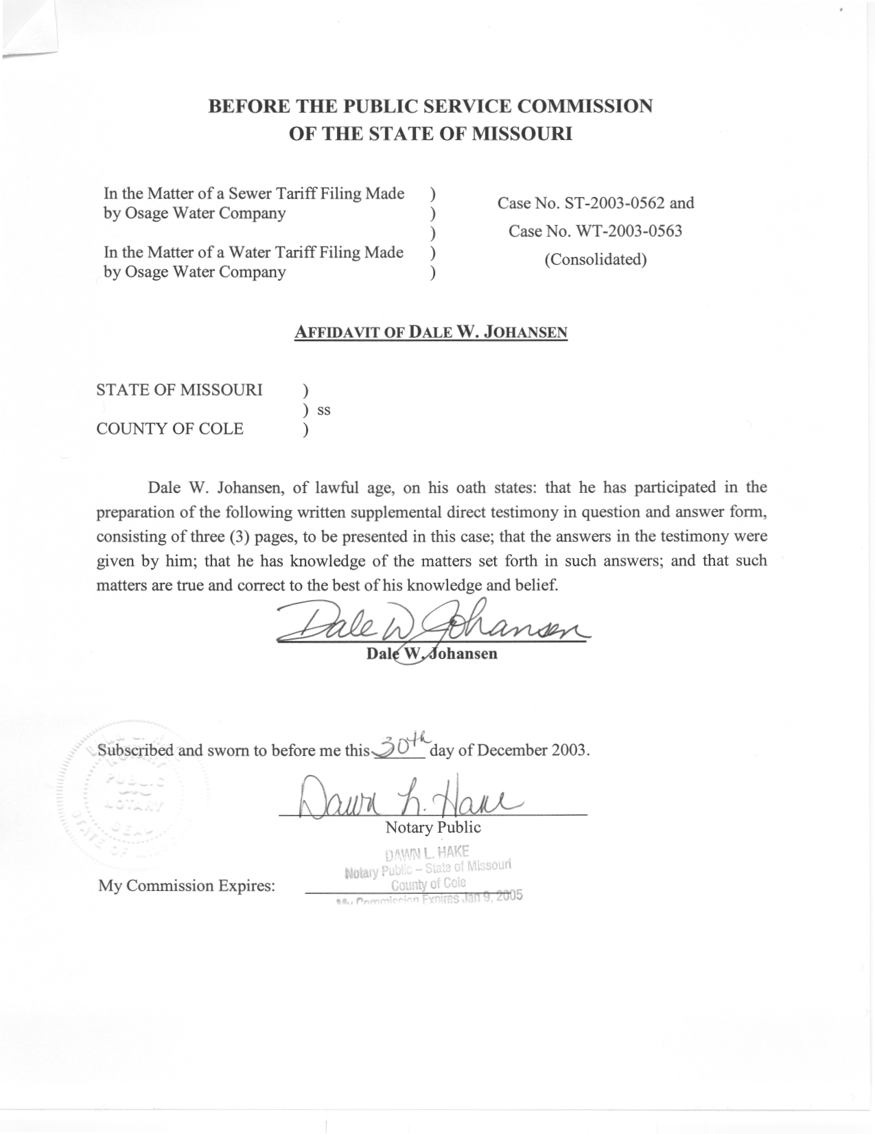

Supplemental Direct Testimony
of
Dale W. Johansen
Case Nos. ST-2003-0562 and WT-2003-0563
(Consolidated)
Osage Water Company

Q. Please state your name and business mailing address.
A. Dale W. Johansen, P.O. Box 360, Jefferson City, Missouri 65102.
Q. Are you the same Dale Johansen that previously filed direct testimony in this case on behalf of the Staff of the Missouri Public Service Commission?
A. Yes, I am.
Q. On page 7, lines 3 through 9, of your direct testimony, you stated that you were going to provide illustrative rate design schedules to Osage Water Company (OWC) and the Office of the Public Counsel (OPC), have you done that?
A. Yes, I have, on two occasions. I provided an Excel workbook containing illustrative rate design schedules to representatives of OWC and the OPC the morning of December 24, 2003. However, the contents of that workbook were not consistent with the accounting schedules that the Staff filed on December 19, and I thus noted that I was doing additional work on the rate design schedules with the hope of identifying and correcting the discrepancies between the workbook and the Staff's accounting schedules. I have since updated that workbook to correct the noted discrepancies and provided that updated workbook to representatives of OWC and the OPC the afternoon of December 29. That updated workbook is being filed with this testimony as Schedule
DWJ-RD-1.
Q. Please describe the worksheets that make up the Excel workbook that is being filed with this testimony as Schedule DWJ-RD-1.
A. The first sheet in the workbook, which is identified as "Annualization Data", shows the following information: (1) OWC's customer numbers at the end of July 2003; (2) the Staff's calculation of OWC's annualized sewer revenues at current rates; (3) the annualized water delivery data developed by the Staff; and (4) the Staff's calculation of OWC's annualized water revenues at current rates. This information is then used in the remaining worksheets.
The second and third sheets in the workbook pertain to OWC's sewer service and are identified as "Sewer – Page 1" and "Sewer – Page 2". The sheet identified as Sewer – Page 1 contains a sewer "ratemaking income statement". That sheet shows OWC's annualized sewer revenues at its current rates (as taken from the Annualization Data sheet), the Staff's cost-of-service filed on December 19, the portion of the cost-of-service to be collected through OWC's regular monthly sewer rates and the overall change in sewer operating revenues needed based upon the Staff's filing on December 19. The sheet identified as Sewer – Page 2 contains the calculations showing how rates would be developed using the information contained in Sewer – Page 1 and certain information from the Annualization Data sheet (the rate calculation shown is for a flat rate similar to OWC's current sewer rate). This sheet also contains a customer impact calculation showing a comparison between the sewer rates that would result from using the Staff's filed information and rate design calculations and OWC's current sewer rates.
The fourth and fifth sheets in the workbook pertain to OWC's water service and are identified as "Water – Page 1" and "Water – Page 2". The sheet identified as Water – Page 1 contains a water "ratemaking income statement". That sheet shows OWC's annualized water revenues at its current rates (as taken from the Annualization Data sheet), the Staff's cost-of-service filed on December 19, the portion of the cost-of-service to be collected through OWC's regular water rates and the overall change in water operating revenues needed based upon the Staff's filing on December 19. The sheet identified as Water – Page 2 contains the calculations showing how rates would be developed using the information contained in Water – Page 1 and certain information from the Annualization Data sheet (the rate calculation shown is for a minimum monthly charge and commodity rate similar to OWC's current water rates, which include recovery of 2,000 gallons in the monthly minimum charge). This sheet also contains a customer impact calculation showing a comparison between the water rates that would result from using the Staff's filed information and rate design calculations and OWC's current water rates.
Q. Does this conclude your supplemental direct testimony?
A. Yes, it does.

