Exhibit No.:

Issues: Territorial Agreement
Witness: James L. Ketter
Sponsoring Party: MoPSC Staff
Type of Exhibit: Rebuttal Testimony
Case No.: EO-2002-1091
Date Testimony Prepared: August 5, 2002

MISSOURI PUBLIC SERVICE COMMISSION

Utility Operations DIVISION

REBUTTAL TESTIMONY

OF

james l. ketter

Union electric company
d/b/a amerenue

AND

CUIVRE RIVER ELECTRIC COOPERATIVE

CASE NO. EO-2002-1091

Jefferson City, Missouri

August, 2002

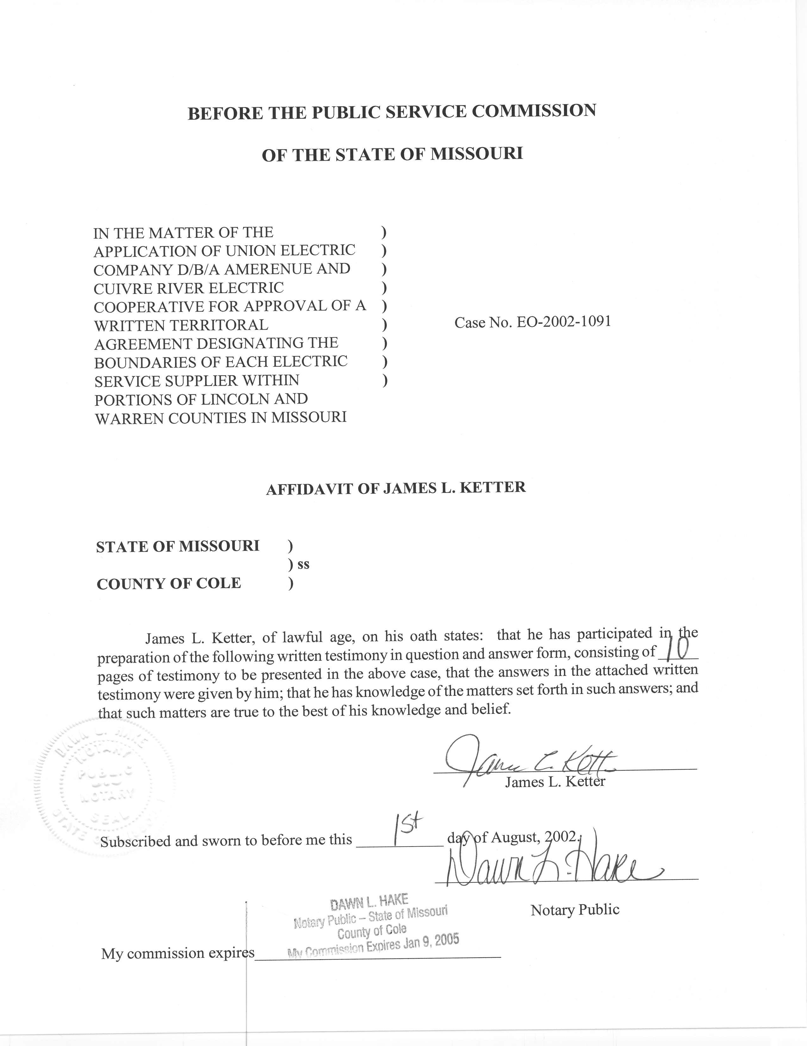
REBUTTAL TESTIMONY
OF
JAMES L. KETTER
UNION ELECTRIC COMPANY
d/b/a AMERENUE
AND
CUIVRE RIVER ELECTRIC COOPERATIVE
CASE NO. EO-2002-1091
Q. Please state your name and give your business address.
A. James L. Ketter, P.O. Box 360, Jefferson City, Missouri 65102.
Q. Mr. Ketter, by whom are you employed and in what capacity?
A. I am employed by the Missouri Public Service Commission (MPSC or Commission) as Utility Regulatory Engineer II in the Engineering Analysis section of the Energy Department.
Q. Please summarize your educational background and professional experience.
A. I received a Bachelor of Science degree in Electrical Engineering from the University of Missouri-Columbia in 1970. I served for 4 1/2 years as an officer in the United States Navy and returned to the University of Missouri-Columbia campus to pursue an advanced degree. In December 1977 I received a Masters degree in Business Administration from the University of Missouri-Columbia.
I have been employed by the Commission since 1976. As an engineer on the Staff, I have testified before the Commission on certificates for service areas, electric transmission and power plant certification cases, territorial agreements and I have presented testimony on rate design in electric, steam and gas rate cases. I am a registered Professional Engineer in the state of Missouri; my registration number is E-20056. I am a member of the National Society of Professional Engineers and I am a member of the Jefferson City Chapter of the Missouri Society of Professional Engineers.
Q. What is the purpose of your testimony in this case?
A. I will address the Territorial Agreement filed by Union Electric Company d/b/a AmerenUE (AmerenUE or Company) and Cuivre River Electric Cooperative (Cuivre River or Cooperative). In addition, the application requested a waiver from 4 CSR 240-14 to meet unregulated competition.
Q. What is your recommendation concerning this territorial agreement between AmerenUE and Cuivre River?
A. I recommend that the Commission approve the Territorial Agreement. The distribution facilities that Cuivre River has in place to serve its service area defined by the agreement are situated to provide good service quality and reliability. Likewise, AmerenUE has distribution facilities in place to provide good service quality and reliability to customers in its proposed service area as defined in the agreement. This delineation of service areas will control the duplication of facilities that has been prominent in this area. The Territorial Agreement will allow each utility to make long-range plans to serve their designated territory and anticipate the electric needs of its customers. In consideration of all these factors, Staff believes that the Territorial Agreement is in the public interest.
Q. Describe the geographic area that this territorial agreement encompasses.
A. This territorial agreement involves northeastern portions of Warren County and south-central portions of Lincoln County. In Warren County, AmerenUE would provide electric service to all new customers primarily along the I-70 corridor from the City of Warrenton to the City of Foristell. Under terms of the agreement, Cuivre River would serve all new customers in rural areas generally north and south of this I-70 corridor. In Lincoln County, AmerenUE would serve in and around the City of Troy and Cuivre River would serve in rural areas. The areas are shown in Exhibit D of the application.
Q. Do the illustrative tariffs in Schedule 3 of AmerenUE witness Robert W. Schmidt correctly recognize the changes contemplated by the Territorial Agreement?
A. With the changes outlined on page 14 of Mr. Schmidt’s Direct Testimony, the illustrative tariffs correctly reflect the impact of approval of the Territorial Agreement. The AmerenUE service area is outlined on the tariff sheets on file at the Commission. AmerenUE has requested that its authority to serve be only limited by the terms of the agreement, such that AmerenUE could not serve new customers in the exclusive service area of Cuivre River, but could build other facilities necessary to provide service to its existing or new customers.
The tariff sheets list each section within the Township and Range that AmerenUE has authority to serve customers. Section numbers are marked to identify areas subject to an approved territorial agreement that restricts AmerenUE’s ability to serve new customers. Sections restricted by a territorial agreement are underlined on the tariff and a footnote references the approved territorial agreement. The additions and corrections noted above are necessary to accurately reflect the impact of approval of the territorial agreement.
Q. Have you observed the duplication of electric facilities in St. Charles, Warren and Lincoln Counties?
A. Yes I have. For many years as new development moved into this area, Cuivre River and AmerenUE have sought to serve the expanding electric load. Customers would chose one electric supplier or the other, and in many places there are electric facilities on both sides of the roads and highways. Overhead lines cross over and under each other as each utility extended its facilities to serve new customers.
Q. Will this territorial agreement help control the duplication of electric facilities?
A. Yes, it will help control duplication. With only one authorized electric supplier in the exclusive areas, only one supplier will extend its facilities to serve the new customers in that area.
Q. How will this Territorial Agreement aid the long-range planning for Cuivre River and AmerenUE?
A. With a competitive arena, an estimate was necessary to determine the expected growth of any area plus the expected percentage of the development as developers would chose one utility or the other. With exclusive territory, each utility will serve the entire new electric load in a designated area and thereby be more efficient in the utilization of the distribution facilities. This will allow each utility to better estimate and plan for future needs.
Q. Will there be a change of supplier or exchange of customers pursuant to this territorial agreement?
A. No, there will be no change of electric service provider.
Q. How is this application for a territorial agreement, identified as the Second Territorial Agreement, different from the First Territorial Agreement approved in Case No. EO-93-166?
A. The First Territorial Agreement designated boundaries in portions of St. Charles County between AmerenUE and Cuiver River. A significant difference is that the First Territorial Agreement included a provision for a waiver from the Promotional Practices Rule, 4 CSR 240-14, within the agreement between AmerenUE and Cuiver River. In the Report and Order in Case No. EO-93-166 the waiver was approved but the Commission expressed that it did not believe that a territorial agreement is the proper place to include a request for a waiver from the Commission’s utility promotional practices rules. In the Second Territorial Agreement, the parties to the agreement support the waiver in the designated Highway T corridor but the request for waiver is a separate part of the application. In effect, this allows consideration of the waiver as a separate issue from acceptance or rejection of the territorial agreement.
Q. What is the area referred to as the Highway T corridor in the First Territorial Agreement?
A. The Highway T corridor is an area of approximately eight and one-half (8½) square miles that is located south of the City of Foristell, along the east side of State Highway T in St. Charles County as shown on Exhibit D of the application in this case. Portions of State Highway T are along the boundary between Warren and St. Charles Counties. This area is also referred to as the Competition Area. This area was not divided into exclusive territory, but was an area in which each utility had existing facilities and there was no agreement on separation for exclusive territory. The First Territorial Agreement included language concerning the proposed waiver in Case No. EO-93-166 and notice requirements for the Staff. The terms of that territorial agreement stated when, and in general terms, what information would be provided to the Staff concerning waiver of charges to meet unregulated competition. AmerenUE has not exercised this clause for the Highway T corridor from the First Territorial Agreement because development has not expanded to this area and the blanket waiver has not been exercised. This competition area from the First Territorial Agreement is not changed by the Second Territorial Agreement.
Q. What is the area referred to as the Highway T corridor, or Competition Area, in the Second Territorial Agreement?
A. The Highway T corridor, or Competition Area, is an area of approximately three and one-half (3½) square miles that is located south of the City of Foristell, along the west side of State Highway T in Warren County as shown on Exhibit D of the application in this case. This area was not divided into exclusive territory, but was an area in which each utility has existing facilities and there was no agreement on separation for exclusive territory. As part of the application in this docket, AmerenUE is requesting a waiver from the Commission’s rule concerning promotional practices (4 CSR 240-14) to meet unregulated competition from the cooperative while seeking to serve new customers in this area.
Q. What charges would be subject to waiver?
A. In the application filed in this docket, AmerenUE has requested waiver for any charge or service to provide service to any new structure located in the Competition Area, including wiring, conduit, appliances or equipment.
Q. What is the waiver procedure outlined by AmerenUE in the application?
A. In paragraph 11 of the application in this docket the waiver procedure is stated. If an offer is accepted, notice is provided to the Staff and information on the costs associated with the waiver of normal charges for that specific case to meet unregulated competition. Recovery of any costs associated with a waiver would be subject to submission of evidence to the Commission and a finding by the Commission that there was a benefit to AmerenUE from this action and that it will benefit existing customers.
Q. Is this the same procedure approved in Case No. EO-93-166 for the Competition Area?
A. Yes.
Q. Does the Staff oppose the blanket waiver as proposed in the application?
A. No, the Staff does not oppose the blanket waiver but has some concerns regarding encouraging addition of new customers at less than the cost allowed by the approved extension rules of AmerenUE and consequently the calculation of benefits to meet unregulated competition.
Q. What are the areas of concern in relation to defining the cost to provide service to new customers in the Competition Area?
A. I would expect that the addition of new customers in an area where AmerenUE has existing facilities of adequate capacity could generate new revenue to help cover the cost of facilities already in place. However, the waiver procedure does not specifically identify energy or capacity costs that new customers would add to the electric system. Recent rate investigation in Case No. EC-2002-1 identified the need for new generation capacity to serve AmerenUE customers. Analysis of the cost/benefit of any recovery of costs waived to meet unregulated competition should include a component to quantify the cost to meet new electric load. The Staff would expect AmerenUE to identify these capacity and energy costs, as well as the waived distribution costs, as part of the evidence presented to the Commission in a rate recovery docket used to recover waived costs.
Q. If the waiver is approved to meet unregulated competition, what other conditions should the included in the report and order?
A. AmerenUE tariff sheet Nos. 202 and 203 contain a list of the area or subdivision for which a waiver from the promotional practices rule to meet unregulated competition have been granted. If this waiver is granted, AmerenUE should be directed to file a revised tariff to include the Highway T corridors for the waiver approved in EO-93-166 and in this docket.
Q. What is the benefit for Cuivre River in participating in a territorial agreement?
A. Cooperatives serving in Missouri are authorized to serve customers in rural areas, defined as any area not included within the boundaries of any city, town or village having a population in excess of fifteen hundred (1500) inhabitants, Section 394.020(3), RSMo (2000). A cooperative may also supply electric energy in cities having a population in excess of fifteen hundred (1500), if the cooperative is the predominate supplier and the city has granted a franchise to serve within the city, Section 394.080.2, RSMo. (2000). In addition, a territorial agreement approved by the Commission authorizes the cooperative to serve within a city having a population in excess of fifteen hundred (1500), Section 394.312.2, RSMo. (2000).
For the areas near incorporated towns of population over 1500, Cuivre River gains the authority to serve new customers if this area is part of its service territory pursuant to the agreement. This is significant because Cuivre River may have significant investment in facilities to serve existing and future customers that could be stranded by annexation into an incorporated area of over fifteen hundred (1500). An example of this problem is in a subdivision served by Cuivre River in which the service facilities have been installed but all the lots are not developed. The cooperative may be the logical provider in this example in serving the remaining lots of the subdivision, but the law may not allow the cooperative to set new meters.
Other provisions, as previously cited, authorize a cooperative to serve new customers in these non-rural areas if the cooperative is the predominate supplier and has a franchise from the city to serve. AmerenUE witness Schmidt addresses the issue of predominate supplier in Moscow Mills, Wright City and St. Paul which exceeded the fifteen hundred (1500) population in the census of the year 2000. This territorial agreement will resolve a potential dispute between the joint applicants concerning the interpretation of predominate supplier.
The exceptions to the exclusive provider listed in Exhibit 5 of the application in this case identifies subdivisions and parks where the utility that has built the facilities to serve the development is allowed to serve the remaining undeveloped area within these developments. These exceptions allow the present electric service provider in these developments to set meters to complete the distribution system within the development, without encouraging duplication outside the development.
Q. What is your recommendation for this application?
A. I recommend approval of the Joint Application as filed and approval of the waiver from 4 CSR 240-14 with the condition that AmerenUE must identify capacity costs, as well as the waived distribution costs, as part of the evidence presented to the Commission in a rate recovery docket used to recover waiver of costs. I also recommend that the Commission include in any order approving a waiver of promotional practice rules in this case that AmerenUE be directed to file a revised tariff sheet to include description of the Highway T corridor in the list of unregulated competition waivers.
Q. Does this conclude your rebuttal testimony?
A. Yes, it does.

