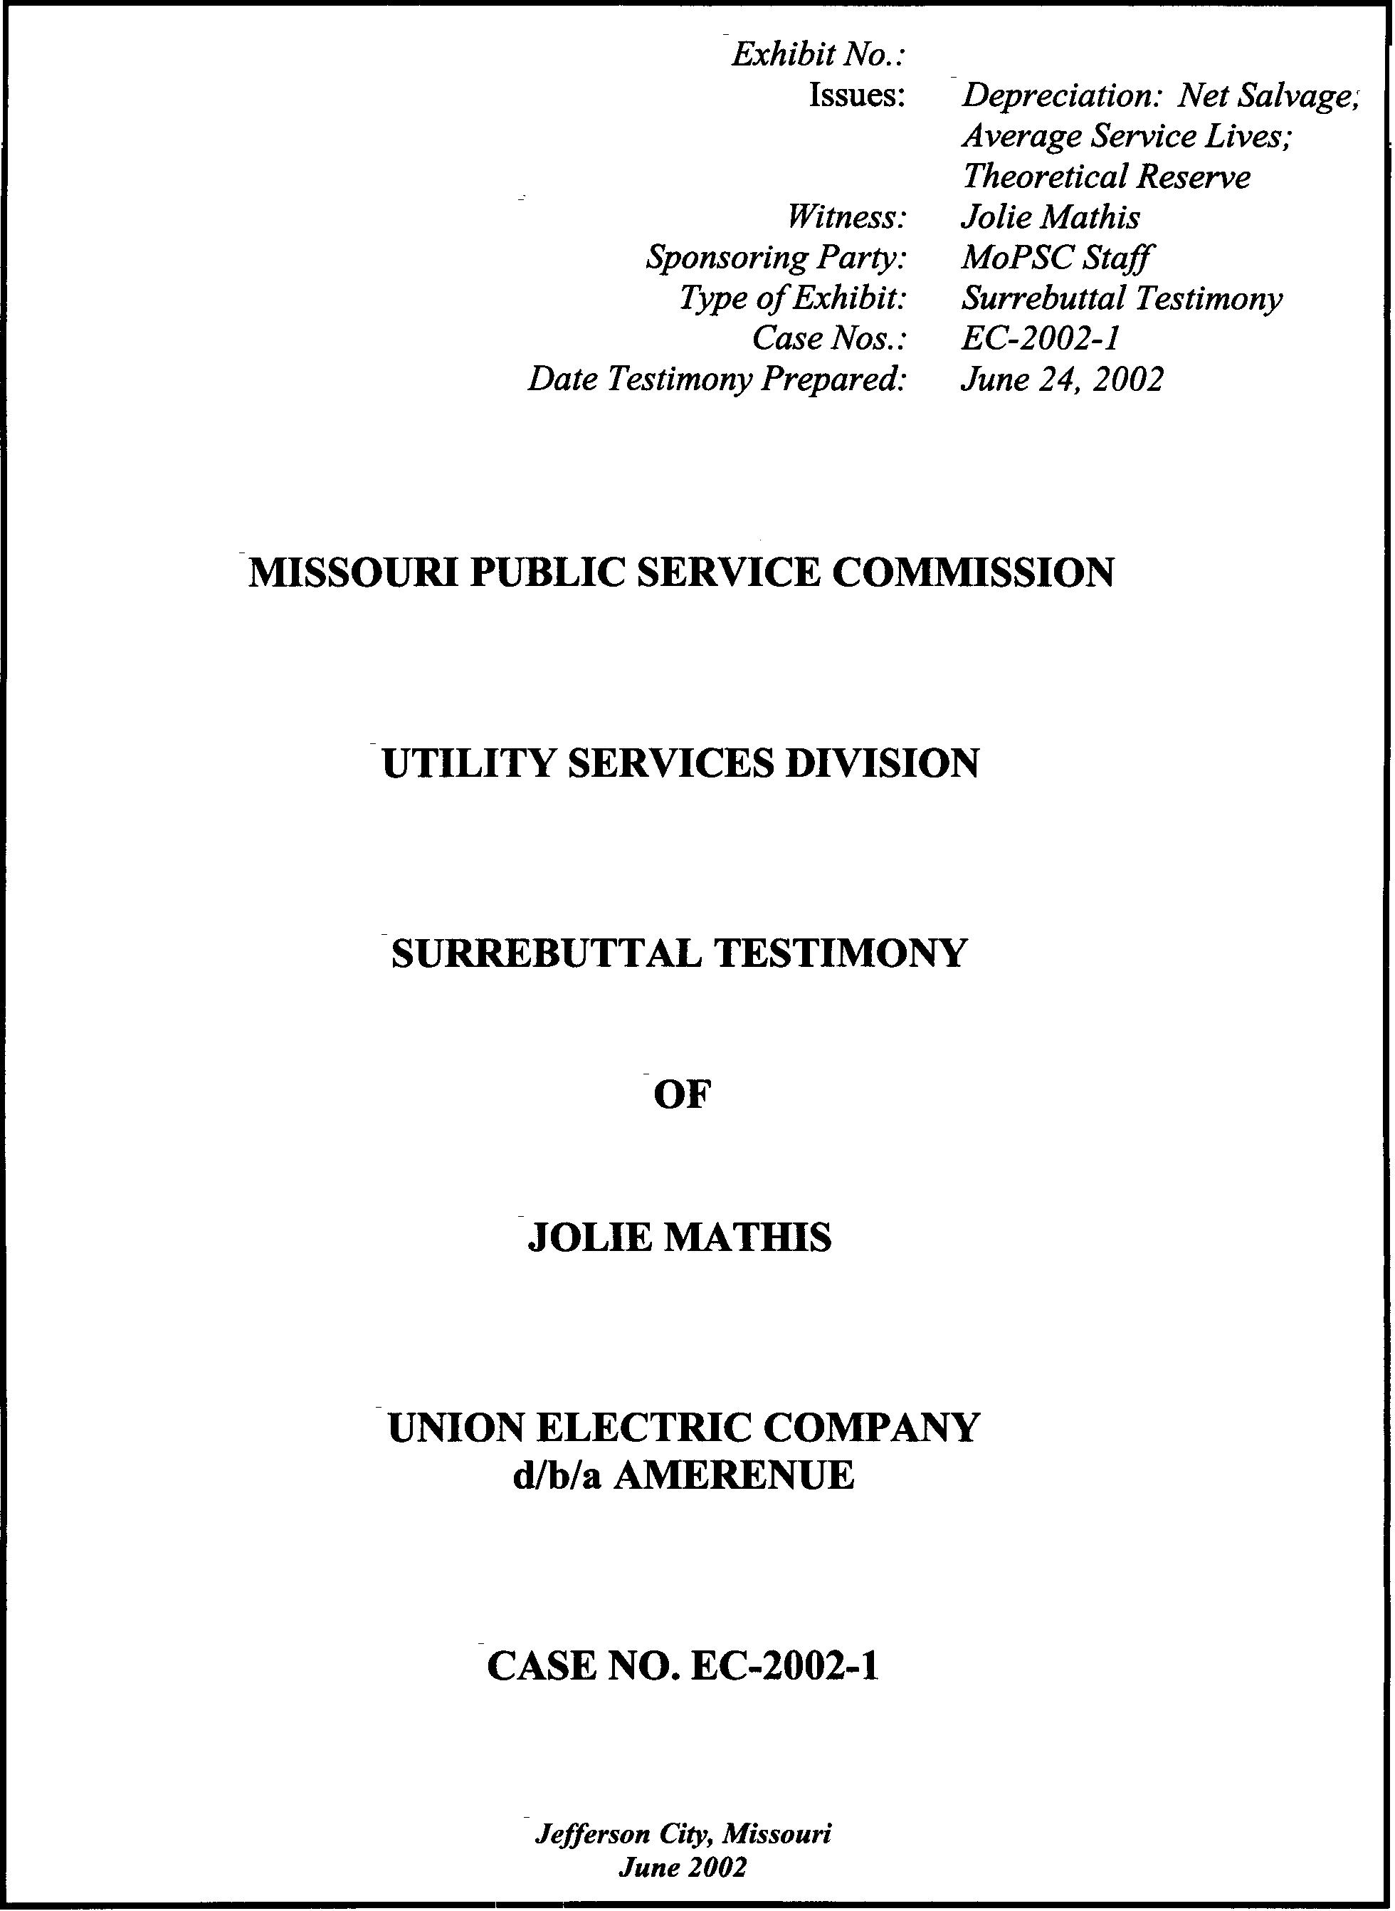
TABLE OF CONTENTS OF
SURREBUTTAL TESTIMONY OF
JOLIE L. MATHIS

NET SALVAGE AMOUNTS IN DISTRIBUTION PLANT 2
STAFF’S POSITION ON NET SALVAGE 6
STAFF’S DETERMINATION OF AVERAGE SERVICE LIVES 10
STAFF’S AMORTIZATION OF THE RESERVE OVER-ACCRUAL 14
COMPANY’S RESERVE DEFICIENCY 14

SURREBUTTAL TESTIMONY
OF
JOLIE L. MATHIS
UNION ELECTRIC COMPANY
d/b/a AMEREN UE
CASE NO. EC-2002-1
Please state your name and business address.
Jolie L. Mathis, P.O. Box 360, Jefferson City, MO 65102.
By whom are you employed and in what capacity?
I am employed by the Missouri Public Service Commission (Commission) as a Utility Engineering Specialist III in the Engineering and Management Services Department.
Are you the same Jolie L. Mathis who has previously filed direct testimony on behalf of the Staff of the Missouri Public Service Commission in this case?
Yes.
What is the purpose of your surrebuttal testimony?
I will respond to the rebuttal testimony of William Stout, the Company’s depreciation consultant.
Which particular issues will you address?
I will address:
1. Net Salvage amounts in Distribution Plant
2. Staff’s position on Net Salvage
3. Staff’s determination of Average Service Lives
4. Staff’s amortization of the Reserve Over-Accrual
5. company’s Reserve Deficiency

NET SALVAGE AMOUNTS IN DISTRIBUTION PLANT
Would you please define Net Salvage?
Net Salvage = Gross Salvage – Cost of Removal.
Would you please define Net Salvage Cost?
Yes. A Net Salvage Cost occurs when the Cost of Removal exceeds the Gross Salvage, resulting in a negative net salvage.
Are there any authoritative texts in depreciation that describe this occurrence?
Yes. In the Public Utility Depreciation Practices NARUC text it states:
It is frequently the case that net salvage for a class of property is negative, that is, cost of removal exceeds gross salvage. This circumstance has increasingly become dominant over the past 20 to 30 years; in some cases negative net salvage even exceeds the original cost of plant. Today few utility plant categories experience positive net salvage; this means that most depreciation rates must be designed to recover more than the original cost of plant. The predominance of the circumstance is another reason why some utility commissions have switched to current-period accounting for gross salvage and, particularly, cost of removal.
Although the Commission has not been able to conduct a thorough review of all the state commissions, it is apparent from the above quote that this approach is being applied to other jurisdictions.
In Mr. Stout’s depreciation study, performed on behalf of Ameren UE, is there any particular part of plant where negative net salvage is predominant?
Yes, that would be Distribution Plant.
Q. Would you please tell us how much the Company is asking for in Net Salvage Cost for Distribution Plant?
Yes. The amount is approximately $35 million on an annual basis related to future cost of removal for distribution plant.
And which accounts make up the substantial portion of that $35 million?
For Account 364 Poles & Fixtures, the Company seeks an annual accrual amount for net salvage costs of approximately $17 million; for Account 365 Overhead Conductor & Devices, $6 million; for Account 369 Overhead Services, $5 million; and for Account 367 Underground Conductors & Devices, $2 million. These four accounts total $30 million in annual net salvage cost dollars requested by the Company.
Have you prepared an analysis of a distribution account that better illustrates the impact of the Company’s proposal regarding net salvage?
Yes. Schedule 1 attached to this testimony presents an analysis of the impact of the Company’s position based upon actual information for Account 364, Poles & Fixtures. Company data supporting this schedule was provided in the Company’s Depreciation Study, pages III-181 and III-182, presented in my surrebuttal as Schedule 2. This is the distribution plant account that has the largest future cost of removal in the Company’s proposal. This schedule indicates that consumers will be paying approximately $14 million dollars in excess of the Company’s actual costs each year, for this account alone, if Mr. Stout’s depreciation rates are adopted. In other words, AmerenUE is proposing to charge its customers approximately four times its actual costs to remove poles and fixtures on an annual and recurring basis.
Does the company provide enough evidence to support the large negative net salvage percentages that generate these dollars?
No. In FERC Form 1, Annual Report (Page 219), for the years 1990 to 2000, Net Salvage Expense in total, for all Company accounts, for each year is reported as being between $8 and $12 million. Mr. Stout states in his Rebuttal Testimony, pg. 15, Line 26, “The net salvage accrual exceeds the net salvage cost because of system growth and maturity…the size of the system has doubled in the past 40 years.” System growth does not provide evidence that a negative 135 percent net salvage for Poles & Fixtures, or a negative 180 percent net salvage for Overhead Services will be required in the future.
Does Mr. Stout talk about the basis of his estimates of Net Salvage in his depreciation study?
Yes. He states on pg. II-26 of his depreciation study that, “The estimates of net salvage were based on judgment which considered a number of factors. The primary factors were the analyses of historical data, the impact of the age of retirements and inflation on net salvage, knowledge of management’s plans and operating policies determined during the management meeting, field trip and other discussions, a general knowledge of the electric industry, and net salvage estimates used by other electric companies.”
Do those factors permit a prediction of what cost of removal will be in upcoming years to be made with reasonable accuracy?
No. It is impossible to project with reasonable accuracy future gross salvage and cost of removal based on any of those factors.
Does Mr. Stout go into some detail on any of the accounts?
Yes, he provides supporting detail. For example, for Account 365, Overhead Conductors he merely states that, “The range of typical net salvage estimates for overhead conductors is negative 20 percent to negative 50 percent.” He also asserts that the remaining accounts are determined in a similar fashion, incorporating historical indications, and ranges of estimates used by other electric companies. Mr. Stout fails to include in his depreciation study how the plant of the electric companies he uses for analogy are similar to Ameren UE’s plant in age, material, size, maintenance, weather conditions.
In Mr. Stout’s rebuttal testimony, Schedule 6, he compares future estimated net salvage costs and net salvage accrual during the period 2001 through 2094 for Account 365. How representative is that example to on-going real life situations?
It is not representative. I have attached the historical data for this account as Schedule 3 to this testimony (Stout rebuttal, pages III-183, III-184). I have attached Mr. Stout’s Schedule 6 as Schedule 4 to this testimony. This example treats Account 365, Overhead Conductors & Devices as a dying account (i.e. there will be no additions). This example is not representative of this account because this is still a growing account (i.e. there are plant additions). Because the account is still growing, this assumption underestimates the amount of negative net salvage that will accrue, thus the amount of negative net salvage that will be accrued (i.e. paid by consumers) as reflected in the “net salvage accrual” column.
Mr. Stout’s Schedule 6 assumes that rates charged to customers are reduced each year to reflect the decrease in the “Ending Plant Balance” shown in this schedule. The likely result is that consumers will continue to pay, for the foreseeable future, the $6,139,173. The Company asks the Commission to order the over-accrual of AmerenUE’s depreciation reserve. It will continue to grow.
Mr. Stout’s Schedule 6 does not match the actual experience in this account as reflected on pages III-183 and III-184 (Schedule 3 to this testimony). Further, this page shows that retirements do not follow the ever-increasing trend shown in the “Retirements” column of Mr. Stout’s Schedule 6-1. (Schedule 4 to this testimony) Actual retirements fluctuated and reached their highest level in 1989 or 11 years prior to year 2000, the date ending Mr. Stout’s study. Page III-183 of Mr. Stout’s study also indicates that net salvage is not proportional to retirements. This is evidenced by the percentage (PCT) of net salvage to retirements that ranges from +11% to –112%.
Actually, page III-183 of Mr. Stout’s study shows that the amount of net salvage is fairly constant and is independent of the dollar value of retirements. This supports the validity of Staff’s proposal to establish cost of removal based upon actual experience versus the AmerenUE proposal to base cost of removal on a percentage of retired plant methodology.
Does Mr. Stout present enough evidence to support a $35 million increase in net salvage accrual?
No, he does not.

STAFF’S POSITION ON NET SALVAGE
Would you please restate your recommendation for the treatment of net salvage in this case?
Yes. Again, the whole life depreciation rate formula is:
[Depreciation Rate = (100% - Net Salvage %) / (Average Service Life)]
Staff is proposing a removal of the net salvage factor from the whole life formula for depreciation rate determination. Depreciation should be the determination of average service life and a subsequent depreciation rate that recovers the capital cost of the original investment. Again, as I noted on page 2, over the past 20 to 30 years, the cost of removal has exceeded the gross salvage, resulting in depreciation rates that have to recover more than the original cost of plant. This is why Staff is proposing current-period accounting for net salvage.
Mr. Stout makes the statement beginning on page 4, line 22 of his rebuttal testimony, that, “Ms. Mathis has proposed a radical departure from the traditional approach to recognizing net salvage in the depreciation rate formula…” Is Mr. Stout’s assessment correct?
No. Mr. Stout’s assessment is incorrect and misleading in several respects. Staff’s approach to recommending depreciation rates in this case is consistent with its approach in numerous previous cases, including other electric companies that have been before the Commission in rate proceedings. Specifically, Staff’s depreciation approach and methodology is consistent with that recommended by the Staff for cases including Missouri Public Service, The Empire District Electric Company, Laclede Gas Company and Missouri Gas Energy.
While Staff’s methodology is a departure from the ‘traditional’ depreciation formula that includes a component for future and estimated net salvage that may or may not occur, Staff’s recommendation in these cases has been to allow the Companies to recover the original cost of their investment over the average service life of that investment. In addition, Staff’s methodology recommends that Companies be allowed to recover actual net salvage cost on a current basis by treating net salvage as an expense.
In Staff’s judgment, its recommended methodology for the development of depreciation rates is a more reasonable method for determining depreciation rates that serve as the basis for utility rates that Ameren UE customers will pay in their monthly bills.
Has the Commission ruled on the net salvage issue in previous cases?
Yes. In Case No. GR-99-315, Laclede Gas Company, the Commission ruled that current depreciation rates should reflect a net salvage component of the depreciation rate that, when multiplied by the plant balance, gives an annual accrual consistent with the current net salvage amount experienced by the Company. More recently, in Case No. ER-2001-299, The Empire District Electric Company (Empire), the Commission found “that net salvage cost considered in setting rates should be based on historical net salvage cost that Empire has actually incurred in the recent past and that it should be treated as an expense.”
The Report And Order in WR-2000-844, St. Louis County Water Company supported the Company’s position regarding depreciation rates, which included a component for future net salvage. Can you provide any additional information regarding the Commission’s support for the Company’s position in this case?
Yes. The Commission stated in the Report And Order in WR-2000-844:
There is ample factual support to allow the Commission to choose either Staff’s approach or the Company’s. Under the circumstances faced by the Company including its need for cash flow to address its infrastructure issues, the Commission concludes that using the whole life method and including estimated net salvage is in the public interest.
Further, the Order went on to say:
The Commission’s conclusion about the use of the (traditional) whole life method should not be taken as a final endorsement of it, nor as a condemnation of Staff’s approach. Both have merit, and the Commission will use the one that fits the particular circumstances under investigation.
The Order clearly states that enough evidence was provided by both the Company and the Staff to allow the Commission to support the position of either. Cash flow was a concern at St. Louis County Water Company and the Commission supported the Company’s higher depreciation rates to provide greater cash flow. The Commission further ordered that any excess collection must be held in a storage fund and only used for infrastructure replacement.
Do any authoritative texts mention the approach to net salvage that you are proposing?
Yes. On pg. 157 of Public Utility Depreciation Practices (1996), it reads:
Some commissions have abandoned the above procedure and moved to current-period accounting for gross salvage and/or cost of removal. In some jurisdictions gross salvage and cost of removal are accounted for as income and expense, respectively, when they are realized. Other jurisdictions consider only gross salvage in depreciation rates, with the cost of removal being expense in the year incurred.
How does this treatment of net salvage benefit the Company and the customer?
It ensures that the ratepayer pays costs that are actually incurred, and that the Company recovers its actual cost of removal less gross salvage.

STAFF’S DETERMINATION OF AVERAGE SERVICE LIVES
Mr. Stout makes the statement beginning on page 5, line 1, “Mrs. Mathis had determined average service lives by relying almost entirely on analyses of historical data and ignoring other relevant information…” Is his statement true?
No. As indicated on page 3 of my March 2002 testimony, line 8, I conducted field inspections and discussed plant operations and plans for property retirement at Ameren UE’s four coal fired plants and two hydroelectric plants. In addition, I reviewed depreciation work including Staff’s proposed and Commission ordered rates for other Missouri electric utilities. As I stated previously in my direct testimony, pg. 5 lines 7 through 11, the ASL (Average Service Life) is determined by actuarial analysis of records of annual additions, retirements by vintage and balances, as well as information provided by engineering and operations personnel. Also, survivor curve estimates from other Missouri PSC-regulated electric companies were considered.
When you mention that you performed an actuarial analysis of plant accounts, are you referring to all 51 accounts?
No. I am referring to the 26 accounts that I actually chose to work on for this case. The prescribed lives in the remaining 25 accounts remained as ordered in Case No. ER-83-163. I did not perform an actuarial analysis on those 25 smaller accounts.
Did you consider information provided by engineering and operations personnel when touring Ameren UE plant in your estimation of average service lives?
Yes. I used engineering judgment, by taking into consideration the type of plant, how it operates, and how long it will last to confirm or modify the results of the statistical analysis of Ameren UE’s mortality data.
Would you please state the difference in the dollar amount of the life estimate between Staff and Company for Steam Production Plant?
The Company is requesting $28 million more than Staff due to estimated retirement dates for Meramec, Sioux, Venice, Labadie and Rush Island.
How did the Company determine their retirement dates for each particular plant?
Mr. Stout stated that they are based on life spans that range from 50 to 61 years and average 54 years. He also states that Ameren UE’s management participated in the development of those dates and that they are consistent with the Company’s resource plan. He also states that he used the life spans experienced by other electric utilities, and refers to life descriptions in the rebuttal testimony Garry L. Randolph.
What does Mr. Stout state about Staff’s treatment of Production Plant?
Of all of Mr. Stout’s statements, perhaps the most misleading is his statement on pg. 5 line 2 that [Staff’s] “…estimated survivor characteristics for production plant that do not incorporate the final concurrent retirement of all facilities at the end of a unit’s life…” This sentence implies that production plant dates are known or at a minimum, can be estimated within a narrow range of precision. As is the case with Ameren UE facilities and two separate depreciation studies performed by the Company, this has clearly not been the case.
Please describe the two depreciation studies you are referring to and the discrepancies that exist that relate to Mr. Stout’s statement.
On January 22, 2002, Ameren UE submitted its depreciation study consistent with the Missouri Public Service Commission Rule, 4 CSR 240-20.030 that requires electric companies to submit depreciation studies every five years. The difference in some production plant lives presented in the Company’s January 22, 2002 study and those presented in the Company’s study filed in Case No. EC-2002-1 four months later on May 10, 2002, provide clear indication of the difficulty and imprecision in determining final plant retirement dates.
Specifically, there are significant differences between the Company’s two studies with respect to what the Company terms “Probable Retirement Dates” for its hydraulic production plant. The very term “Probable Retirement Dates” indicates that the true dates of plant retirement are unknown and retirement date plans and commitments are subject to change. In the two depreciation studies, the Company’s three hydro plants have differing retirement dates; two of the three plant retirement dates had significant life extensions, yet both studies were based upon December 31, 2000 plant data. In addition, Venice Steam Production Plant life was reduced six years.
Specific retirement date differences are presented in the following:
Retirement Dates
Jan. 22nd Study May 10th Study
Osage 2031 2036
Keokuk 2013 2028
Taum Sauk 2010 2040
Venice 2010 2004
These changes in retirement dates are addressed in Company correspondence, attached as schedule 5.
Did the Company provide sufficient information for the estimation of retirement dates, in your opinion?
No. This issue will be addressed in the separate surrebuttal testimony of Staff witness Rosella L. Schad, P.E..
Did you solely rely on the curve fitting results performed by Gannett-Fleming software for the Production Plant Accounts in your analysis?
No. The results of the Gannett-Fleming analysis I conducted resulted in ASLs that were longer than my proposed ASLs. For example in Account 311, Structures & Improvements, if I had relied strictly on computer software results, the life would have been 120 years. I considered many other factors to conclude that a 69-year ASL is appropriate. Other factors I considered were the plant mix of the account and the engineering judgment of the plant during site visits, plus discussions with other engineers in my department about an appropriate life. This method was followed for all Production Plant accounts, and many other accounts that were analyzed.
Do you recognize the life span method as appropriate for production plant facilities?
Only when the retirement date of that plant can be clearly determined. Rosella Schad addresses the Company’s retirement dates for production plant accounts in surrebuttal testimony filed in response to Company witnesses Garry L. Randolph and William Stout, P.E.
When was the last time depreciation rates were prescribed for Ameren UE?
Depreciation rates were last ordered in Case No. ER-83-163 on July 6, 1983, excluding Callaway Nuclear Power Plant and the coal cars account.
Is it important that new depreciation rates are prescribed in this case?
Yes. It has been almost 20 years since depreciation rates were last ordered for this Company. Staff’s proposed depreciation rates in this proceeding will reflect the expected lives of plant currently in service.

STAFF’S AMORTIZATION OF THE RESERVE OVER-ACCRUAL
Would you please restate the reserve deficiency in this case?
Yes. The actual December 31, 2000 reserve accrual for the 26 accounts is $2,480,149,133. The Staff’s theoretical reserve for these 26 accounts is $1,498,481,336. The Company is over-accrued by $981,667,797, nearly $1 billion.
What is your recommendation again for the treatment of this over-accrual?
Due to the size of the over-accrual, Staff recommends an amortization period of 40 years, or $24,541,695 per year ($981,607,797 / 40yrs). This time period is sufficient in length to allow the over-accrual to be corrected while allowing adjustments to be made to depreciation rates if lives change during future rate cases.
Q. How much of the over-accrual amount is related to the exclusion of net salvage from the whole life depreciation formula?
Approximately one-half is tied to the removal of net salvage from the formula, and the remaining half to the life parameters.

COMPANY’S RESERVE DEFICIENCY
Did the Company determine that the actual reserve was over-recovered or under-recovered?
Because the Company used the “traditional” whole life technique, they concluded that the actual accrual was under-recovered.
What is the Company’ reserve deficiency number?
The Company calculated a theoretical reserve as of December 31, 2000 of $3,668 million and compared it to a booked reserve of $3,571 million. This resulted in an under-accrual of $97 million. The Company’s recommendation is a 20-year amortization of approximately $5 million per year.
Is the Company under-accrued, in your opinion?
No. The inclusion of net salvage in their “traditional” calculations and their estimated retirement dates for Production Plant results in high depreciation rates. These high depreciation rates result in a theoretical reserve amount that is unreasonably high. The Company is over-accrued, not under-accrued.
Does this conclude your surrebuttal testimony?
Yes, it does.

