Exhibit No.:
Issues: Miscellaneous Tariff Issues and Flex Rates

Witness: Thomas M. Imhoff
Sponsoring Party: MO PSC Staff
Type of Exhibit: Direct Testimony
Case No.: GR-2004-0209
Date Testimony Prepared: April 15, 2004

MISSOURI PUBLIC SERVICE COMMISSION

Utility Operations DIVISION

Direct Testimony

OF

thomas m. imhoff

Missouri Gas Energy

CASE NO. GR-2004-0209

Jefferson City, Missouri
April 2004

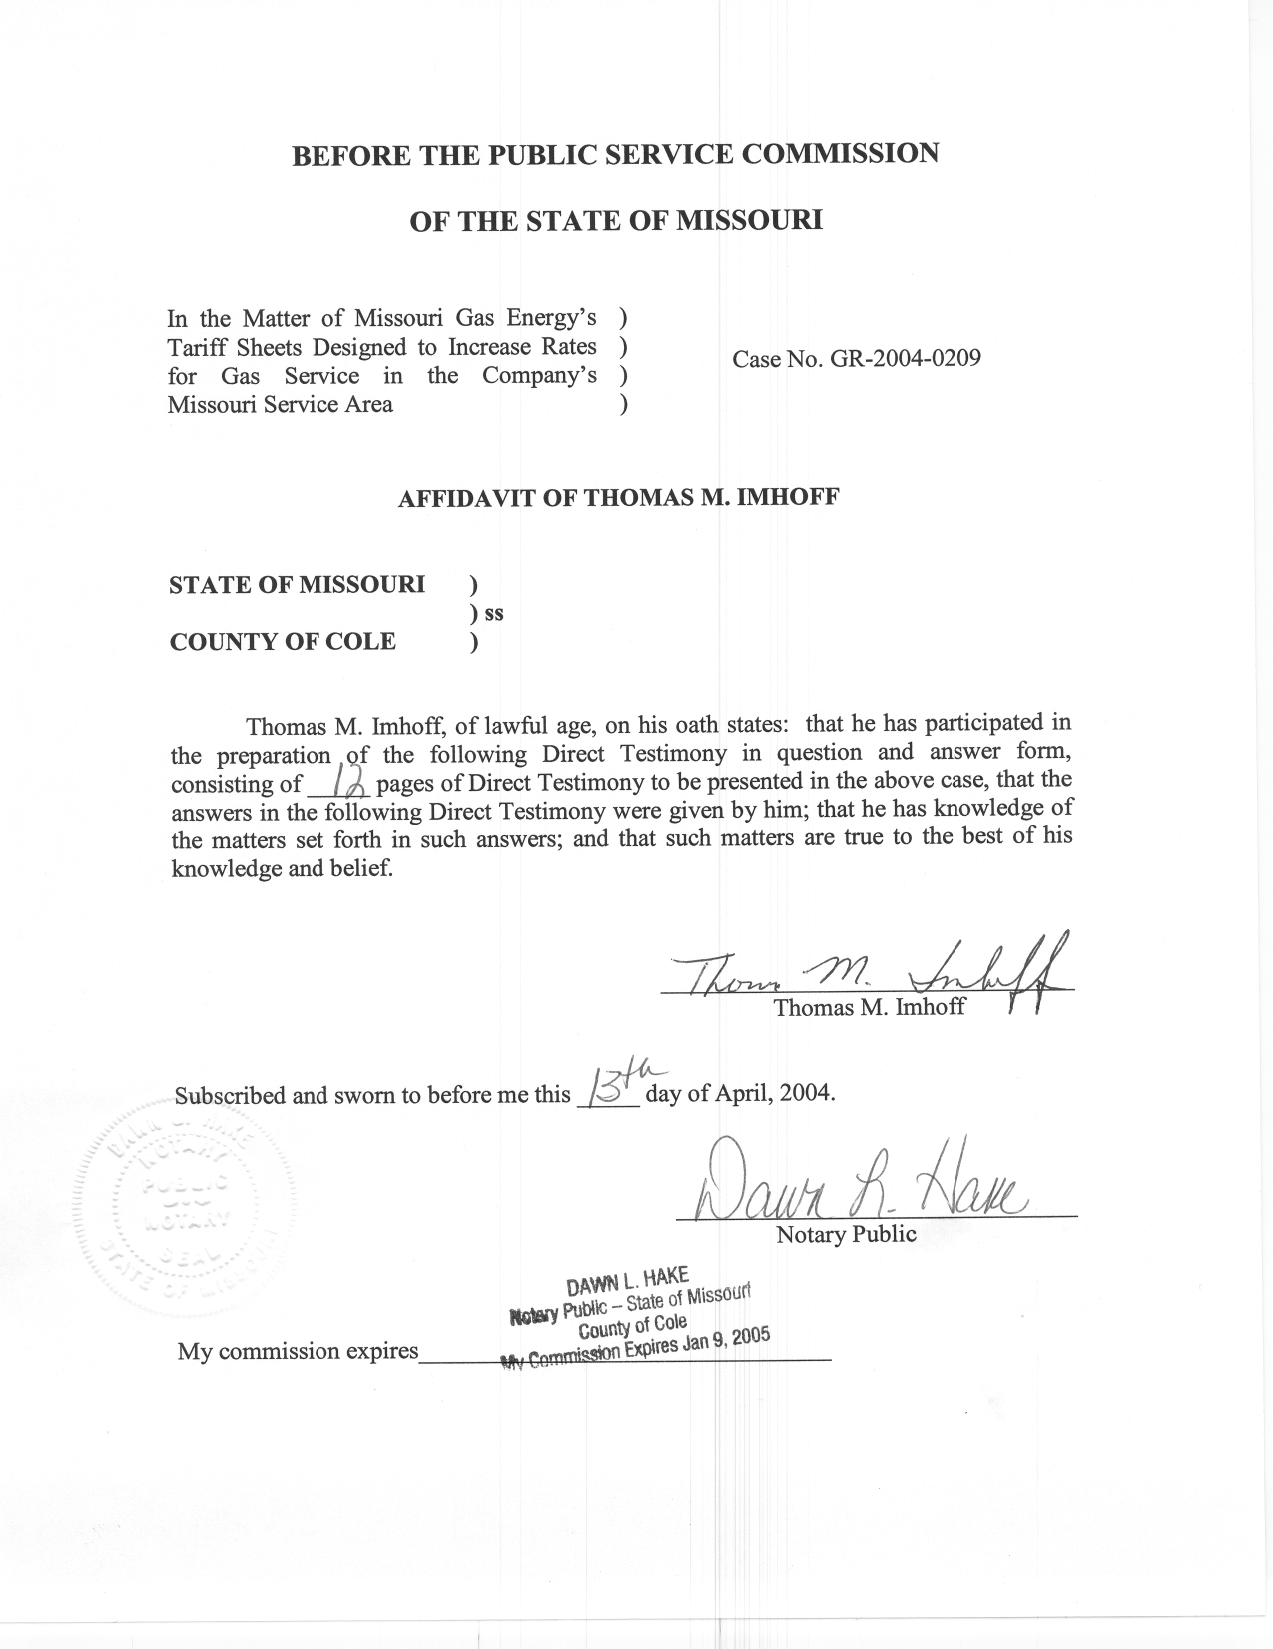
TABLE OF CONTENTS

FLEX RATE REVENUES 3
RECONNECTION, CONNECTION AND TRANSFER TARIFF CHANGES 6
ECONOMIC DEVELOPMENT RIDER (EDR) 8
LATE PAYMENT FEES 8
PURCHASED GAS ADJUSTMENT (PGA) CLAUSE TARIFF LANGUAGE 9
MISCELLANEOUS TARIFF PROVISION CLEANUP 11
TAX ADJUSTMENT TARIFF SHEET (TA) 11
DENIAL OF SERVICE COMPLAINTS 12

DIRECT TESTIMONY
OF
THOMAS M. IMHOFF
MISSOURI GAS ENERGY
CASE NO. GR-2004-0209
Q. Please state your name and business address.
A. Thomas M. Imhoff, P.O. Box 360, Jefferson City, Missouri 65102.
Q. By whom are you employed and in what capacity?
A. I am the Rate & Tariff Examination Supervisor in the Energy Department of the Missouri Public Service Commission (Commission).
Q. Please describe your educational background.
A. I attended Southwest Missouri State University at Springfield, Missouri, from which I received a Bachelor of Science degree in Business Administration, with a major in Accounting, in May 1981. In May 1987, I successfully completed the Uniform Certified Public Accountant (CPA) examination and subsequently received the CPA certificate. I am currently licensed as a CPA in the State of Missouri.
Q. What has been the nature of your duties with the Commission?
A. From October of 1981 to December 1997, I worked in the Accounting Department of the Commission, where my duties consisted of directing and assisting with various audits and examinations of the books and records of public utilities operating within the State of Missouri under the jurisdiction of the Commission. On January 5, 1998, I assumed the position of Regulatory Auditor IV in the Gas Tariffs/Rate Design Department,

where my duties consist of analyzing applications, reviewing tariffs and making recommendations based upon those evaluations. On August 9, 2001, I assumed the position of Rate & Tariff Examination Supervisor in the Energy Tariffs/Rate Design Department, where my duties consist of directing Commission Staff within the Department, analyzing applications, reviewing tariffs, and making recommendations based upon my evaluations and the evaluations performed by Staff within the Department.
Q. Have you previously filed testimony before this Commission?
A. Yes. A list of cases in which I have filed testimony before this Commission is attached as Schedule 1 to my direct testimony.
Q. With reference to Case No. GR-2004-0209, have you made an examination and study of the material filed by Missouri Gas Energy, a division of Southern Union Company (MGE or Company) relating to its proposed increase in gas rates?
A. Yes, I have.
Q. Are you sponsoring any adjustments?
A. Yes. I am sponsoring Staff Adjustment S-2.15, and Staff Adjustment S-2.16.
Q. What is the purpose of your direct testimony?
A. The purpose of my direct testimony is to present the Commission Staff’s (Staff) position relating to the flex rate issue; reconnections, reconnections at the curb, reconnections at the main, connections and transfer charges, and late payment fees; and an adjustment relating to the MGE’s economic development rider. This responsibility includes a review and analysis to determine if MGE’s contracted flex rates are in accordance with the Commission’s flex rate guidelines set forth in MGE’s rate case, Case No. GR-96-285. I am also proposing tariff language relating to MGE’s Purchased Gas Adjustment Clause (PGA) that reflects agreements reached by the parties in the PGA generic docket GO-2002-452 and I am addressing the definition of the Tax Adjustment tariff.

FLEX RATE REVENUES
Q. What are flex rates?
A. Flex rates are discounted transportation rates. MGE can only flex down the non-gas cost portion of its transportation rate. MGE’s flex rate tariff First Revised Sheet
No. 43 provides:
The Company may from time to time at its sole discretion reduce its charge for transportation service by any amount down to the minimum transportation charge for customers who have alternative energy sources, which on an equivalent BTU basis, can be shown to be less than the sum of the Company’s transportation rate and the cost of natural gas available to the customers.
Such reductions will only be permitted if, in the Company’s sole discretion, they are necessary to retain or expand services to a previous customer or to acquire new customers.
The Company will reduce its transportation rate on a case-by-case basis only after the customer demonstrates to the Company’s satisfaction that a feasible alternative energy source exists.
If the Company reduces its transportation charge hereunder, it may, unless otherwise provided for by contract upon 2 days notice to the customer, further adjust that price within the rates set forth above.
Q. How do flex rates affect the rate setting process?
A. The use of flex rates for certain transportation customers could result in a shift of revenue collections from those customers to potentially all non-flex customers for ratemaking purposes. The Company could request to increase rates of non-flex customers to recover lost revenues due to the flex down of certain transportation customer’s rates. If allowed, the burden and risk of flexing down rates would fall squarely on the shoulders of the non-flexing ratepayers (i.e., residential, commercial, etc…), essentially taking all of the burden and risk from MGE’s shareholders.
Q. Does the Commission have established guidelines in place for regulated gas local distribution companies that want to recover foregone revenues related to the use of flex rates?
A. Yes it does.
Q. What are the Commission’s guidelines for rate recovery related to MGE’s use of flex rates?
A. To justify flowing the negative revenue impact of flex rate use to other customers, MGE is required to show by full, complete, substantial and competent evidence that the arrangement:
1) was necessary to avoid imminent bypass of MGE’s system, resulting in the loss of a customer, or because of a competitive alternative (i.e., fuel oil);
2) recovers variable costs plus a reasonable contribution to fixed costs; and
3) in instances involving affiliates, was at arms length and flexes rates no lower than necessary to meet relevant competition.
Q. When did the Commission establish these guidelines?
A. These guidelines were first established by the Commission in a United Cities Gas Company rate case, Case No. GR-95-160, and were reiterated by the Commission in MGE’s rate case, Case No. GR-96-285.
Q. Is the Staff proposing to include foregone revenues in MGE’s revenue requirement due to its use of flex rates in this case?
A. No. The Company did not provide Staff with a current analysis or the breakdown of costs to substantiate the current level of discounts that it is affording certain transportation customers, despite earlier Commission orders.
Q. Did the Staff request copies of all supporting documentation and contracts to flex down rates with potential bypass customers or alternative fuel customers?
A. Yes it did. This information was requested in Staff Data Request (DR) Numbers 0199 through 0205. The information the Company provided to Staff did not have any analysis of the breakdown of variable and fixed costs to substantiate the level of discounts that MGE is affording certain transportation customers.
Q. Were any of the contracts and supporting information current?
A. Some contract addendums were current. However, none of the contracted flex rates were supported by any breakdown between variable and fixed costs.
Q. Has MGE provided evidence to support that contractual flexing transactions conform to Commission Standards?
A. No, it has not. Absent any supporting breakdown between variable and fixed costs for each flex customer to demonstrate that the rate covers MGE’s variable cost and makes a reasonable contribution to fixed costs, I recommend that all flex transportation volumes be priced at the full tariffed margin rates when calculating revenues for ratemaking purposes.
Q. Do the contractual flex rates that MGE currently has with some of its transportation customers, which are identified in Staff DR No. 0202, conform to the guidelines established by the Commission in MGE’s rate case, Case No. GR-96-285?
A. No, they do not. MGE did not provide supporting information or any analysis or breakdown of costs to substantiate the level of discounts that certain transportation customers are receiving.
Q. Have you determined an appropriate treatment for ratemaking purposes?
A. Yes, I have. I recommend imputation of revenue using the full margin in establishing MGE’s rates in this case.
Q. Have you made an adjustment to the Staff’s revenue requirement to reflect your recommended imputation of revenues regarding the flex rate issue?
A. Yes, I have. Staff Adjustment S-2.15 reflects the Staff’s adjustment computation.

RECONNECTION, CONNECTION AND TRANSFER TARIFF CHANGES
Q. Has MGE proposed a change in their charges for connection, reconnection, reconnection at the curb, reconnections at the main, and transfer fees?
A. Yes. MGE is proposing the following increases:
Connection Fee from $20 to $45;
Standard reconnect fee from $35 to $45;
Reconnection at the curb from $56 to $425;
Reconnection at the Main from $106 to $425; and
Transfer fee from $5 to $6.50.
Q. Is it important for these miscellaneous charges to accurately reflect what it costs to provide these services?
A. Yes, it is important that these miscellaneous charges reflect MGE’s cost of performing these various services. The individual customers causing the Company to incur these expenses should be responsible for the associated costs.
Q. Does the Staff agree with these proposals?
A. After careful review of MGE’s proposed changes, Staff believes that charges relating to the reconnect at the curb and at the main should remain the same, but agrees with the other proposed changes.
Q. Does Staff dispute the loading rate MGE has applied to these services?
A. Yes. The Staff disagrees with MGE’s inclusion of a non-productive time loading. This non-productive time loading factor includes vacation, sick time, holiday, training and standby time.
Q. Why does Staff disagree with the inclusion of the non-productive time loading?
A. These charges are based on a cost causation, per-job basis. Performing these various miscellaneous services are only a portion of the different jobs these employees must perform. Since the costs are based on a per-job basis, these non-productive loadings should not be included in these miscellaneous tariff rates. The vacation, sick time, holidays, training and standby time are already included in customer rates for gas supply services provided by the Company, and are not calculated on a per-job basis.
Q. What does Staff believe is the correct charge for each service?
A. Even though Staff disagrees with the non-productive time loading part of MGE’s miscellaneous charge computations, MGE’s use of the factor did not materially affect the rate calculation. Staff believes the proposed charges are representative of the MGE’s costs for those services.
Q. Why is the Staff proposing no changes for charges relating to the reconnections at the curb and at the main?
A. In Staff DR No. 0208, Staff requested supporting information for the costs associated with all reconnects, disconnects and transfers but to date, MGE has not supplied Staff with any support for these proposed changes. Without such documentation, Staff is unable to determine whether an increase to the charges is justified.
Q. What is the net effect of these miscellaneous charge changes that Staff agrees with?
A. The net effect of these changes results in an increase of $1,259,855, and will be reflected in Staff witness Daniel I. Beck’s class cost of service/rate design testimony.

ECONOMIC DEVELOPMENT RIDER (EDR)
Q. Please explain the EDR adjustment?
A. Staff Adjustment S-2.16 reflects the net increase in revenue due to a decrease in the amount of the discount to the customer who is eligible to participate under the EDR, and the increase of revenues that is computed at tariffed rates in effect at the end of the test year.

LATE PAYMENT FEES
Q. What change is Staff proposing to the late payment charge on delinquent bills?
A. Staff is proposing that the late payment charge on delinquent bills be reduced from 1 and ½ percent, compounded per month, to a simple ½ percent per month of the original net amount due on the delinquent bill. In other words, the late payment charge would not be applied to a previous late charge balance, thus eliminating the compounding effect of the late payment charge. This proposed late payment charge rate would be a simple annual rate of 6 percent. The current annual late payment charge rate is equal to 18 percent.
Q. Why is Staff proposing this change?
A. Staff believes this change better reflects current interest rates and the cost to the Company to carry a customer’s bill for an additional billing period. The current 18% rate increases the difficulty customers have when paying their gas bills.
Q. What is the financial impact of this proposed change?
A. Staff calculates the financial impact to be $770,156 and has accounted for this amount in Staff’s proposed rate design.

PURCHASED GAS ADJUSTMENT (PGA) CLAUSE TARIFF LANGUAGE
Q. Does Staff have any recommendations concerning MGE’s PGA clause?
A. Yes. The Staff is proposing PGA changes that are based on agreements reached by the parties in the PGA generic docket GO-2002-452, and have previously been approved by the Commission for AmerenUE, Atmos Energy Inc, Fidelity Natural Gas and Southern Missouri Gas Company.
Q. What changes are you proposing?
A. Staff is proposing to modify the computations of over or under recovery of gas costs. Staff proposes to eliminate the Deferred Carrying Cost Balance (DCCB) approach of tracking over or under recovery balances for gas costs and replacing it with the Actual Cost Adjustment (ACA) account methodology for tracking and recovering gas supply costs. This should simplify the tracking of over or under recovery balances for gas costs.
Second, Staff proposes to modify the interest recovery on over or under recovery balances of gas costs through the ACA method. Interest shall be computed based upon the average of the accumulated beginning and ending monthly ACA account balances. MGE should maintain detailed work-papers that provide the interest calculation on a monthly basis. This should simplify the computation of interest costs on any over or under recovery of gas costs.
Third, Staff proposes revisions that eliminate the threshold for interest calculations on over or under recovery of purchased gas costs. Interest will continue to accrue on over or under recovery balances, but will now be computed from the first dollar of over or under recovery of gas costs during the ACA period. The elimination of the interest threshold provides for immediate recognition of over or under recovery balances.
Fourth, Staff proposes that all pipeline refunds would be used to directly offset gas costs in the ACA account. MGE would no longer have to wait for a PGA filing to incorporate any pipeline refunds they have received.
Fifth, Staff proposes to eliminate the PGA cap language. The proposed tariff language replacing the cap tariff language describes and details the factors used in calculating the PGA rates.
Sixth, Staff proposes that specific language detailing the factors to be included in the calculation of the PGA consistent with an approach that considers all gas supply sources and cost so that the PGA accurately represents the blended cost of gas delivered during the forecast period. Currently, when calculating their PGA, MGE has the option to use the higher of the NYMEX strip price or the weighted average commodity-related gas cost in its three most recent ACA periods. Staff’s proposed change includes more relevant factors directly related to their current applicable gas resources. The computation is similar to the method currently being used by Laclede Gas Company, AmerenUE and Atmos Energy.
Seventh, Staff proposes that MGE be allowed four PGA filings per calendar year with one of those PGA filings to be effective in their November ACA filing, and the other three filings could be made by MGE at any time, with the caveat that they cannot make more than one PGA filing in any two consecutive calendar months unless specifically ordered by the Commission.
Eighth, the rate used to compute interest on the ACA balance would equal to the prime-lending rate minus two percent, but could never go under zero percent in the event that the prime-lending rate would go below two percent. The interest rate would be determined on the final business day of the calendar year for the upcoming calendar year.

MISCELLANEOUS TARIFF PROVISION CLEANUP
Q. What tariff provisions are Staff proposing to cleanup?
A. Staff proposes to eliminate tariff language that is no longer in effect for MGE. Staff proposes to delete the Experimental Gas Cost Incentive Mechanism (EGCIM), Experimental Price Stabilization Fund (EPSF) and the Fixed Commodity Price PGA (FPC) tariff language. The EGCIM tariff sheets that need to be deleted are 24.2 through 24.5. The EPSF tariff sheet that needs to be deleted is 24.6, and the FPC tariff sheets that need to be deleted are 24.8 through 24.31. These programs have terminated and are no longer used by MGE, therefore, the tariff language to these programs need to be deleted.

TAX ADJUSTMENT TARIFF SHEET (TA)
Q. Please describe the issue relating to the TA.
A. TA applies to Municipal taxes such as gross receipts tax and sales taxes that are based directly on the amount of each customer’s bill, and are charged directly to customers. These amounts have no impact on revenue requirement. Other fees that may be charged by the City, such as street cut fees, cannot be calculated directly by reference to a customer’s bill, and are an increase to ordinary expenses for ratemaking purposes.

DENIAL OF SERVICE COMPLAINTS
Q. Please describe the issue of denial of service complaints?
A. This issue refers to MGE’s tariff sheet R-19, Section 3.02 entitled “Prior Indebtedness of Customer”. The language states that “Company shall not be required to commence supplying gas service if at the time of application, the applicant, or any member of applicant’s household (who has received benefit from previous gas service) is indebted to Company for such gas service previously supplied at the same premises or any former premises until payment of such indebtedness shall be made. This provision cannot be avoided by substituting an application for service at the same or at a new location signed by some other member of the former customer’s household or by any other person acting for or on behalf of such customer.”
Staff proposes a denial of service tariff that mimics the language agreed to by all parties in the recent denial of service rulemaking proceeding. Schedule 2 reflects the proposed rule that has been agreed to by MGE. This should eliminate problems in the future that have been encountered in the past.
Q. Does this conclude your direct testimony?
A. Yes it does.

