COMMENTS BY OPOWER, INC. TO THE PROPOSED RULEMAKING

OPOWER, Inc. (“OPOWER”), an energy efficiency and smart grid company, respectfully submits the following comments to the Missouri Public Service Commission on Case No. EX-2010-0368. Currently partnering with 47 utilities across 21 states, including seven of the ten largest U.S. utilities, OPOWER is using its Home Energy Reporting program to help residential households reduce energy consumption by 1.5 and 3.5 percent annually. When deployed to 100,000 households over three years, OPOWER’s program saves roughly 75 GWh of energy – significantly more than other efficiency measures. At a cost of 3 cents/kWh, it also among the most cost effective programs in the market.

In the proposed rulemaking (240-20.094, 240-3.163, 240-3.164, and 240-20.093) the PSC has put forward energy efficiency targets and a shared-savings performance incentive to enable utilities to reduce energy usage without adversely affecting their bottom line. Specifically, the PSC includes cost recovery, lost revenue adjustment, and performance incentives. It also establishes the beginnings of a measurement and verification process for utilities to follow.

Following are three recommendations respectfully submitted for the MO PSC’s consideration:

Recommendation #1 for MO PSC Consideration: Establish Energy Efficiency Targets

OPOWER recommends that the MO PSC adopt the draft rule as proposed – with clear and meaningful efficiency targets. In our experience working for 47 utilities in 21 states, energy efficiency targets are necessary to stimulate cost-effective utility investments in energy efficiency. Efficiency targets give utilities a clear incentive to partner with companies like ours and provide them with transparent and measurable goals. Targets also enable companies like ours to benefit ratepayers by helping them lower their bills, keep that money in the state, and create jobs.

Energy efficiency has been successful in the region, particularly in Illinois and Minnesota. Both have had energy efficiency targets since 2007, with ratepayers already seeing benefits. In 2008, for example, the net economic benefit to Minnesota ratepayers due to electric and gas efficiency programs was nearly $300 million. Similarly, according to their most recently filed efficiency plan, Commonwealth Edison’s plan will be saving Illinois ratepayers nearly $500 million dollars, and 2 million megawatt hours of electricity – more electricity than generated by two of the state’s largest power plants over the past few years. As a result, other states in the region have begun to put in place energy efficiency targets. In December 2010, the Arkansas PSC created energy efficiency standards for its utilities.

Energy efficiency has tremendous potential in Missouri, and the goals set forth in the draft rulemaking can be achieved cost-effectively. For example, behavior-based efficiency, like OPOWER’s Home Energy Reporting Program, alone could save up to 245 GWh in the state at around 3 cents/kWh if deployed to one million households. For more information on the potential for behavior-based efficiency in Missouri, consult the chart below:

Recommendation #2 for MO PSC Consideration: Further Build Upon the Shared Savings Incentive Mechanism Discussed In the Proposed Rulemaking
Under typical regulatory structures, utilities do not have an economic incentive to help their customers be more energy efficient. By creating a framework where utilities can receive a performance incentive for exceeding their targets, the MO PSC would incentivize utilities to pursue energy efficiency. Across the country, utilities have proven to be effective at reducing demand for energy when they are properly incentivized to do so. Establishing performance incentives for utilities can motivate utilities to actually exceed state efficiency targets. In Texas, for example, where utilities have a performance incentive for every 2% they achieve beyond their efficiency goal, a local utility, Oncor, exceeded its statewide energy efficiency target by 85% percent in 2010, saving 45,656 kW more than required.
The MO PSC has also proposed a performance incentive – a shared savings incentive model – to allow utilities to receive a percentage of the net benefits of energy efficiency programs. OPOWER recommends that the MO PSC build on this proposal and define the exact performance incentive to reward utilities. It is important that approval of incentives and associated cost and lost revenue recovery be provided expeditiously to utilities so as to minimize uncertainty. Providing certainty and timeliness will allow utilities to better incorporate efficiency programs into their bottom line and reduce business risk. Such an approach will serve both ratepayers and shareholders alike.
OPOWER points to the following performance incentives as potential models for the MO PSC to explore. Keeping in mind that the PSC has already identified the shared savings model, OPOWER has focused its examples around that type of incentive. OPOWER firmly believes that the final incentive mechanism adopted by the PSC will reflect the Missouri regulatory landscape. OPOWER is not suggesting that Missouri adopt any these exact mechanisms. We wish simply to point out other shared savings incentive structures that have been adopted in other states that may provide some insights:
- Shared Savings Mechanism I (Oklahoma): The Oklahoma regulator has approved a different type of shared savings mechanism for both Oklahoma Gas and Electric (OG&E) and PSO (AEP). OG&E can earn up to 25% of net benefits for each measure with a Total Resource Cost (TRC) of greater than 1.0 and 15% of net benefits for programs where TRC is less than 1.0. PSO may earn up to 25% net benefits for programs where "savings can be estimated" and 15% for other programs where savings cannot be accurately identified (i.e., education and marketing programs). This incentive structure has had the desired effect of rapidly ramping up efficiency programs in Oklahoma.

- Shared Savings Mechanism II (Minnesota): In 2010 Minnesota revamped its incentive structure to a shared savings mechanism. When a utility achieves energy savings equal to 1.5% of retail sales, electric utilities will earn 0.09 cents for each kWh saved, and gas utilities will earn 4.50-6.50 times the number of Mcf saved.

- Shared Savings Mechanism III (California): Utilities are able to earn back a percentage of net benefits based on what percentage of goals they achieve:
  - Over 100%: If the utilities achieve this threshold of savings, then utilities can achieve 12% of net benefits.
  - 85%-100%: If the utilities achieve this threshold of savings, then utilities can receive 9% of net benefits.
  - 65-85%: No earnings or penalties
  - 0-65%: Utilities are penalized 5 cents/kWh, $25/KW, 45 cents/therm below goals (penalties capped at $450 million per utility).

The advantage of this incentive structure is that it rewards utilities for strong performance, while only penalizing utilities for severely underperforming.

Recommendation #3 for MO PSC Consideration: Develop a Technical Resources Manual

To encourage transparent, verifiable energy savings, MO PSC should develop a comprehensive set of guidelines for measuring the impact of energy efficiency programs, also known as a Technical Resources Manual (TRM). A TRM defines the proper method for calculating savings for specific measures across the residential, commercial, and industrial sectors. A Missouri TRM would provide the PSC and MO taxpayers with clearer insight into how estimates of energy savings are generated. Regulators in states with Technical Resources Manuals, including Pennsylvania, Vermont, and Massachusetts, are more confident than those without them that the efficiency savings claimed by their utilities are real and verified.

Measures typically fall into two broad categories:

- Asset-based (installed measures): algorithms are assigned for each individual measure in order to calculate deemed savings values. Examples of asset-based programs include CFL light bulbs, energy efficient appliances, and electric motors.
- Non-Asset based (non-installed measures): for programs where a deemed savings approach is insufficient or not feasible, the TRM establishes protocols for how to measure program setup and net impact. Examples of non-asset based programs include behavior-based programs, home energy audits, and large-scale plant expansions.

A TRM not only provides clarity in measuring and reporting savings, but also regulatory certainty for all stakeholders. In short, a TRM ensures that ratepayer money is being spent to generate cost-effective savings that provide net economic benefits to ratepayers.

Conclusion

OPOWER applauds the energy efficiency goals proposed by the MO PSC in rulemaking 240-20.094, 240-3.163, 240-3.164, 240-20.093, encourages the Missouri PSC to further develop incentive mechanisms for utilities, and proposes that the PSC work with utilities and stakeholders to establish a TRM in order to establish a transparent measurement and verification methodology for determining the efficiency savings from different types of programs.

Sincerely,
Michael Sachse Jim Kapsis
General Counsel & Director of Market Development &
Senior Director for Government Affairs Policy Strategy

Appendix A
Description of OPOWER’s Home Energy Reporting Program
Provided is a description of the OPOWER Home Energy Reporting program for the Missouri Public Service Commission.
- Behavior-based messaging creates measureable energy savings.

Behavior is the single largest untapped efficiency resource. The reason is straightforward – behavior impacts almost every facet of energy use in the home or business. For example, the value of an energy star washing machine is reduced if the consumer views the “Energy Star” label as a license to use the hot cycle. Often, the only way for renters to realize meaningful energy savings is to adjust their behavior. Behavior-based programs, like OPOWER’s, address this problem by motivating customers to take actions that result in measurable, large-scale energy savings.

OPOWER’s approach to energy efficiency is organized around two concepts – motivating behavior change, and providing relevant, targeted information to the motivated consumer. Relying on utility supplied data, OPOWER’s program translates individual usage patterns into meaningful insights coupled with targeted action steps.

OPOWER’s Home Energy Reports, provide recipients with a context for understanding their energy use. OPOWER does this by dynamically creating a 100-home comparison group for each house that only compares home of similar square footage. Home comparison groups are defined by a number of customizable variables, including proximity (e.g., within 0.25 miles) and census and climate data. Years of behavioral science research have demonstrated that peer based comparisons is a highly motivating way to present information. A sample neighbor comparison module is shown below.

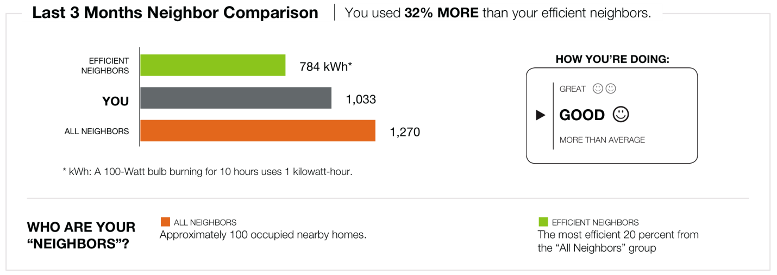

Second, customers receive individually targeted savings tips based on their energy usage patterns, housing characteristics, and demographics. Instead of presenting customers with a thick booklet of ideas on how to save energy, OPOWER presents customers with only several of the most relevant and immediately actionable suggestions on how to save. For example, OPOWER would not suggest that a renter insulate his apartment, but might recommend smart thermostats to owner-occupied homes with high heating bills.

Critical to OPOWER’s strategy is an “opt out” program design with an emphasis on mailed reporting. Mailed reports enable Missouri utilities to engage the majority of targeted customers and enable the delivery of large-scale energy savings. By using mail, behavior-based messaging reaches all demographic groups, including low income and elderly populations. This means that Missouri utilities can engage 85% of participants - far more than other efficiency measures.

This high participation rate means that small savings on a per household basis add up to significant savings in aggregate. Moreover, behavior-based messaging increases participation in other utility programs. By motivating customers to act and enabling them with information, OPOWER has demonstrated a 15% impact on utility-sponsored efficiency programs.

Most importantly, these efficiency changes are generated cost effectively – on average, OPOWER’s program costs $.03/kWh saved. This means that by including Home Energy Reporting in its portfolio, Missouri utilities can generate significant, large-scale energy savings at very low cost.

- Behavior-based programs are proven to generate measureable and verifiable results.

OPOWER’s Home Energy Reporting program has been consistently effective in each deployment to date. Every utility with at least six months of results has achieved energy savings between 1.5% and 3.5%. These results have been consistent across electric and gas utilities, as well as in winter-peaking, summer-peaking, and mild climates.

Figure 1 shows the consistency of savings that utilities have achieved through OPOWER’s program:

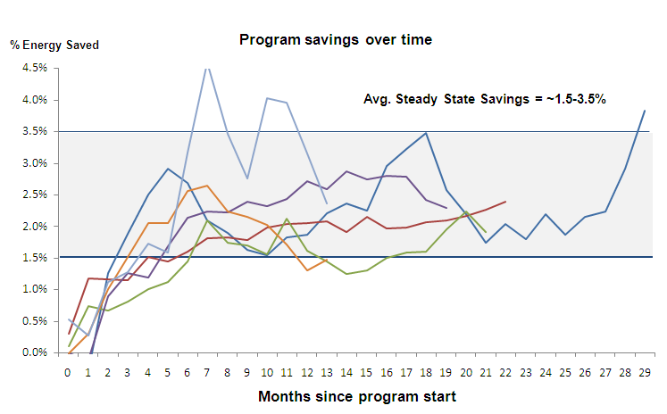
Figure 1: Results from OPOWER’s Home Energy Reporting Program

These results have been verified by several leading authorities in the field. Summit Blue, an industry leading evaluation firm, has verified OPOWER’s impact in Sacramento, California. Professor Ian Ayers, of Yale University, has verified OPOWER’s impact with in Washington State. Professor Hunt Allcott, of the Massachusetts Institute of Technology, has verified OPOWER’s savings with Connexus Energy in Minnesota. Moreover, Professor Allcott and Professor Sendhil Mullainathan, of Harvard University, published a discussion of OPOWER’s approach in Science. In each case, the studies have not only verified the results of OPOWER’s program, but have concluded that behavior-based programs are a simple and cost-effective source of energy savings.

- The results of OPOWER’s program can be accurately measured through experimental design

The results of OPOWER’s Home Energy Reporting are measured using a simple test and control methodology. By using test and control groups, OPOWER is able to isolate and cleanly evaluate the impact of its program.

For example, consider SMUD’s behavior-based program. Together with OPOWER, SMUD launched its behavior-based program to 35,000 homes, while maintaining a 50,000 home control group. The two groups were randomly selected and had no statistically significant difference in their energy consumption prior to deployment. Since deployment, the impact has been clear – over twenty months, behavior-based messaging has decreased consumption by 2.5% in the test group. Because the groups are, in the aggregate, identical—save for the fact that one group receives OPOWER’s reports while the other does not—the difference in energy savings may safely be attributed to OPOWER’s Home Energy Reporting.

This test and control methodology is explicitly endorsed in the California Evaluators Protocols and the guidelines for the National Action Plan for Energy Efficiency, which was jointly produced by the US Department of Energy and the Environmental Protection Agency.

Summit Blue. Impact Evaluation of OPOWER SMUD Study. September 2009. <http://www.opower.com/LinkClick.aspx?fileticket=naU7NN5-430%3d&tabid=72>. For more information on the OPOWER program, please see Appendix A.
In this context “net benefits” means monetary benefits to the consumer, or, in other words, how much consumers save on energy efficiency.
McKinsey and Company. Unlocking Energy Efficiency in the US Economy. Page 22
Summit Blue. Impact Evaluation of OPOWER SMUD Study. September 2009. <http://www.opower.com/LinkClick.aspx?fileticket=naU7NN5-430%3d&tabid=72>
Summit Blue. Impact Evaluation of OPOWER SMUD Study. September 2009. <http://www.opower.com/LinkClick.aspx?fileticket=naU7NN5-430%3d&tabid=72>
Ayres, Ian. Evidence from Two Large Field Experiments that Peer Comparison Feedback Can Reduce Residential Energy Usage. July 2009. Available online at: <http://papers.ssrn.com/sol3/papers.cfm?abstract_id=1434950>
Alcott, Hunt. Social Norms and Energy Conservation. February 2010. Availabe online at: <http://web.mit.edu/allcott/www/Allcott%202010%2020Social%20Norms%20and%20Energy%20Conservation.pdf>
Alcott, Hunt and and Sendhil Mullainathan. Behavior and Energy Policy. Science. March 2010. Available online at: <http://web.mit.edu/allcott/www/Allcott%20and%20Mullainathan%202010%20-%20Behavioral%20Science%20and%20Energy%20Policy.pdf>

