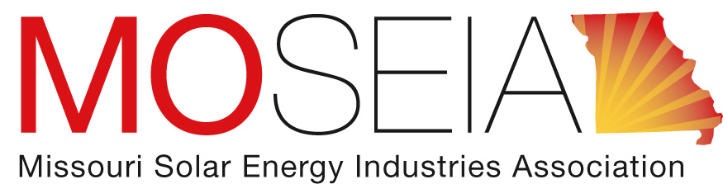

MOSEIA Comments
PSC Workshop Docket # EW-2017-0245
May 1, 2017

The Missouri Solar Energy Industries Association, founded in 2009, has a mission to expand the solar industry and establish a sustainable energy future for all Missourians. We are the Chamber of Commerce for Missouri’s solar industry with over 50 members throughout the state. We set standards for the companies that are part of our organization and make sure they are operating at their highest standards. MOSEIA is educating the industry throughout the state to ensure that solar installers understand how to build the highest quality and safest rooftop solar systems, and ensures that knowledge is put into use to ensure the industry maintains an excellent reputation.

Rooftop solar in Missouri is an overregulated industry. Existing safeguards related to size of each system, per year capacity growth, overall capacity limits per utility, monthly accounting of kWh credits as opposed to annual, and safety and design of systems make it difficult for small businesses to expand into a market that has seen growth in other states.

In relation to larger, more mature markets around the country, the net metering statute and especially permitting across the state are some of the more restrictive regulations in existence. When our MOSEIA members were surveyed multiple times over the past few years they have expressed that Missouri would see a sizable market entry point for projects that are over 100kW. Companies like General Motors, Wal-Mart, and Target have set renewable energy standards and want to see more access to this market in Missouri to meet their needs. Changing our policies so that these companies could meet their clean energy goals would likely result in more economic growth in the state, as Missouri would be signaling that it is looking to attract their business.

With regulation of the solar industry right-sized to the actual risk, the industry could grow at a much faster pace, which would have several positive impacts on the state. Those benefits include but are not limited to: More Missourians employed with family-supporting jobs, more Missourians saving money on their monthly utility bills, alleviated stress on aging electrical infrastructure, and alleviated capacity needs for Missouri utilities.

There are currently 161MW of solar installed in Missouri. That is the equivalent to 352,590 MWhs of energy, far less than 1% of the overall sales of electricity in the state. Comparatively, the utilities in Missouri have invested tens of millions of dollars in their efficiency programs, which has helped them save significantly more energy than distributed solar has produced in the state. From the perspective of the solar industry, it doesn’t appear that solar has much to do with lost revenue to the utilities. An inefficient transmission and distributive grid is the real culprit, and there is already broad-based agreement that the system-wide gains of those added efficiencies far outstrip the cost of the programs. MOSEIA believes that focusing on these items rather than looking to the negligible impacts of distributed solar would help utilities deal with their fixed cost issues.

Even with only 161 installed MWs of capacity, distributed solar, operating in its limited legal parameters, has had a fundamentally positive impact on Missouri’s energy economy. We’d be happy to help design more nuanced studies for how DG impacts the grid in positive ways. These studies should take into account costs and benefits, which include but aren’t limited to avoided capacity investments, environmental mitigation costs, etc. The solar industry is happy to continue to work with the electric utility sector to ensure that Missouri has a prosperous economic framework which can be leveraged to attract more businesses and jobs to the state.

Solar and electric vehicles have shown the potential to work very well together, and MOSEIA sees a positive future for this partnership in Missouri. EV market penetration provides a once-in-a-generation opportunity for utilities to grow load. Such an opportunity hasn’t occurred since the ubiquity of air conditioning. The key to growing both solar and EVs together is tailored rate design which sends appropriate signals to consumers. Many people will be slow charging their EVs while they’re at work, which is often when solar production is at its peak. TOU (time of use) charges could encourage solar and EV daytime charging, allowing for more system-wide efficiencies. Solar could help mitigate the demand that growing EV penetration would have on the market. Without DG, such a potentially massive growth of load would require major upgrades to utility distribution systems, which would add costs that get passed on to the consumers. DG offers a public/private partnership to help mitigate those additional costs.

The enabling statute for PACE in Missouri under (HB 1692) as it amended parts 67.2800 through 67.2835 of the Missouri Revised Statute, already cedes the authority for regulatory oversight within the Environmental Improvement and Energy Resource Authority (EIERA) as established under Section 260.010. Furthermore – PACE is a financing vehicle appropriately subject to oversight by the local jurisdictions and the energy districts under which they are enabled by state law and local ordinance or resolution. PACE has proven itself to be an excellent financing tool for enabling clean energy investments in the state. As it is a financing tool and has little or nothing to do with the public infrastructure of the transmission and distributive grid, or investor owned utilities, MOSEIA believes that the PSC should not be involved with PACE.

Rate design is one of the key areas to easing implementation of new technologies into the electrical market in Missouri. The foremost goal is to help send the proper signals to Missouri consumers about the actual costs of energy so the market can react appropriately. TOU rates would allow the solar industry to help design systems that are geared more towards mitigating peak load. Many MOSEIA companies also offer efficiency upgrades, and IBR (inverse block rates) would send the proper signal to help propel this market as well.

MOSEIA is enthusiastic about working with the PSC and utilities to make sure the solar industry and Missouri’s economy continue to grow together. If the PSC Commission or Staff have any questions please contact MOSEIA’s Executive Director, Zachary Wyatt-Gomez at zach@moseia.com

