Exhibit No.:
Issue: Expense Decommissioning
Witness: Lisa A. Kremer

Sponsoring Party: MoPSC Staff
Type of Exhibit: Rebuttal Testimony
Case No.: GR-2002-356
Date Testimony Prepared: August 2, 2002

MISSOURI PUBLIC SERVICE COMMISSION

UTILITY SERVICES DIVISION

REBUTTAL TESTIMONY

OF

LISA A. KREMER

LACLEDE GAS COMPANY

CASE NO. GR-2002-356

Jefferson City, Missouri

August 2002
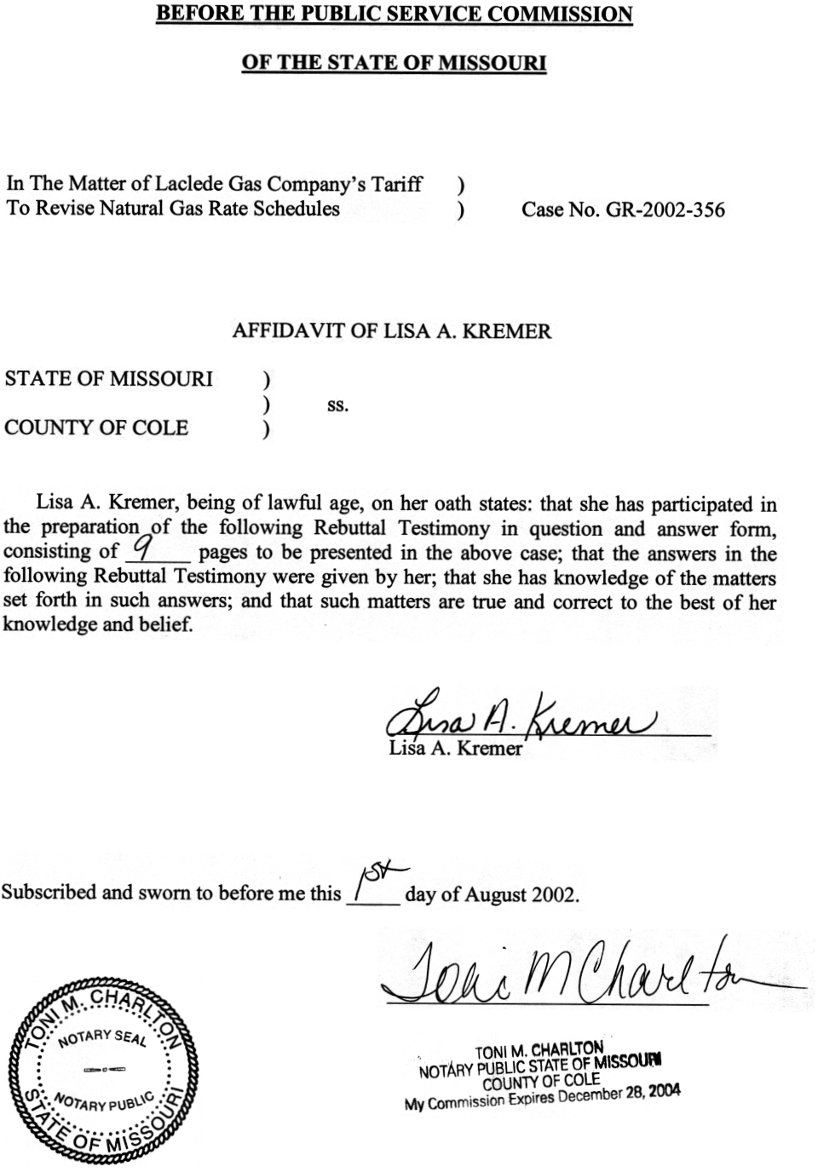
REBUTTAL TESTIMONY
OF
LISA A. KREMER
LACLEDE GAS COMPANY
CASE NO. GR-2002-356
Q. Please state your name and business address.
A. Lisa A. Kremer, P.O. Box 360, Jefferson City, Missouri 65102.
Q. By whom are you employed and in what capacity?
A. I am the Manager of the Engineering and Management Services Department with the Missouri Public Service Commission (Commission or MoPSC).
Q. Describe your educational and professional background.
A. I graduated from Lincoln University in Jefferson City, Missouri in 1983 with a Bachelor of Science degree in Public Administration, and in 1989 with a Masters degree in Business Administration. I successfully passed the Certified Internal Auditor examination in 1997.
I have been employed for approximately 15 years by the Commission in the Management Services Department as a Management Services Specialist, except for a
four-month period when I was employed by the Missouri Department of Transportation. The Management Services Department was combined with the Commission’s Depreciation Department in February 2000 and the newly combined Department was named Engineering and Management Services. I assumed my current position at the time the departments were combined. Prior to working for the Commission, I was employed by Lincoln University for approximately two and one-half years as an Institutional Researcher.
Q. What is the purpose of your rebuttal testimony in this case?
A. The purpose of my testimony is to respond to the Direct Testimony of Laclede Gas Company (Laclede or Company) witnesses Craig R. Hoeferlin and R. Lawrence Sherwin in Case No. GR-2002-356 regarding removal of the Company’s gas holders. Specifically, my testimony will address managerial considerations that should be evaluated by the Company in determining whether or not and when to remove the Company’s four gas holders. My testimony will also address the importance of the performance of cost/benefit or economic analyses in making complex and costly managerial decisions for projects of this magnitude. My testimony will further indicate that, as of this writing, the Company has not demonstrated that there is an incontrovertible need to remove the gas holders and that it has not presented an economic or cost/benefit analysis that supports its decision for removal.
Q. Will other Commission Staff (Staff) address the Company’s gas holders in this proceeding?
A. Yes. Staff witness Rosella L. Schad, PE, will address engineering and depreciation issues associated with the Company’s gas holders as well as their final removal costs.
Q. What is a gas holder?
A. Company witness Hoeferlin described gas holders, on page 7 of his Direct Testimony, as “large, above-ground steel tanks that store natural gas for use by Laclede’s customers.”
Q. Is the present rate proceeding the first time the removal of the gas holders has been addressed before the Commission?
A. No. Discussions concerning the Company’s four gas holders and their removal have taken place for many years and were addressed in other Company rate proceedings including: Case Nos. GR-99-315, GR-96-193 and GR-94-220.
Q. Briefly describe the context of past testimony presented by the Company and by Staff regarding the removal of the Company’s gas holders.
A. The primary points addressed by the Company and Staff in previous cases have included: 1) the time at which the gas holders would be dismantled, 2) the costs of their removal and 3) when such recovery of costs will occur.
Q. Has the Company expressed its intention to remove the gas holders in the present case?
A. Yes. On page 7, line 21 of Company witness Hoeferlin’s Direct Testimony, he states:
Q. Is Laclede now committed to the decommissioning and removal of these holders?

A. Yes. Laclede has concluded that it is prudent to commence removal of the gas holders in the near future.
Mr. Hoeferlin further indicated support for the Company’s decision to remove the holders by the following comments found on pages 8, line 22 through page 9, line 6, of his Direct Testimony. He states:
A. . . . The gas holders continued to provide an economical means to inject appreciable volumes of gas into the core of the distribution system at times of peak load.

Q. Do they no longer serve this function?

A. They are still capable of serving this function, but over the years our reliance on the gas holders for periodic peak shaving has been reduced, and this trend will continue.
Q. Did Mr. Hoeferlin provide further explanation of the Company’s decision to remove the gas holders?
A. Yes. In his Direct Testimony, on page 9, beginning on line 19, Mr. Hoeferlin states the following:
Q. Are there other factors involved in Laclede’s decision to accelerate removal of the gas holders?

A. Yes. There are several other considerations involved. Due to their reduced frequency of usage, the expense to man and maintain the gas holders has begun to exceed the value of any system benefits. Also, in most situations it would not be economically feasible to replace or repair a major component of a gas holder or appurtenant equipment in the event of failure. In considerations of the age of these structures, Laclede believes it prudent to begin planned removal rather than risk waiting until such a failure is imminent or has already occurred. Furthermore, some of the gas holders are located near residential areas and there is growing public sentiment to eliminate them for aesthetic reasons.
Mr. Hoeferlin’s Direct Testimony further stated that the Company’s current estimate to fully decommission the gas holders would be $5.13 million.
Q. As quoted previously, Mr. Hoeferlin indicated that the “Company has determined it is prudent to commence with the removal of the gas holders.” Do the factors presented by Mr. Hoeferlin above provide conclusive evidence that removal of the gas holders is prudent and cost-effective?
A. Prudent is defined by The American Heritage Dictionary as “managing carefully and with economy.” While the Company has identified several significant factors that should be considered in its analysis and decision to remove the gas holders, these factors alone do not provide conclusive evidence that removal of the gas holders is a prudent management decision at this time. Mr. Hoeferlin’s Direct Testimony included a listing of items of concern to the Company should the gas holders remain standing; however, the Company has not presented an economic or cost/benefit analysis which indicates that the Company’s decision to remove the holders is cost-justified.
Q. Has the Company demonstrated that an incontrovertible need exists to remove the gas holders?
A. The Company has not presently demonstrated that there is an imminent or unquestionable need to remove the holders. Further, to Staff’s knowledge, the Company has not indicated that by leaving the holders in place, the general public, its customers or the Company’s gas distribution system is being harmed or that the Company is in violation of any federal or state regulations.
Q. What other analysis or criteria should Company management consider in its decision to dismantle the gas holders?
A. The Company should perform a cost/benefit or economic analysis study. Such analysis should include the actual costs that would be incurred to retire the gas holders in place as compared with the costs to remove them. Such a study should also evaluate
non-quantifiable criteria as well. The analysis should also examine associated risks for all alternatives, including leaving the holders standing or removing them, as well as any detriment to the Company’s customers or to the general public for each alternative.
Q. Should the Company prepare a cost/benefit analysis primarily for the purpose of justifying such projects to regulatory entities?
A. No. Such analysis is a management tool that should enable the Company to more effectively determine and evaluate the actual costs and benefits of given alternatives related to the disposition of $3 million of assets. The Company should require the performance of such studies to assure Company management, its customers, Staff, and shareholders that it is taking the most appropriate course of action.
Q. The Company has indicated in direct testimony that public sentiment is growing to remove the holders because they are aesthetically displeasing. Has the Company provided evidence to support its statement?
A. No, the Company has not provided Staff any documentation regarding concerns expressed by the public. Staff has contacted various departments of the Commission to determine if any Staff member has received complaints regarding the holders; but as of this time no complaints have been reported.
While the Company indicates that some citizens have voiced concerns regarding the appearance of the gas holders, these concerns must be weighed against the costs of removal as compared with other alternatives, such as leaving the gas holders in place.
Q. The Direct Testimony of R. Lawrence Sherwin, on page 7, line 5, states, “the Company proposes to amortize the $5,130,400 over a five-year period, commencing with the effectiveness of gas rates resulting from this rate case.” Mr. Sherwin also indicated on page 6, line 24, of his Direct Testimony that this proposed amortization is consistent with Staff witness Paul Adam’s position in a previous proceeding that “removal costs of major facilities such as these should be recovered through an amortization process at the end of the life of the facility, rather than through the inclusion in depreciation over the life of the property.” Did Staff witness Adam also specify criteria that the Company would need to meet prior to the Staff’s support of an amortization?
A. Yes. The Staff has indicated in previous testimony filings that the Company must satisfy two criteria before an amortization is activated for the removal of the gas holders.
Q. What are those two criteria?
A. 1. Removal of the gas holders must be imminent.
2: Verifiable evidence as to the removal must be presented.
(Direct Testimony in case GR-99-315, Staff witness Adam, page 14, lines 4 through 8).
Q. Has the Company met these criteria?
A. The Company has not demonstrated that the removal of the gas holders is imminent and has not provided verifiable evidence that the holders will be removed. In this proceeding, it is the Staff’s position that the Company should perform and document an analysis to determine whether or not removal is the most cost-effective and justified course of action for the gas holders.
Q. Has the Company demonstrated that removal of the gas holders is imminent?
A. The Company has not produced any documentation that removal is imminent. Staff is using the term imminent to mean “likely to happen without delay” as defined by The American Heritage Dictionary. The removal of gas holders has been addressed in several past Laclede cases, however, Staff presently has no additional evidence that removal is likely to begin soon.
Q. Has the Company provided verifiable evidence that the gas holders will actually be removed?
A. The Company has not presented verifiable evidence that the gas holders will be removed. Staff does have a one-page “Gas Holder Remediation/Demolition” schedule, (presented as Schedule 1 to this testimony) dated June 7, 2002 that was prepared by the Company.
Q. What does the “Gas Holder Remediation/Demolition” schedule contain?
A. The schedule contains three columns that present the ‘Project Activity’, ‘Schedule’, and ‘Cost’.
Q. Has the Company progressed in the removal of its gas holders?
A. The Company has provided no evidence that it has progressed in the removal of its gas holders. During the prehearing conference of this case, the Staff requested and has not yet received verifiable information that the Company has indeed progressed in this project. Therefore, the Staff is presently not assured that the Company intends to remove the gas holders, absent ratepayers being required to fund the dismantling expense in advance of the work being performed.
Q. Has the Company provided any other documentation regarding the removal of the gas holders?
A. No. The Company has not provided draft or final RFPs (Request for Proposals), bid documentation or contractual agreements with any contractor for removal of the gas holders. All of these items would be required to be completed before Staff would agree that the removal of the gas holders was imminent.
Q. What would the Company need to do to demonstrate that it has made a prudent management decision to remove these gas holders?
A. The Staff recommends that the Company:
1. Perform a documented analysis that supports the Company’s decisions to retire and dismantle the gas holders versus other options including retiring the structures in place.
2. Develop and issue an RFP and evaluate responses to determine actual costs to dismantle.
3. Revisit Item 1 if the actual costs to dismantle significantly exceed the estimate used to support a dismantling decision.
Q. Does this conclude your rebuttal testimony?
A. Yes, it does.

The American Heritage Dictionary (2nd C. ed. 1976)
Id.

