Exhibit Number: | ________
Issues: | 1) Overview of Staff Testimony
 | 2) Staff Recommendations
 | 3) Rate Design
Witness Name: | Dale W. Johansen
Type of Exhibit: | Direct Testimony
Sponsoring Party: | MoPSC Staff
Case Number: | ST-2003-0562 and  WT-2003-0563  (Consolidated)
Date Testimony Prepared: | December 19, 2003

Missouri Public Service Commission

Utility Operations Division

Water & Sewer Department

Direct Testimony

of

Dale W. Johansen

Case No. ST-2003-0562 and WT-2003-0563
(Consolidated)

Osage Water Company

Jefferson City, Missouri
December 2003

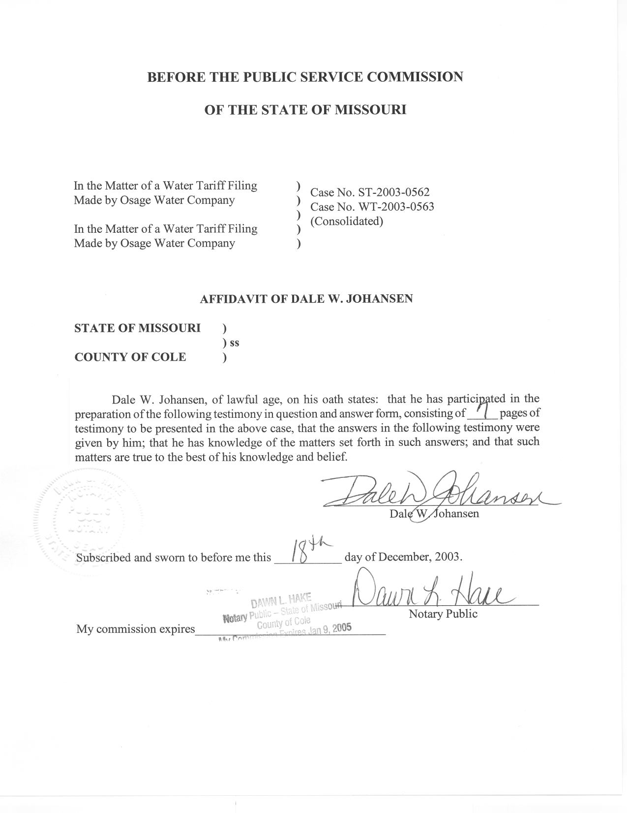
Table of Contents for the Direct
Testimony of Dale W. Johansen

Case No. ST-2003-0562 and WT-2003-0563
(Consolidated)
Osage Water Company
Introduction 1
Involvement in This Case 2
Purpose of Testimony 2
Overview of Staff's Direct Testimony 2
Special Recommendations on the Rate Increase Requests 3
Design of the Company's Rates 5

Direct Testimony
of
Dale W. Johansen
Case No. ST-2003-0562 and WT-2003-0563
(consolidated)
Osage Water Company

Introduction
Q. Please state your name and business mailing address.
A. Dale W. Johansen, P.O. Box 360, Jefferson City, Missouri 65102.
Q. By whom are you employed and in what capacity?
A. I work for the Missouri Public Service Commission (Commission) and my position at the Commission is Manager of the Water & Sewer Department (W/S Dept) in the Utility Operations Division.
Q. Please briefly describe your job responsibilities.
A. My responsibilities include general administrative and supervisory duties for the overall operation of the W/S Dept, and direct participation in water and sewer utility cases before the Commission regarding both technical and policy matters.
Q. What are your educational and work experience backgrounds?
A. Please refer to Schedule DWJ – 1 attached to this testimony for a summary of my education and work experience backgrounds.
Q. Have you previously testified before this Commission?
A. Yes, I have, on numerous occasions.

Involvement in This Case
Q. What has been the nature of your involvement in this case?
A. I have acted as a co-case coordinator for the Staff's investigation of the rate increase request that Osage Water Company (OWC or Company) filed to initiate this case and a companion water rate case, Case No. WT-2003-0563, which has been consolidated with this case. In that function I have reviewed all of the Staff testimony being filed in the case and have participated in the development of the Staff recommendations that are being presented in the Staff's direct testimony. I have also participated in the Staff's investigation of the Company's request regarding the matters of the design of the Company's rates and the determination of the Company's rate base being used by the Staff in its revenue requirement calculations.

Purpose of Testimony
Q. What is the purpose of this pre-filed direct testimony you are presenting in this case?
A. I will be presenting a general overview of the Staff direct testimony being filed in this case, and will also be presenting certain special Staff recommendations on OWC’s rate increase requests. Additionally, I will be presenting testimony on the design of the Company's sewer and water rates.

Overview of Staff's Direct Testimony
Q. In addition to you, what other Staff members are filing direct testimony in this case and what issues are they addressing?
A. The following Staff members are also presenting testimony in this case.
Martin Hummel of the Water & Sewer Department is presenting testimony regarding quality of service and system operation related matters.

Greg Meyer of the Auditing Department is presenting testimony on various accounting related issues, including several issues pertaining to the rate base that is being used in the Staff’s revenue requirement calculations.

Janis Fischer of the Auditing Department is presenting testimony on various accounting related issues and is also sponsoring the Staff's accounting schedules.

Dana Eaves of the Auditing Department is presenting testimony on various accounting related issues.

Greg Macias of the Engineering & Management Services Department is presenting testimony regarding the appropriate depreciation rates to be established for OWC.

David Murray of the Financial Analysis Department is presenting testimony on the appropriate rate of return to be allowed for OWC.

Special Recommendations on the Rate Increase Requests
Q. In addition to the issue-specific recommendations that are inherent in the direct testimony of each Staff witness, and in the Staff’s accounting schedules, does the Staff have any general recommendations regarding OWC's rate increase requests?
A. Yes, it does. In particular, the Staff does not believe that the Commission should grant OWC permanent rate increases at this time, if it grants any increases at all. Instead, the Staff believes that the Commission should make any rate increases that it may grant to OWC interim subject to refund pending the Company's compliance with certain conditions related to improvements in the Company's water and sewer systems and in the operation of those systems. Additionally, the Staff believes that any rate increases that the Commission may grant OWC should be interim subject to refund pending the Company becoming current on the filing of its Commission annual reports and on the payment of its Commission assessments.
Q. Has the Commission previously taken actions consistent with the Staff’s recommendation that any rate increases granted should be made interim subject to refund?
A. Yes, it has. It did this in OWC’s last water service rate case, Case No. WR-2000-557.
Q. Regarding improvements in the Company's water and sewer systems and in the operation of those systems, what conditions does the Staff believe should be met before any rate increases that the Commission may grant OWC become permanent?
A. There are several such items discussed in the testimony of Staff witness Martin L. Hummel and also one discussed in the testimony of Staff witness Janis Fischer. As an example of the types of matters that OWC needs to address, Ms. Fischer notes in her testimony that many of the customers in the Company’s Eagle Woods service area are not currently metered. Because of this, it is difficult for the Staff to properly analyze the Company’s water sales and Ms. Fischer thus recommends that the Company install meters for all customers.
Q. Please summarize OWC's delinquencies regarding its annual report filings and assessments payments.
A. In a review of electronic records maintained by the Commission’s Data Center, I found that OWC has not filed its Commission annual reports for calendar years (CY) 2000 or 2001. Also, in a search of the Commission’s Electronic Filing & Information System annual report database, I found that the Company has not filed its Commission annual report for CY2002. Additionally, by an order issued on April 18, 2002 in Case No. WE-2002-240, the Commission ordered OWC to update its CY1999 annual report to correct identified deficiencies in that report, but the Company has not yet done so.
In a review of available electronic records maintained by the Commission’s Administration Division, I found the following assessment delinquencies:
Fiscal Year 1998 – Water -- $86.13 unpaid
Fiscal Year 2003 – Water -- $374.44 unpaid
Fiscal Year 2003 – Sewer -- $3,282.90 unpaid
Fiscal Year 2004 – Water -- $527.58 unpaid
Fiscal Year 2004 – Sewer -- $4,967.21 unpaid

Design of the Company's Rates
Q. What is the Staff's position regarding the design of the Company's rates?
A. Generally speaking, the Staff does not believe that any major changes are needed in the manner in which the Company's currently effective rates were designed at the time of its last rate case. For example, the Staff believes that the continued inclusion of an assumed usage of 2,000 gallons of water per month per customer is appropriate for calculating the Company's monthly minimum water service customer charge and the commodity rate for water service. Likewise, the Staff does not believe that any major changes are needed in the cost allocations used in determining what cost-of-service components should be recovered through the customer charge and the commodity charge, respectively. Additionally, the Staff believes that the Company's sewer rates should continue to be a flat monthly charge.
Q. Is your recommended rate design for water service consistent with OWC's proposed rate design for water service?
A. No, it is not. OWC's proposal is that only its minimum monthly charges be increased to recover the revenue increase it is seeking in this case, with no changes proposed in the commodity rate. Comparatively, the rate design approach that I am using will affect both the minimum monthly charge and the commodity rate.
Q. Is your recommended rate design for sewer service consistent with OWC's proposed rate design for sewer service?
A. Yes, it is. The Company and I are both proposing a flat monthly charge for sewer service, and the only differences in the actual rates will therefore only be reflective of the differences between the Company's and the Staff's cost-of-service to be recovered by those rates.
Q. Are you including any rate design schedules with this testimony?
A. No, I am not.
Q. Why not?
A. The revenue requirements calculated by the Staff, and presented in the Staff’s accounting schedules, indicate that relatively minor revenue decreases are needed in the annual revenues for both OWC’s sewer service and water service. However, the indicated decreases are not significant enough to warrant the Staff seeking a rate reduction as a part of this consolidated proceeding. As a result, the Staff is not recommending any changes in the Company’s current rates.
I am, however, preparing illustrative rate design schedules that will show what the rates would be under the Staff’s proposed rate design and revenue decreases, and will be providing those to OWC and the Office of the Public Counsel (OPC), hopefully before the end-of-business on December 23, 2003. At the time the Staff provides those schedules to OWC and the OPC, it will also file a motion for leave to file late-filed exhibits so that the schedules can be made a part of the record in this consolidated proceeding.
Q. Do you expect that the rates you are developing will differ significantly from the Company’s rates that are currently in effect?
A. Because the Staff’s recommended revenue requirements would result in only relatively minor changes to the Company’s current annual revenues, I do not expect that the rates themselves would change significantly either. This is particularly true since I am using the same rate design approach now as was used to design the current rates.
Q. Does this conclude your pre-filed direct testimony?
A. Yes, it does. However, as noted above, the Staff will be submitting late-filed exhibits consisting of my illustrative rate design schedules at the time that it presents those schedules to OWC and the OPC.

Education & Work Experience
Summary of Dale W. Johansen

College Education

Associate of Arts in Pre-Engineering Studies
State Fair Community College – Sedalia, Missouri

Bachelor of Science in Agricultural Engineering
School of Engineering – University of Missouri @ Columbia

Regulatory/Utility Work Experience

Missouri Public Service Commission
Manager – Water & Sewer Department
Utility Operations Division
June 1995 to Present

Johansen Consulting Services
Utility & Regulatory Consultant
February 1994 to June 1995

Missouri One Call System, Inc.
Executive Director
January 1992 to February 1994

Missouri Public Service Commission
(service prior to current position)

Director – Utility Services Division
November 1990 to January 1992

Case Coordinator – Utility Division
November 1987 to November 1990

Assistant Manager – Engineering
Gas Department – Utility Division
October 1980 to November 1987

Gas Safety Engineer
Gas Department – Utility Division
May 1979 to October 1980

