BEFORE THE PUBLIC SERVICE COMMISSION
OF THE STATE OF MISSOURI

In the Matter of the Application of )
Kansas City Power & Light Company )
For Approval to Make Certain Changes ) Case No. ER-2006-0314
in its Charges for Electric Service to )
Begin the Implementation of Its )
Regulatory Plan )

APPLICATION TO INTERVENE
OF THE MISSOURI INDUSTRIAL ENERGY CONSUMERS

Comes now the Missouri Industrial Energy Consumers and, pursuant to 4 C.S.R. 240-2.075, and the Commission’s February 3, 2006 Order in this Proceeding, files its Application to Intervene.. For its Application, the Missouri Industrial Energy Consumers states as follows:
- The Missouri Industrial Energy Consumers is a Missouri corporation and is a group of large industrial energy consumers, including customers of Kansas City Power & Light Company (“KCPL”).
- The Commission’s decision in this case regarding Kansas City Power & Light Company’s Application will impact the rates and services of MIEC members served by KCPL.
- As large industrial customers of KCPL, the MIEC’s interest in this case is different than that of the general public.
- The MIEC is unsure of the position that it will take in this case, but reserves the right to take positions on the issues as this case proceeds.
- The MIEC’s intervention will serve the public interest by assisting the record for the Commission’s decision in this case.
WHEREFORE, the MIEC respectfully requests that it be permitted to intervene, and that it be made a party to this case for all purposes.

Respectfully submitted,

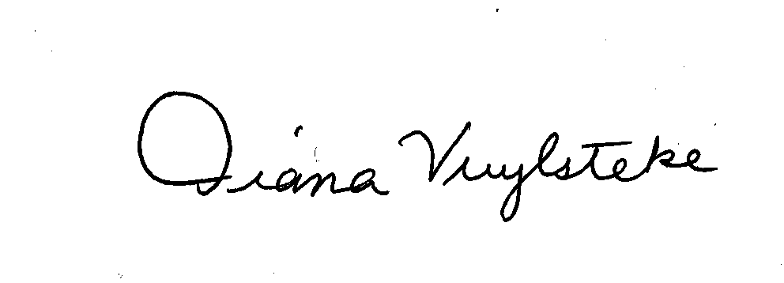
BRYAN CAVE, LLP

By:______________________
Diana M. Vuylsteke, # 42419
211 N. Broadway, Suite 3600
St. Louis, Missouri 63102
Telephone: (314) 259-2543
Facsimile: (314) 259-2020
E-mail: dmvuylsteke@bryancave.com

Attorney for The Missouri Industrial Energy Consumers

CERTIFICATE OF SERVICE

I do hereby certify that a true and correct copy of the foregoing document has been hand-delivered, transmitted by e-mail or mailed, First Class, postage prepaid, this 23rd day of February, 2006, to all parties on the Commission’s service list in this case.

______________________________________________

