Exhibit No.:
Issues: Purchasing Practices-Neelyville District; Purchasing Practices-Consolidated District;

Witness: Anne M. Allee
Sponsoring Party: MoPSC Staff
Type of Exhibit: Rebuttal Testimony
Case Nos.: GR-2001-396 and GR-2001-397 (Consolidated)
Date Testimony Prepared: February 28, 2003

MISSOURI PUBLIC SERVICE COMMISSION

UTILITY SERVICES DIVISION

REBUTTAL TESTIMONY

OF

ANNE M. ALLEE

ATMOS ENERGY CORPORATION
CASE NO. GR-2001-396

AND

UNITED CITIES GAS COMPANY
CASE NO. GR-2001-397

(CONSOLIDATED)

Jefferson City, Missouri
February 2003
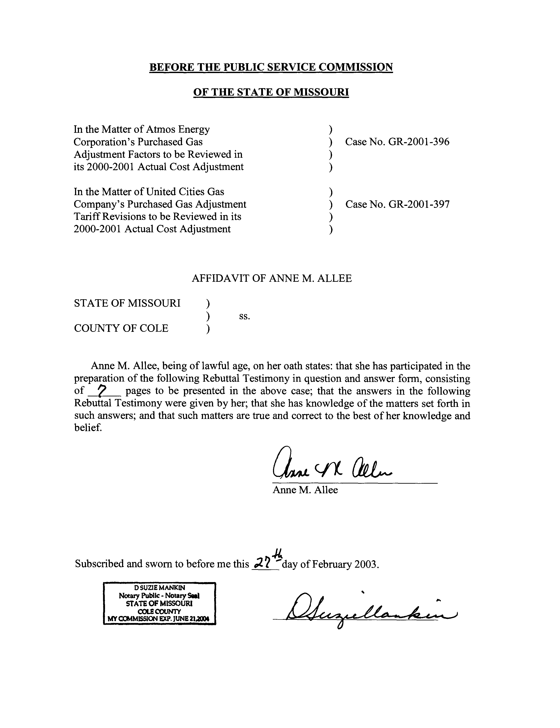

REBUTTAL TESTIMONY
OF
ANNE M. ALLEE
ATMOS ENERGY CORPORATION
CASE NO. GR-2001-396
AND
UNITED CITIES GAS COMPANY
CASE NO. GR-2001-397
(CONSOLIDATED)
- Please state your name and business address.
- Anne M. Allee, P.O. Box 360, Jefferson City, Missouri 65102.
- Are you the same Anne M. Allee that filed direct testimony in this case?
- Yes.
- What is the purpose of your rebuttal testimony?
- The purpose of my testimony is to address the direct testimony of Atmos Energy witness, John Hack. I will address the direct testimony related to United Cities Gas Company in Case GR-2001-397 in regard to the purchasing practices for the Neelyville and Consolidated Districts.
Q. In describing his understanding of the Staff’s recommendations regarding United Cities’ purchasing practices, Mr. Hack states on page 7, lines 12-15 of his direct testimony, “The Staff believes 30% of normal requirements, as a minimum level of hedging for each month during the period of November 2000 through March 2001, is reasonable and that financial hedges are appropriate vehicles.” Do you agree with Mr. Hack’s understanding of the Staff’s recommendations?
A. Yes. However, I would add that the Staff is not claiming that financial hedges are the only appropriate vehicles that can be used to hedge a Company’s price risk. The Staff considered all types of hedges the Company had in place for the winter of 2000/2001. For the Neelyville District, the Company’s hedged volumes of natural gas consisted of storage. For the Consolidated District, the Company’s hedged volumes of natural gas consisted of storage and fixed price purchases.
Q. Please comment on Mr. Hack’s statement (Hack direct, page 8, line 13) that the use of financial instruments is presumed by the Staff.
A. In order to calculate the increased cost of natural gas to the customers of United Cities as a result of the Company’s failure to hedge at least 30% of normal monthly requirements, the Staff uses an average of the NYMEX closing prices to estimate a reasonable price at which the Company could have hedged using either fixed price forward contracts or futures contracts.
Q. Mr. Hack states (Hack direct, page 12, lines 1-4) that, “Based upon the information that was available at the time the purchasing decisions were being made for the winter of 2000-2001, there was no reason to expect that extraordinary measures needed to be taken to protect the Company’s customers from price volatility.” Do you consider an LDC hedging its price risk to be “extraordinary measures”?
A. No. I would expect a hedging or risk management plan to be included as a routine element of a Company’s gas supply portfolio planning. It is the Company’s responsibility to develop a gas supply pricing structure that provides some level of price protection for its customers.
Q. Mr. Hack states (Hack direct, p. 12, lines 6-8) that, “This [price] volatility was not anticipated by the Company or the rest of the natural gas industry, prior to the winter heating season of 2000-2001.” Do you believe that the Company should have been aware of the volatility of natural gas prices?
A. Yes. As Staff witness Lesa A. Jenkins discusses in her rebuttal testimony, natural gas prices are volatile and most in the industry were well aware of this long before the heating season of 2000/2001. Staff witness Jenkins has attached to her rebuttal testimony Schedule 1, which depicts the change in level of spot prices from January 1991 through May 2001.
Q. On page 14, lines 10-12, Mr. Hack refers to a survey conducted by The National Association of Regulatory Utility Commissioners that, “[I]ndicated that most states allow, but do not require, the use of hedging with financial instruments by gas utilities.” Is the Staff requiring that the Company use financial instruments to hedge?
A. No. It is the Company’s responsibility to determine the types of hedging instruments that are most suitable. The Staff accepted the storage withdrawals and the fixed price purchases as hedges utilized by the Company during the winter of 2000/2001.
Q. On page 18, lines 1-14 of his direct testimony, Mr. Hack indicated that the Staff is suggesting that it was imprudent for the Company to utilize only index pricing contracts to purchase its Neelyville supplies. Please discuss.
A. Staff evaluated the requests for proposal that United Cities sent to marketers and producers requesting bids for firm gas supply for Neelyville with a term of April 1, 2000 through March 31,2001. United Cities requested that prices be quoted on an index basis. In the Staff’s opinion, the Company should have at least attempted to obtain a variety of pricing structures and not limit the bids to index based prices.
Q. On page 19, lines 11-13, Mr. Hack states that, “[T]he Company was unaware of any surveys or of guidance from the Staff or the Commission regarding their desire for price risk management for its Missouri customers.” Did the Staff provide guidance to the Company regarding its desire for price risk?
A. Yes. The Staff ACA recommendation filed September 30, 1998 in Case
GR-97-259 (attached as Schedule 1) contains a section entitled Hedging that states:
The Staff, as part of its ACA audit, reviewed the Company’s gas supply purchasing practices. In this ACA period, the Company entered into contracts for supply that were based on spot market indices. Spot market index prices have no upper limit. Thus, the Staff encourages United Cities to continually review and evaluate pricing strategies that provide more pricing diversification, as opposed to the ratepayer being initially [at] risk for the market volatility associated with gas supply contracts which fluctuate with changes in the spot market indices.
The Staff also sponsored a natural gas roundtable, “Understanding and Managing Natural Gas Price Volatility,” on May 20, 1997 in St. Louis, MO. In this meeting Union Electric Company presented the results of its Commission- approved futures market pilot program.
Furthermore, Mr. David M. Sommerer, a member of the Missouri Public Service Commission Staff, called Mr. Hack in August 2000 to inquire about the Company’s upcoming winter price of its natural gas supply. Mr. Sommerer indicated that market based index pricing may not be a prudent decision.
Q. Has there been any other time that the Staff has shared its position on hedging with the Company?
A. Yes. Staff shared its position in Case No. GO-97-410. Mr. Michael J. Wallis states in his direct testimony in that case (page 3, lines19-22 and page 4, lines 1-5):
I strongly encourage UCGC [United Cities Gas Company] to use futures market instruments to hedge part of their gas supply portfolio, rather than rely totally on index based contracts. Index based gas supply contracts are completely at the mercy of the spot market and because they have no upper limit, the Missouri local distribution companies (LDC) could be forced to pay enormously high prices for natural gas. The LDCs should realize that index pricing is not a risk free proposition. If the index moves to unreasonable levels, and the LDC has not taken steps to mitigate the price fly-up, disallowances will likely be made. Even if the LDC uses storage for price moderation, measures should be taken to reduce the price risk of the flowing (non-storage withdrawal) gas supply. The LDC should also insure reasonable internal controls are in place for hedging.
Q. What was United Cities position on the use of financial instruments to hedge its gas supply portfolio in Case No. GO-97-410?
A. Untied Cities Gas Company witness, Ron McDowell, states in his rebuttal testimony on page 2, lines13-15, that,
The financial instruments that are traded on the gas futures market are strictly forbidden by our board of directors because of the perceived financial risk that is involved in speculation of gas prices. We can achieve the same results as actually trading futures, options, calls, or collars by using a marketer or producer to execute gas purchases based on these instruments without actually trading the financial instrument.
Q. What other guidance did the Staff provide to the Company in Case No.
GO-97-410?
A. Mr. Sommerer states (Sommerer surrebuttal, page 4, lines 16-21 and page 5, lines 1-2):
Q. Mr. McDowell indicates on page 4 of his rebuttal testimony that the Company needs clear rules on what will be considered prudent. What are your comments?
A. There should be consistency in the way index prices are evaluated versus hedged prices. In other words, index priced contracts can be viewed as taking a bet that the market will stay low. The Company should not have guarantees that no matter how high the spot market goes, the consequences will be borne by the customer. In the same way, a company should not set up a fixed price contract for all of its load without regard to what the market is doing. The goal should be a balanced and diversified portfolio that minimizes risks of excessive price increases while still allowing some significant participation in downward price swings.
Q. Mr. Hack’s statement (Hack direct, p. 18, lines12-14) that the, “Staff’s recommended purchasing practices standard is inappropriate and unreasonable, given circumstances and the available information at the time the Company made its purchasing decisions.” Do you agree with Mr. Hack’s statement?
A. No. Staff witness Jenkins discusses the volatility surrounding natural gas prices in her rebuttal testimony and, as I have demonstrated above, the Company should have been aware of the Staff’s desire for the Company to take some measures to hedge price risk.
Q. Do you agree with Mr. Hack statements, on pages 10, 20 and 21 lines 11-14, lines 4-22 and lines 1-2, respectively, that the proposed Neelyville hedging disallowance is unreasonable and inappropriate because it fails to consider the physical and administrative difficulties involved in hedging such a small load?
A. No. The Staff agrees that the Neelyville load is small and that it would not be realistic to purchase futures contracts solely for the Neelyville district. However, Atmos is much larger. Atmos Energy’s 2000 Annual Report states that it is the fifth largest pure natural gas utility in the nation and it serves approximately 1.4 million customers. It is logical for the Company to combine hedging opportunities of Neelyville with those of its other operations in order to take advantage of financial instruments. Storage is also another tool available to hedge price risk. Furthermore, Mr. Hack discusses (Hack direct, page 23, lines 14-22 and page 24, lines 1-2) the current hedging program, which allocates the costs and benefits to the various Atmos operating divisions in Missouri.
Q. On page 19, lines 14-23 and page 20, lines 1-2 of his direct testimony, Mr. Hack focuses on the January 2001 futures price of natural gas and the establishing price trends. What is the correct focus of a hedging or risk management plan?
A. The focus of a hedging or price risk management plan should be on pricing strategies available to diversify the market price risk and thereby reduce the customers’ price risk exposure.
Q. Does this conclude your rebuttal testimony?
A. Yes
