Exhibit No.:

Issues: Weather Normalization
Witness: Dennis Patterson
Sponsoring Party: MoPSC Staff
Type of Exhibit: Direct Testimony
Case No.: GR-2002-356
Date Testimony Prepared: June 20, 2002

MISSOURI PUBLIC SERVICE COMMISSION

UTILITY OPERATIONS DIVISION

direct TESTIMONY

OF

DENNIS PATTERSON

LACLEDE GAS COMPANY

CASE NO. GR-2002-356

Jefferson City, Missouri
June, 2002

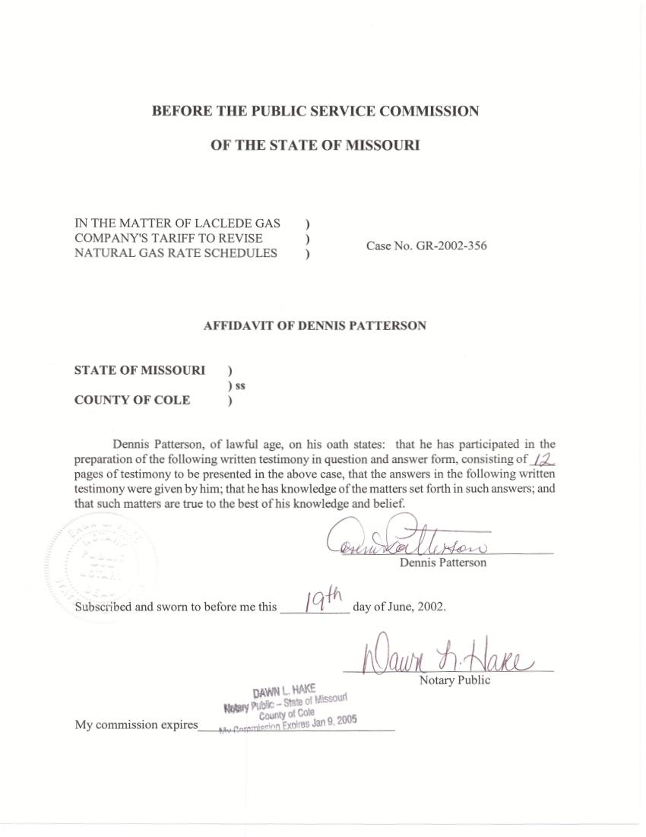

TABLE OF CONTENTS

Summary 1
Organization 6
Water Heating Degree-Days 6
Normal Weather 9

DIRECT TESTIMONY
OF
DENNIS PATTERSON
LACLEDE GAS COMPANY
CASE NO. GR-2002-356

Q. Please state your name and business address.
A. My name is Dennis Patterson and my business address is Missouri Public Service Commission, P. O. Box 360, Jefferson City, MO 65102.
Q. What is your present position with the Missouri Public Service Commission (Commission)?
A. I am a Regulatory Economist in the Energy Department of the Utility Operations Division.
Q. Please review your educational background and work experience.
A. I was trained as an officer and aviator in the U.S. Army. I studied economics, math, sciences and languages at the University of Missouri, receiving an M.S. in Agricultural Economics (1989) and a B.A. in Latin American Studies (1983). I joined the Staff of the Commission in 1986. I established the Staff's centralized weather data base, and have continued to maintain and improve it by employing data and methods from reliable sources. I have been employed by the Commission, the Missouri Army National Guard, the University of Missouri, the U.S. Army Reserves, and the U.S. Army.

Summary
Q. Please summarize the issues, position, method, process and products that you describe in your direct testimony.
A. The issues I address are the temperature variables used by other Staff for the weather normalized gas sales for Laclede Gas Company (LGC) in the current rate case. Staff’s position is that a thirty-year history of consistent heating degree-days (HDD) from the St. Louis International Airport weather station (STL) should be used for weather normalization in the present rate case. The Staff’s weather data products are based on information from the National Oceanic and Atmospheric Administration (NOAA), and include actual and normal HDD at STL for every day in the test year (the billing year that ends on November 30, 2001). I have provided both actual and normal HDD to Staff witnesses Daniel I. Beck, Kim J. Elvington, James A. Gray and Henry E. Warren.
Q. What degree-day measurements did you provide to the Staff witnesses?
A. I provided daily HDD so that the witnesses might explain actual and normal gas usage for space heating. I also provided water-heating degree-days (WHDD) so that the witnesses might explain actual and normal gas usage for water heating. Finally, I provided peak day HDD so that the witnesses might explain actual and normal gas usage on the peak day of the year.
Q. What were the historical weather data for the HDD and WHDD quantities that you provided?
A. All actual and normal HDD and WHDD were calculated from daily HDD and WHDD that were drawn from the appropriate periods between January 1, 1971 and November 30, 2001. The daily HDD and WHDD are described in detail in the section entitled “Normal Weather.”
Q. What are the normal HDD products that you provided to the witnesses for use in calculating weather normalized test year gas usage for LGC?
A. The products are daily normal HDD for STL. Test year calendar month actual HDD and normal HDD are presented at Table 1.

The observed monthly HDD in Table 1 were calculated as sums of observed daily values for each of the twelve calendar months in the period December 2000 through November 2001. The monthly normal HDD in Table 1 were calculated from the daily normal HDD for STL, which are presented at Schedule 1. These were calculated from daily values over the thirty-year period ending December 31, 2000, as the average HDD over thirty occurrences of January 1, the thirty occurrences of January 2, and so on.
Q. What are the normal WHDD products that were provided for use in calculating weather normalized test year gas usage for LGC?
A. The products are daily normal WHDD for STL. Test year calendar month actual WHDD and normal WHDD are presented at Table 2.

The actual monthly WHDD in Table 2 were calculated as sums of actual daily values for each of the twelve calendar months in the period December 2000 through November 2001. The monthly normal WHDD in Table 2 were calculated from the daily normal WHDD for STL, which are presented at Schedule 2. These 365 daily normals were calculated from daily values over the thirty-year period ending December 31, 2000, as the average WHDD over thirty occurrences of January 1, the thirty occurrences of January 2, and so on.
Q. What is the product that was provided to Staff witnesses for use in calculating weather normalized test year peak day gas usage for LGC?
A. This product is a tabulation of the twelve monthly normal peak (coldest) day HDD, presented at Table 3, which follows.

Peak day HDD were drawn from the series of ranked normal degree-day values from the calendar years 1971 through 2000. This HDD series is presented at Schedule 3, and includes the normal HDD as average daily HDD over the thirty occurrences of the coldest day of the year, thirty occurrences of the second coldest day, the third coldest, and so on down through days with no expected HDD.
Q. How were the ranked normal HDD assigned to the months?
A. Schedule 1, shows that January 10 is the coldest day of the normal year, where on the average the greatest number of HDD occur. However, the coldest day of a given year might possibly occur in any month from November through March. The ranked normal coldest day HDD (at January 10 on Schedule 3) was, therefore, assigned to the day of the normal year that possessed the lowest normal temperature and the greatest daily normal HDD (at January 10 on Schedule 1). The ranked normal HDD for the second coldest day was similarly assigned to January 9 (Schedule 3 and Schedule 1), and so on through to where ranked normal HDD were zero.

Organization
Q. How is your direct testimony organized?
A. In the next section, WHDD are described in detail. In the last section, weather normals and temperature adjustments are discussed.

Water Heating Degree-Days
Q. How do gas sales vary in response to weather?
A. The majority of residential and commercial class gas sales are for space heating. Space heating gas sales increase in cold weather, and are analyzed with respect to HDD, the number of degrees accumulated below the threshold temperature of 65 degrees Fahrenheit (65° F). First, the day’s mean daily temperature (MDT) is calculated as the average of the maximum and minimum temperatures (Tmax and Tmin). Then, if the MDT for the day is below 65° F, HDD are calculated by subtracting the MDT from 65° F. If the day’s MDT is 65° F or warmer, there are no HDD on that day.
A majority of customers also use natural gas for water heating. LGC studies have shown that water heating gas sales vary with inlet water temperature, and that a desired hot water temperature of 140° F works well for the analysis of this end use. Subsequent Staff analysis has shown that Missouri River water temperatures (RWT) serve as a statistically reliable proxy for inlet water temperatures in the St. Louis area. Thus, water-heating degree-days (WHDD) for a day may be specified as 140° F minus daily RWT (140-RWT).
Q. What was the Staff’s source of RWT data?
A. The Staff acquired RWT for the days from January 1, 1986, through March 31, 2002, from the City of St. Louis.
Q. Were these data sufficient to calculate actual and normal daily WHDD for the present case?
A. No. In order to calculate daily WHDD, an observation for RWT must be available for all days in the 1971-2000 normals period sponsored by the Staff, as well as for all days in the test year. However, the Missouri River water temperature data obtained by the Staff do not begin until January 1, 1986. It was, therefore, necessary to estimate RWT for the observations that were missing between January 1, 1971, and December 31, 1985.
Q. How were the missing RWT observations estimated?
A. The statistical relationship of daily RWT with lagged MDT and hours of daylight (day length) was estimated using regression analysis of data from the period January 1986 through the present. This estimated relationship was then used to calculate daily RWT for the missing observations. Finally, daily WHDD were calculated from the estimates of daily RWT values (1971-1985) and daily observations (1986-2000) of RWT. The calculation of normal WHDD then proceeded as for normal HDD, using data from the years 1971 through 2000. Actual and normal WHDD for the calendar year ending November 30, 2001 are summarized in Schedule 1-1, attached to my direct testimony.
Q. Were there any statistical issues with the regression between RWT and MDT?
A. Yes. There was the issue of using ordinary least squares regression in the presence of serial correlation. Since the temperature of any large body of water can respond only incrementally to changes in air temperature, the current day's RWT is highly correlated with the previous day's RWT as well as with the current day's values of lagged MDT and day length. This is, identically, first-order serial correlation. I took the standard statistical measures to correct for the effects of serial correlation. The procedure is detailed in my work papers.
Q. How have WHDD varied since 1971?
A. The maximum observed RWT has been 91 degrees F (seen only in the exceptionally warm summers of 1987 and 1988). Since liquid fresh water is not usually observed below 32 degrees F, daily observations of WHDD have therefore ranged between (140-32)=108 degree-days in the winter and (140-91)=49 degree-days in the hottest summer weather.
Q. Are WHDD levels the same every year?
A. No. They vary considerably. Annual total WHDD since 1971 have varied between 28,514 (observed in1998) and 30,029 (observed in 1996), for a range of 1,515 WHDD. This range is 5.18% of the 1971-2000 normal of 29,265 WHDD. The varying annual total is a signal that gas sales for the water heating end use should be weather normalized.
Q. Are WHDD levels the same every summer?
A. No. The sum of July and August WHDD has varied from an estimated 3,251 WHDD in the exceptionally hot summer of 1980 to an observed 3,745 WHDD in the cool summer of 1992. This is a spread of 494 WHDD for the two summer months, which would add up to 2,964 WHDD when annualized. This annualized summer WHDD would be 10.1% of the normal annual level of 29,265 WHDD. The varying summer level of WHDD would indicate that summer gas sales for water heating are not insensitive to weather.

Normal Weather
Q. What is normal weather?
A. The National Oceanographic and Atmospheric Administration (NOAA) usually expresses normal weather as the average level of a climatological element over thirty years. “Normals have been defined as the arithmetic mean of a climatological element computed over a long time period.” See Climatography of the United States No. 81, Monthly Station Normals of Temperature, Precipitation, and Heating and Cooling Degree-days 1971-2000, MISSOURI, NOAA, National Climatic Data Center, Asheville, North Carolina, February, 2002 (Monthly station normals). Examples of published normals that are available for Missouri weather stations would be the normal daily average temperature for each month, and the normal annual precipitation.
Q. What period is used by NOAA in its calculations of its thirty-year temperature normals?
A. NOAA uses the three most recent consecutive decades, which are currently the thirty years ending in 2000. International agreement among members of the World Meteorological Organization (WMO) has established that the desirable period for the calculation of normals is three decades. NOAA recalculates thirty-year normals at the end of each decade as a way of dealing with climatic and non-climatic changes. The current NOAA normals period is 1971-2000, which the Staff has adopted for the calculation of normal weather variables.
Q. Has the Staff consistently used the NOAA thirty-year normals period, products and procedures to tabulate weather data?
A. Yes, it has, since April of 1994. The importance of using these products and procedures became evident when NOAA replaced the 1951-1980 normals with the 1961-1990 normals in 1992. The narrative portion of NOAA’s 1961-1990 Monthly Station Normals disclosed that the normals were calculated from weather data that had been adjusted for inconsistencies. As a result, the Staff devised a data tabulation process that incorporated NOAA’s adjusted temperatures from the 1961-1990 edition of Climate Normals. The Staff continues to use this process to incorporate NOAA’s adjusted temperatures from the 1971-2000 edition, which was published in February 2002.
This data tabulation process was first established in November 1992. A period of internal and external review followed. I used the process exclusively after April, 1994, for all weather data sets developed for weather normalization. However, NOAA's adjustments for the 1971-2000 normals period do not address temperature data inconsistencies that occurred after the end of the normals period.
Q. Has the Commission made any findings on the use of NOAA’s thirty-year normals period?
A. Yes. The use of the NOAA 30-year normals period complies with a provision of the Commission’s Report and Order in the Missouri Gas Energy rate case, Case No. GR-96-285 (Report and Order). At page 18, the Commission’s Report and Order states:
The Commission finds that NOAA’s 30-year normals is the more appropriate benchmark . . . In addition, the data upon which Staff’s recommendation is based has gone through the processes established by NOAA to ensure the best data possible.

Q. How are NOAA’s temperature and degree-day normals calculated?
A. NOAA temperature normals are calculated as simple averages by month over 30 years from data that have been adjusted to be consistent. In order to follow this procedure in the current case, I adjusted daily Tmax and Tmin to be consistent with adjusted monthly temperatures from the products that accompany NOAA normals for STL. I then calculated observed MDT and HDD for each day in each of the twelve calendar months in the years 1971 through 2000.
With the history of daily degree-days now available, I calculated daily normal HDD for each of the 365 days in the normal year for STL as the respective average for that month and day over the thirty years in the normals period. I furnished these daily normals to the Staff witnesses. Finally, I added up monthly totals of HDD, and then calculated an average total over thirty years for each of the twelve calendar months. As a crosscheck, I used these twelve monthly averages of HDD as the benchmark to verify the accuracy of the 365 daily normal HDD values that I furnished to the Staff witnesses. A similar procedure was followed for WHDD.
Q. Have you made the adjusted and unadjusted temperatures, HDD and WHDD available to the Company and interveners?
A. Yes. I have included NOAA’s unadjusted daily temperatures and Staff’s adjusted daily temperatures for STL in my work papers. In addition, I have included the adjusted daily HDD and WHDD that were calculated from these adjusted daily temperatures. Finally, I have included the HDD and WHDD from unadjusted daily temperatures so that comparisons might be made.
Q. Why do you believe that using HDD from the STL weather station in the present case is preferable to using HDD from the five-station composite as you recommended in the prior LGC rate case, Case No. GR-2001-629?
A. I believe this is the best available choice that complies with intent of the Commission’s findings in Case No. GR-96-285. Since NOAA has adjusted the historical data from STL for the thirty-year period 1971-2000, the monthly observations that were used to calculate NOAA’s 1971-2000 normals for STL are now consistent with the current temperature observations at STL.
Q. Does this conclude your direct testimony?
A. Yes, it does.

