Exhibit No.:
Issues: Weather Normalization

Witness: Dennis Patterson
Sponsoring Party: MO PSC Staff
Type of Exhibit: Direct Testimony
Case No.: GR-2004-0209
Date Testimony Prepared: April 15, 2004

MISSOURI PUBLIC SERVICE COMMISSION

UTILITY OPERATIONS DIVISION

DIRECT TESTIMONY

OF

DENNIS PATTERSON

MISSOURI GAS ENERGY

CASE NO. GR-2004-0209

Jefferson City, Missouri
April 2004
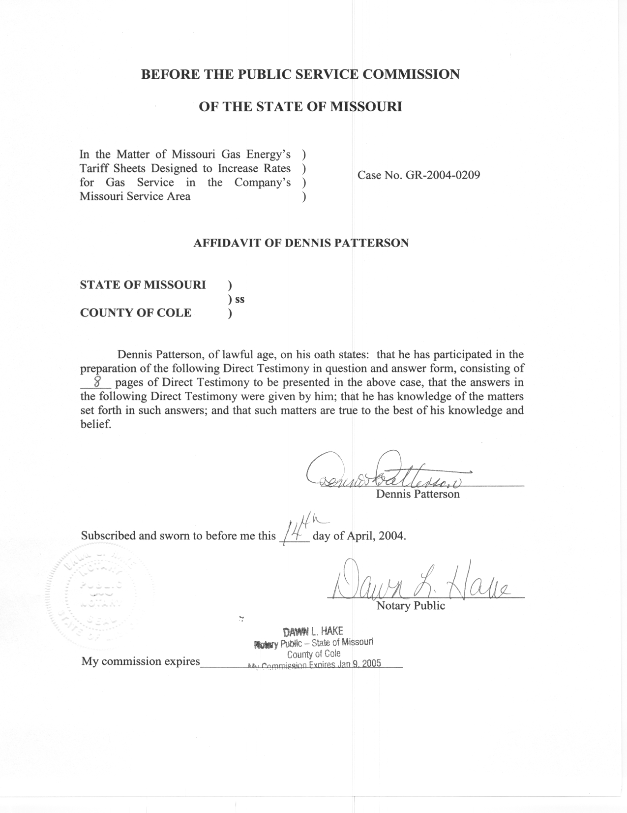
TABLE OF CONTENTS

SUMMARY 2
DEFINITION OF HEATING DEGREE DAYS 2
SELECTION OF WEATHER STATIONS 3
TYPES OF WEATHER STATIONS 4
TEMPERATURE DATA QUALITY 4
WEATHER VARIABLES 6

DIRECT TESTIMONY

OF

DENNIS PATTERSON

MISSOURI GAS ENERGY

CASE NO. GR-2004-0209

Q. Please state your name and business address.
A. My name is Dennis Patterson and my business address is Missouri Public Service Commission, P. O. Box 360, Jefferson City, Missouri, 65102.
Q. What is your present position with the Missouri Public Service Commission (Commission)?
A. I am a Regulatory Economist in the Energy Department of the Utility Operations Division.
Q. Please review your educational background and work experience.
A. I was trained as an officer and aviator in the U.S. Army. I studied economics, math, sciences and languages, receiving a B.A. in Latin American Studies (University of Missouri, 1983) and an M.S. in Agricultural Economics (University of Missouri, 1989). I joined the Staff of the Commission in April 1986. I established the Staff's centralized weather database, and have continued to maintain and improve it by employing official weather data and accepted methods of calculating normals. I have served with the Commission, the Missouri Army National Guard, the University of Missouri, U.S. Army Reserves, and the U.S. Army. I have retired, but continue part-time employment with the Commission.
Q. What is the purpose of your testimony?
A. I will explain my calculations of actual and normal heating-degree-day (HDD) variables, which I furnished to Staff witnesses James A. Gray and Daniel I. Beck. Mr. Gray required daily actual and normal HDD for his weather normalization analysis. Mr. Beck required the peak-day normal HDD for each of the 12 calendar months.

SUMMARY
Q. How is your testimony organized?
A. I have organized my testimony in the following sections: Definition of Heating Degree-day (HDD), Selection of Weather Stations, Types of Weather Stations, Temperature Data Quality, and Weather Variables.
Q. Have you attached any schedules to your Direct Testimony?
A. Yes. Specific calculations of HDD variables for the Kansas City International Airport (KCI) and Springfield Regional Airport (SGF) weather stations are attached as Schedules 1 and 2, respectively. Weather station location information for KCI and SGF is attached as Schedules 3 and 4, respectively. Graphs of adjustments to historical temperatures at KCI and SGF are attached as Schedules 5 and 6, respectively.
Q. Are your calculations explained in greater detail elsewhere?
A. Yes. Additional detail is included in my workpapers, which have been provided to Missouri Gas Energy Company (MGE or Company) and are available to the other parties.

DEFINITION OF HEATING DEGREE DAYS
Q. What is a heating degree day?
A. Degree days are weather measures that were originally devised to evaluate energy demand and consumption. Degree days are based on how far the daily average temperature departs from a human comfort level of 65 °F. Heating degree days are used to examine the relationship between temperature and natural gas usage for residential heating. Cooling degree days are used to examine the relationship between temperature and electricity demand and usage for air conditioning.
Q. How are HDDs calculated?
A. HDDs are calculated as the number of degrees the daily average temperature is below 65 degrees Fahrenheit (F), and are set equal to zero when the daily average temperature is above 65 F. The daily average temperature (TAVG) is the average of the day’s maximum (TMAX) and minimum temperatures (TMIN).
Q. What is the source of your data on TMAX and TMIN?
A. The TMAX and TMIN data were acquired from the National Oceanic and Atmospheric Administration (NOAA).

SELECTION OF WEATHER STATIONS
Q. Which weather stations did you use in the current rate case?
A. I used the weather stations at Kansas City International Airport (KCI) and Springfield Regional Airport (SGF).
Q. How did you select these weather stations?
A. I continued to support the weather stations that the Staff selected in the most recent MGE rate case, Case No. GR-2001-292. In that case, the Staff chose KCI as the nearest station to the Kansas City and St. Joseph service areas that had the most consistent daily temperature data. Also in that rate case, the Staff chose SGF as the nearest weather station to the Joplin service area that had the most consistent daily temperature data. Staff rejected the Joplin weather station because the TMIN values were not recorded for the important dates of near-record cold weather between January 18, 1984 and January 21, 1984. In addition, approximately 12 months of temperature data between February 26, 1998 and February 28, 1999, were not recorded at Joplin.

TYPES OF WEATHER STATIONS
Q. What types of weather stations are maintained at the selected locations?
A. Both KCI and SGF have first-order stations
Q. What are first-order weather stations?
A. First-order weather stations are usually located at regional or municipal airports, where professional observers continuously monitor the weather instruments. The instruments record daily TMAX and TMIN, along with hourly observations of precipitation, temperature, dew point, wind and other weather elements. In contrast, trained volunteers usually man cooperative weather stations, where they record daily observations of TMAX, TMIN and precipitation.

TEMPERATURE DATA QUALITY
Q. Were the reported daily temperatures complete for KCI and SGF?
A. No. Although the test year had complete temperature data, KCI and SGF, like most stations, have had occasional short periods of missing days since 1971. At KCI, temperature observations did not exist until this weather station was commissioned in November 1972. The treatment of missing values is discussed at Schedule 1.
Q. Were the reported daily temperatures consistently measured throughout the period 1971 through the test year?
A. No. Over those many years, temperatures were measured at various locations and with various instruments that were periodically replaced and updated at each weather station.
Q. Do these factors affect NOAA’s recorded temperatures?
A. Yes. It is important to note that: 1) temperatures vary by location; 2) daily TMAX and TMIN temperatures for the day will vary depending on the time that the 24 hours begins and ends; and 3) temperature measurements under identical conditions but with different types of instruments will not be equal. Events that have an effect on measurement conditions are called exposure changes.
Q. What measures were taken to correct for exposure changes at KCI and SGF?
A. The measures were different for each weather station and depended on the nature of the exposure change, as it was described in the weather station documents I provided in my working papers. Exposure change adjustment procedures are described in my workpapers.
Q. Do the events described above always result in the necessity to adjust NOAA’s reported TMAX and TMIN?
A. No. For instance, no adjustment appears in the NOAA normals products for the installation of the Automated Surface Observation System (ASOS) at KCI in July, 1995.
Q. Have you prepared schedules listing the exposure changes at KCI and SGF?
A. Yes. Exposure change is documented for KCI in Schedule 3-2, and for SGF in Schedule 4-2. Exposure change adjustments for KCI are graphed in Schedule 5, and for SGF in Schedule 6.
Q. Do exposure change adjustments always correspond to a documented exposure change event?
A. No, not necessarily. Adjustments are sometimes calculated for obvious discontinuities in the temperature data series, even though no corresponding exposure changes are documented in the weather station records. This might occur if a thermometer “drifted” significantly out of calibration, but was replaced by a calibrated instrument of the same type, or when trees were harvested and buildings constructed in the vicinity of the weather station. Such events might be omitted from the record because they were not judged to be of any importance at the time they occurred.

WEATHER VARIABLES
Q. What weather variables did you develop for the present rate case?
A. I developed the daily actual HDDs and the daily normal HDDs to be used by Mr. Gray to weather normalize Company’s sales and revenues. I also calculated the monthly peak-day normal HDDs used by Mr. Beck to allocate certain costs in the customer class cost-of-service study. Calendar month summaries of actual and normal HDDs for the test year are presented for KCI and SGF at Schedules 1 and 2 respectively, attached to my Direct Testimony.
Q. How did you calculate daily HDDs for the test year?
A. I calculated daily HDDs (“actual HDDs”) using the above formula and the daily TMAX and TMIN.
Q. How did you calculate adjusted daily HDDs for each of the days in the 30-year period, January 1, 1971 through December 31, 2000?
A. I first tabulated daily TMAX and TMIN for each day in these 30 years for KCI and for SGF, as well as for selected alternates where data were missing, because NOAA only adjusts the monthly average temperatures. I adjusted actual daily TMAX and TMIN for these 30 years so that the monthly averages of the adjusted daily TMAX and TMIN were equal to the adjusted monthly average TMAX and TMIN that NOAA uses to calculate the monthly station normals over the same period. Adjusted daily TAVG and HDD were then calculated as discussed above. The details of the tabulation and adjustment processes are discussed in my workpapers.
Q. How did you determine the daily normal HDDs for Mr. Gray?
A. As described above, I determined the daily normal HDDs by averaging the adjusted daily HDDs for each calendar date, without respect to the year. For example, the 30 observations of actual HDDs for January 1st of each year were averaged to determine the normal HDDs for January 1st.
Q. How did you calculate the normal peak-day HDDs for the 12 monthly normal peak days in the test year for Mr. Beck?
A. I calculated the normal HDD value for January’s coldest day as the average of the 30 coldest days over all the January days in the 30 years of the normals period, where daily HDD during the normals period were calculated from adjusted TMAX and TMIN as discussed above. The normal HDD values for the coldest day in each of the other months were calculated in the same way.
Q. What were the monthly peak day normal HDDs for each month?
A. A summary of the monthly peak day normal HDDs is presented for KCI in Schedule 1 and for SGF in Schedule 2.
Q. Does this conclude your Direct Testimony?
A. Yes, it does.

