Exhibit No.:
Issues: Weather Normalization

Witness: Dennis Patterson
Sponsoring Party: MO PSC Staff
Type of Exhibit: Rebuttal Testimony
Case No.: GR-2004-0209
Date Testimony Prepared: May 24, 2004

MISSOURI PUBLIC SERVICE COMMISSION

UTILITY OPERATIONS DIVISION

REBUTTAL TESTIMONY

OF

DENNIS PATTERSON

MISSOURI GAS ENERGY

CASE NO. GR-2004-0209

Jefferson City, Missouri
May 2004
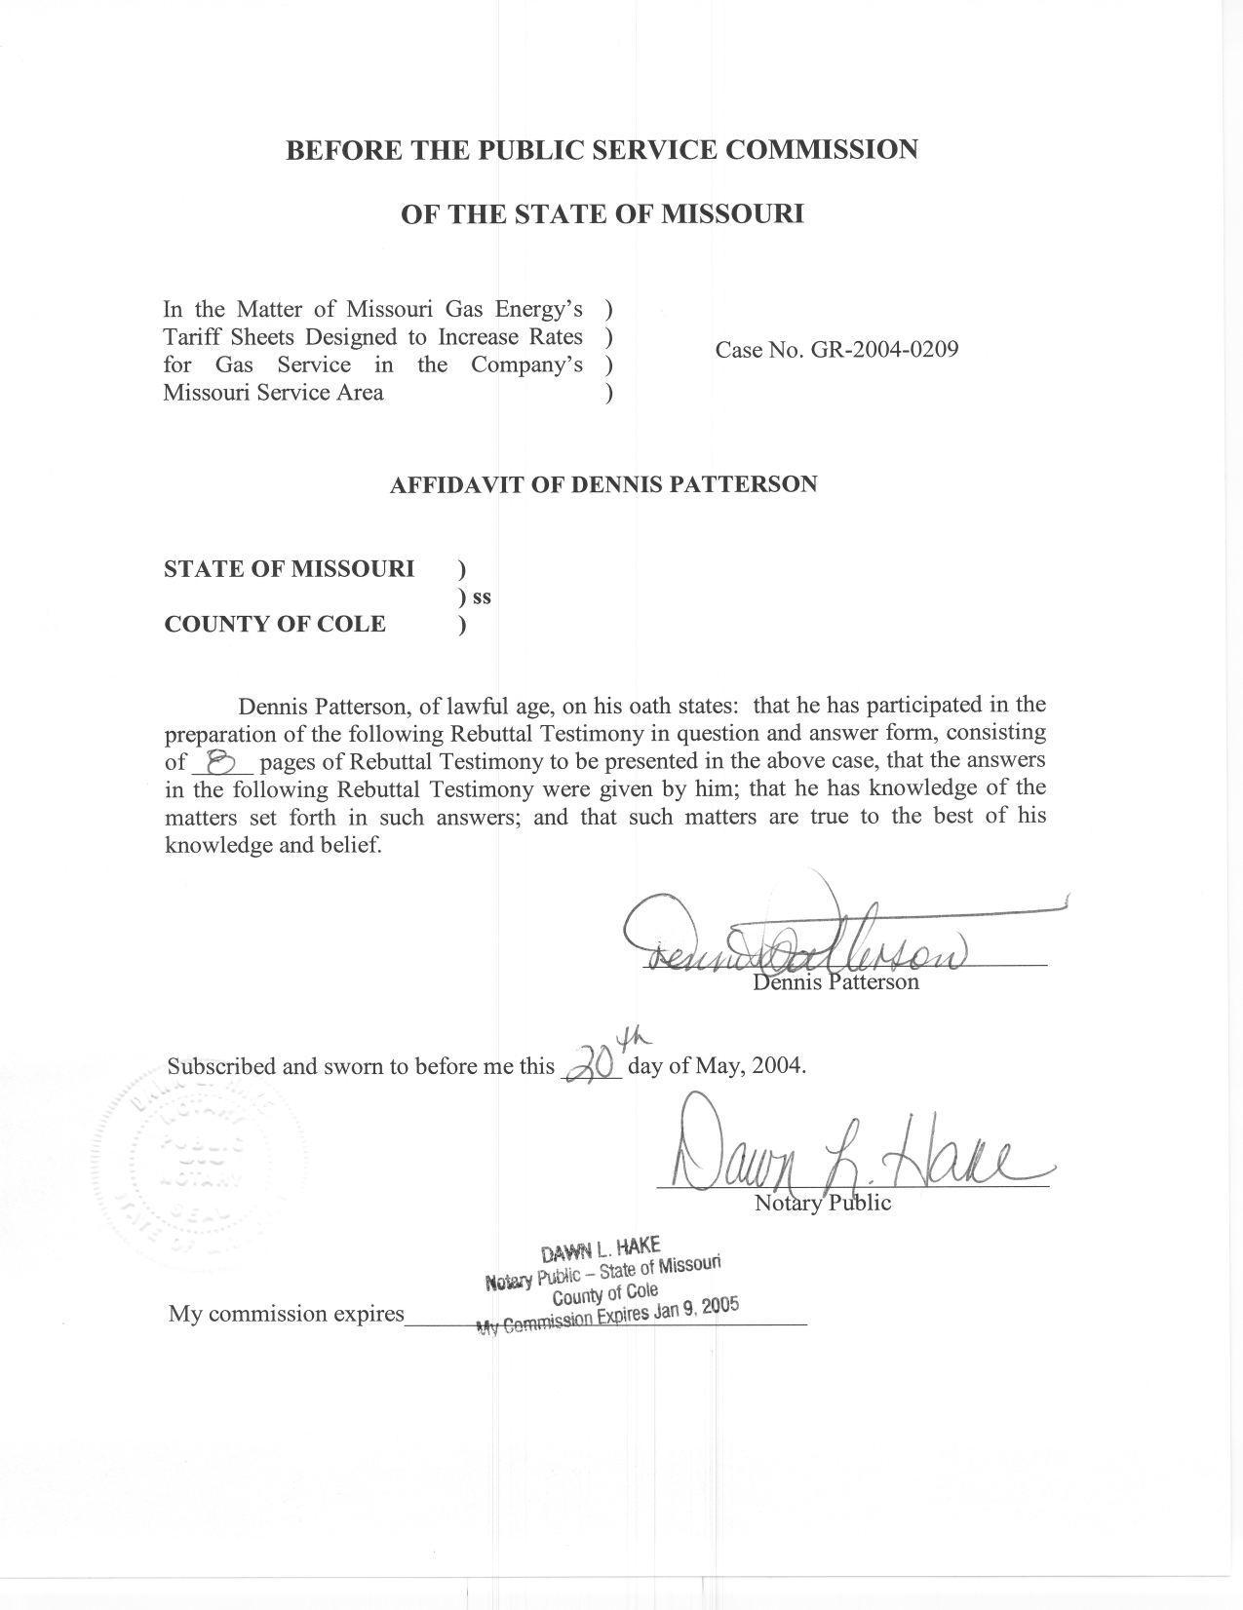
TABLE OF CONTENTS

SUMMARY 1
COMMISSION FINDINGS 2
SIMULATION 3
CONCLUSIONS 8

REBUTTAL TESTIMONY

OF

DENNIS PATTERSON

MISSOURI GAS ENERGY

CASE NO. GR-2004-0209

Q. Please state your name and business address.
A. My name is Dennis Patterson and my business address is Missouri Public Service Commission, P. O. Box 360, Jefferson City, Missouri, 65102.
Q. What is your present position with the Missouri Public Service Commission (Commission)?
A. I am a Regulatory Economist in the Energy Department of the Utility Operations Division.
Q. Are you the same Dennis Patterson who has submitted direct testimony in this case?
A. Yes, I am.

SUMMARY
Q. What is the purpose of your rebuttal testimony?
A. I will address the written direct testimony of Company witness F. Jay Cummings, PhD. Dr. Cummings states: “The Company uses an average of the last 20 years of weather experience to derive normal heating degree days. This measure is up-to-date and long enough so that one or two years of extreme weather will not unduly influence the measure of normal.” (Cummings direct testimony, page 5, lines 19-22.) I will first show that the 20-year normal does not comply with previous findings by the Commission. I will then use the weather data to show that changing to Company’s 20-year average would allow the Company to over-collect from the ratepayers in the short run, and that the change would impose the costs of unstable rates in the long run. In addition, I will show that NOAA’s thirty-year normal is superior to moving average over a shorter time frame, both under conditions where the climate is not changing and where it is warming or cooling by as much as 0.5 degrees per decade. Finally, I will show that these conditions of warming are much greater than those that have been measured by NOAA.

COMMISSION FINDINGS
Q. Has the Commission ruled previously on the length of the weather normals period?
A. Yes. In the MGE rate case, Case No. GR-96-285, the Commission decided on this issue in its Report and Order, issued January 22, 1997. At Page 18 of that Report and Order, the Commission states:
The Commission finds that NOAA’s 30-year normals is (sic.) the more appropriate benchmark. The 10-year moving average would needlessly cause frequent rate changes based on the introduction of new data every year. If one takes MGE’s argument to its logical extreme, the Commission would use the most recent year’s experience in MGE’s service territory and re-set rates each year. This could lead to serious financial problems for MGE if its rates were set after a record-setting cold year. In addition, the data upon which Staff’s recommendation is based has gone through the processes established by NOAA to ensure the best data possible. This safeguard is not present in MGE’s approach.” (Missouri Public Service Commission, Case No. GR-96-285, Report and Order, Issue Date January 22, 1997, Effective Date February 1, 1997, Page 18.)

Q. Does the 20-year updated normal comply with the Report and Order?
A. No. It is simply a moving average with a time frame only two-thirds as long as the 30-year normal that the Commission has found to be superior. While it is possible that the 20-year normal could be potentially less damaging than the 10-year normal supported by the Company in GR-96-285, the shortcomings are the same and differ only in degree and timing.

SIMULATION
Q. What are the implications of the statements in Dr. Cummings’ direct testimony? (Cummings direct testimony, page 5, lines 19-22.)
A. Dr. Cummings’ statements imply that updating the 20-year normal is no worse than the practice of using the NOAA thirty-year normal for 10 years until the next edition is recalculated and published. These statements also imply that the accuracy of the updated 20-year normal is no worse than that of the NOAA thirty-year normal because the 20-year period is “long enough.” I will show that neither of these implications is accurate.
Q. How will you address Dr. Cummings’ statements by analyzing the weather data?
A. I have developed a simulation model to evaluate the use of alternative time frames to calculate normal annual HDDs. I use the NOAA 30-year normal that is recalculated each decade throughout the years in the simulation as a base, and compare three moving averages that are updated each year. I selected 20 years, 10 years and five years as the periods for the updated moving averages. To show the conditions under which each of the normals might be superior, I repeated the simulation specifying cooling and warming trends between –1.0 degrees Fahrenheit (F) per decade and +1.0 degrees F per decade. For simplification, I assumed that an upward adjustment of +1.0 degrees in annual average temperature resulted in a reduction of 200 HDD per year.
Q. How did you perform the simulation?
A. For each trend scenario, I calculated the differences between each HDD observation and each calculation of normal as if the calculations of normal were forecasts. I then calculated the root mean square error (RMSE) in units of HDD for the resulting forecast errors. I then converted the RMSE value in HDD to absolute value adjustment dollars, using the simplifying assumption that a 1.0-degree decrease in normal annual HDD would increase the revenue requirement by $10,000.00. This yielded an absolute value dollar figure by which the accuracy of each measure of normal might be compared with the others.
In addition, for each trend scenario, I calculated the standard deviation of each calculation of normal annual HDD from its average over the years in the simulation period. The NOAA normal, being constant through every decade of the simulation for all the scenarios, had the smallest standard deviation. I also converted the standard deviations of each calculation of normal to absolute value adjustment dollars at the $10,000.00/HDD rate, so that the stability of each of the calculations of normal might be compared with that of the others in terms of dollars at risk.
Q. How did you arrive at using $10,000 per annual HDD?
A. This figure is the approximate, rounded difference between Staff and Company HDD adjustments. It is used as a convenient way to provide an order of magnitude for my simulation, and is not meant to represent either the Company or Staff position.
Q. How did imposing trends affect the results?
A. The relative performance of normals from the selected time frames did not change until the trends approached 0.5 degrees per decade, after which the performance of the shorter-term moving averages began to exceed that of NOAA’s thirty-year normal. This would indicate that the performance of 5, 10 and 20-year moving averages will not be superior to NOAA’s 30-year normal unless the climate begins to change drastically.
Q. Just how drastic would the change in temperatures of 0.5 degrees F. per decade be?
A. Such a change would be more than three times the per-decade rate of all the global warming that has been experienced in the last quarter of a century. The National Climatic Data Center (NCDC) has published a synopsis of studies that includes the following statement:
“Global surface temperatures have increased about 0.6°C (plus or minus 0.2°C) since the late-19th century, and about 0.4°F (0.2 to 0.3°C) over the past 25 years (the period with the most credible data). The warming has not been globally uniform. Some areas (including parts of the southeastern U.S.) have, in fact, cooled over the last century. The recent warmth has been greatest over North America and Eurasia between 40 and 70°N. Warming, assisted by the record El Niño of 1997-1998, has continued right up to the present, with 2001 being the second warmest year on record after 1998.” (NCDC: “National Oceanic and Atmospheric Administration Global Warming Frequently Asked Questions,” http://www.ncdc.noaa.gov/oa/climate/globalwarming.html, downloaded Wednesday, 19-May-2004 12:23:43 EDT.)

Q. How did you arrive at the rates per decade you have compared?
A. The rate of warming quoted above for the last 25 years was 0.4 degrees F. per 25 years, or 0.16 degrees per decade. The ratio, 0.5 degrees per decade divided by 0.16 degrees per decade is 3.125, so that the minimum rate at which the short-term moving averages could ever outperform NOAA’s thirty-year normal is more than three times as great as the rate at which global warming has been progressing.
Q. Have you provided a comparison of the adjustment performance of each calculation of normal annual HDD?
A. Yes. I combined the results of the accuracy and stability calculations so that the four calculations of normal could be compared for each scenario using a single product. The difference between the accuracy and stability dollars for each of the updated normals and those for the constant NOAA normal represents an average of unnecessary revenue adjustment dollars that would be imposed by each of the updated normals if adjustments were made every year over the simulation period. This comparison is presented on the chart at Schedule 1. Schedule 1 shows that on the average, about $0.3 million in unnecessary revenue adjustments would be imposed each year if the 20-year updated normal HDD were used as a basis. The $0.3 million is an average of excesses with larger and smaller absolute values, and which might be positive in some years and negative in others.
Q. Did you examine whether any of the calculations were biased?
A. Yes. I noted that if the run of the calculations is long and the mean of the data does not change via shifts or trends, then none would be biased. The question then becomes, “How severe a shift or trend can be tolerated before one calculation or another becomes superior to the NOAA normal?” This question is the basis for the simulation model I chose. The answer, as stated above, is that the NOAA thirty-year normal is robust unless the Missouri climate changes much more drastically than could reasonably be expected.
Q. How do the results of your simulation address the implications of Dr. Cummings’ statements above?
A. The results in the chart at Schedule 1 show that the NOAA three-decade normal, updated each decade, puts fewer revenue adjustment dollars at risk due to error and instability than do the twenty-year, ten-year or five-year updated moving averages.
Q. In the current rate case, what would happen to the adjustment in rates if the Commission allowed the twenty-year updated normal annual HDD to be used as the basis for weather normalization?
A. I have estimated these differences by calendar year over the simulation period, using the assumption of $10,000 per HDD, under the scenario where no temperature trend was added to the HDD data. The difference results in the chart at Schedule 2, attached to my rebuttal testimony, show that in the calendar year 2003, the change to the updated twenty-year calculation of normal would cause rates to be increased by approximately $1.0 million more than the adjustment indicated by the use of the thirty-year NOAA normal. Other Staff witnesses will calculate the exact adjustment for the test year.
Q. Why would it be necessary to update the twenty-year calculation of normal every year?
A. Because the average over only twenty years will usually be farther from the long-term average than the average over thirty years. Constant updating is necessary to prevent the forecast errors from becoming larger on the average for the twenty-year normal. For example, in the simulation, if the 2003, twenty-year calculation of normal were adopted for several years without an update, the rates would be too high by about a million dollars for all of those years. This would be a significant burden on the residential ratepayers.

CONCLUSIONS
Q. Please summarize your rebuttal testimony.
A. First, the twenty-year moving average, or “up-to-date” twenty-year normal, does not comply with the Commission’s Report and Order in
Case No. GR-96-285. Second, as illustrated in Schedule 1, when a longer time frame is used to evaluate normal HDDs, the error term in these normals versus simulated future weather is reduced. Simply put, a thirty-year normal updated each decade is better than a twenty-year moving average for purposes of establishing what constitutes “normal” weather. Third, the NOAA thirty-year normal continues to be superior under warming conditions that are three times as severe as those that the federal government has measured for North America. Finally, where only the present rate case is considered, the twenty-year normal yields a rate increase that is about $1.0 million too high.
Q. Does this conclude your rebuttal testimony?
A. Yes, it does.

