Exhibit No.:

Issues: Weather Mitigation
Witness: Michael S. Proctor
Sponsoring Party: MoPSC Staff
Type of Exhibit: Surrebuttal Testimony
Case No.: GR-2002-356
Date Testimony Prepared: August 23, 2002

MISSOURI PUBLIC SERVICE COMMISSION

Utility Operations DIVISION

surREBUTTAL TESTIMONY

OF

Michael S. Proctor

LACLEDE GAS COMPANY

CASE NO. GR-2002-356

Jefferson City, Missouri
August 2002

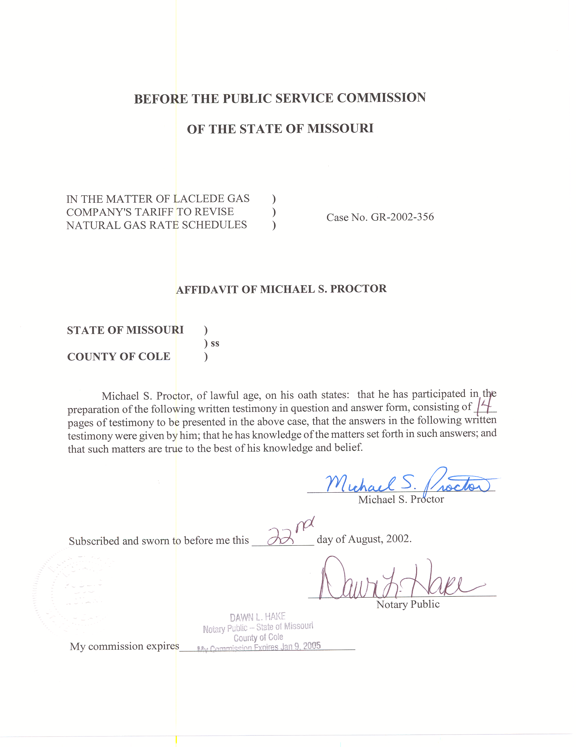
SURREBUTTAL TESTIMONY
OF
MICHAEL S. PROCTOR
LACLEDE GAS COMPANY
CASE NO. GR-2002-356

Q. Please state your name and business address.
A. My name is Michael S. Proctor and my business address is Missouri Public Service Commission, P. O. Box 360, Jefferson City, MO 65102.
Q. By whom are you employed and in what capacity?
A. I am employed by the Missouri Public Service Commission (Commission) as Manager of Economic Analysis in the Energy Department.
Q. What is your education background and work experience?
A. I have Bachelors and Masters of Arts Degrees in Economics from the University of Missouri at Columbia, and a Ph.D. degree in Economics from Texas A&M University. My previous work experience has been as an Assistant Professor of Economics at Purdue University and at the University of Missouri at Columbia. Since June 1, 1977, I have been on the Staff of the Commission and have presented testimony on various issues related to weather normalized energy usage and rate design for both electric and natural gas utilities. With respect to electric issues, I have worked in the areas of load forecasting, resource planning and transmission pricing. In 1997 and 1998, I served as the Staff Vice Chair of the Market Structure and Market Power working group of the Commission’s Task Force on Retail Competition. From December of 2000 until the Southwest Power Pool’s (SPP’s) application as a Regional Transmission Organization (RTO) was rejected by the Federal Energy Regulatory Commission (FERC) in the summer of 2001, I served as chairman of the Forward Congestion Markets Subgroup of SPP’s Congestion Management Systems Working Group.
Q. What are your current duties in the Energy Department as Manager of Economic Analysis?
A. I supervise the Economic Analysis group within the Energy Department. This group is responsible for various issues related to weather normalization of sales, class cost of service and rate design. In addition to my supervisor’s role, I have focused my attention on the development and structure of RTOs for the purpose of increasing efficiency and reliability in the competitive supply of electricity. Because of the restructuring of the electric industry toward the increased competitive supply of electricity, I have also focused on the issue of market power within the electric industry. Finally, I am responsible for the review of the economic analysis performed by Missouri, investor-owned, electric utilities for their resource plans.

BACKGROUND AND POSTION
Q. What is the focus of your surrebuttal testimony?
A. My surrebuttal testimony will address the rebuttal testimony of Laclede Gas Company (Laclede or Company) witness Mr. Michael T. Cline concerning the issue of weather mitigation.
Q. What is your understanding of the weather mitigation issue?
A. My understanding of this issue is that Laclede has experienced under recovery of its costs over much of the last decade due to warmer than normal winter weather. Weather mitigation encompasses various proposals to deal with this situation.
Q. What is meant by the term “fixed costs?”
A. In regulatory economics, the term “costs” is used to describe any component that contributes to the utilities total revenue requirement. For example, the term “cost of service” includes both annual expenses as well as rate of return on the utilities rate base. Of the utility’s total costs (or cost of service), some of expenses vary directly with the level of sales. These are called “variable costs.” Other of these costs do not vary with the level of sales. These are called “fixed costs,” and include both fixed expenses as well as return on fixed rate base.
Q. Why are fixed, non-gas costs under recovered when weather is warmer than normal?
A. This under recovery of fixed, non-gas costs occurs because the revenue requirements for non-gas expenses and rate of return on fixed rate base are collected in a commodity rate, causing the revenue recovery of these fixed costs to vary with the level of sales of natural gas. Specifically, when weather is warmer than normal, sales are less than the normalized levels that were used to calculate the commodity rate. When gas sales are less than their design (normalized) levels, Laclede recovers less in revenues than its non-gas expenses and its allowed rate of return on fixed rate base.
Q. What changes can be made to mitigate this problem of under recovery of costs when the winter weather is warmer than normal?
A. There are several possible solutions, but my surrebuttal testimony is in response to a weather mitigation proposal presented in the rebuttal testimony of Laclede witness Michael Cline. Mr. Cline makes a rate design proposal that moves the recovery of fixed cost into an initial block of usage that is significantly less sensitive to weather variations.
Q. What is the Staff’s position regarding Mr. Cline’s proposal?
A. If the Commission determines that weather mitigation measures are supported by the testimony submitted in this case, the Staff supports the application of rate design changes as the best possible weather mitigation measure. In particular, the Staff supports the proposed rate design changes presented by Mr. Cline, conditioned on having the weather normalized billing units needed to properly implement this proposal for the non-residential, general service customers. Otherwise, if the Commission decides to adopt this rate design proposal to mitigate the impact of weather on revenue collection, the change should be made for the residential customers only at this time.

WEATHER MITIGATION: ALTERNATIVE METHODS
Q. Why does the Staff prefer a rate design to other weather mitigation alternatives?
A. This is best answered with respect to specific weather mitigation alternatives. For example, the Staff prefers the weather mitigation rate design proposal of Mr. Cline over the proposal of Ms. Krieger to move to a ten-year average weather normal. My reading of Ms. Krieger’s rebuttal testimony is that Laclede also prefers other forms of weather mitigation over leaving this issue to be resolved by simply decreasing the number of heating degrees days used to calculate weather normalized usage.
Q. How does reducing weather normalized usage help to mitigate the under recovery experienced as a result of warmer than normal winter weather?
A. Reducing the level of design usage over which revenue requirements are collected results in higher rates; i.e., dividing the same total revenue requirements by a lower level of usage produces higher rates. With higher rates, for the same level of actual usage, the Company earns higher levels of revenues. In essence, reducing weather normalized usage to determine rates is comparable to increasing the allowed rate of return or any other proposal that increases rate levels as a weather mitigation measure.
Q. What is the danger from increasing rate levels to compensate for under recovery of costs caused by warmer than normal weather?
A. The obvious danger is that once rates go into effect, the actual winter weather experienced may no longer be warmer than normal. When this happens, sales are at higher levels, which along with the higher rates, allows the Company to over earn.
Q. Are there other dangers that are specific to using a ten-year normal as the basis for setting rates?
A. Yes, there are. In Staff witness Dennis Patterson’s rebuttal testimony, he points out the increased volatility of ten-year averages compared to thirty-year averages. For example, suppose there are ten years where weather averages colder than normal rather than warmer than normal, and rates are set on this colder than normal average. This will result in a calculation of “normal” sales that is higher and, therefore, rates that are lower than they would be if they were set using the standard thirty-year normal. Then if the Company experiences a following decade of warmer than normal winter weather, its under recovery problems will be magnified beyond what they are today. Finally, with the use of a moving ten-year average, and its inherent volatility, it will not take a decade for this type of problem to occur. Moreover, just a few years of colder than normal winter weather can result in the ten-year average moving from reflecting relatively low heating degree days to reflecting relatively high heating degree days.
Q. What other types of weather mitigation proposals has the Staff reviewed in its determination that rate design is the best alternative?
A. Laclede has proposed a weather mitigation clause that would accumulate the shortages or overages in recovery of non-gas costs, and then apply a mechanism similar to the Actual Cost Adjustment (ACA) for gas costs; i.e., where under recovery is added to rates and over recovery is subtracted from rates to be applied in the next period. Staff witness Mr. James M. Russo addresses the Staff’s concerns with this type of proposal in his rebuttal and surrebuttal testimony.

WEATHER MITIGATION: LACLEDE’S RATE DESIGN PROPOSAL
Q. What are the rate design principles that Mr. Cline followed in his proposed rate structure for weather mitigation?
A. First, Mr. Cline designed the rates that would allow non-gas costs to be recovered in an initial block of usage for the Residential, Small Commercial and Industrial (C&I), Medium C&I and Large C&I customers that are currently Laclede’s general service customers.
Second, moving total non-gas cost recovery to the initial block has a detrimental impact on low-use customers in each of these four classes. However, Mr. Cline proposes to offset that impact through a change in gas cost recovery by lowering the initial block rate for gas costs and thereby increasing the tail block rate. In this way, the customers’ bundled rate for both non-gas and gas costs is left unchanged.
Third, because the revenue recovery problem is primarily during the winter months of November through April, Mr. Cline proposes to only apply this new blocked rate design for these winter months.
Fourth, any Purchase Gas Adjustment (PGA) change would be applied to all firm classes on a cents per therm basis, as it is today. This means that the cents per therm difference between the initial block and tail block PGA rate would remain constant.
Q. If customers are paying the same rates as under the current rate design, how does Mr. Cline’s proposed rate design mitigate the problem of under recovery of costs when there is warmer than normal weather?
A. Mr. Cline’s rate design proposal effectively moves the potential to under collect revenues in warmer than normal winters from the non-gas cost component of rates to the gas cost component of rates. At the same time, it moves the potential to over collect revenues in colder than normal winters from the non-gas component of rates to the gas cost component of rates.
Q. Does this mean that the volatility in recovery of Laclede’s non-gas costs has been shifted to the recovery of its gas costs?
A. No, this is not the case. Unlike non-gas costs, a significant portion of gas costs are variable. Thus, when sales fall due to warmer than normal weather, while revenues to cover gas costs will fall, actual gas costs will also decrease. For example, if the fall in revenues happens to equal the fall in gas costs, then Laclede would have zero volatility in the recovery of its gas costs. This is not true for non-gas cost that are primarily fixed costs and do not decrease when gas sales fall.
Q. Does the Staff have any concerns about the rate design proposed by Mr. Cline?
A. Yes, the Staff has a few concerns. Staff’s greatest concern is with respect to the billing determinants needed to properly calculate these blocked rates. While such billing units are available on a weather-normalized basis for Residential customers, they do not currently exist for the C&I customers.
Q. What do you mean by billing determinants needed to “properly calculate “ the blocked rates proposed by Mr. Cline?
A. Proper rate calculation means that the Staff can in essence “certify” to the Commission that the calculated rates will recover the revenues approved by the Commission in this case.
Q. Do the rates calculated by Mr. Cline in his rebuttal testimony satisfy this criterion of recovery of the revenues approved by the Commission?
A. No, they do not. While the Staff does have billing determinants for the Residential class that will properly calculate rates for Mr. Cline’s proposed rate design, it does not have such billing determinants for the three C&I classes proposed by Mr. Cline. The billing determinants used by Mr. Cline in his rebuttal testimony for the three new C&I classes are based on the actual usage for the twelve months ending August 2000. To properly calculate rates requires weather normalized billing determinants for the test year in this case; i.e., twelve months ending November 2001.
Q. Why does the Staff have weather normalized billing determinants for the Residential class, but not for the C&I classes?
A. The Residential class is an existing class and the initial block of zero to sixty-five therms per month is the existing structure for Residential rates. The three C&I classes proposed by Mr. Cline are new, and the initial blocks for the Medium and Large C&I classes are also new. Since the Company’s proposal was unveiled in rebuttal rather than direct testimony, the Staff had no reason to have developed billing determinants for any rate classes and rate designs other than the existing ones.
Q. Can billing determinants that will properly calculate rates be developed by the time rates go into effect in this case?
A. I discussed this with Mr. Cline, and Laclede has provided Staff with individual C&I customer data from the test year. Staff is currently performing the analysis of this data and we believe that it is possible for the Staff to process that data by late September or early October of this year.
Q. Beyond the question of being able to properly calculate the rates corresponding to Mr. Cline’s rate design proposal, does the Staff have any other concerns with this rate design?
A. Yes, there are a few other concerns. The most important of these concerns is whether this new rate design will result in greater volatility in the recovery of gas costs. A second concern is, instead of an equal cents per therm ACA factor (rate) for all firm service, Mr. Cline’s proposal appears to encompass the potential for a different ACA factor for each of the classes taking firm service; i.e., Residential, Small C&I, Medium C&I, Large C&I and Large Volume. A third concern is with confusion over the fact that the current Purchase Gas Adjustment (PGA) clause is being applied on a pro rata basis, but the seasonal rates for non-gas cost are being applied on a billing month basis.
Q. What have you determined regarding the volatility of gas cost recovery under Mr. Cline’s rate design proposal?
A. If there are no changes in the PGA rate levels, in colder than normal winters the revenue recovery with the blocked rate design would be higher than the average unit cost built into the PGA, and the revenue recovery in warmer than normal winters would be less than the average unit cost built into the PGA. Thus, an increase in usage from colder than normal weather will recover more incremental revenues than the decrease in revenues that would result from a corresponding decrease in usage from warmer than normal weather. This asymmetry in revenue recovery occurs because the percentage of sales in the initial block of use decreases (increases) with increased (decreased) sales. With increasing sales above normalized levels, a greater than normal percentage of those incremental sales are in the tail block that has a higher rate. With decreasing sales below normalized levels, a greater than normal percentage of those decremental sales are in the initial block that has a lower rate. If the percentage in the usage blocks were to stay constant, then there would be no difference in revenue recovery between the current PGA rate design and the proposed blocked rate design.
Q. Does greater volatility in revenue recovery imply greater volatility in gas cost recovery?
A. No. Greater volatility in revenue recovery does not mean that the blocked rate design proposed by Laclede will be more volatile with respect to over and under recovery of Laclede’s gas costs.
When weather is colder than normal, it is likely that monthly spot market prices for gas will rise and Laclede’s average gas costs will increase. In this case the current PGA rate design would under collect revenues needed to cover Laclede’s higher gas cost. Since the blocked rate design proposal would collect more revenues than the current PGA rate design, it would be less likely to under collect the revenues needed to cover Laclede’s higher gas costs.
On the other side, if weather is warmer than normal, the monthly spot market price for gas is likely to decrease. In this case, the current PGA rate design would over collect revenues needed to cover Laclede’s lower gas costs. The revenues collected with the blocked rate design will be smaller than for the current PGA rate design, and therefore less likely to over collect the revenues needed to cover Laclede’s lower gas costs.
Q. Given Mr. Cline’s rate design proposal results in different gas cost rates for the various firm rate classes, do you recommend that under and over recovery of gas costs be determined by rate classes?
A. No, I do not. The recovery of gas costs that occurred from each rate class compared to Laclede’s total gas costs gives the overall level for the under or over recovery of gas costs. Beyond this aggregate determination, to further determine class responsibility for under and over recovery would require a determination of class gas cost responsibility.
Currently, the Commission has determined that an equal cents per therm is a just and reasonable method for gas cost responsibility both for PGA and for the ACA. Although the PGA rates will be blocked under Mr. Cline’s proposed rate design, that rate design is based on an equal cents per therm allocation of purchased gas costs to the various classes taking firm service. The Staff continues to support this rate design, and is concerned that by having different ACA factors for the various classes of firm service, the ACA proceedings could become unnecessarily complicated with rate design issues, resulting in even longer times to implement the ACA factors (tariffed rates). Thus, the Staff is recommending that the ACA rates continue to be calculated on an equal cents per therm basis for the Residential and C&I firm service customer classes.
Q. What are your concerns about how the PGA proposed by Mr. Cline will be applied?
A. Mr. Cline’s rebuttal testimony was unclear on the specifics of how the PGA would be applied. Moreover, Mr. Cline’s schedules portraying the associated tariffs for the newly proposed rates appeared to indicate, at worst, that a new PGA would need to be filed for summer versus winter rates, and at best, failed to address this issue. The best way to implement the seasonal differentiation in PGA rates is to have a PGA tariff that shows both winter and summer rates and limit PGA filings to instances in which the level of the rates on the PGA tariff change.
Q. You also indicated an issue related to pro rata billing of gas costs versus monthly bill cycle billing of non-gas cost. What is the problem with having these two types of billings?
A. If they are handled correctly, there are no problems with pro rata billing of changes in gas cost that occur through the PGA filings. The rates on the tariff change and customer usage is pro rated to the number of days on the old rate and the number of days on the new rate. What is a problem is if the seasonal rates on the PGA tariff were to be billed on a pro rata basis when the seasonal rate for the non-gas costs are billed on a monthly bill cycle basis. For each billing month there are twenty-one bill cycles that determine the date on which the customers’ meters are read. Seasonal rates apply to customer usage for an entire billing month and are not pro rated as of a specific date. The billing of the seasonal differentials in the PGA rate need to match the billing of the seasonal differentials in non-gas costs in order that customers are paying the same total rate as under the current rate design. Bill cycle billing is less likely to be subject to error, and the Staff recommends that monthly bill cycle billing be used for seasonal rates for both the PGA and non-gas costs.

RECOMMENDATIONS
Q. What is your recommendation regarding the rate design proposal by Mr. Cline to recover non-gas costs in the initial block and correspondingly to lower the initial block and increase the tail block rate for gas costs?
A. While the Staff favors using rate design as a weather mitigation measure, because of the detrimental impact on small users, the Staff was not willing to recommend recovering all of the non-gas costs in either the customer charge, first block rate or a combination of these rate components. Mr. Cline has presented an innovative method for resolving this detrimental impact problem. While Mr. Cline’s solution is not perfect, the Staff is not aware of any better solution at this time, and any imperfections in Mr. Cline’s proposal are not significant enough for the Staff to reject this particular proposal. Therefore, if the Commission determines that the impact of weather mitigaion measures are supported by the testimony submitted in this case, the Staff recommends that the Commission adopt Mr. Cline’s rate design proposal. However, the implementation of this rate design for the three classes of C&I customers is conditioned on having billing determinants that will allow the proper calculation of rates. The Staff also recommends that there be no changes made to the method of calculation of the ACA factors at this time. In essence this means that there will be only one ACA factor for the Residential and C&I firm service customers as there is today. Finally, the Staff recommends that the seasonal PGA be filed as a single tariff and that seasonally differentiated PGA charges be implemented on the same basis as non-gas costs. Changes in the levels of the PGA rates will continue to be applied on a pro rata basis.
Q. Does this conclude your surrebuttal testimony?
A. Yes, it does.

