Exhibit No.:

Issues: Other Tariff Issues

Witness: James M. Russo
Sponsoring Party: Mo PSC Staff
Type of Exhibit: Surrebuttal Testimony
Case No.: GR-2002-356
Date Testimony Prepared: August 23, 2002

MISSOURI PUBLIC SERVICE COMMISSION

Utility Operations DIVISION

Surrebuttal testimony

OF

James M. Russo

Laclede Gas Company

CASE NO. GR-2002-356

Jefferson City, Missouri
August, 2002

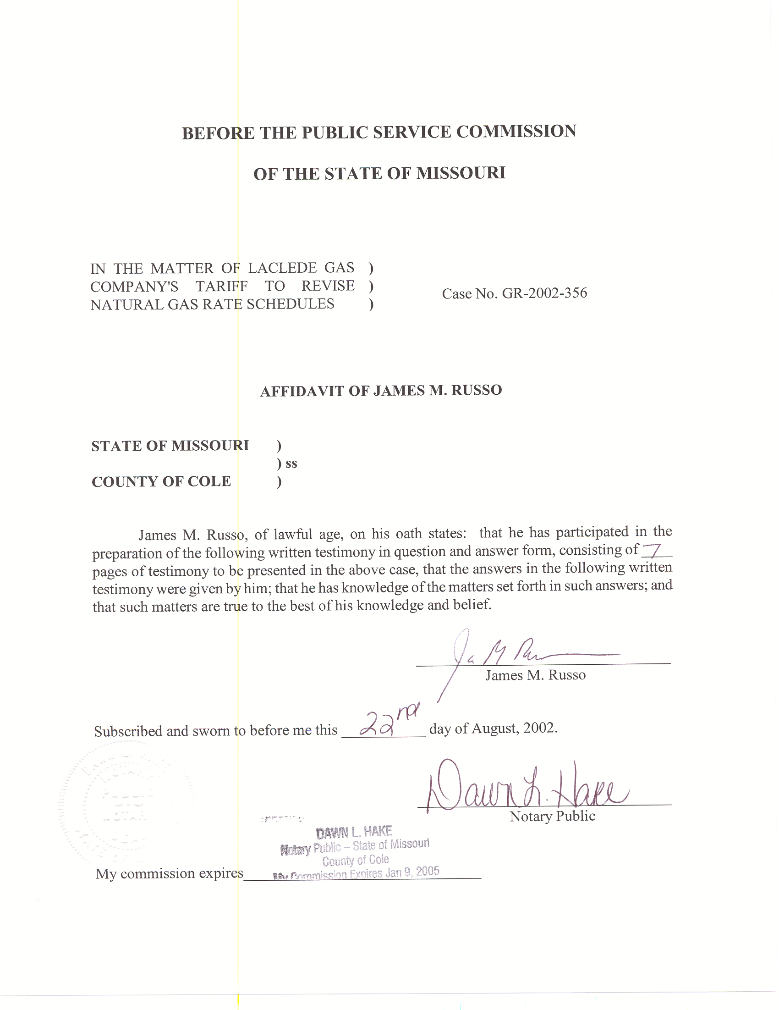
SURREBUTTAL TESTIMONY
OF
JAMES M. RUSSO
LACLEDE GAS COMPANY
CASE NO. GR-2002-356
Please state your name and business address.
James M. Russo, P. O. Box 360, Jefferson City, Missouri 65102.
Are you the same James M. Russo who filed Direct and Rebuttal Testimony in Case No. GR-2002-356?
Yes I am.
What is the purpose of your Surrebuttal Testimony?
A. The Purpose of my Surrebuttal Testimony is to respond to the pre-filed Rebuttal Testimony of Laclede Gas Company (Laclede or Company) Witness Paul H. Raab as it relates to Laclede’s proposed Weather Mitigation Clause (WMC).

Weather Mitigation
Do you agree with Company Witness Raab’s interpretation (Rebuttal Testimony of Paul H. Raab, Page 14, lines 7-14) of your Direct Testimony on page 11, lines 23-26 as it relates to the provision of a guaranteed rate of return?
No. The quote was clearly taken out of context. The Company is attempting to make it appear that the under collection of revenues is related solely to weather. The purpose of the WMC is to guarantee that the Company earns a predetermined amount of revenue based on “normal” sales for a “normal” year. The purpose of my testimony is to bring to the Commission’s attention the fact that weather may not be the only reason why Laclede did not earn its authorized rate of return, and that granting a WMC clause based only on weather is a flawed approach. Staff was making the point that there are other factors influencing the Company’s earnings such as customer conservation, changes in expenditure levels and financial decisions made by Laclede’s management. Staff believes the Commission should consider all of these factors when the Commission makes its decision on the WMC proposal.
Do you agree with Company Witness Raab’s assertion that the WMC is not retroactive ratemaking?
No. Mr. Raab asserts that the WMC is an attempt to reflect under or over collection of costs as a result of weather and that this makes the WMC no different then the Actual Cost Adjustment (ACA) used in the computation of the Laclede’s Purchased Gas Adjustment (PGA). There are many reasons that the WMC is different from the ACA; for example the PGA is based on the actual cost of a commodity that Laclede passes through its system to its customers. That is not true of the proposed WMC. The PGA rates are set prospectively and are interim subject to refund. That is not true of Laclede’s non-PGA rates. Additionally, Laclede is a for profit entity. As discussed in my Rebuttal Testimony for this case and in Laclede’s Case No. GA-2002-429, Laclede has earned a profit for at least the last four years. The proposed WMC is not recovering the under collection of costs, rather, it is further enhancing and stabilizing Laclede’s net revenue. Through its WMC proposal, Laclede seeks to avoid all weather related business risk by placing all the risk on the ratepayers. In addition, the proposed WMC does not return the over collection of costs, rather, it is returning excessive revenues collected above and over the approved revenue level from the last Commission approved rate case.
Do you agree with Company Witness Raab’s statement on page 15 of his Rebuttal Testimony that if the Commission approves the WMC Laclede would be no more or no less likely to earn above its authorized rate of return?
No. The point that Staff is making is that the WMC, in effect, guarantees Laclede will earn its authorized rate of return, and with everything else being equal, Laclede can lower its expenses, potentially enabling the Company to earn above its authorized rate of return. While cost control is a valuable goal, guaranteeing a certain level of return on equity has not historically been the role of the Commission. This collected revenue pays the current expenses of the Company, including the fixed expenses previously determined in Laclede’s current rate case, with the revenue remaining becoming return on equity. Staff believes that the WMC leads itself to the possibility of Laclede earning above its authorized rate of return and making it possible that Staff would have to perform an over earnings investigation that would be similar to the last Ameren UE complaint case.
Do you agree with Company Witness Raab’s characterization of your statement that savings would be minimal to the ratepayer when the weather was colder than normal?
No. Mr. Raab attempts to make the argument that the net impact on the customer would be zero if the weather was warmer than normal, and subsequently colder than normal by an equal amount. While that may be true in theory as it relates to the non-PGA portion of gas charges, the reality is it will never happen. The largest portion of the residential customers monthly bill is the PGA portion of the monthly commodity charge. The WMC only applies to the margin rate per therm of gas used that includes Laclede’s non-gas fixed and variable costs. The residential customers’ bill will increase in cold weather because the amount of gas consumed increases in colder weather. The statement on page 6, lines 20 thru 22 in my Direct Testimony clearly states the relationship of the fixed cost portion of the residential commodity charge to residential customer usage: “Removing the variable cost portion of the residential commodity charge results in the fixed cost per therm being $0.1017 or 18.4% of the total charge per therm when including the $.4125 per therm PGA.” Staff believes this to be a minimal savings when compared to the total residential customer bill. The percentage of savings would decrease even further if the residential customer charge of $12.00 per month was factored into the calculation.
Company Witness Raab attempts to further discredit your statement that savings would be minimal by stating on page 16, lines 3 thru 5 of his Rebuttal Testimony: “I do not understand how Mr. Russo can make this claim, particularly in view of his assertions regarding the “significant” impact that the WMC would have on customers when weather is warmer than normal.” Do you agree with Mr. Raab’s statement?
No. Mr. Raab makes no reference to where this statement was located in my Direct Testimony. I believe he is referring to the additional, and proportionately higher, burden that would be placed on lower income residential customers located in the City of St. Louis. I discussed this on page 8, line 18 through page 9, line 7 of my Direct Testimony filed in this case.
Do you agree with Mr. Raab’s statement that the WMC proposal does not guarantee Laclede a rate of return?
No. Generally speaking, rates are developed on normal weather after the revenue requirement has been determined, and included in these rates is an opportunity for Laclede to earn up to a certain return on equity on the Company’s shareholders investment. With all else being equal, when the weather is warmer than normal, a Company does not collect all the revenue it would collect in a normal weather year and, when the weather is colder than normal, a Company would collect more revenue than it would in a normal weather year. With a WMC in effect, all else being equal, in warmer than normal weather, the WMC guarantees that a predetermined level of revenue will be earned, thus guaranteeing the authorized rate of return.
Do you agree with Mr. Raab’s statement that the WMC implementation is fair?
No. When describing how the WMC is fair for Laclede, Mr. Raab is using the same argument that the Company put forth in Laclede’s Direct Testimony that the WMC would allow Laclede to collect costs that it is entitled to. Staff has pointed out that Laclede is recovering its costs and has had a profit for at least the last four years. Staff believes the WMC is a revenue enhancement mechanism, not a cost recovery mechanism for Laclede.
When explaining how the WMC is fair to the customers, Mr. Raab states it is equally fair to Laclede’s customers because it ensures that Laclede does not over-collect from its customers solely due to weather. Staff does not share that viewpoint. As explained in my Direct Testimony, the very fact that all customers in a Laclede division are used to determine the adjustment factor for any charge or refund triggered by warmer or colder than normal weather does not make the WMC fair for all customers. For example, all residential customers in the division will be required to pay for the gas not used by residential customers that conserve energy when the weather is warmer than normal. This means penalizing the residential customer that conserves energy. These same residential customers who conserve energy will be penalized with smaller credits when the weather is colder than normal because they use less gas.
Company Witness Raab also states in his fairness opinion on page 17 that these results are ensured because the same UCDD factors that the Commission used to develop test year weather-normalized therm sales are used in the WMC. Do you agree with this thinking?
No. As stated in my Direct Testimony on pages 9 and 10, the Staff and Company do not agree on the methodology used by Laclede to determine the energy used to heat water. In fact, my Direct Testimony points out that Laclede was ordered by the Commission in Case No. GR-92-165 to resolve this issue with Staff and to date has not done so.
Do you agree with Mr. Raab’s statement on page 16, line 17 through page 17, line 2 of his Rebuttal Testimony that states: “…then low-income customers are more likely to benefit from the Company’s WMC proposal than are high-income customers.”
No. Staff believes low-income customers have greater difficulty paying their bill under normal circumstances. Presently, when weather is warmer than normal low-income customers receive a lower than normal monthly gas bill. Under the proposed WMC, the low-income customer will lose this relief when the weather is warmer than normal, as they will be charged more to receive gas service than they are presently charged. Surely this additional charge cannot be portrayed as a benefit to an individual who is having trouble making ends meet. True, customers will receive a slight benefit when the weather is colder than normal, but they will still be required to pay for the Purchased Gas Adjustment portion of their bill. This portion is approximately 75% of the existing tariffed rate on December 31, 2001, for gas usage over 65 therms. If a low-income customer is having trouble paying his/her gas bill under normal weather conditions, there is no relief from the WMC. The reality is quite simple. The low-income customer who is having difficulty paying his/her bill will continue to have great trouble paying bills for heating. At least the low-income residential customer receives an economic break under the existing tariff if the weather is warmer than normal. This economic break will disappear if the WMC is approved.
Do you agree with Raab’s statement that other utilities with lower customer charges have no relevance in this case?
No. Staff reviewed other public utilities and Laclede’s existing residential customer charge is the second highest when compared to 17 other public utilities with an existing WMC. Staff believes the Commission needs to be aware that Laclede is presently collecting a higher portion of its fixed charges in the Company’s existing tariffed rates than are other utilities reviewed by Staff.
Does this conclude your Surrebuttal Testimony?
Yes, it does.

