Exhibit No.:
Issues: Deferral of Alleged Costs
Witness: James M. Russo
Sponsoring Party: MoPSC Staff
Type of Exhibit: Rebuttal Testimony
Case No.: GA-2002-429
Date Testimony Prepared: June 28, 2002

MISSOURI PUBLIC SERVICE COMMISSION

Utility Operations DIVISION

REBUTTAL TESTIMONY

OF

JAMES M. RUSSO

LACLEDE GAS COMPANY

CASE NO. GA-2002-429

Jefferson City, Missouri
June, 2002

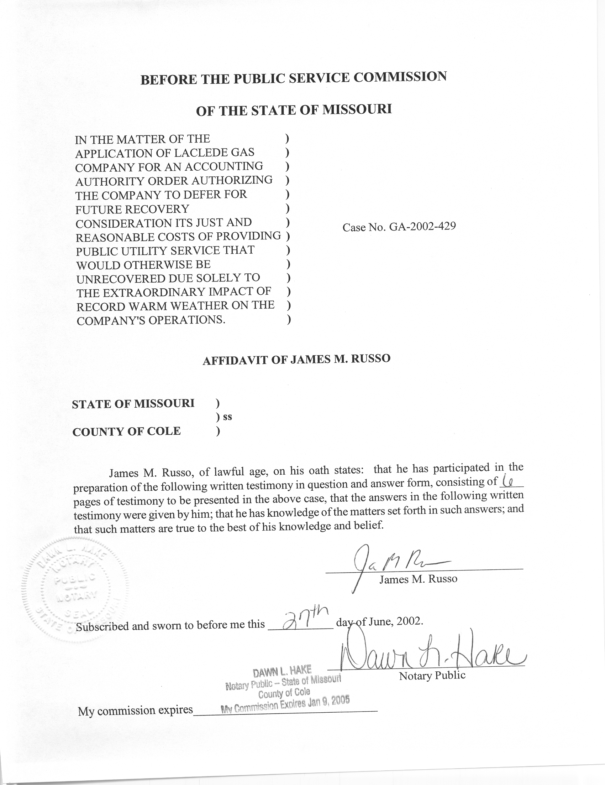
REBUTTAL TESTIMONY
OF
JAMES M. RUSSO
LACLEDE GAS COMPANY
CASE NO. GA-2002-429
Please state your name and business address.
James M. Russo, P. O. Box 360, Jefferson City, Missouri 65102.
By whom are you employed and in what capacity?
I am a Regulatory Auditor with the Missouri Public Service Commission (Commission).
Please describe your educational background and other qualifications.
I graduated from California State University-Fresno, Fresno, California and received a Bachelor of Science degree in Accounting. Prior to my employment with the Commission, I was employed in various capacities by local elected officials in county government. I was the assistant treasurer-tax collector for San Joaquin and El Dorado Counties in California. My responsibilities included all financial dealings of the counties and all accounting activities of the agency. In addition, I was the supervising accountant auditor in El Dorado County for two years. My division was responsible for internal audits of all county agencies, special districts and franchise/lease agreements.
What has been the nature of your duties with the Commission?
From April 1997 to December 2001, I worked in the Accounting Department of the Commission, where my duties consisted of directing and assisting with various audits and examinations of the books and records of public utilities operating within the State of Missouri; under the jurisdiction of the Commission. On December 16, 2001, I assumed the position of Regulatory Auditor IV in the Energy Tariffs/Rate Design Department where my duties consist of analyzing applications, reviewing tariffs and making recommendations based upon these evaluations.
Have you previously filed testimony before this Commission?
Yes, I have. Please refer to Schedule 1, which is attached to this rebuttal testimony, for a list of cases in which I have filed testimony.
With reference to Case No. GA-2002-429, have you made an examination and study of the material filed by Laclede Gas Company (Laclede or Company) relating to its proposal to defer costs?
Yes, in conjunction with other members of the Commission Staff (Staff).
Please describe the principal area of your rebuttal testimony in this case.
My principal area of responsibility is responding to the Company’s request to defer costs of service.

Deferral of Alleged Costs
Company Witness Michael R. Spotanski states that Laclede is seeking to defer and recover costs related to the Company’s cost of service that the Company has not collected. Does Staff agree with this position?
No. Staff believes the Company has recovered its cost of service and is attempting, through a form of retro-active ratemaking, to have the ratepayer, after rates have been set, pay for gas the ratepayer did not use this last winter heating season over the next five years. If Laclede doesn’t earn as much revenue as it believes it is entitled too, Laclede proposes to increase the customer rates, after the fact, to levels that are not just and reasonable.
Why does Staff believe the Company has recovered its cost of providing service to the ratepayers?
Staff believes the Company has recovered its cost of providing service to the ratepayers because the Company’s financial records show Laclede earning a profit through March 31, 2002, which is the first six months of the Company’s fiscal year. In fact, Laclede’s news release dated April 25, 2002, states:
The Laclede Group, Inc. (NYSE: LG) today reported earnings of $1.10 per share for the second quarter of its fiscal year, the period ended March 31, 2002, an amount equal to earnings for the same period last year.

In addition, Laclede issued another news release dated May 23, 2002, which states:
The Board of Directors of The Laclede Group, Inc. at a meeting held May 23, 2002, declared a quarterly dividend of 33 ½ cents per share on the $1 Par Common Stock, payable July 1, 2002, to stockholders of record on June 11, 2002.
The above news releases are attached to my rebuttal testimony as Schedule 2.
Laclede would have the Commission believe that their Company is not recovering its costs and is struggling to meet its everyday and Commission-mandated obligations. The financial facts are different. Not only has Laclede had a profit for at least the last four years, they have also increased their stock dividend from 32 cents per share to 34 cents per share during this time period. In addition, Standard & Poor’s credit rating for Laclede as of May 7, 2002, is A+. This is defined as high-grade, high quality.
Q. Why does Staff believe this is a form of retroactive ratemaking?
A. Staff believes this a form of retroactive ratemaking because Laclede is coming before this Commission after rates have been set and requesting permission to collect additional revenues for this previous time period. The Company is asking this Commission to allow the Company a mechanism to collect revenues that Laclede had the opportunity to collect, but that simply did not materialize.
Q. Does Staff support the proposed accounting authority order (AAO) by the Company?
A. No. Staff does not support the proposed AAO.
Q. Why is Staff opposing the proposed AAO?
A. As stated earlier, Staff believes the proposed AAO is a form of retroactive ratemaking. Staff also believes the proposed AAO alters the meaning of the Commission granting the Company a rate of return on its investment. In the past, under traditional rate making rules, the Commission approves a rate of return on a utility’s investment in rate base and grants the Company an opportunity to earn a rate of return on this investment.
The Company would lead the Commission to believe that warmer than normal weather has caused Laclede to not recover costs. Staff believes that the weather in this case, based on Laclede’s press releases to the public, did not have an unusual impact on earnings for the current year. As stated earlier, Laclede earned $1.10 per share for the quarter ending March 31, 2002, which was the same amount Laclede earned for the same quarter one year earlier. In the Company’s press release dated April 25, 2002, the Company states:
However, natural gas sales were significantly lower than last year due to temperatures in the St. Louis area that were 15% warmer than last year and 12% warmer than normal.
The Company’s press release dated April 26, 2001, which I have attached to my rebuttal testimony as Schedule 3, states:
The 7% increase in earnings is primarily the result of higher gas sales volumes resulting from winter weather that was 24% colder than last year and 3% colder than normal.
Staff believes that the above statements from the Company’s press releases clearly show that the weather for the last two heating seasons resulted in the same earnings for the quarter ending March 31. Staff does not believe the year to date earnings for Laclede to be significantly impacted by the weather, and, if the weather has had some type of impact on earnings for Laclede, that the impact is minimal.
Q. Are there any other reasons why Staff opposes the proposed AAO?
A. Yes. Staff believes the proposed AAO does not meet the criteria employed by the Commission for granting AAO’s. Mark Oligschlaeger, of the Accounting Department, will address the criteria in his rebuttal testimony.
Does Staff agree with the methodology used by Laclede to calculate the revenue shortfall?
- No. Staff has opposed the methodology used by Laclede in previous rate cases and is opposing the methodology in Laclede’s pending current rate case
GR-2002-356. Specifically, Staff does not agree with Laclede’s weather normalization as discussed in Mr. Patterson’s direct testimony filed in case GR-2002-356, and does not agree with Laclede’s amount of gas used per customer degree day (UCDD) which is discussed in the direct testimony of Dr. Henry Warren, filed in case GR-2002-356.
Is the Staff in agreement with the Company’s computed deferred dollar amount should the Commission allow the Company to defer costs under the proposed AAO?
No. Staff does not agree with the revenue shortfall calculated by Laclede. Specifically, Staff does not agree with the heating degree-days or the therms per heating degree-day calculated by Laclede. Furthermore, Staff does not believe it is correct or appropriate to use Laclede’s method of a point estimate of 109.0 therms per heating degree-day to adjust the test year therms to normal. Staff Witness James A. Gray will discuss this further in his rebuttal testimony.
Does this conclude your rebuttal testimony?
Yes, it does.
RATE CASE PROCEEDING PARTICIPATION

JAMES M. RUSSO

COMPANY CASE NO.
Union Electric Company GR-97-393
Gascony Water Company WA-97-510
St. Joseph Light and Power Company EC-98-573
St. Joseph Light and Power Company HR-99-245
St. Joseph Light and Power Company GR-99-246
St. Joseph Light and Power Company ER-99-247
UtiliCorp United Inc./St. Joseph Light and Power Company EM-2000-292
UtiliCorp United Inc./Empire District Electric Company EM-2000-369
Osage Water Company WR-2000-557
Osage Water Company SR-2000-556
Missouri Gas Energy GR-2001-292
Environmental Utilities WA-2002-65
Laclede Gas Company GR-2002-356

