Exhibit No.:
Issues: Laclede Pipeline; Safety and Copper Service Replacement Programs
Witness: Stephen M. Rackers
Sponsoring Party: MoPSC Staff
Type of Exhibit: Rebuttal Testimony Case No.: GR-2002-356
Date Testimony Prepared: August 2, 2002

MISSOURI PUBLIC SERVICE COMMISSION

UTILITY SERVICES DIVISION

REBUTTAL TESTIMONY

OF

STEPHEN M. RACKERS

LACLEDE GAS COMPANY

CASE NO. GR-2002-356

Jefferson City, Missouri
August 2002
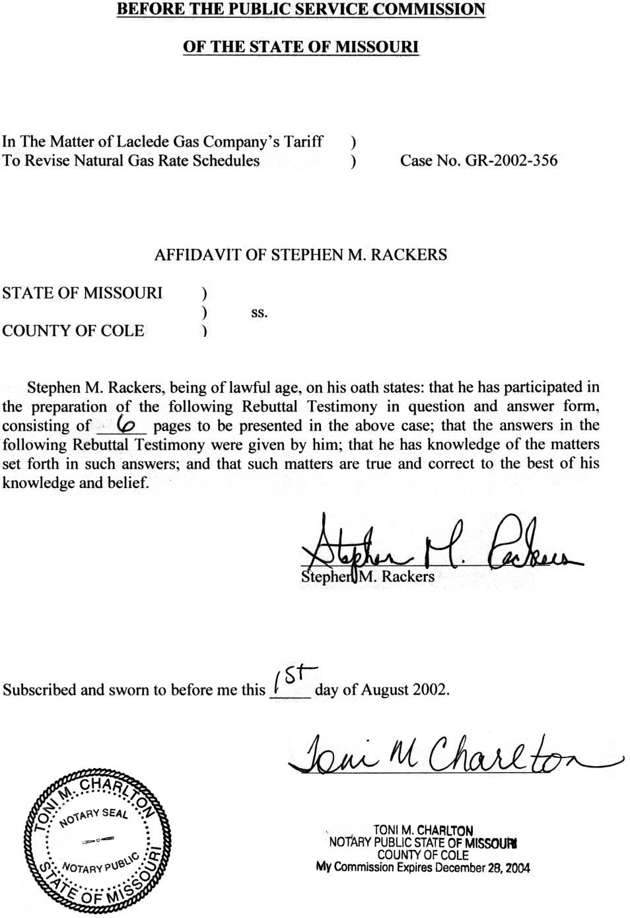

TABLE OF CONTENTS

REBUTTAL TESTIMONY OF

STEPHEN M. RACKERS

LACLEDE GAS COMPANY

CASE NO. GR-2002-356
LACLEDE PIPELINE 1
SRP AND CSRP 3

REBUTTAL TESTIMONY

OF
STEPHEN M. RACKERS

LACLEDE GAS COMPANY

CASE NO. GR-2002-356

Please state your name and business address.
Stephen M. Rackers, 815 Charter Commons Drive, Suite 100B, Chesterfield, Missouri 63017.
By whom are you employed and in what capacity?
I am employed by the Missouri Public Service Commission (Commission) as a Regulatory Auditor V.
Are you the same Stephen M. Rackers who has previously filed direct testimony in this case?
Yes. I previously filed direct testimony in this case on June 20, 2002.
What is the purpose of your rebuttal testimony?
The purpose of this testimony is to rebut the direct testimony of Laclede Gas Company (Laclede or Company) witnesses Glenn Buck regarding Laclede Pipeline Company (Laclede Pipeline) costs and James Fallert regarding the costs associated with the Company’s Safety Replacement Program and Copper Service Line Replacement Program, (SRP and CSRP, respectively).

LACLEDE PIPELINE
Please briefly describe the function of Laclede Pipeline.
Laclede Pipeline owns and operates a pipeline for transporting liquid propane gas, purchased by Laclede from its suppliers, to a Company owned storage cavern. Laclede maintains an inventory of liquid propane gas at an underground storage site in St. Louis County for use during peak periods. Laclede Pipeline is a wholly owned subsidiary of Laclede Group, Inc. and an affiliate of Laclede Gas Company.
How has the Company included the costs from Laclede Pipeline in the determination of revenue requirement?
The Company’s position is discussed in Mr. Buck’s direct testimony. As he states on page 13, the Company proposes to include a cost of service item (expense) in the income statement.
How was the level of the expense determined by the Company?
A calculation of the expense appears in the workpapers supplied by Laclede to support its adjustments. The calculation reflects a component for return on investment, including income taxes and a component for operating expenses.
Q. Do you agree with the Company’s position and its calculation of the return component?
A. No. In the Staff’s opinion, Laclede Pipeline exists almost exclusively to provide the essential function of delivering propane for peaking to Laclede for the provision of service to the Company’s ratepayers. Therefore, the net investment should be included in rate base and should receive the same return that the Commission finds is appropriate for all other utility assets. The net income from Laclede Pipeline operations should also be included in the cost of service as an offset to the return on investment and the operating costs. This is consistent with the manner in which the Staff has recognized the return on Laclede Pipeline net investment in its determination of revenue requirement.
Do you agree with the operating cost component as calculated by the Company?
No. Mr. Buck’s calculation does not consider the revenue earned by Laclede Pipeline. This revenue is charged to Laclede in the form of a mark-up on the cost of propane delivered to the Company. During the Staff’s test year, the revenue exceeded the operating costs of Laclede Pipeline by over $250,000. It is inappropriate to include the operating expenses and a return on investment in the cost of service without removing this net mark-up embedded in expense. The Staff’s cost of service includes the Laclede Pipeline net operating income, which effectively recognizes the operating costs and eliminates the mark-up. Also included in the net income of Laclede Pipeline is a minimal amount of transportation sales to customers other than Laclede. Including the income from these sales in the cost of service compensates Laclede’s ratepayers for the third party use of the investment and partially offsets the operating costs borne by ratepayers.
Q. Has the Staff treated this item in a similar manner in the past?
A. Yes, the Staff used the same methodology for including Laclede Pipeline in the cost of service in the previous Laclede rate case.

SRP AND CSRP
Q. Please explain the Company’s position regarding this issue.
A. Laclede is proposing to include one third of the total amount of cost, which it estimates would be incurred during the next three years, associated with the SRP and CSRP. The Company’s proposal is discussed on pages 31 through 33 of Mr. Fallert’s direct testimony.
Q. Do you agree with this proposal?
A. No. The Company’s proposal is an attempt to include costs associated with future construction that would occur through July of 2005 in current rates. Also, a proposal similar to the one being advanced by Laclede has previously been rejected by the Commission.
Q. Please explain how Laclede’s proposal is an attempt to include future plant costs in current rates.
The Company’s proposal addresses the items that the Commission has historically allowed to be deferred, through an accounting authority order (AAO), associated with the SRP and CSRP. These items are carrying cost (return) on investment, depreciation expense and property taxes incurred prior to the plant being recognized in rates. Laclede’s proposal seeks to include these costs, associated with future construction, in the revenue requirement in the current case. These costs occur after the July 31, 2002 Commission ordered true-up cut-off date for construction additions in this case. In fact, the majority of these costs are associated with construction that is estimated to occur during the two and one-half years following the operation of law date in this case, December 25, 2002.
How has the Company calculated these future plant costs?
A. The Company has estimated the amount of plant that it expects to invest in the SRP and CSRP from July 2002 through June 2005. Laclede has offset this estimated future investment by the amount of associated reserves for depreciation and deferred taxes that would accumulate from August 1, 2002 through July 31, 2005, to determine its net plant investment. The Company applied the interest rate for short-term debt, which it uses to fund construction, to its calculated future net plant investment, to determine the associated carrying cost. The depreciation expense that would be incurred on the estimated future plant and estimated property tax expense associated with the investment were then added to the carrying cost on future plant to determine the total estimated costs incurred from August 1, 2002 through July 31, 2005. This total estimated future plant cost was divided by three to determine an annual level. This annual level was included as an expense in the Company’s calculation of its cost of service.
Q. Previously you stated that the Commission has allowed these types of cost to accumulate according to an AAO. Is this calculation representative of the deferrals that would be expected to accumulate according to an AAO?
A. No. AAOs usually end at the update or true-up date of the case following their establishment. For example, the SRP and CSRP AAOs established in the last Laclede rate case, GR-2001-629, will end at the true-up cut-off date of July 31, 2002, in this case. Any future AAO for SRP and CSRP would begin August 1, 2002. The calculation supporting Laclede’s proposal reflects an accumulation of cost for the next three years ending July 31, 2005. This calculation assumes that there are no changes in rates during the next three years. Considering the frequency of rate filings by Laclede, it is unrealistic to expect or assume that these costs will accumulate for three full years prior to a rate change. In recent history, Laclede has filed a rate case on less than a two-year interval. Therefore, Laclede’s calculation overstates the annual expense, since it is based on one-third of a three-year accumulation of cost.
Q. Please explain your previous statement regarding the Commission’s rejection of a similar adjustment.
A. In Case No. WR-2000-844, St. Louis County Water Company (SLCWC) proposed to recover future plant costs associated with its water main replacement program. This proposal is similar to Laclede’s request to recover future plant cost associated with its gas main and service line replacement programs in this case. In its order the Commission stated the following regarding SLCWC’s future plant proposal.
The Commission will not get bogged down in the arguments over whether the Company has in the past made commitments to ramp up its replacement, or whether the Commission made an invitation for the Company to request inclusion in rate base of future plant or a suggestion that the Commission would approve such a request. The evidence in this case indicates that, while the situation may not yet be a crisis, now is the time for the Company to begin its infrastructure replacement program. The Company has recognized that such a program is necessary, and the Commission has found it to be so.

The Company's future plant proposal, however, runs afoul of several core regulatory principles and the Commission will not adopt it. It violates the used and useful standard, with the attendant harm to intergenerational equity. In other words, it would require current customers to pay for plant that is proposed to be built in the future, and possibly not used to provide service until after some of them are no longer customers. It violates the matching principle, that is, it builds into current rates an increase in one area of expenses, but does not take into account any possible savings in other areas or possible increased revenues.
Does Laclede’s proposal, like that of SLCWC, run afoul of the core regulatory principles sited by the Commission in its order in Case No. WR-2000-844?
Yes. The costs that Laclede seeks to include in its current cost of service, through its proposal, are clearly related to plant that will not be in service until after the true-up cut-off date and/or the operation of law date in this case.
- Does this conclude your rebuttal testimony?
Yes, it does.

