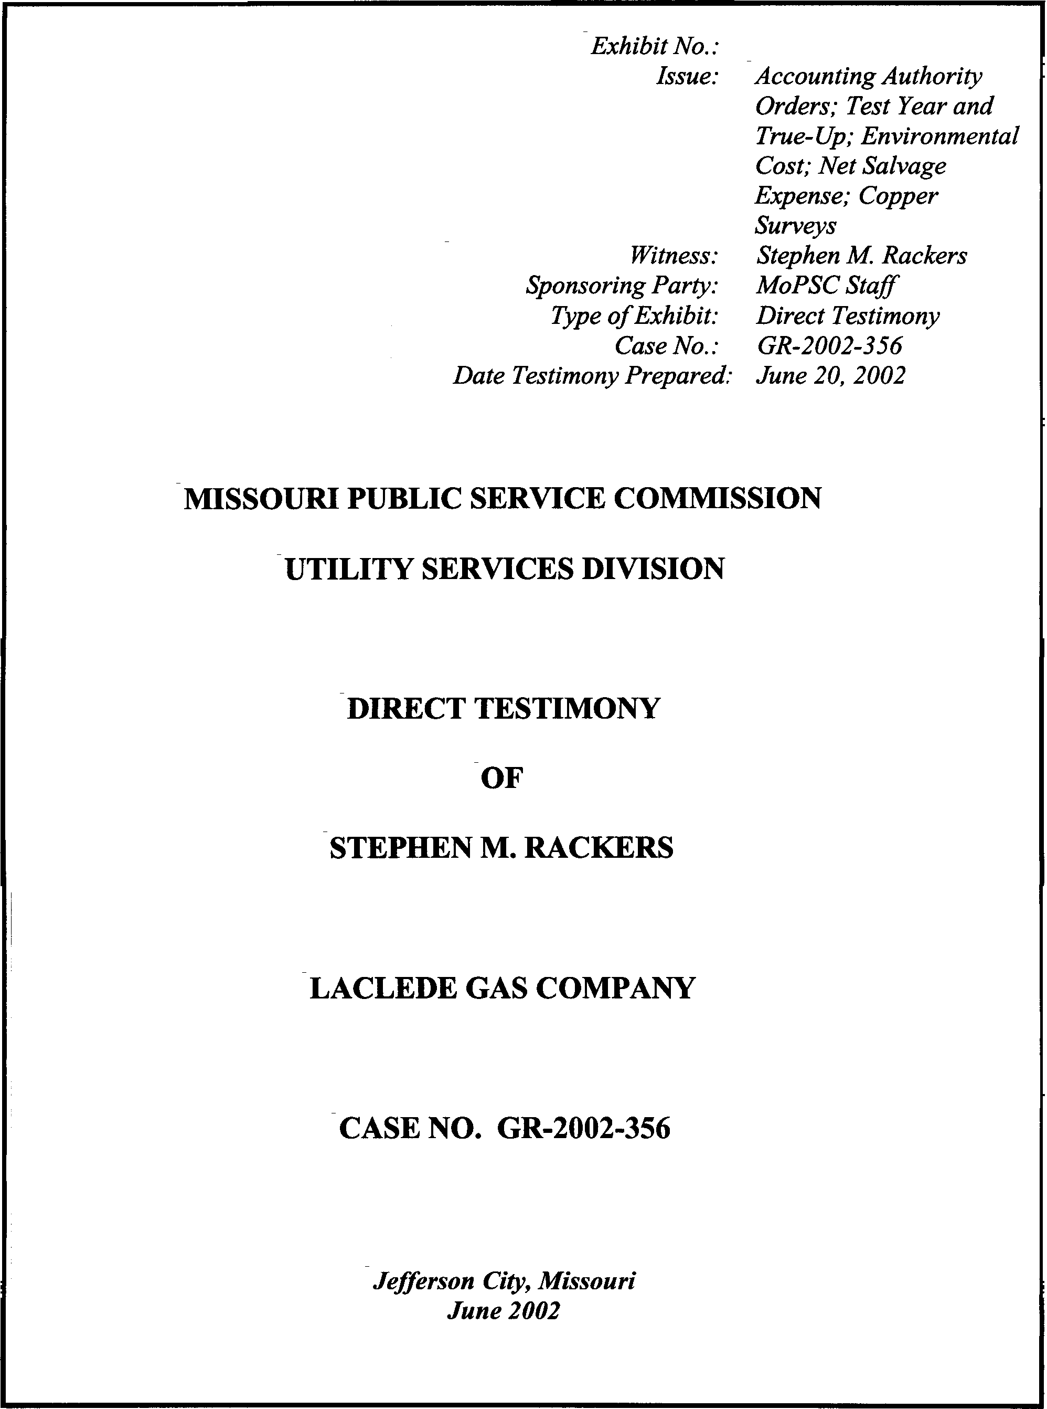
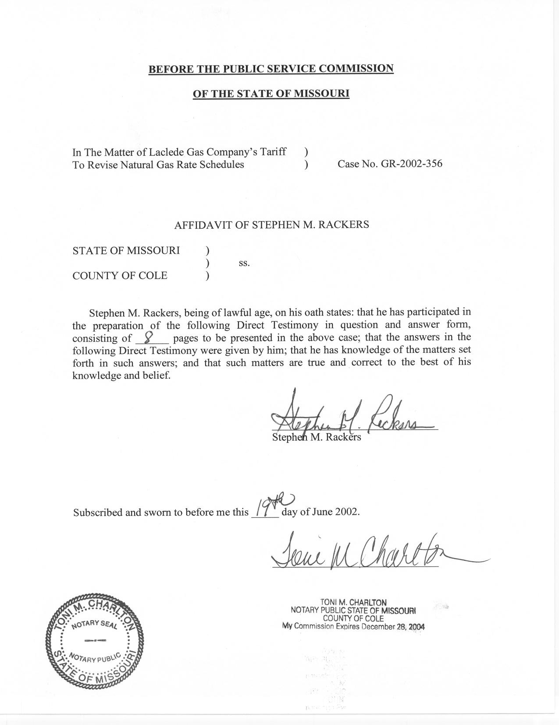

TABLE OF CONTENTS

DIRECT TESTIMONY OF

STEPHEN M. RACKERS

LACLEDE GAS COMPANY

CASE NO. GR-2002-356

TEST YEAR AND TRUE-UP AUDIT 2
ENVIRONMENTAL COSTS 4
NET SALVAGE EXPENSE 5
ACCOUNTING AUTHORITY ORDERS (AAOs) 6
COPPER SURVEYS 8

DIRECT TESTIMONY
OF
STEPHEN M. RACKERS
LACLEDE GAS COMPANY
CASE NO. GR-2002-356

Please state your name and business address.
Stephen M. Rackers, 815 Charter Commons Drive, Suite 100B, Chesterfield, Missouri 63017.
By whom are you employed and in what capacity?
I am employed by the Missouri Public Service Commission (Commission) as a Regulatory Auditor V.
Please describe your educational background.
I attended the University of Missouri – Columbia, where I received a Bachelor of Science degree in Business Administration with a major in Accounting in 1978. I have passed the Uniform Certified Public Accountant examination and am licensed to practice in the state of Missouri.
What has been the nature of your duties while in the employ of this Commission?
I have conducted and assisted with the audits and examinations of the books and records of utility companies operating within the state of Missouri.
Have you previously filed testimony before the Commission?
Yes, I have. Please refer to Schedule 1, attached to this direct testimony, for a list of cases in which I have previously filed testimony.
With reference to Case No. GR-2002-356, have you made an investigation of the books and records of Laclede Gas Company (Laclede or Company)?
Yes, with the assistance of other members of the Commission Staff (Staff).
What are your primary areas of responsibility in this case?
My primary responsibilities in this case are environmental costs associated with manufactured gas plants, accounting authority orders (AAOs), copper surveys and net salvage expense.
What Accounting Adjustments to the Income Statement are you sponsoring?
I am sponsoring the following adjustments in Accounting Schedule 10, Adjustments To Income Statement:
S-11.2 Safety related maintenance savings
S-11.5 Copper survey expense
S-15.19 Environmental expense
S-16.3 Net salvage expense
S-17.2 Terminated AAO amortization
S-17.3 Safety related AAO amortization

TEST YEAR AND TRUE-UP AUDIT
What test year has the Staff utilized in this case?
The Staff has used a test year ending November 30, 2001, updated through March 31, 2002.
Is the Staff proposing a true-up audit in this case?
Yes. In accordance with the Commission’s Order, the Staff will perform a true-up audit for the period ending July 31, 2002, provided that the necessary information is available in a timely manner. As provided in the Order, the items considered in the true-up audit must result in a proper matching of rate base, expenses and revenue. To that end, the following items should be included in the true-up audit:
Rate Base: Plant-in-service, depreciation and amortization reserves, customer advances for construction (advances), prepaid pension asset, customer deposits, gas inventories, Insulation Finance and Energy Wise programs, and deferred income taxes. Cash working capital and the income tax and interest offsets will also change, to the extent these amounts are affected by other true-up items.
Income Statement: Depreciation expense as affected by net plant additions, property taxes based on new property assessments and tax rates, revenues associated with customer additions, payroll and related payroll costs as a result of changes in employee levels and wage rates, employee benefits, rate case expense, changes in gas safety deferrals associated with the accounting authorizations in Case No. GR-2001-629, insurance expenses, postage and income taxes, as affected by all the true-up items.
Capital Structure and Associated Embedded Costs: Changes in the Company’s capital structure and associated embedded costs of the related capital items excluding return on common equity will also be reflected in the Staff’s true-up audit.
To be included in the true-up audit, all items must be known, evidenced by documentation (i.e., inspection, monthly operating reports, invoices, Company ledgers, etc.) and the effect must be measurable.
The above items, at a minimum, will be examined in the context of a true-up audit. In addition, other items may be subject to review, as events may warrant, as indicated in the direct testimony of other Staff witnesses.
- Have you included an estimate of the value of true-up?
A. Yes. The Staff has calculated an estimate of the major items that it believes will impact the value of true-up. The actual amount will be determined based on the examination of the items listed above during the Staff’s true-up audit. The estimated amount associated with the true-up appears on Accounting Schedule 1 – Revenue Requirement. The amount shown on Schedule 1 includes the estimated impact of return on investment and depreciation expense associated with the increase in net plant. Also included in the true-up estimate is the impact on payroll and payroll taxes associated with wage rate increases occurring after the March 31, 2002, update period. The amount reflects simplified calculations of the impacts of these items. Detailed calculations for these and other items will be performed to determine the impact on revenue requirement during the true-up audit.

ENVIRONMENTAL COSTS
Please briefly describe the environmental costs associated with manufactured gas plants.
The manufactured gas plants were formerly used by the Company to produce gas from coal. The Company has, and continues to incur, costs associated with an Environmental Protection Agency (EPA) mandate to clean up these sites.
Please explain the Staff’s treatment of the costs associated with the environmental clean up of manufactured gas plant sites.
The Staff is recommending the use of the actual test year payments to determine a normal level of expense associated with environmental clean-up costs. Adjustment S-15.19 on Accounting Schedule 10 reflects the difference between the actual payments and the test year recorded accrual related to the clean up of the manufactured gas plants.

NET SALVAGE EXPENSE
Please explain the Staff’s adjustment to depreciation expense for net salvage expense.
A. The Staff’s adjustment reflects the actual net salvage expense incurred during the test year ended November 30, 2002. Net salvage expense has been increasing over the past several years due primarily to the various plant replacement programs the Company is engaged in, particularly with respect to copper service lines. Since these programs are expected to continue in the future at the same level, it is the Staff’s opinion that the test year level of net salvage expense represents a reasonable ongoing amount.
Q. Is the inclusion of net salvage expense in the cost of service as a separate expense item consistent with the treatment proposed by the Staff in the Company’s previous rate case?
A. Yes. In Case No. GR-2001-629, net salvage costs were included in the cost of service as an operating expense. This treatment of the net salvage cost is supported by Staff witness Rosella L. Schad, of the Commission’s Engineering and Management Services Department, and is further discussed in her testimony.

ACCOUNTING AUTHORITY ORDERS (AAOs)
Please identify the adjustments you are sponsoring related to AAOs.
I am sponsoring adjustment S-17.2 to reflect the amortization of AAOs that were granted in Case No. GR-98-374 and terminated by Commission Order in Case No. GR-99-315. I am also sponsoring adjustment S-17.3 to reflect the amortization of the current copper service line and safety related AAOs that were granted in Case No. GR-2001-629 and adjustment S-11.2 for the imputed maintenance savings related to the gas safety AAO.
What do the AAOs consist of that were granted in Case No. GR-98-374?
Subsequent to the Report And Order in Case No. GR-98-374, the Company implemented AAOs for the deferral of costs for supplemental pensions (SERP), Year 2000 computer maintenance (Y2K), manufactured gas plant (MGP), main safety replacement (SRP) and other post-retirement benefits (OPEBs). In a Stipulation And Agreement in Case No. GR-99-315, it was agreed that these AAOs would be terminated. The deferred balance associated with SRP would be amortized over 10 years and the deferred balances for SERP, Y2K, MGP, and OPEBs would be amortized over 15 years.
If the Company was granted the authority to amortize these AAOs, and it has, in fact, been recording the amortization, why is adjustment S-17.2 necessary?
Adjustment S-17.2 is necessary to include the full annual amortization in the cost of service as directed in the Commission’s Report And Order from Case No. GR-99-315. The Company’s understanding of the Federal Regulatory Energy Commission (FERC) rules require that the amortization of any costs that were deferred be charged to the accounts that would have been charged had there been no deferral. Compliance with this accounting methodology results in an omission of a portion of the amortization from the cost of service. In addition, the Staff’s methodology used to calculate the adjustment to depreciation expense eliminates the portion of the amortization that was charged to depreciation expense during the test year. Adjustment S-17.2 reflects the inclusion of the AAO amortization that was recorded below-the-line as allowance for funds used during construction (AFUDC) and restores the amortization that was eliminated through adjustment S-16.1 to depreciation expense.
What cost is the Company currently authorized to defer in the AAOs that were granted by this Commission in the Company’s last case, Case No. GR-2001-629?
The Company is currently authorized to use an AAO for the deferral of cost related to its copper service line and safety main replacement programs. The costs being deferred include depreciation, property tax and carrying charges.
How is the Staff proposing to treat the costs deferred in these AAOs?
The Staff, as reflected in adjustment S-17.3, is proposing a 10-year amortization of the deferrals, no rate base inclusion of the unamortized balances and a rate base offset for the related deferred income taxes. Additionally, the Staff has made an adjustment to reflect the imputed plant maintenance savings directed in the Report And Order from Case No. GR-99-315. The imputed maintenance savings is identified as adjustment S-11.2. Except for the imputation of maintenance savings, adjustment S-17.3 reflects the prescribed treatment in Case No. WR-2000-844 involving St. Louis County Water Company for its infrastructure replacement program AAO and in Case No. GR-98-140 involving Missouri Gas Energy’s (MGE) safety deferrals. In the Commission’s Order in Case No. GR-98-140 involving MGE, the Commission noted that by using a 10-year amortization period it was recognizing a shorter term than the 20 years the Staff had recommended, and it had approved, in prior cases. Given this reduced amortization period, the Commission deemed it proper for the ratepayers and shareholders to share the effect of regulatory lag by allowing the Company to earn a return of, but not a return on, the deferred balance.
Is the Staff recommending that the Commission authorize AAOs to continue the deferral of costs related to the replacement of service lines and mains?
A. Yes, the Staff recommends that the Commission authorize AAOs for the deferral of depreciation, property taxes and carrying costs associated with copper service line and safety replacement programs. The current AAOs should cease at the end of the true-up period in this case. The new AAO should begin following the true-up audit in this case and continue through the later of the end of the test year, up-date period or true-up period in the next case. As with previous AAOs for Laclede’s copper service line and safety deferrals, the Company should be required to file a case within 24 months following the effective date of the order in this case for the deferrals to be considered for possible future recovery.

COPPER SURVEYS
What level of copper surveys has the Staff included in its cost of service?
The annualized level of copper service line leak survey costs reflects the actual cost incurred for the test year ending November 30, 2001. This amount was booked to a deferred account during the test year. Adjustment S-11.5 includes the deferred amount in expense.
- Does this conclude your direct testimony?
A. Yes, it does

RATE CASE PROCEEDING PARTICIPATION
STEPHEN M. RACKERS

Company Case Number
Bowling Green Gas Company | GR-78-218
Central Telephone Company | TR-78-258
Empire District Electric Company | ER-79-19
Fidelity Telephone Company | TR-80-269
St. Louis County Water Company | WR-80-314
Union Electric Company | ER-81-180
Laclede Gas Company | GR-81-245
Great River Gas Company | GR-81-353
Union Electric Company | ER-82-52
Laclede Gas Company | GR-82-200
St. Louis County Water Company | WR-82-249
Union Electric Company | ER-83-163
Union Electric Company | ER-84-168
Arkansas Power and Light Company | ER-85-20
Kansas City Power and Light Company | ER-85-128
Arkansas Power and Light Company | ER-85-265
Union Electric Company | EC-87-114
Union Electric Company | GR-87-62
Southwestern Bell Telephone Company | TC-89-14
St. Louis County Water Company | WR-89-246
Laclede Gas Company | GR-90-120
Missouri Cities Water Company | WR-91-172
St. Louis County Water Company | WR-91-361
Laclede Gas Company | GR-92-165
Missouri Pipeline Company | GR-92-314
St. Louis County Water Company | WR-92-204
St. Louis County Water Company | WR-94-166
St. Louis County Water Company | WR-95-145
Union Electric Company | ER-95-411
Union Electric Company d/b/a AmerenUE | EM-96-149
St. Louis County Water Company | WR-96-263
St. Louis County Water Company | WR-97-382
Laclede Gas Company | GR-99-315
Missouri-American Water Company | WR-2000-281 et al
St. Louis County Water Company | WR-2000-844
Laclede Gas Company | GR-2001-629
Union Electric Company d/b/a AmerenUE | EC-2002-1
Union Electric Company d/b/a AmerenUE | EC-2002-1025

