Exhibit No.:

Issues: Other Tariff Issues
Witness: James M. Russo
Sponsoring Party: MoPSC Staff
Type of Exhibit: Rebuttal Testimony
Case No.: GR-2002-356
Date Testimony Prepared: August 2, 2002

MISSOURI PUBLIC SERVICE COMMISSION

Utility Operations DIVISION

REBUTTAL TESTIMONY

OF

James M. RUSSO

LACLEDE GAS COMPANY

CASE NO. GR-2002-356

Jefferson City, Missouri
August, 2002

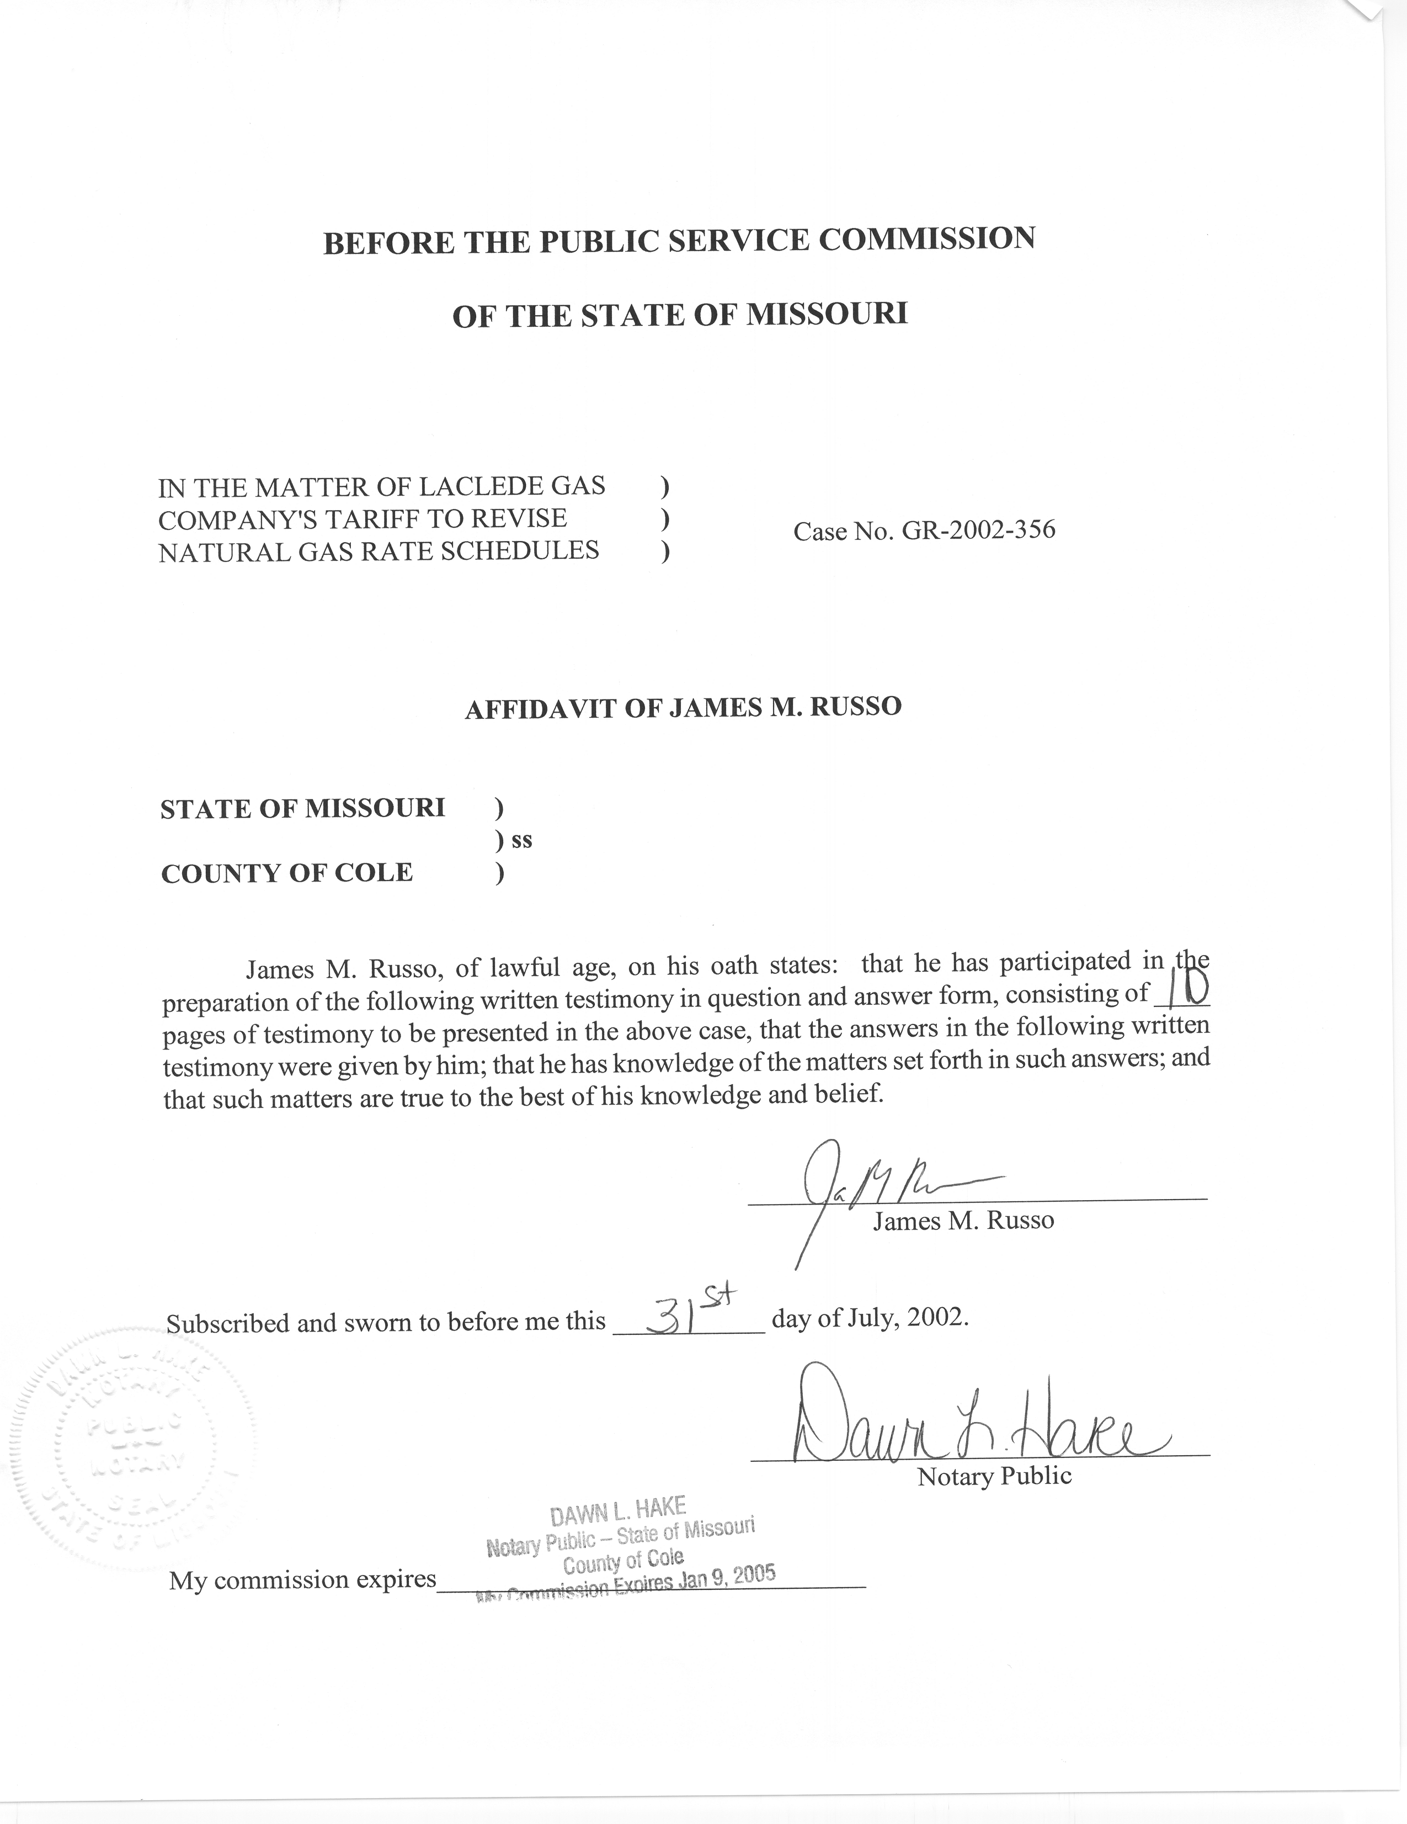
REBUTTAL TESTIMONY
OF
JAMES M. RUSSO
LACLEDE GAS COMPANY
CASE NO. GR-2002-356
Q. Please state your name and business address.
- James M. Russo, P. O. Box 360, Jefferson City, Missouri 65102.
Q. Are you the same James M. Russo who filed Direct Testimony in Case No. GR-2002-356?
A. Yes I am.
Q. What is the purpose of your Rebuttal Testimony?
A. The Purpose of my Rebuttal Testimony is to rebut the Weather Mitigation Clause (WMC) proposed by Laclede Gas Company (Laclede or Company) in the pre-filed Direct Testimony of Company Witnesses Douglas H. Yeager and Michael T. Cline.

Weather Mitigation
Q. Company Witness Cline refers to the mismatching of revenues and costs throughout his direct testimony. Does Staff believe this is correct terminology?
A. No. Staff believes Company Witness Cline is attempting to say that every expense is directly offset by the Company collecting a matching revenue. Staff believes, simply stated, a company sells a product and collects revenues from that sale, expenses are paid from the revenues collected and what ever is left over is profit and that profit is not guaranteed. However, Mr. Cline states in his Direct Testimony on page 6, lines 15 thru 19:
The WMC proposed by the Company would alleviate the mismatching of revenues and costs that occurs under the Company’s existing rate design when the weather in the Company’s service area is colder or warmer than normal. The WMC would also reduce the bill volatility that occurs as a result of such weather variations.
Mr. Cline further explains what he means by the mismatching of revenues and costs that occur under the Company’s existing rate design in his Direct Testimony on page 6, line 22 thru page 7, line 10:
Presently, over one-half of the non-gas revenues generated by the Company under the Residential General Service (“RG”) and Commercial and Industrial General Service (“CG”) rate schedules are derived from the Charge For Gas Used (“CGU”), a volumetric rate that varies based on the time of the year the gas is used (winter or summer) and the rate block into which the customer’s usage falls. The balance of the RG and CG revenues are derived from the customer charge. The CGE is determined in the Company’s general rate case proceedings based on normalized sales volumes, which, in turn, are based on normal weather. Because the CGU charge is volumetric in nature, the level of revenues received by the Company to recover its costs will, in turn, vary (i.e. be either higher or lower) from the level assumed when rates were established in the event it is colder or warmer than normal.
And Mr. Cline states in his direct testimony on page 7, lines 12 and 13 that:
A mismatch results because virtually all of the Company’s costs, other than the cost of gas, are fixed.
Mr. Cline also states on page 7, line 23 thru page 8, line 5:
Stated another way, under the Company’s existing rate design, when the weather is either colder or warmer than normal, customers are needlessly forced to pay for costs that do not exist or the Company is prevented from recovering costs that have, in fact, been incurred. Implementation of the WMC proposed by the Company would significantly alleviate this mismatch of revenues and costs.
Q. Do you agree with Mr. Cline that there is a mismatch of revenues and costs?
No, because the Company is including return on equity when it uses the term cost. Further, the Company is omitting the very important point that rates are set to give the Company an opportunity to earn a rate of return. Weather can have an impact on a Company’s overall earnings when it is warmer or colder then normal, but there are other factors, such as consumers using less gas through conservation efforts and changes in the level of expenditures that help contribute to the overall earnings of a Company.
Q. Company Witnesses Yeager and Cline attempt to justify the WMC, in part, by claiming the Company is under-recovering costs for the last four years. Do you agree with this?
No. The Company is attempting to build its case for the WMC by continuously using such buzzwords and phrases as under-recovering costs, substantial under-recovery of costs and abnormally warm weather. For instance, Mr. Yeager states in his direct testimony on page 5, lines 1-4:
… the impact of abnormally warm weather, which during the last three months of 2001 alone, caused the Company to under-recover its fixed distribution costs by an amount equal to nearly one-third of the increase.
And on lines 9 thru 10:
They have led to a persistent and increasingly serious under-recovery by the Company of its actual costs of providing service.
Again on page 6, lines 8 thru 10:
To the contrary, such under-recoveries consist primarily of costs that form the backbone of our utility operations—costs that no one has even suggested are unnecessary or non-essential to the Company’s fulfillment of its mandated public utility obligations.
In his Direct Testimony on page 6, line 20 thru line 21, Mr. Yeager states: “Ratemaking policies that, by one device or another, permit a chronic under-recovery of such non-discretionary costs are simply unsustainable.”
Company Witness Cline states in his direct testimony on page 7, lines 18 thru 21:
As a result, under the existing rate structure, the reduction in sales volumes attributable to warmer than normal will cause the Company to under-recover its costs and fail to earn the rate it was authorized in its last rate case (emphasis added).
Finally, even the Company’s work papers filed with this case titled Schedule 2, Laclede Gas Company, Summary of Normalization and Annualization, Adjustments to Items of Income and Expense, Year ended November 30, 2001, Adjustment #1k refers to their WMC adjustment as: “adjust revenues associated with the weather mitigation clause.”
Q. Does Staff believe that Laclede is not recovering its fixed costs?
No. Staff believes that Laclede has been recovering its fixed costs related to the provision of natural gas service to its customers. Both witnesses are instead testifying that Laclede has not been able to earn its authorized rate of return. However, the Commission authorizing a rate of return does not guarantee that the Company will earn that, but gives the Company the opportunity to earn that return. Staff further believes the naming of the adjustment to include the word revenue and the comments from Mr. Yeager stating the Company is not achieving its authorized rate of return, further bolsters Staff’s belief that the Company has recovered its expenses and is attempting to further bolster its bottom line for the direct benefit of the Company’s shareholders at the expense of its ratepayers.
In fact, Laclede has had a profit for at least the last four years. Lacledes news release dated October 25, 2001 states:
The primary use for natural gas in Laclede’s service area is for residential and commercial heating. Colder weather results in increased volumes of natural gas sold and transported, thus contributing to higher earnings. Heating season temperatures in Laclede’s service area during fiscal 2001 were 10% colder than normal and 30% colder than in fiscal 2000 – which was the third warmest heating season on record. As a result, Lacledes earnings for fiscal 2001, at $1.61 per share, were up nearly 18% over the Company’s fiscal 2000 earnings of $1.37 per share.
Laclede’s news release dated October 26, 2000 states:
Per-share earnings in fiscal 2000 were $1.37 (on average shares outstanding of 18,877,987), compared with per-share earnings of $1.43 in fiscal 1999 (on average shares outstanding of 18,138,261).
Laclede’s news release dated October 28,1999 states:
…The impact of this non-recurring charge was to reduce Lacledes fiscal 1999 earnings by 11 cents per share, to $1.43 (on average shares outstanding of 18,138,261), compared with $1.58 per share last year (on average shares outstanding of 17,597,591).
Please see schedule 1 attached to my Rebuttal Testimony for copies of the above press releases.
The statements quoted by senior Company personnel paint a bleak financial picture of the Company. The financial reports issued by Laclede in the Company’s press releases paint a different picture.
Q. Do you agree with the statement by Company Witness Cline in his Direct Testimony on page 10, lines 18 thru 23, that states:
Nor can I understand how anyone would claim that public policy is better served by maintaining an approach that, due solely to the uncontrollable vagaries of the weather, virtually guarantees a result different from what the Commission has just determined to be just and reasonable. For all of these reasons, the Company believes the need for, and merits of, its proposed weather mitigation clause, is both clear and compelling.
No. The above statement indicates that any difference in earnings from what the Commission has deemed as just and reasonable for Laclede is solely caused by weather. There are many other factors that contribute to Laclede’s earnings. These include management decisions on the operations of the Company and the control of expenditures.
Q. Your earlier testimony quoted Company Witness Yeager saying:
Ratemaking policies that, by one device or another, permit a chronic under-recovery of such non-discretionary costs are simply unsustainable.
In addition, Mr. Yeager, in his Direct Testimony on page 6, lines 5 thru 7 states:
The magnitude of the under-recoveries experienced by the Company as a result of weather and a significant deviation from the traditional ratemaking process, however, far exceeds any amount that could be attributed to such items.
Mr. Cline says the CGE is determined in the Company’s general rate case proceedings based on normalized sales volumes, which in turn, are based on normal weather.
These statements would lead one to believe that the Commission has issued ratemaking decisions related to weather that are a detriment to Laclede. Are you aware of any recent decision by the Commission on weather in a Laclede rate case?
No, I am not. It is my understanding that the Commission has not made a decision on weather normals or a methodology for weather adjustment volumes in a Laclede rate case for at least the last ten years. The Company has stipulated to dollar amounts without coming to any agreement with Staff on weather or adjustment methodology.
Q. Earlier you referred to Mr. Yeager’s statement in his Direct Testimony on page 5, lines 1 thru 5 that stated: that the impact of weather alone has caused the Company to under-recover its fixed distribution costs.
Mr. Yeager quantifies his under-recovery statement, noted above, in his Direct Testimony on page 10, lines 3 and 4, by stating: “As a result, the Company under-recovered its costs in these two months alone by approximately $5 million dollars.”
Do you agree that the Laclede has under-recovered $5 million dollars due to this abnormally warm weather?
No. The Company has offered no evidence that the weather was abnormally warm and the Company provides no definition for what Laclede considers to be abnormally warm weather. Nor does the Company offer any evidence that the purported under-recovery was not caused by something else. Laclede’s press release dated January 24, 2002, shows a profit of $.41 cents per share for the last three months of 2001. Staff notes that this press release indicates Laclede’s operating income for this period is $18.24 million dollars. Staff also notes that Laclede’s operating income would have been $240,000 higher were it not for losses in Laclede’s non-utility operations. Staff is perplexed by Mr. Yeager’s claim of a $5 million dollar under-recovery and finds no basis for this statement.
Q. Does Staff agree with the statement you earlier quoted from Company Witness Cline as saying that: “The WMC would also reduce the bill volatility that occurs as a result of such weather variations.”
No. As stated in my Direct Testimony, up to 80% of the total charge per therm is attributable to the Purchased Gas Adjustment (PGA). Staff believes that bill volatility is primarily influenced by the actual price of natural gas. Even though weather may have an impact on the price of gas there are numerous other factors such as lack of production, storage, and pipeline and wellhead problems that have a bigger and more immediate impact on price. For instance, lack of production and gas in storage may cause the purchased price of gas to increase regardless of the weather when demand outstrips supply.
Q. Do you agree with Company Witness Cline’s statement in his Direct Testimony on page 8, lines 15 thru 18 that states: “As I will explain later in my testimony, the WMC could help to alleviate this situation and contribute to more stable bills by reducing the impact that weather would have on the magnitude of customers’ bills. Moreover, it would likely do so at the very time that such bill mitigation is most needed.”
No. It is highly unlikely that the WMC will help customers alleviate high bills at the very time that bill mitigation is most needed. The very design of the proposed WMC clause, as provided by Laclede shows how unlikely it will be for this to occur. In fact, under the right set of circumstances the opposite could happen and make it worse for customers. Company Witness Cline states on page 11, lines 12 thru 14, of his Direct Testimony: “Any amounts that have not been credited or charged to customers during the winter would be reflected on customers’ bills during the following winter at the same time the Company’s November PGA rates become effective.”
Under its proposed WMC, Laclede would recover any under recovery of revenue in the following November and December, if there were an early spring in March and April of the preceding winter heating season. If, the weather in November and December were cold then, the financial impact on the ratepayer would be significant.
Q. Does Staff agree with the way the proposed WMC would be calculated?
No. Staff is in disagreement with Laclede's methodology in determining the Water Heating Degree Days (WHHD) for hot water.
Q. Why does Staff disagree with Laclede’s methodology in determining the WHDD for hot water?
Staff has previously discussed this issue in case numbers GR-92-165 and GR-99-315. The Company multiplies therms used in the two summer months of July and August by a factor of 135% to obtain the amount of gas usage related to heating water. Staff Witness Henry E. Warren, PhD. of the Energy Tariffs/Rate Design Department, states in lines 19 thru 22 of his rebuttal testimony in Case No. GR-99-315:
No, this method assumes a constant adjustment between water heating in July and August of the test year and total water heating use for the test year. It does not accurately measure the water heating use in the test year or normal annual water heating use.
Dr. Warren continues on page 3, lines 8 thru 11 of his rebuttal testimony:
So, in the two largest divisions that contain over 90% of the residential customers, the water heating estimates are over 25% above that which is indicated by end-use analysis. Consequently, the amount of therms set aside as not sensitive to heating degree days (HDD) is overstated.

Q. Has the Commission attempted to address the different approaches used by the Company and Staff.
Yes. The Commission issued an Order on August 21, 1992, in case number GR-92-165 for Laclede to “…work with Staff to determine appropriate procedures for estimating and normalizing monthly water heating use.” Dr. Warren referred to an alternative in his Surrebuttal Testimony in that case with the statement on page 6, lines 16 thru 24:
Laclede needs to be given specific procedures and a schedule to implement the procedures for the Order to be implemented. An end-use study needs to be conducted according to recognized procedures. This would provide information for the quantification of water heating use and water temperatures, space heating use and HDD, and possibly other major uses of gas. Detailed information on space heating patterns of customer classes could augment the recommendation of Staff witness James A. Gray in his rebuttal testimony “that the Commission approve Staff’s regression methodology…” Regression results could be compared to end-use results to verify the estimated regression coefficients.

Q. Has the Company fully complied with the Commission Order?
No, the company has not fully complied with the Commission’s Order. As stated in the Rebuttal Testimony of Staff Witness Henry E. Warren in Case Number
GR-99-315, this had not happened as of that date, and to my understanding, still has not happened as of today. The Company is still using the same method it used in Case No. GR-92-165 to adjust for non-space heating usage in this case as they have in these previous cases.
Q. Would you summarize the concerns of the Staff if the WMC is approved?
Staff believes that the WMC is a form of retroactive ratemaking, and, in effect, guarantees Laclede a level of earnings, rather than an opportunity to earn a profit. This guaranteed return allows for the potential of over earnings by the Company in the future. In effect, the WMC gives Laclede initiative to lower the Company’s cost of service in the future without having to consider what impact if any, the weather would have. If the weather is warmer than normal, Laclede will collect purported revenue shortfalls from the customer and keep any additional revenue generated from the Company’s lower cost of service. If the weather is colder than normal, Laclede will refund a portion of any over collections, but Laclede would still keep any additional revenues generated from the Company’s lower cost of service. This is a win win opportunity for the Company.
Q. Does this conclude your rebuttal testimony?
Yes, it does.
