BEFORE THE PUBLIC SERVICE COMMISSION
OF THE STATE OF MISSOURI

In the Matter of the Application of )
Kansas City Power & Light Company )
For Approval to Make Certain Changes ) Case No. ER-2006-0314
in its Charges for Electric Service to )
Begin the Implementation of Its )
Regulatory Plan )

POST-HEARING REPLY BRIEF OF THE
THE MISSOURI INDUSTRIAL ENERGY CONSUMERS

Pursuant to the Commission’s March 29 Order Setting Procedural Schedule, the Missouri Industrial Energy Consumers (MIEC) submits its Post-Hearing Reply Brief.
I. Off-System Sales
KCPL states that no party’s expert disagreed with its witness Schnitzer’s analysis of the probable range of KCPL’s off-system sales or offered a counter-analysis. (KCPL Brief at p. 11). But KCPL misses the basis of the parties’ objections. The problem is not Mr. Schnitzer’s analysis, which happens to correspond to KCPL’s budgeted numbers for 2007 and which KCPL describes as a 50:50 estimate. (Tr. 918, ln. 10-15). The problem is KCPL’s use of this analysis to stack the deck against customers and in favor of shareholders to set projected off-system sales at 25:75 (Tr. 925-236).
KCPL asserts that its proposal to set rates for off-system sales at 25 percent is necessary because “[t]he likelihood of not reaching the 50:50 point would have severe consequences to have sufficient cash to meet the credit metrics and diminish the opportunity for KCPL to realize the ROE established in this case”. (KCPL Brief p. 13). However, KCPL has not shown evidence to support these alleged consequences. As pointed out in by Praxair/MIEC Witness Maurice Brubaker, rates in this case are being set essentially for a one-year period pursuant to KCPL’s Regulatory Plan. The evidence regarding KCPL’s financial metrics and ability to pursue its construction program shows that rates should be set based on current evidence of near-term margins. To the extent that margins vary from KCPL’s best estimate, rates established in next year’s rate case will take that into account. (Exh. 601, p. 9, ln. 7-18). To balance the interests of the customer and the company, off-system sales margins should be set at the 50:50 point -- “the best place to be is in the middle of the best estimate of where the numbers are.” (Tr. 926, ln. 12-16).
KCPL claims that its proposal would not violate the Regulatory Plan Stipulation’s provisions that “off-system energy and capacity sales revenue and related costs will continue to be treated above-the-line for ratemaking purposes”. It argues that the Stipulation does not prohibit use of KCPL’s “risk-based analysis”. (KCPL Brief p. 14). However, as shown in the testimony of KCPL witness Giles, KCPL’s proposal indeed results in retaining off-system sales margins for shareholders. (Tr. 751-52). KCPL’s proposal would transfer credit for off-system sales from native load customers to shareholders, effectively nullifying this provision of the Regulatory Plan. (Exh. 601, p. 4, ln. 10-12).
II. Jurisdictional Allocations
KCPL argues to change the established 4 CP method for allocating generation and transmission costs to the 12 CP method. It asserts that Praxair/MIEC witness Maurice Brubaker “simply observes” that KCPL has summer peaks supporting the use of the 4 CP allocation methodology. (KCPL Brief at 60). To the contrary, Mr. Brubaker’s recommendation is based not just on a “simple observation” but on the analysis presented in his testimony and class cost-of-service study. (Exh. 602; Exh. 604 p. 4-11). KCPL argues that the “operating realities” of its system, such as year-round planning and maintenance during off-peak months, require use of the 12 CP method, but KCPL witness Frerking acknowledged that all electric utilities do this. (Tr. 581, ln. 17, 582, ln. 9). The Commission Staff explains well in its Post-Hearing Brief that KCPL’s proposed 12 CP allocation is fundamentally misguided: “[n]on-firm off-system sales, with which no demand charge is associated, should play no role in determining the appropriate jurisdictional demand allocation methodology for a utility”. (Staff Brief at 43).
KCPL proposes a novel “unused energy allocator” approach to allocating margins from non-firm off-system sales among jurisdictions. (KCPL Brief at 14-15) KCPL’s “unused energy allocator” falls outside of accepted ratemaking principles. Indeed, although Praxair/MIEC witness Maurice Brubaker has been involved in utility rate cases for over 30 years, he has never seen a similar proposal in any case that he had been in. (Tr. Ln. 16-18).
KCPL mistakenly argues that the correctness of its rationale for the unused energy allocator is undisputed by the parties. (KCPL Brief at 15). As explained in Mr. Brubaker’s testimony, this methodology is incorrect because it fails to (1) consider sales made from the reserve capacity that is paid for by all customers and carried for the benefit of all customers in proportion to customer loads; (2) recognize scheduled maintenance requirements or forced outage events; and (3) recognize specific class load patterns. (Exh. 604, p. 5, ln. 9-20; Tr. 737-740). The evidence demonstrates that KCPL’s “unused energy allocator” inappropriately and unreasonably shifts non-firm off-system sales margins from Missouri to Kansas customers.
WHEREFORE, for the above-stated reasons, the MIEC respectfully requests that the Commission adopt its recommendations in this case.

Respectfully submitted,

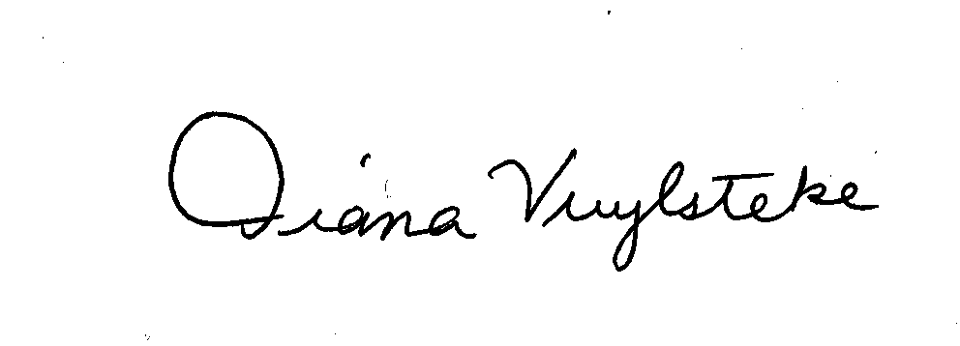
BRYAN CAVE, LLP

By:______________________
Diana M. Vuylsteke, # 42419
211 N. Broadway, Suite 3600
St. Louis, Missouri 63102
Telephone: (314) 259-2543
Facsimile: (314) 259-2020
E-mail: dmvuylsteke@bryancave.com

Attorney for The Missouri Industrial Energy Consumers

CERTIFICATE OF SERVICE

I do hereby certify that a true and correct copy of the foregoing document has been hand-delivered, transmitted by e-mail this 27th day of November, 2006, to all parties on the Commission’s service list in this case.

______________________________________________

