Exhibit No.:

Issues: Off System Sales/Capacity Release;
Storage Inventory
Witness: David M. Sommerer
Sponsoring Party: MoPSC Staff
Type of Exhibit: Direct Testimony
Case No.: GR-2002-356
Date Testimony Prepared: June 20, 2002

MISSOURI PUBLIC SERVICE COMMISSION

UTILITY SERVICES DIVISION

DIRECT TESTIMONY

OF

DAVID M. SOMMERER

LACLEDE GAS COMPANY

CASE NO. GR-2002-356

Jefferson City, Missouri
June 2002
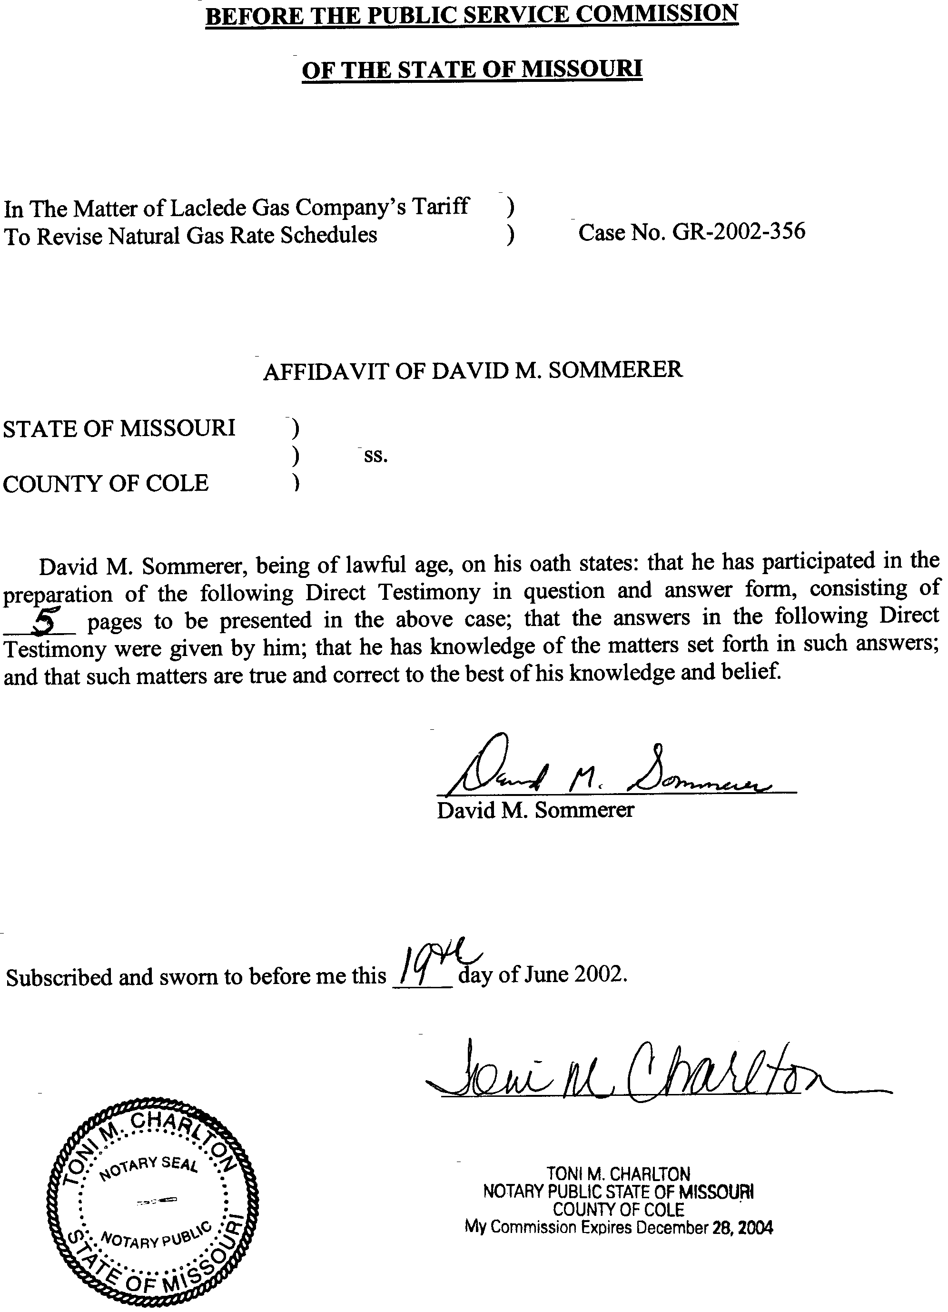

TABLE OF CONTENTS
DIRECT TESTIMONY OF
DAVID M. SOMMERER
LACLEDE GAS COMPANY
CASE NO. GR-2002-356
GAS INVENTORIES 2
OFF-SYSTEM SALES AND CAPACITY RELEASE 3

DIRECT TESTIMONY
OF
DAVID M. SOMMERER
LACLEDE GAS COMPANY
CASE NO. GR-2002-356
Please state your name and business address.
David M. Sommerer, P.O. Box 360, Jefferson City, Mo. 65102.
By whom are you employed and in what capacity?
I am the Manager of the Procurement Analysis Department with the Missouri Public Service Commission.
How long have you been employed with the Commission?
I have been employed with the Commission since August 1984.
Please describe your educational background and experience.
In May 1983, I received a Bachelor of Science degree in Business and Administration with a major in Accounting from Southern Illinois University at Carbondale, Illinois. In May 1984, I received a Master of Accountancy degree from the same university. Also, in May 1984, I sat for and passed the Uniform Certified Public Accountants examination. Upon graduation, I accepted employment with the Commission.
What has been the nature of your duties at the Commission?
From 1984 to 1990 I assisted with audits and examinations of the books and records of public utilities operating within the State of Missouri. In 1988 the responsibility for conducting the Actual Cost Adjustment (ACA) audits of natural gas utilities was given to the Accounting Department. I assumed responsibility for planning and implementing these audits and trained available Staff on the requirements and conduct of the audits. I participated in most of the ACA audits from early 1988 to early 1990. On November 1, 1990, I transferred to the Commission’s Energy Department. Until November of 1993, my duties consisted of reviews of various tariff proposals by electric and gas utilities, Purchased Gas Adjustment reviews, and tariff reviews as part of a rate case. In November of 1993, I assumed my present duties of managing a newly created department called the Procurement Analysis Department. This Department was created to more fully address the emerging changes in the gas industry especially as they impacted the utilities’ recovery of gas costs. My duties have included managing the five member staff, reviewing ACA audits and recommendations, participating in the gas integrated resource planning project, serving on the gas project team, serving on the natural gas commodity price task force, and participating in matters relating to natural gas service in the State of Missouri.
Have you previously testified before this Commission?
Yes. A list of cases in which I have filed testimony is included as Schedule 1 of my testimony.
What is the purpose of your testimony in this case?
I am sponsoring the Staff’s inventory levels for underground storage. I will also discuss Staff’s position on off-system sales and capacity release.

GAS INVENTORIES
What inventory levels are you proposing to use in this case?
I have attached as Schedule 2, the balances for Laclede Gas Company’s (Laclede, Company) three types of storage. The calculated balance is based on a 13-month average inventory for the period ending March 2002.

OFF-SYSTEM SALES AND CAPACITY RELEASE
What is Staff’s position regarding off-system sales and capacity release?
The Staff believes that off-system sales should be treated consistently with capacity release credits.
Please describe the terms “capacity release” and “off-system sales?”
Capacity release transactions occur when the Company has idle pipeline transportation capacity that is temporarily available and not currently needed for system requirements. The Federal Energy Regulatory Commission (FERC) requires that capacity release transactions be posted to the relevant interstate pipeline’s electronic bulletin board unless certain conditions are met. Capacity release deals may occur on a pre-arranged basis or be auctioned to the highest bidder. The “replacement shipper” pays the interstate pipeline for the capacity. The interstate pipeline then credits the transportation invoice of Laclede. These credits are made possible because Laclede must pay the interstate pipeline fees, called reservation charges for firm pipeline capacity.
Off-system sales occur outside of Laclede’s service territory and always include the sale of gas commodity (sometimes bundled with transportation). These off-system sales are possible because Local Distribution Companies (LDCs), such as Laclede, sometimes pay demand charges to gas suppliers to meet winter requirements. If the supply is available, but the LDC does not currently need the supply, and there is a market for the supply, the LDC can sell the supply off-system.
What is the current ratemaking treatment for capacity release and off-system sales?
In Laclede’s last rate case, off-system sales and capacity release were considered part of Laclede’s non-gas costs and included in the cost of service for the determination of base rates. Staff’s position in this case is to continue this treatment.
Please explain the rationale for this decision.
Including the net revenues at a cost of service component gives the Company an inventive to maximize the use of idle capacity. However, off-system sales and capacity release are both directly related to and facilitated by components that are already recognized in Laclede’s PGA Clause. Interstate pipeline reservation charges and supplier demand charges reserve the capacity or create the right to call on gas. If the rate case approach is used for off-system sales and capacity release, there is a risk that on-system customers could end up subsidizing the transactions by paying higher gas costs than off-system customers. Off-system sales and capacity release should also be treated consistently, if possible, because the transactions are sometimes substitutes for each other. This happens because the idle capacity can be used in a capacity-release transaction or bundled with gas supply.
Is the Staff suggesting tariff changes to help address the risk of on-system customers subsidizing off-system sales?
Yes. Schedule 3 addresses changes to Laclede’s off-system sales provisions. As a general rule, Laclede should not enter into an off-system sale unless it is at a cost of gas supply that is at least as high as the highest cost of gas supply for on system customers. Absent that practice, there may be an incentive to stream cheaper supply away from the traditional sales customer to enhance the off-system transaction. However, the Staff has provided criteria for those situations where the highest cost of gas supply is not allocated to the off-system transaction. In those cases the Company would need to document the reason for the departure from the general rule and indicate why it cannot procure the cheaper gas supply for the on-system customers.
In addition, the Staff has made modifications to clarify the treatment for off-systems sales to an affiliate, making these sales consistent with other off-system sales. The tariff changes also include clarification that a reasonable amount of fixed pipeline reservation costs should be allocated to off-system sales transactions that use Laclede’s pipeline transportation capacity. Finally, minor changes are proposed for improving the documentation of the Cost of Gas Supply Schedule.
With regard to including off-system sales and capacity release revenues in the cost of service for determining base rates, do you have a recommendation for the appropriate level?
Yes. The amounts for off-system sales have fluctuated greatly over the years. To address this fluctuation, the Staff has developed a three-year average for off-system sales that results in a revenue adjustment of $2,645,000. Capacity release, however, has trended down over the last several years. A current period has been used for capacity release and results in a level of $1,628,000.
Does this conclude your direct testimony?
Yes.
CASES WHERE TESTIMONY WAS FILED

DAVID M. SOMMERER

COMPANY CASE NO.

Missouri-American Water Company WR-85-16
Great River Gas Company GR-85-136
Grand River Mutual Telephone TR-85-242
Associated Natural Gas Company GR-86-86
Empire District Electric Company WR-86-151
Grand River Mutual Telephone Company TR-87-25
Great River Gas Company GM-87-65
KPL Gas Service Company GR-89-48
KPL Gas Service Company GR-90-16
KPL Gas Service Company GR-90-50
Associated Natural Gas Company GR-90-152
United Cities Gas Company GR-90-233
United Cities Gas Company GR-91-249
Laclede Gas Company GR-92-165
United Cities Gas Company GR-93-47
Western Resources Inc. GR-93-240
Union Electric Company GR-93-106
Missouri Public Service GA-95-216
Missouri Gas Energy GO-94-318
Missouri Gas Energy GO-97-409
United Cities Gas Company GO-97-410
Missouri Gas Energy GR-96-450
Missouri Gas Energy GC-98-335
COMPANY CASE NO.
Laclede Gas Company GO-98-484
Laclede Gas Company GR-98-374
Laclede Gas Company GC-99-121
Laclede Gas Company GT-99-303
Laclede Gas Company GR-98-297
Laclede Gas Company GT-2001-329
Laclede Gas Company GO-2000-394
Laclede Gas Company GR-2001-629

Gas Stored Underground
Laclede Gas Co. |  |  | Case No. |  | GR-2002-356
13 month Average
Amounts Taken From GL/TBR Account 164.100, 164.110, 151.xxx
and DR 5002
Month |  |  | Laclede |  | Other Fields |  | Propane
 |  |  | 164.10 |  | 164.11 |  | 151.xxx
 |  |  |  |  | & 164.120
Nov-00 |  |  | $19,393,962.62 |  | $80,794,297.09 |  | $12,186,967.56
Dec-00 |  |  | $13,797,686.11 |  | $48,116,750.95 |  | $9,716,883.34
Jan-01 |  |  | $16,446,891.85 |  | $31,894,022.32 |  | $9,622,011.66
Feb-01 |  |  | $13,201,494.74 |  | $21,518,771.00 |  | $9,621,875.74
Mar-01 |  |  | $10,263,592.80 |  | $8,763,510.01 |  | $9,620,644.65
Apr-01 |  |  | $10,458,922.36 |  | $6,342,270.31 |  | $11,087,265.43
May-01 |  |  | $10,554,342.60 |  | $5,994,433.06 |  | $13,149,458.17
Jun-01 |  |  | $14,862,085.68 |  | $20,147,021.29 |  | $14,888,693.85
Jul-01 |  |  | $14,474,914.95 |  | $34,363,599.43 |  | $16,416,071.18
Aug-01 |  |  | $16,386,742.70 |  | $49,118,705.90 |  | $14,213,406.00
Sep-01 |  |  | $17,204,187.74 |  | $59,425,766.61 |  | $14,213,170.17
Oct-01 |  |  | $17,664,455.66 |  | $65,134,350.53 |  | $14,212,758.08
Nov-01 |  |  | $18,488,959.39 |  | $63,992,163.75 |  | $14,189,495.19
Dec-01 |  |  | $17,668,052.98 |  | $54,791,057.58 |  | $14,187,497.23
Jan-02 |  |  | $17,731,277.39 |  | $47,734,665.58 |  | $14,718,109.92
Feb-02 |  |  | $15,725,029.99 |  | $24,295,774.93 |  | $14,723,169.85
Mar-02 |  |  | $11,785,089.17 |  | $8,409,266.96 |  | $14,724,020.48
13 Month Average
 | Mar 01-Mar 02 |  | $14,866,742.57 |  | $34,500,968.15 |  | $13,872,596.94

P.S.C. MO. No. 5 Consolidated, Original Sheet No. R-42
CANCELLING All Previous Schedules
Laclede Gas Company |  |  |  |  |  |  |  |  |  |  |  | For |  |  |  |  | Refer to Sheet No. R-1
Name of Issuing Corporation or Municipality Community, Town or City

 | RULES AND REGULATIONS
33. Off-System Sales

(1) Definitions:

Off-system marketing Sales (OS-Sales) are herein defined as any Company sale of gas, or gas bundled with pipeline transportation, made to parties at locations off the Company's distribution system. Subject to any waivers or approved modifications, OS-Sales made to an affiliate of the Company shall be accounted for in accordance with the Company's Cost Allocation Manual or, if and when applicable, the Commission's affiliate transaction rules.as provided herein.

Off-system Sale Revenues (OS-Revenues) are the actual revenues received by the Company from an OS-Sale.

Cost of Gas Supply (CGS) is the commodity cost related to the purchase of gas supply, exclusive of transportation costs.

Off-system Cost of Gas Supply (OS-CGS) is the CGS related to the purchase of gas supply for a proposed OS-Sale. In determining the OS-CGS, the costs of gas supplies: (1) which have been procured on behalf of the Company's on-system customers for a period greater than one month; and (2) which have a commodity price at the time of the OS-Sale that has been altered from an indexed price as a result of a hedge in a physical gas supply contract, shall not be considered. Nor shall the Company use such gas supplies for OS-Sales, unless the Company determines, and provides sufficient information to verify, that selling such gas supplies is not detrimental to its customers. Subject to the foregoing exclusion of certain gas supplies, the OS-CGS is equal to the highest CGS from the CGS-Schedule (as defined below) considering all pipelines serving the Company, both upstream and downstream, associated with the quantity of actual OS-Sales for the pipeline on which the sale is made, unless a lower CGS is documented and supported in accordance with the provisions of Section 3 of this rule. No OS-Sales may occur unless the OS-CGS is greater than the highest Cost of Gas Supply considering all pipelines serving the Company, both upstream and downstream, unless a lower CGS is documented and supported in accordance with the provision of section 3 of this rule. The total OS-CGS to be booked as a cost to the OS-Sales Accounts shall be equal to the sum of the multiplication of the gas cost of each individual transaction by the associated quantities actually sold as shown on the CGS-Schedule.

Off-system Cost of Transportation (OS-COT) is the incremental cost of transportation related to the delivery of the gas supply for an OS-Sale to the point of delivery. The OS-COT shall include all commodity related transportation costs, including fuel, associated with the OS-Sale. The OS-COT shall not include non-commodity related LDC system supply transportation costs. If an off-system sale delivery uses any of Laclede’s pipeline transportation, either upstream or downstream, a reasonable amount of fixed pipeline reservation costs shall be allocated to the transaction.

Off-system Net Revenue (OS-Net-Revenue) is equal to OS-Revenues minus OS-CGS and OS-COT.
DATE OF ISSUE |  |  |  |  |  |  |  |  |  |  |  |  |  |  | DATE EFFECTIVE
Month Day Year |  |  |  |  |  |  |  |  |  |  | Month Day Year
ISSUED BY
Name of Officer Title Address

P.S.C. MO. No. 5 Consolidated, Original Sheet No. R-43
CANCELLING All Previous Schedules
Laclede Gas Company |  |  |  |  |  |  |  |  |  |  |  | For |  |  |  |  | Refer to Sheet No. R-1
Name of Issuing Corporation or Municipality Community, Town or City

 | RULES AND REGULATIONS
33. Off-System Sales (continued)

(2) Accounting:

The Company shall maintain separate revenue and expense accounts to record its OS-Sales transactions, which accounts shall be audited and subject to modification by the Commission at the same time the Company’s other gas costs for system supply purposes are reviewed pursuant to the ACA process. Each OS-Sales transaction shall be accounted for and analyzed separately.

(3) Record Keeping:

For the first day of each month and for each day where a subsequent change in the cost of gas supplies or in the cost of delivery thereafter occurs, the Company shall construct and retain a CGS-Schedule. This CGS-Schedule shall provide contract volumes, scheduled volumes, available volumes, unit commodity cost of gas, and unit transportation costs associated with the delivery of gas to the Company’s city gate for all of the Company’s gas supply contracts. The CGS-Schedule will also provide information relating to any OS-Sales. This information will include the location of sale, volume sold, sales price, total revenue from the sale, the unit commodity cost of gas used for the sale, gas purchase contract number used for the sale, unit transportation costs to point of sale, sales contract number used for the sale, any other costs or cost reductions associated with the sale (e.g. avoided penalty costs) and the total costs associated with the sale.

To the extent that the CGS-Schedule costs associated with the OS-Sales are different than the costs accrued for each transaction, the Company will prepare and retain a complete explanation and related records regarding such difference. If the CGS associated with the volumes of gas distributed to Company's system sales customers is at a higher cost than the OS-CGS for the OS-Sale, the Company shall document all reasons for each such occurrence and shall retain the documentation explaining such costing.The general rule shall be that OS-Sales shall be at the highest on-system cost of gas supply on all of the Company’s upstream and downstream pipelines. If the OS-Sale occurs at less than the highest cost of gas supply, the Company shall:
1. Document the reason that the OS-Sale was done at less than the highest cost of gas supply and,
2. Document all reasons why the Company cannot procure the less expensive gas for its on-system sales customers.

In the event the OS-CGS assigned to the OS-Sale is less than the highest price, as described herein, nNothing in this tariff shall preclude the review of such transaction or impair a party's right to propose an adjustment in connection with such transaction in the relevant ACA proceeding.

(4) Limitation on Sales:

The Company’s OS-Sales shall be made on an as-available basis.

The Company shall make no individual OS-Sale where a negative margin results, unless the Company determines and documents that such a transaction is not detrimental to the Company's customers.
DATE OF ISSUE |  |  |  |  |  |  |  |  |  |  |  |  |  |  | DATE EFFECTIVE
Month Day Year |  |  |  |  |  |  |  |  |  |  | Month Day Year
ISSUED BY
Name of Officer Title Address

