Exhibit No.:

Issues: Incentive Mechanism;
AAO Balance
Witness: David M. Sommerer
Sponsoring Party: MoPSC Staff
Type of Exhibit: Surrebuttal Testimony
Case No.: GR-2002-356
Date Testimony Prepared: August 23, 2002

MISSOURI PUBLIC SERVICE COMMISSION

UTILITY SERVICES DIVISION

SURREBUTTAL TESTIMONY

OF

DAVID M. SOMMERER

LACLEDE GAS COMPANY

CASE NO. GR-2002-356

Jefferson City, Missouri
August 2002
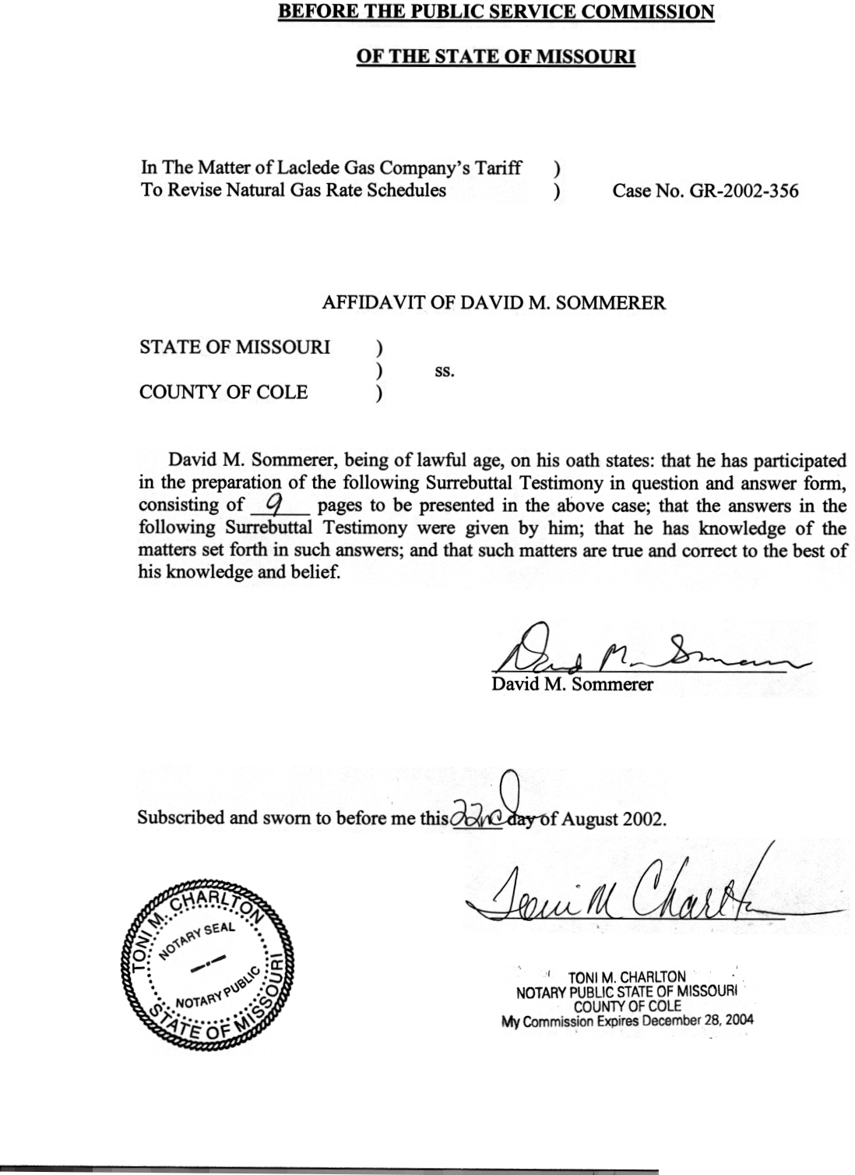

SURREBUTTAL TESTIMONY
OF

DAVID M. SOMMERER

LACLEDE GAS COMPANY

CASE NO. GR-2002-356

Please state your name and business address.
David M. Sommerer, P.O. Box 360, Jefferson City, Mo. 65102.
By whom are you employed and in what capacity?
I am the Manager of the Procurement Analysis Department with the Missouri Public Service Commission.
Are you the same David M. Sommerer who filed direct and rebuttal testimony in this case?
Yes.
What is the purpose of your surrebuttal testimony?
The purpose of my surrebuttal testimony is to respond to the rebuttal testimony of Laclede Gas Company (Laclede, Company) witness Michael Cline, Office of Public Counsel (OPC, Public Counsel) witness Barbara Meisenheimer, and Public Counsel witness James Busch. Specifically, I will be addressing the Actual Cost Adjustment (ACA) aspects of Mr. Cline’s rate design proposal and details of OPC’s Incentive Mechanism proposal. Other Staff witnesses will review Mr. Cline’s proposal in more detail.
Please summarize Mr. Cline’s rate design proposal as it affects the Actual Cost Adjustment process.
On page 3 of Mr. Cline’s rebuttal testimony, he states:
The Company proposes to lower the PGA factor that would apply to consumption in the first block so as to offset the increase in the first block non-gas rate that would result from the Company’s proposal. The result is that since the total rate paid by the customer in the first rate block remains exactly the same, the total rate paid by each customer, including low use customers, is not increased or decreased.”
On page 5 he goes on to state that:
In terms of total dollars recovered through the PGA clause, there would be no impact since the Company would recover in the second rate block the balance of the gas costs that the Company does not recover in the first rate block. The only change, as is the case with the Company’s recovery of non-gas costs, is in the block in which recovery occurs.
Do you agree that there would be no impact in terms of total dollars recovered through the PGA clause?
If normal weather is assumed, I believe that there will be no overall impact in terms of total dollars billed. That is the reason that Staff supports this proposal as discussed in the testimony of Dr. Michael Proctor.
Do you have a concern with this proposal?
Yes, assuming the weather is warmer then normal, the Actual Cost Adjustment balance may be impacted. The intent of the Company’s proposal is to shift additional “non gas costs” to the first block so that more of the Company’s fixed costs are recovered when the weather is warmer than normal. If the PGA blocking proposal offsets the customer impact in the warmer than normal situation, total PGA recoveries would be reduced, in an effort to counteract the increase in charges for the non-gas costs. However, the non-gas cost effect is permanent while the PGA recovery effect is temporary since, regardless of what PGA recoveries are, the rates are “trued-up” to actual in the ACA process so that the Company recovers the actual gas costs incurred. To state it another way, a customer’s bill might not be affected by this proposal in a normal winter, but in a warmer than normal winter, if Laclede undercollects its gas costs it will recover those costs from customers at the time of “true-up” potentially resulting in higher customer bills. What this means in times of warmer than normal weather is that there may be some increase in customers bills because of the new rate design on the non-gas cost side which contributes to an under-recovery on the ACA balance which would flow through to customers, all else being equal.
What do you mean by “all else being equal?”
The ACA balance results from a comparison between the Company’s actual gas costs and billed PGA revenue recovery. The level of the balance is affected by many variables. Warm winters tend to result in under-recoveries of gas costs in the ACA balance since a certain portion of the total PGA rate is designed for fixed gas cost recovery. Fewer volumes translate into less recovery of fixed costs until the ACA reconciliation. Another significant factor is the reality that the PGA factor itself is merely an estimate of what the Company’s costs will be. The biggest part of that estimate is the portion representing gas supply commodity costs that the company must pay. Recent revisions have attempted to provide more clarity on what should be involved in making the estimate. However, the fact remains that, to the extent the estimate does not match the ultimate gas cost closely, large ACA balances can result.
Why is it important and desirable for the Commission to expect Companies to strive for an ACA balance that is as close to zero as possible?
There are many policy reasons that the Company should strive for a minimal ACA balance. The current generation of ratepayers should pay for the costs that were incurred on their behalf, as those costs are incurred. The larger the ACA balance becomes, the bigger the gap between cost incurrence and payment. Large ACA balances can also create an additional burden on customers because collection of those underrecoveries start at the same time winter PGA filings are made. If these filings reflect large changes by themselves, a large ACA adjustment may simply make a difficult situation worse. Volatility in connection with a price increase is generally not viewed as a favorable outcome. Large ACA balances would potentially increase volatility.
Have you reviewed past ACA balances to assess the volatility of the current procedure?
Yes. It is common to have ACA balances of $10,000,000 to $15,000,000. Balances of greater than $20,000,000 are rare and should be avoided.
Are there other comments you wish to make regarding the Cline proposal?
Yes. Mr. Cline attaches as part of Schedule MTC Rebuttal – 1 a proposed tariff sheet No. 22-a. This proposed tariff sheet contains the following provision:
Also, effective at the same time, for purposes of Sections B and C of this clause, separate ACA and refund factors shall be established for each of the above residential and commercial and industrial general service categories. Specifically, with respect to Section C.2, the Company shall allocate actual gas costs to the above categories based on the gas cost revenue recoveries of each such category.
This provision indicates that the Company intends to develop separate ACA factors for all the various proposed service categories. It will separately allocate gas costs for each class of customers based upon revenue recoveries.
Do you agree with this concept?
No. This would add to the complexity of the ACA ratemaking process by instituting many new ACA sub-category reconciliations over and above the existing process. If some form of Mr. Cline’s proposal were adopted, I would propose maintaining the existing ACA classes. The newly blocked PGA revenue recovery would simply be consolidated and compared to the traditional ACA categories. As previously discussed, there are many causes that can create an ACA under/over recovery. Splitting gas costs among several new classes will compound the uncertainties associated with Mr. Cline’s proposal. If PGA estimates create a $10,000,000 over-recovery, that over-recovery should be allocated as is presently done, over a broad group of customers, each receiving a refund based upon eventual usage regardless of the rate block.

PUBLIC COUNSEL’S INCENTIVE PLAN PROPOSAL
Please provide an overview of Public Counsel’s Incentive Plan proposal?
Public Counsel offers its incentive plan as a possible method of reducing the volatility of gas prices for consumers. One critical aspect of this proposal must be described with reference to Public Counsel witness James Busch’s CHART 1, contained on page 7 of his rebuttal testimony. This chart is replicated here for ease of reference.
Public Counsel’s Chart
Tier Levels
Tier 1 |  | < | $3.000
Tier 2 | $3.001 | < | $5.000
Tier 3 | $5.001 | <

The chart sets various price tiers for the gas supply commodity cost of gas. Mr. Busch calls this plan a gas commodity incentive mechanism (GCIM). The chart is the basis from which determinations are made regarding whether or not Laclede will be sharing “savings” under the plan. It also serves as a guide to determine whether or not a prudence review will be necessary for gas supply commodity costs. It must be emphasized that the Public Counsel’s GCIM pertains only to gas supply commodity cost. It does not include transportation or fixed storage costs as part of the incentive calculation. A benchmark is developed using the first of month (FOM) prices for each month of the year based upon Laclede’s buying patterns. Determination as to whether savings or prudence reviews will be performed is based on a two-step comparison. The questions asked are: (1) did the Company’s actual price beat the benchmark; and (2) in what part of the tier do the benchmark and actual gas costs fall? Pursuant to Mr. Busch’s rebuttal schedule JAB-R4-1: “In order to be able to receive compensation, Laclede must keep actual gas costs below the benchmark price plus fall within either Tier 1 or Tier 2. Secondly, the benchmark price must fall within Tier 2 or Tier 3.” With regard to prudence reviews (presumably for gas supply commodity), “When actual prices achieved by Laclede are above the benchmark or are in Tier 3, Laclede shall be subject to prudence review and any proper party may recommend a disallowance.” (Schedule JAB-R4-2)
What are Staff’s concerns regarding Public Counsel’s GCIM?
As pointed out by Public Counsel witness Barbara Meisenheimer, on page 9, line 11 of her rebuttal testimony: “Obviously, the devil is in the details and probably it is no surprise to the Commission that the Task Force members could not reach agreement in this area.” On page 7, lines 18 through 20, Ms. Meisenheimer goes on to state: “To insure the mechanism’s success it is critical to avoid creating ‘perverse incentives’ that would encourage Laclede to act in ways that do not achieve the desired outcomes for ratepayers.” It is with the aforementioned application of details and the creation of improper incentives that Staff is most concerned.
Please provide an overall list of Staff’s concerns with the GCIM.
The Staff’s concerns are as follows:
- Storage costs are not addressed.
- Bundled Supply contracts are not addressed.
- Detail lacking on FOM calculation and handling of gas supply premiums.
- Affiliate transactions.
- Reporting and tariff requirements not specified.
- Reliability.
- Prudence reviews not specified with regard to transport and storage.

Please explain what you mean by the concern that storage charges are not addressed.
To a certain extent storage can be a substitute for transportation. In the same way that it is possible to decrease gas supply costs by increasing transportation costs, it is possible to decrease gas supply costs while increasing storage costs. These storage costs should be reviewed for prudence and subject to the same safeguards and transportation costs.
Please explain Staff’s concern that bundled supply contracts are not addressed.
In a bundled supply arrangement, also known as a delivered city-gate arrangement, supply can be combined with transportation. The marketing company or gas supplier would generally be indifferent as to how the ultimate delivered costs was allocated between supply and transportation. Therefore it is conceivable that by a mere change in pricing structure, artificial savings could be achieved for “supply costs,” while “delivery costs” increase by the same amount. For example, a premium could be paid for the transportation portion of the bundled costs and a discount on the supply portion of the bundled costs.
Why is Staff concerned about the lack of detail regarding FOM and gas supply premiums?
It is not stated in Public Counsel’s program description how gas supply premiums would be handled. Such charges are often closely related or part of the gas supply price itself. An increase in the level of premiums could result in the ability to access cheaper commodity, but at the cost of an additional or higher premium. Also, if the Public Counsel’s plan is adopted, the Missouri Public Service Commission would be considering prices achieved below these published indices as prudent in certain “tiers.” However, Public Counsel has provided little detail on how the mix of FOM prices would be calculated for the benchmark. Since the Federal Energy Regulatory Commission has recently criticized some of the pricing methodology for index pricing and is investigating how various publications in the power and natural gas markets report index pricing, care would need to be taken in establishing the component parts of the benchmark calculation.
Please describe Staff’s concern about affiliate transactions.
This type of mechanism is untested in terms of how the Company will structure gas supply, transportation, and storage agreements. The Company does have affiliated marketers and has recently restructured its gas procurement function. Staff is investigating this restructuring in Case No. GO-2002-1099. Prudence reviews for affiliated transactions should be applicable to all affiliated transaction regardless of what “tier” the Company’s actual gas costs fall into, or whether the benchmark is achieved or not. There is simply too much uncertainty regarding pricing structure and affiliate transactions to bar a prudence review.
What are Staff’s concerns regarding reporting requirements and tariff provisions?
Routine reporting should be a prerequisite of any experimental mechanism. Details should be provided about how savings were achieved and what the split of savings are between customer and Company. In addition, no proposed tariff language has been provided. The Staff has found in the past that many disputes have arisen from tariffs and how they are implemented. Well-defined tariffs should be developed and filed before any incentive plan is approved.
Please describe your concern with regard to reliability.
Reduced gas costs can result in reduced reliability. Usually firm service costs more that interruptible service. Reliability is the foundation of a reasonable procurement process. If reliability is sacrificed, the Company should not share in any savings.
Please explain your concern with regard to prudence reviews of gas transportation and storage costs.
The Public Counsel’s plan does not specify that these costs are to continue under traditional prudence review. Although this might be implied from the description of the plan, exactly which costs are subject to prudence reviews should be specified. The Staff believes that transportation and storage costs should still be subject to a prudence review.
Does Staff have any other overall concerns?
It appears that as long as actual gas supply commodity costs are less than $4.99, and are below the benchmark (FOM annual average), the costs are presumed prudent. If summer prices are relatively low, there could be a couple of fairly significant winter months in excess of $7.00 and the presumption of prudence would still apply. In addition, timing of payments could provide additional complications where long-term agreements defer costs into future years while creating savings in early years that are subject to compensation.
Would Staff oppose mechanisms that could reduce volatility of gas prices for consumers?
No. The Staff believes this is an important goal along with the goals of reasonable rates and reliable service.
Does this conclude your surrebuttal testimony?
Yes.

