Exhibit No.:

Issues: Other Telephone

Specific Issues

Witness: Michael S. Scheperle

Sponsoring Party: MO PSC Staff
Type of Exhibit: Additional Rebuttal
Testimony

Case No.: TC-2002-57

Date Testimony Prepared: February 20, 2004

MISSOURI PUBLIC SERVICE COMMISSION

Utility Operations DIVISION

Additional Rebuttal TESTIMONY

OF

Michael S. Scheperle

Northeast Missouri Rural Telephone Company
And Modern Telecommuncations Company

CASE NO. TC-2002-57

Jefferson City, Missouri
February 2004

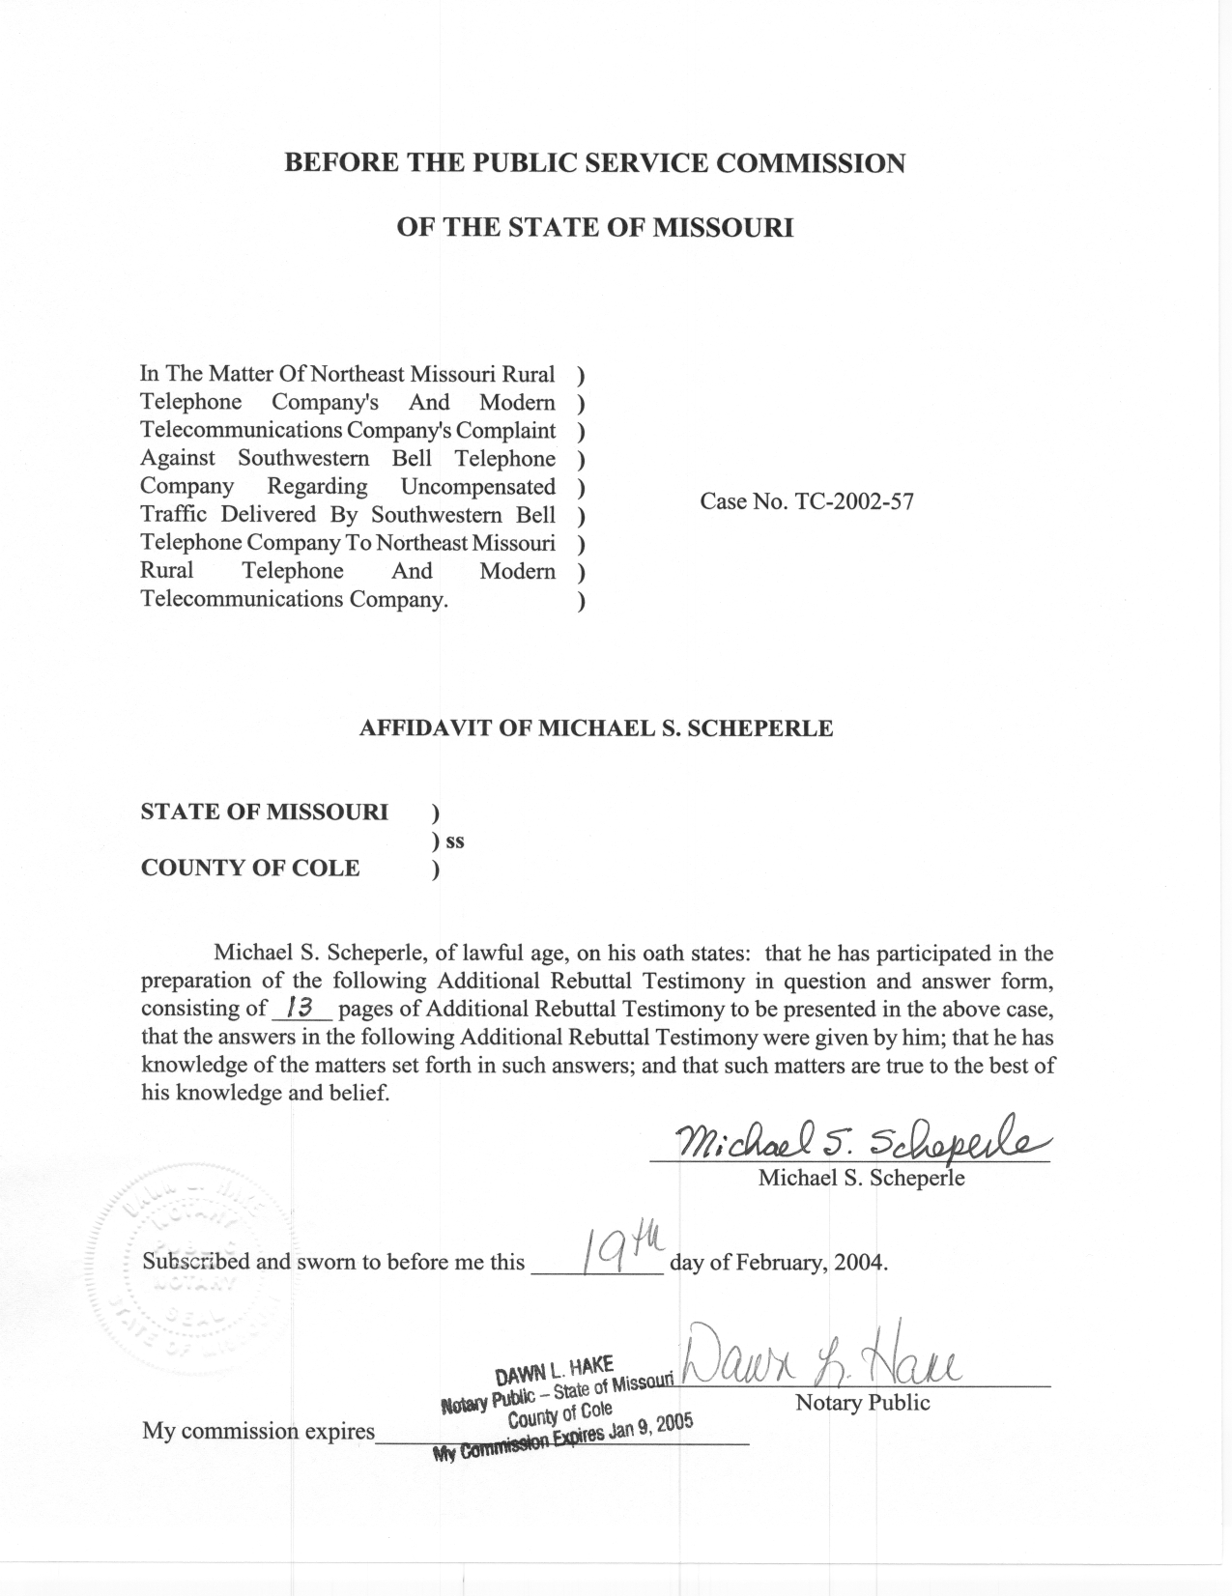
TABLE OF CONTENTS

CMRS Providers And Complainant’s Agreement Regarding InterMTA Factors 3
NOTICE Filed By Alma, Choctaw And Mokan Agreeing To A 0 % InterMTA Factor 3
Staff’s Understanding Of What Would Be Required To Ascertain A Percentage Of Traffic That Is InterMTA 4
InterMTA Traffic Terminating To The Respective Company 11
Summary 13

ADDITIONAL REBUTTAL TESTIMONY
OF
MICHAEL S. SCHEPERLE
CASE NO. TC-2002-57

Q. Please state your name, employer and business address.
A. My name is Michael S. Scheperle and I am employed in the Telecommunications Department Staff (“Staff”) of the Missouri Public Service Commission (“Commission”). My business address is Post Office Box 360, Governor Office Building, Suite 500, 200 Madison Street, Jefferson City, Missouri 65102-0360.
Q. Are you the same Michael S. Scheperle who filed initial Rebuttal Testimony in this case on behalf of Staff?
A. Yes, I am. I filed Rebuttal Testimony on June 10, 2002.
Q. What is the purpose of your Additional Rebuttal Testimony?
A. By Commission Order dated June 3, 2003, the Commission reopened the record for purposes of receiving additional evidence concerning the proportion of wireless-originated traffic that is interMTA and the proportion that is intraMTA. Also, the Commission Order noted that in the event that the parties are unable to adduce this evidence in any other way, the Commission would require that they cooperate in the performance of a traffic study or studies. Since the Commission Order of June 3, 2003, the Complainants (6 ILECs, see Schedule 2 for listing) have filed Direct Testimony or a NOTICE that the individual company will not be filing Direct Testimony concerning the interMTA factors.
One purpose of my Additional Rebuttal Testimony is to respond to the Direct Testimonies of Joe Knipp representing Mid-Missouri Telephone Company (“Mid-Missouri”), Gary Godfrey representing Northeast Missouri Rural Telephone Company (“Northeast”) and William Biere representing Chariton Valley Telephone Corporation (“Chariton”). Also, my testimony is responding to the Notice (filed January 9, 2004) stating that Alma Telephone Company (“Alma”), Choctaw Telephone Company (“Choctaw”) and MoKan Dial, Inc. (“MoKan”) have elected not to file Direct Testimony and “will accept the determination that none or zero percent of the traffic terminating to these Petitioners between February 5, 1998 and December 31, 2001, is interMTA traffic, and that all or 100 percent of the traffic terminating to these Petitioners is intraMTA traffic” (Paragraph 8 of NOTICE filed January 9 ,2004 by Alma, Choctaw and MoKan) except where there is a stipulation between Alma, Choctaw and MoKan and a wireless provider.
Q. What issues will Staff address in its Additional Rebuttal Testimony?
A. Through Additional Rebuttal Testimony, Staff is addressing the following:
- Commercial Mobile Radio Service (“CMRS”) providers and Complainant’s agreement regarding interMTA factors.

- NOTICE filed by Alma, Choctaw and MoKan agreeing to a 0 % interMTA factor.

- Staff’s understanding of what would be required to ascertain a percentage of traffic that is interMTA.

- InterMTA traffic terminating to the respective company.

CMRS Providers And Complainant’s Agreement Regarding InterMTA Factors

Q. Have any CMRS providers and Complainant’s agreed to interMTA factors?
A. Yes. Stipulations have been filed by which Alma and Western Wireless Corporation (“Western”) negotiated and agreed to an interMTA factor (discussion of interMTA versus intraMTA follows below) of 2.5 %; MoKan and Western negotiated and agreed to an interMTA factor of 2.5 %; and Sprint PCS agreed to interMTA factors with Alma of 10 %, with MoKan of 0 %, and with Mid-Missouri of 43 %. The interMTA factors identify the portion of total traffic terminating to each Complainant that would be identified and billed as interMTA traffic under the Complainants’ access tariffs. InterMTA traffic is traffic that originates in one Major Trading Area (“MTA”) and terminates in another MTA. Staff supports the concept of these parties negotiating and agreeing to interMTA factors.

NOTICE Filed By Alma, Choctaw And Mokan Agreeing To A 0 % InterMTA Factor

Q. Does Staff object to the Notice filed by Alma, Choctaw and MoKan?
A. No. Alma, Choctaw and MoKan filed a Notice with the Commission on January 9, 2004, that each company has elected not to file Direct Testimony and that Alma, Choctaw, and MoKan would accept a 0 % interMTA factor from CMRS providers except where there is a stipulation between Alma, Choctaw and MoKan and a wireless provider.
Staff does not object to this concept. As previously stated, interMTA traffic is billed under the Complainants’ access tariffs. IntraMTA traffic is billed under the wireless termination tariffs. The intraMTA tariff rate is less than the switched access tariffed rates for interMTA traffic. Therefore, Staff does not believe it is discriminatory to the wireless provider to apply a factor of 0 % to interMTA traffic (see Schedule 3 for listing of current tariffed rates).
Q. Are there interMTA factors not agreed to by the CMRS providers and Complainants?
A. At this time, it appears there are still 11 interMTA factors that have not been agreed to by the wireless providers and three MITG companies (see Schedule 2 for listing). Cingular has not agreed to interMTA factors with Chariton, Mid-Missouri and Northeast; Sprint PCS has not agreed to interMTA factors with Chariton and Northeast; US Cellular has not agreed to interMTA factors with Chariton and Northeast; T-Mobile has not agreed to interMTA factors with Chariton and Northeast; and Western has not agreed to interMTA factors with Chariton and Northeast. Staff understands that negotiations are continuing and encourages the parties to agree to interMTA factors.

Staff’s Understanding Of What Would Be Required To Ascertain A Percentage Of Traffic That Is InterMTA

Q. Why is the jurisdiction of the wireless-originated traffic important?
A. Wireless-originated traffic, at issue in this case, originates and terminates either within the same MTA (i.e., intraMTA traffic) or between various MTAs (i.e., interMTA traffic). Wireless-originated interMTA calls are subject to access charges, just like all long distance calls, while wireless-originated intraMTA calls are considered local calls and are not subject to access charges. The local rate is commonly contained in Wireless Termination Tariffs absent an interconnection agreement between the wireless provider and the Complainants.
Q. Can the jurisdiction of the wireless-originated traffic be easily obtained to determine if a call is interMTA or intraMTA?
A. No. The wireless-originated traffic, at issue in this case, is terminated to Complainants within the LATA over trunk groups owned by Southwestern Bell Telephone, L.P. d/b/a SBC Missouri (“SBC”). At this point in time, neither the wireless providers, the transiting carrier (SBC) or the Complainants, create records to know the jurisdiction (interMTA or intraMTA) of the calls. Based on Staff’s understanding, CMRS provider switches are currently incapable of determining the cell site MTA location and placing this information in any kind of call detail record for identifying the jurisdiction of the traffic. SBC creates Cellular Transiting Usage Summary Reports (“CTUSRs”) for the wireless-originated traffic, but no information is passed to SBC to identify the location for the origination of the wireless call, and as a result no information exists that could be used to identify whether the traffic is interMTA or intraMTA.
Q. How do carriers solve this jurisdictional situation?
A. In the past, to solve this situation, some wireless providers and Local Exchange Carriers (“LECs”) negotiated interMTA factors in interconnection agreements. It is because interconnection agreements and interMTA factors have not occurred between the Complainants and wireless providers that this complaint case was created. Staff supports the concept that interMTA factors be negotiated and agreed to by the originator of the traffic and the respective individual Complainant.
Q. Does the Federal Communications Commission (“FCC”) give any guidance on the jurisdiction of the wireless-originated traffic?
A. Yes. The FCC in the First Report and Order states:
We recognize that, using current technology, it may be difficult for CMRS providers to determine, in real time, which cell site a mobile customer is connected to, let alone the customer’s specific geographic location. … We conclude, however, that it is not necessary for incumbent LECs and CMRS providers to be able to ascertain geographic locations when determining the rating for any particular call at the moment the call is connected. We conclude that parties may calculate overall compensation amounts by extrapolating from traffic studies and samples. For administrative purposes, the location of the initial cell site when a call begins shall be used as the determinant of the geographic location of the mobile customer. As an alternative, LECs and CMRS providers can use the point of interconnection between the two carriers at the beginning of the call to determine the location of the mobile caller or called party. (First Report and Order, paragraph 1044)

Based on FCC guidelines, there are three alternatives that the FCC outlined as possibilities.
- That the parties may calculate overall compensation amounts by extrapolating from traffic studies and samples.

- The location of the cell site when a call begins shall be used as the determinant of the geographic location of the mobile customer.

- LECs and CMRS providers can use the point of interconnection between the two carriers at the beginning of the call to determine the location of the mobile caller or called party.

Q. What is Staff’s recommendation concerning the jurisdiction of the traffic?
A. Based on Staff’s understanding, Staff lists the following possibilities for solving the jurisdiction of the traffic:
- The wireless providers could create a billing record for each wireless call from cell site information terminating to a specific telephone number of the Complainant for traffic transited by a transiting carrier (i.e., SBC). This takes into account that a wireless-originated call may originate from many locations. Staff believes this possibility was contemplated when the Commission reopened the record where if the parties are unable to adduce evidence concerning the proportion of the traffic at issue that is interMTA or intraMTA traffic, the Commission will require that the parties cooperate in the performance of a traffic study or studies.

- The wireless provider and the Complainants could negotiate and agree to an interMTA factor.

- The parties could use any method outlined by FCC guidelines: (1) calculating overall compensation amounts by extrapolating from traffic studies and samples; (2) using the location of the cell site when a call begins as the determinant of the geographic location of the mobile customer; (3) using the point of interconnection between the two carriers at the beginning of the call to determine the location of the mobile caller or called party.

- If solutions suggested in 1, 2, or 3 (above) do not occur, the wireless provider should provide a listing of all cell sites, which are used to serve Missouri customers. The Complainants would also provide a detailed listing of the exchanges served outlining the LATA, MTA and the number of access lines in each exchange. This allows an understanding of specific cell sites and exchange boundaries of the Complainant. Then the wireless carrier should provide an explanation of how the wireless cell sites route traffic to the Mobile Switching Center (“MSC”) of the wireless carrier and how the wireless carrier routes traffic from the MSC to the transiting company switches (tandem, end office) that are transited to the network of the terminating Complainant.

Q. Please state why Staff believes that its recommendations will help in developing an interMTA factor.
A. Staff’s recommendations follow a progressive order where interMTA factors may be developed on the best information available or on the possibility that two parties may agree on an interMTA factor.
Staff’s first possibility outlines the ultimate solution where the cell site location of each call is detailed (connects to cell site) and the terminating location is known. Unfortunately, the originating and terminating detail information is not known. A wireless-originated call may originate from many locations and the originating location of the call (where it connects to cell site) is not currently available for analysis. From Staff’s understanding, wireless-originated calls are not currently set up to track originating calls placed from a mobile device.
Staff’s second possibility is that the wireless provider and the Complainants negotiate and agree to an interMTA factor. Staff believes this is the best alternative.
Staff’s third possibility is that any of the three guidelines outlined by the FCC is acceptable. However, Staff believes that the first option may be the best alternative of the three FCC guidelines based on current technology where percentages may be extrapolated from traffic studies and samples. The second option is where the initial cell site information is known. However, this information is not currently known as previously outlined. The third option uses the point of interconnection between the two carriers as an alternative. From Staff’s perspective, there are three parties involved in this traffic (CMRS provider, transiting provider and terminating company). Therefore, option three as outlined by the FCC does not seem viable.
Staff’s fourth possibility is that the wireless providers provide a listing of all cell sites outlining the county of the cell sites that are used to serve Missouri customers. This is to understand the wireless company’s service territory and cell sites in relation to the four LATA boundaries in Missouri as well as the four MTAs in the state. (See Schedule 1 for map of LATAs and MTAs in Missouri). Specifically, MTA boundaries follow county lines and Staff wants to identify the MTA area of each cell site. The Complainants would need to provide a detailed listing of the exchanges served outlining the LATA, MTA and the number of access lines in each exchange. This information clarifies specific cell sites and exchange boundaries of the Complainant. To complete the picture, a wireless provider would then have to explain how wireless provider’s route traffic to their MSCs. Staff seeks this information to understand the routing of wireless calls from the cell sites to the MSCs. Also, the wireless provider would have to explain how each MSC routes traffic to SBC switches that is then transited to the network of the terminating LEC. From this information and routing of calls, Staff seeks an understanding of how a wireless-originated call is routed to a cell site; to a MSC; to a SBC tandem switch or end office; and, to a terminating LEC.
Q. What is Staff’s recommendation should the wireless providers and Complainant’s not agree to an interMTA factor?
A. Based on Staff’s recommendations and testimony to date, Staff developed interMTA factors using the fourth possibility above. Specifically, Staff obtained information from data requests to the wireless providers and Complainants. The factors based on data request responses are contained in Schedule 5.
Following is an explanation of how Staff developed the factors. First, Staff calculated an access line factor for Mid-Missouri, Northeast and Chariton based on the number of access lines in each MTA area divided by the total access lines for that Complainant (i.e., Mid-Missouri in the Kansas City MTA, 3004 access lines divided by 3769 total access lines which shows an access line factor of .797 or 79.7% in the Kansas City MTA). Secondly, Staff calculated a cell site factor for Cingular, Sprint PCS and affiliates, US Cellular, T-Mobile and Western based on the number of cell sites in each MTA divided by the total cell sites for that wireless provider (i.e., Cingular in the Kansas City MTA, 176 cell sites divided by 615 total cell sites which shows a cell site factor of .286 or 28.6% from the Kansas City MTA). To complete the picture, Staff sought an understanding or explanation of how each wireless provider routed the traffic from each cell site to the wireless switch (MSC) that terminated on each Complainant’s network. However, Staff did not obtain information of sufficient detail for analysis. Therefore, Staff developed interMTA factors on the probability that a wireless-originated call in an MTA area would terminate in a different MTA area. For example, the interMTA factor for a Cingular-originated call terminating to Mid-Missouri would be .63 or 63%. The calculation is as follows:
- Kansas City MTA access line factor X St. Louis MTA cell site factor (i.e., .797 X .709 = .565 or 56.5%)

- Plus: St. Louis MTA access line factor X Kansas City MTA cell site factor (i.e., .203 X .286 = .058 or 5.8%)

- Plus: 100% X Memphis MTA cell site factor (i.e. 1.000 X .005 = .005 or 0.5%).

The addition is as follows: .565 + .058 + .005 = .628 or 63%.
Staff realizes developing interMTA factors by this method has certain limitations. Specifically, wireless providers may have more than one switch, and may route traffic based on the MTA location of the cell site, thereby significantly reducing the percentage of interMTA traffic. Some wireless providers realize the MTA limitation and route interMTA traffic through an IXC. Therefore, absent further discussion between the parties, Staff encourages parties to develop samples based on traffic flow or on negotiated interMTA factors.
A comparison of the proposed interMTA factors by the Complainants and Staff are outlined in Schedule 6.

InterMTA Traffic Terminating To The Respective Company

Q. Do Mr. Knipp, Mr.Godfrey and Mr. Biere propose any interMTA factors in Direct Testimony?
A. Yes. Mr. Knipp, representing Mid-Missouri, asks the Commission to find that interMTA traffic terminating to Mid-Missouri between February 5, 1998 and December 31, 2001, for Cingular be 61 % and for Sprint PCS be 43 %.
Mr. Godfrey, representing Northeast, asks the Commission to find that interMTA traffic terminating to Northeast between February 5, 1998 and December 31, 2001, for Cingular be 60 %, for Sprint PCS be 37 %, for US Cellular be 100 % and for T-Mobile be 100 %.
Mr. Biere, representing Chariton, asks the Commission to find that interMTA traffic terminating to Chariton between February 5, 1998 and December 31, 2001, for Cingular be 41%, for Sprint PCS be 35%, for US Cellular be 100%, for T-Mobile be 73% and for Western be 73%.
Q. Please describe the uniqueness of Mid-Missouri, Northeast and Chariton.
A. According to Staff’s understanding, Mid-Missouri, Northeast and Chariton are uniquely situated with respect to MTA boundaries. Schedule 4 illustrates the difference between the locations of these companies’ service areas and the locations of the other parties service areas. Mid-Missouri and Chariton have exchanges in both the Kansas City MTA and St. Louis MTA with some individual exchanges overlapping both MTA areas. Also Schedule 4 outlines Northeast’s peculiar situation, with exchanges in three different MTA areas.
Q. What is the Staff response to the proposals by Mr. Knipp, Mr. Godfrey and Mr. Biere?
A. As previously stated, Staff prefers that any interMTA factors be negotiated and agreed to by the originator of the traffic (wireless company) and the company terminating the traffic. The interconnection agreements between the wireless companies (i.e., Cingular, Sprint PCS, US Cellular, T-Mobile, Western) and SBC (transiting company) contemplate agreements between the wireless company originating the traffic and the small LEC (i.e. Mid-Missouri, Chariton, Northeast) terminating the traffic. Specifically, the interconnection agreements state in Section 3.1.3 of each interconnection agreement under Traffic To Third Party Providers:
… The Parties agree to enter into their own agreements with Third Party Providers. … (Information contained in Exhibits 34,36,37 and 38; Section 3.1.3)

According to Staff’s understanding, the proposed interMTA factors by Mr. Knipp, Mr. Godfrey and Mr. Biere are based on the geographical area in which the NPA/NXX was assigned for originating detail information for wireless-originated traffic. The Complainants then used the location of that NPA/NXX as a surrogate for the caller’s location where the call was made. This information provided an originating MTA location. With the number and location (MTA area) of the terminating call, the Complainant’s could determine the jurisdiction of the call, whether intraMTA or interMTA. Mr. Knipp, Mr. Godfrey and Mr. Biere do note that the potential for inaccuracies exists because the information does not reveal the actual location (cell site) where the call was made. Staff has the same concerns. Staff has one additional concern in that the total minutes of use calculated in the studies differs significantly from traffic detailed in the CTUSR reports generated by SBC. However, the study performed is an analysis of wireless traffic on best information available to Mid-Missouri, Northeast and Chariton based on sample traffic for October 2001 through December 2001.

Summary

Q. Please summarize your Additional Rebuttal Testimony.
- Staff asserts that Alma and MoKan have agreed to interMTA factors with Western. Also, Sprint PCS has agreed to interMTA factors with Alma, MoKan and Mid-Missouri. Staff supports the concept of parties agreeing to interMTA factors.
- Staff does not object to the NOTICE filed by Alma, Choctaw and MoKan whereby each company would accept a 0 % interMTA factor except where there is a stipulation between Alma, Choctaw and MoKan and a wireless provider.
- At this time, it appears that there are still 11 interMTA factors that have not been finalized. Staff encourages the parties to agree to interMTA factors (see Schedule 2 for listing).
- In the absence of sample studies or agreement between the parties, Staff recommends interMTA factors be calculated based on Schedule 5.
- Does this conclude your Additional Rebuttal Testimony?
A. Yes, it does.
LATA 524
Kansas City

MTA 34
Kansas City
MTA 19
St. Louis

Missouri Telephone LATA Boundaries

with CMRS MTAs
LATA 520
St. Louis

LATA 522
Springfield

LATA 521
Jefferson City-Columbia
Market Service Area
(Westphalia)

MTA 32
Des Moines – Quad Cities
MTA 28
Memphis - Jackson

