Exhibit No.:
Issues: Other Telephone Specific Issues
Witness: Michael S. Scheperle
Sponsoring Party: MO PSC Staff
Type of Exhibit: Surrebuttal Testimony
Case No.: TC-2002-57
Date Testimony Prepared: July 2, 2002

MISSOURI PUBLIC SERVICE COMMISSION
UTILITY OPERATIONS DIVISION

SURREBUTTAL TESTIMONY
OF
MICHAEL S. SCHEPERLE
NORTHEAST MISSOURI RURAL TELEPHONE COMPANY
AND MODERN TELECOMMUNICATIONS COMPANY
CASE NO. TC-2002-57

Jefferson City, Missouri
July, 2002
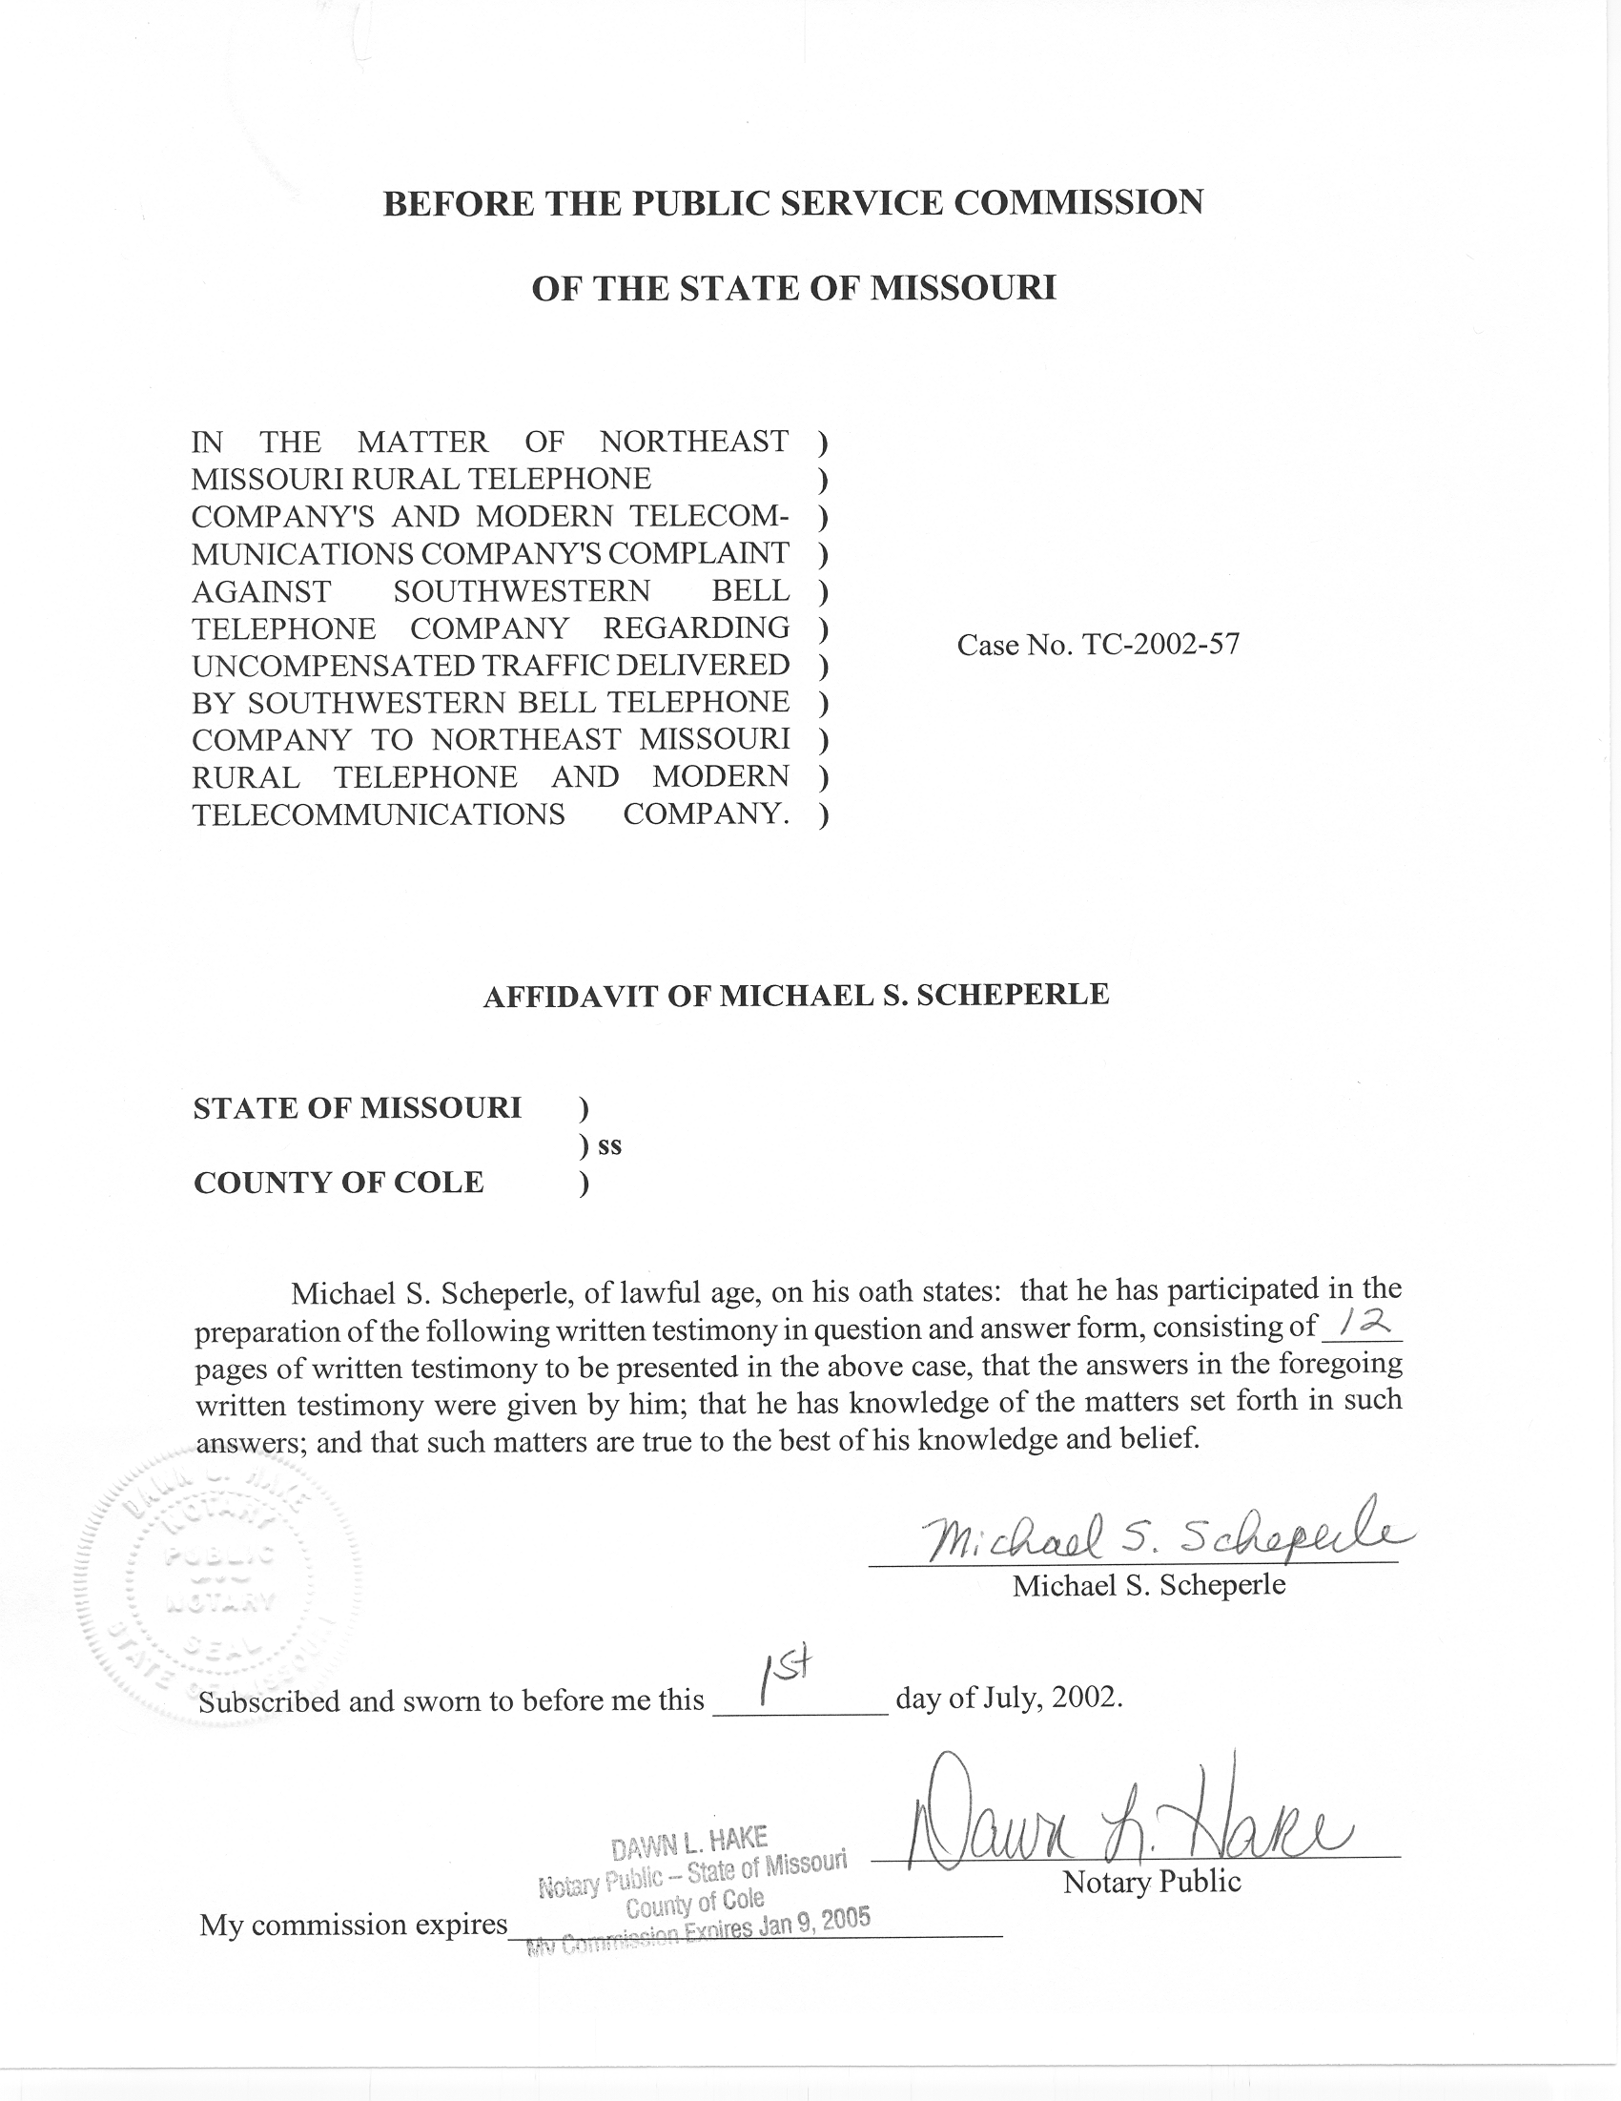
TABLE OF CONTENTS

Purposes of Testimony 1
Agreements between Respondents and Staff 2
Disagreements between Respondents and Staff 7

SURREBUTTAL TESTIMONY
OF

MICHAEL S. SCHEPERLE

NORTHEAST MISSOURI RURAL TELEPHONE COMPANY
AND MODERN TELECOMMUNICATIONS COMPANY
CASE NO. TC-2002-57
- Please state your name, employer and business address.
A. My name is Michael S. Scheperle and I am employed in the Telecommunications Department Staff (Staff) of the Missouri Public Service Commission (Commission). My business address is Post Office Box 360, Governor Office Building, Suite 500, 200 Madison Street, Jefferson City, Missouri 65102-0360.
Q. Are you the same Michael S. Scheperle who filed Rebuttal Testimony in this case on behalf of Staff?
A. Yes, I am.

Purposes of Testimony
Q. What are the purposes of your Surrebuttal Testimony in this case?
A. The first purpose of my Surrebuttal Testimony is to discuss Staff’s understanding of where agreements and/or disagreements may exist with Respondents in this case based on Staff’s recommendations.
The second purpose of my Surrebuttal Testimony is to respond to the Rebuttal Testimonies of John Clampitt, representing Ameritech Mobile Communications, Inc., Ameritech Cellular, CMT Partners and Verizon Wireless (collectively, Verizon Wireless); Gregory Tedesco representing VoiceStream Wireless Corporation, Aerial Communications, Inc. and Western Wireless (collectively, VoiceStream/Western); Lawrence Krajci representing ALLTEL Communications, Inc. (ALLTEL); William Brown representing Southwestern Bell Wireless LLC (Southwestern Wireless); Billy Pruitt representing Sprint Spectrum L.P., d/b/a Sprint PCS (Sprint PCS); Thomas Hughes representing Southwestern Bell Telephone, L.P. d/b/a Southwestern Bell Telephone Company (SWBT) and John Idoux III, representing Sprint Communications Company L.P. (Sprint). Collectively, these companies are the Respondents.
Staff, in Rebuttal Testimony, addressed wireless termination and compensation issues raised by Mid-Missouri Telephone Company (Mid-Missouri), Alma Telephone Company (Alma), Chariton Valley Telephone Corporation (Chariton), MoKan Dial, Inc. (MoKan), Choctaw Telephone Company (Choctaw), Northeast Missouri Rural Telephone Company (Northeast) and Modern Telecommunication Company (Modern) (collectively, MITG companies). These recommendations are contained in Staff’s Rebuttal Testimony and summarized on pages 21, 22 and 23.

Agreements between Respondents and Staff
- What areas of agreement appear to exist among the Respondents and Staff?
- There appears to be several areas of agreement:
  - MITG companies may charge switched access rates for terminating interMTA wireless traffic.
  - MITG companies are entitled to compensation for terminating intraMTA traffic.
  - It is not lawful for MITG companies to apply switched access charges for terminating intraMTA wireless traffic “transported” by SWBT and/or Sprint.
  - SWBT and Sprint transport wireless originated traffic to MITG companies as a transport service and not as an Interexchange Carrier (IXC).
  - Wireless traffic may terminate on MITG network(s) absent an Interconnection Agreement (IA) between Commercial Mobile Radio Service (CMRS) providers and MITG companies.
Q. Please explain your belief that agreement exists among Respondents and Staff that MITG companies may charge switched access rates for terminating interMTA traffic.
A. Staff believes Respondents agree with Staff’s recommendation that MITG companies may charge switched access rates for terminating interMTA wireless traffic as defined in each MITG company’s Switched Access Tariff and IAs between the CMRS providers and SWBT. Section H.1. (Schedule 1-8, Staff’s Rebuttal Testimony) of the Wireless Termination Tariffs supports this position: “the rates and rate elements applicable to Inter-MTA Traffic are set forth in the Telephone Company’s Switched Access Tariff.”
Q. Please explain your belief that agreement exists among Respondents and Staff that MITG companies are entitled to compensation for terminating intraMTA traffic; it is not lawful for MITG companies to apply switched access charges for terminating intraMTA wireless traffic “transported by SWBT and/or Sprint; and SWBT and Sprint transport wireless originated traffic to MITG companies as a transport service and not as an Interexchange Carrier.
A. Staff’s recommendation states that MITG companies may not charge switched access rates for terminating intraMTA wireless traffic unless carried by an IXC. This issue is the heart of the complaints by MITG companies. Staff believes that Respondents and Staff agree on these points:
MITG companies are entitled to compensation for terminating intraMTA traffic.
Mr. Clampitt (Verizon Wireless) states:
[C]omplainants are entitled to be compensated for wireless traffic terminated on their respective networks. I do not believe there is any dispute about this. (John Clampitt, Rebuttal Testimony, page 3, lines 13-15).

Mr. Hughes (SWBT) states:
SWBT agrees with the MITG companies that they should be paid appropriate compensation for terminating not only wireless traffic but all traffic. (Thomas Hughes, Rebuttal Testimony, page 11, lines 20-21).

It is not lawful for MITG companies to apply switched access charges for terminating intraMTA wireless traffic “transported” by SWBT and/or Sprint.
Mr. Clampitt (Verizon Wireless) states:
Verizon Wireless would propose that the Commission reaffirm its prior Orders and continue to follow FCC rules and orders by prohibiting the imposition of Complainants’ access charges upon any intra-MTA traffic terminated via SWBT to the exchanges of Complainants, either previously or into the future. (John Clampitt, Rebuttal Testimony, page 14, lines 3-7).

Mr. Idoux (Sprint) states:

The FCC has specifically ruled that intraMTA calls are not subject to access charges; rather, intraMTA calls are subject to local reciprocal compensation principles. Access is not an option for intraMTA calls. (John Idoux, Rebuttal Testimony, page 9, lines 1-3).

SWBT and Sprint transport wireless originated traffic to MITG companies as a transport service and not as an Interexchange Carrier (“IXC”).
Mr. Clampitt (Verizon Wireless) states:
SWBT is not an IXC for purposes of this telecommunications relationship. SWBT is what is known as a “transiting carrier,” providing only transiting services regarding this traffic, and not IXC services. (John Clampitt, Rebuttal Testimony, page 6, lines 20-23).

Mr. Hughes (SWBT) states:
First, transiting carriers like SWBT and Sprint-Missouri are not IXCs. (Thomas Hughes, Rebuttal Testimony, page 12, line 13).

Q. Please explain your belief that agreement exists among the Respondents and Staff that wireless traffic may terminate on MITG network(s) absent an IA between CMRS providers and MITG companies.
A. Staff’s recommendation requests that the Commission find that wireless traffic may terminate on MITG network(s) absent an Interconnection Agreement (IA) between Commercial Mobile Radio Service (CMRS) providers and MITG companies. From Staff’s perspective, this recommendation is consistent with what already occurs based on language in IAs between SWBT and CMRS providers when SWBT transports traffic to third party providers (i.e., MITG companies) without an agreement between the CMRS provider and MITG companies. For instance, Staff reviewed the IAs between CMRS providers and SWBT, and all strongly suggest that CMRS providers enter into their own agreements with third party providers. However, only one IA (between Ameritech Mobile Communications, Inc. and SWBT) has language that prohibits third party traffic unless or until the CMRS provider has a traffic interchange agreement with the third party provider. However, the next sentence of the IA states:
In the event that Carrier does send traffic through SWBT’s network to a Third Party Provider with whom Carrier does not have a traffic interchange agreement, then Carrier agree to indemnify SWBT for any termination charges rendered by a Third Party Provider for such traffic. (IA between Ameritech Mobile Communications, Inc. and SWBT, TO-97-523, page 15)

Mr. Idoux (Sprint) states:
Section 251(a)(1) of the Act [Telecommunications Act of 1996] requires all carriers to interconnect directly or indirectly with the facilities and equipment of other telecommunications carriers. The FCC has found that indirect interconnections with carriers’ networks are economically attractive. (John Idoux, Rebuttal Testimony, page 10-11, lines 24, 1-3)

Mr. Hughes (SWBT) states:
Section 251(a)(1) of the Act states that each telecommunications carrier has the duty “to interconnect directly or indirectly with the facilities and equipment of other telecommunications carriers.” We believe this section obligates SWBT to permit the wireless carriers to interconnect with SWBT for the purpose of establishing an indirect interconnection with other carriers’ networks. (Thomas Hughes, Rebuttal Testimony, page 6, lines 9-13)

Mr. Tedesco (VoiceStream/Western) states:
The Act treats all competitive carriers, including both competitive local exchange carriers (CLECs) and CMRS providers, alike with respect to interconnection rights. The Act speaks in terms of the rights and obligations of “telecommunications carriers.” The Act defines “telecommunications carrier” to mean any provider of telecommunications services. 47 U.S.C. § 3(49). The FCC has explicitly addressed the applicability of the interconnection rules to CMRS providers, and determined that CMRS providers are telecommunications carriers, and therefore are entitled to interconnection with the ILECs pursuant to Section 251. (Implementation of the Local Competition Provisions of the Telecommunications Act of 1996, CC Docket No. 96-98, …… First Report and Order). Thus, under the Act, all telecommunications carriers are required to interconnect, directly or indirectly, with other telecommunication carriers. (Gregory Tedesco, Rebuttal Testimony, pages 4-5, lines 13-21, 1-2).

Staff agrees with Respondents that Section 251(a)(1) of the Telecommunications Act of 1996 (Act) requires SWBT, Sprint, MITG companies and CMRS providers to interconnect directly or indirectly with the facilities and equipment of other telecommunications carriers. Staff’s recommendation that the Commission find that wireless originated traffic may terminate on MITG companies without an IA between the CMRS provider and MITG companies supports the intention of the Act.
Consistent with the Commission’s Report and Order in Case No. TT-97-524, SWBT’s Wireless Carrier Interconnection Service Tariff states that “Wireless carriers shall not send calls to SWBT that terminate in an Other Telecommunications Carriers’ network unless the wireless carrier has entered into an agreement to directly compensate that carrier for the termination of such traffic.” (P.S.C. Mo. No. 40, Sheet 16.02, Section 6.9) This language is basically bypassed/overruled by an IA between the CMRS provider and SWBT. A better relationship would exist if IAs were established between all parties (CMRS providers and SWBT and/or Sprint; and CMRS providers and MITG companies). However, this has not occurred and CMRS providers and MITG companies have not requested the Commission to arbitrate IAs. Staff is not optimistic that CMRS providers and MITG companies will negotiate IAs in the future; therefore, Staff’s recommendation is based on sound public policy and it is in the public interest to allow traffic to originate and terminate on CMRS providers and MITG companies networks with a compensation arrangement (e.g. Wireless Termination Tariff) in place.

Disagreements between Respondents and Staff
Q. Please discuss Staff’s understanding of where compensation disagreements exist between Respondents and Staff.
A. There seems to be disagreement between Respondents and Staff on the compensation mechanism for intraMTA traffic. For instance, most Respondents suggest a “bill and keep” mechanism is already in place to compensate MITG companies for intraMTA wireless traffic.
Mr. Krajci (ALLTEL) states:
Because no tariff or interconnection agreement was in effect for Choctaw prior to February 17, 2001, and no tariff or interconnection agreement is in effect to this date for Chariton Valley, the default arrangement is bill and keep. (Lawrence Krajci, Rebuttal Testimony, page 4, lines 20-23)

Mr. Brown (Southwestern Wireless) states:
However, Cingular has also attempted to negotiate interconnection agreements with each of the Complaining Carriers. Failing its ability to negotiate such interconnection agreements, the parties are operating under a de facto bill and keep arrangement.

Moreover, Complaining Carriers Alma Telephone, Choctaw Telephone and MoKan Dial, Inc. now have Commission-approved terminating wireless tariffs pursuant to Commission Order TT-2001-139 (consol.), the so-called Mark Twain case. Although Cingular respectfully disagrees with the Commission’s Order approving those tariffs and is pursuing an appeal, Cingular is nonetheless paying the tariffed rates under protest. Any attempt by those carriers or the other Complaining carriers to institute a rate for past traffic constitutes retroactive ratemaking and is inappropriate for that reason. (William Brown, Rebuttal Testimony, page 2-3, lines 35-45)

Mr. Tedesco (VoiceStream/Western) states:
VoiceStream/Western Wireless does take issue with the application of non-negotiated tariffs to traffic exchanged with the Missouri Rural ILECs, but is satisfied with the mutual traffic exchange (bill and keep) compensation arrangements in place. (Gregory Tedesco, Rebuttal Testimony, page 7, lines 12-14)

Mr. Pruitt (Sprint PCS) states:
47 C.F.R. § 51.705 defines the only rates that are appropriate for transport and termination in a reciprocal compensation regime. This rule requires that each incumbent LEC must produce one of the following type of rates:

§ 51.705 Incumbent LECs’ rates for transport and termination.
(a) An Incumbent LEC’s rates for transport and termination of local telecommunications traffic shall be established, at the election of the state commission, on the basis of:
(1) The forward-looking economic costs of such offerings, using a cost study pursuant to §§ 51.505 and 51.511;
(2) Default proxies, as provided in § 51.707; or
(3) A bill and keep arrangement, as provided in § 51.713.
Each of the MITG companies is also free to negotiate a mutually acceptable rate with each wireless company. Absent an interconnection agreement, a state ordered rate, or a negotiated rate the only option under the FCC rules is to have a bill-and-keep arrangement. (Billy Pruitt, Rebuttal Testimony, pages 11-12, lines 15-26, 1-4)

Staff is concerned with developing a compensation proposal for terminating intraMTA wireless traffic prior to establishment of a Wireless Termination Tariff as referenced by Mr. Krajci. Also, Staff is concerned with retroactive ratemaking as stated by Mr. Brown and more specifically, Staff is concerned about compliance with the provisions of § 392.220 RSMo, as a Commission approved Wireless Termination Tariff is only effective going forward or when established. However, Staff recommends that compensation is appropriate for traffic originated prior to the effective dates of Wireless Termination Tariffs. Staff proposes that there are other options available other than a bill and keep arrangement as referenced by Mr. Pruitt. Mr. Pruitt would be correct that bill and keep would be an option if the Commission were arbitrating rates for a reciprocal compensation agreement. ¶ 1060 of the FCC’s Interconnection Order states:
Thus, in arbitration proceedings, states must set the price for end office termination of traffic by: (1) using a forward-looking, economic cost study that complies with the forward-looking, economic-cost methodology set forth above; or (2) adopting a price less than or equal to 0.4 cents ($.004) per minute, and greater than or equal to 0.2 cents ($.002) per minute, pending the completion of such forward-looking, economic cost study….As discussed below, a state may also order a “bill-and-keep” arrangement subject to certain limitations. (FCC 96-325, In the Matter of Implementation of the Local Competition Provisions in the Telecommunications Act of 1996 and Interconnection between Local Exchange Carriers and Commercial Mobile Radio Service Providers, CC Docket Nos. 96-98 and 95-185, respectively) (emphasis added)

However, this case is not an arbitration procedure and other compensation options are available for Commission consideration. For example, the Commission has determined that it was appropriate for twenty-nine small ILECs to establish Commission-approved Wireless Termination Tariffs in Case No. TT-2001-139 absent an IA. In this case (TC-2002-57), Staff recommended that the Commission order Mid-Missouri, Chariton, Northeast and Modern to file a Wireless Termination Tariff, and thereby establish a rate for intraMTA traffic. This solution would guarantee a compensation mechanism for interMTA (switched access charges) and intraMTA (Wireless Termination Tariff) absent an interconnection agreement or arbitration procedure before the Commission.
Also, in rebuttal testimony, Staff made recommendations to address compensation for wireless intraMTA originated traffic prior to establishment of a Wireless Termination Tariff by MITG companies. As previously stated, Staff is concerned about the provisions of §392.220 RSMo, as a Commission-approved Wireless Termination Tariff is only effective going forward or when established. Staff’s recommendation that CMRS providers pay the Wireless Termination Tariff rate for switching and transport less the two-cents per minute adder to contribute to the cost of the local loop facilities for all MITG companies in this case is an option for compensation of traffic delivered prior to the effective date of Wireless Termination Tariffs. In Findings of Fact in Case No. TT-2001-139, the Commission noted the proposed termination rates are a single per-minute charge, consisting of a composite of the current intrastate, intraLATA access rates for switching and transport, plus a two-cent adder to contribute to the cost of the local loop facilities. Further, in its Conclusions of Law, the Commission determined the Wireless Termination Service tariffs are based upon a composite of the traffic-sensitive elements of their intraLATA access rates plus a $0.02 adder to help defray the cost of maintaining the local loop. The intrastate intraLATA traffic sensitive element charges were tariffed prior to the delivery of the wireless traffic at issue in this case. Since the tariffed rates were in effect prior to the origination of the wireless traffic in question, the rates are not retroactive and §392.220 does not prohibit the charges. In reviewing Staff’s Rebuttal Testimony, Staff is concerned that its recommendation that CMRS providers pay Wireless Termination Tariff rate for intraMTA traffic unless carried by an IXC based on PIU traffic study for Alma, Choctaw and MoKan was not as clear as intended. Consistent with the recommendation for Mid-Missouri, Chariton, Northeast and Modern, the two-cent adder should not be included as compensation for traffic delivered to Alma, Choctaw and MoKan prior to the effective date of their respective tariffs.
Q. Please discuss the recommendation by Mr. Hughes (SWBT) that the Commission order the MITG companies and the CMRS providers to negotiate an interconnection agreement.
A. Mr. Hughes (SWBT) recommends:
The Commission should deny the MITG companies’ complaint and direct the parties to negotiate an interconnection agreement under the Act. If the parties conduct good faith negotiations but are not able to reach agreements on the rates, terms and conditions, they should request arbitration under the Act. (Thomas Hughes, Rebuttal Testimony, page 26, lines 12-15)

Staff agrees that the preferable solution to this case would be for the companies to negotiate IAs. I would note that Staff’s recommendation in the complaint cases does not preclude any MITG company or CMRS provider from entering into IAs. Because MITG companies and CMRS providers have failed to enter into such agreements, these complaint cases are now before the Commission. Pursuant to Section 252 of the Act, the Commission does not have jurisdiction to order CMRS providers to enter into agreements, but can only arbitrate open issues or approve negotiated or arbitrated agreements. In light of this limitation, Staff continues to recommend the Commission order the MITG companies to file Wireless Termination Tariff(s) as proposed in its Rebuttal Testimony at pages 14 and 15, absent an IA or arbitrated case before the Commission.
Q. Does this conclude your Surrebuttal Testimony?
A. Yes, it does.

