Exhibit No.:
Issues: Alternative Regulation Plan
Witness: Anne Ross
Sponsoring Party: MoPSC Staff
Type of Exhibit: Surrebuttal Testimony
Case No.: EC-2002-1
Date Testimony Prepared: June 24, 2002

MISSOURI PUBLIC SERVICE COMMISSION

Utility Operations DIVISION

SURREBUTTAL TESTIMONY

OF

ANNE ROSS

UNION ELECTRIC COMPANY d/b/a

amerenUE

CASE NO. EC-2002-001

Jefferson City, Missouri
June, 2002

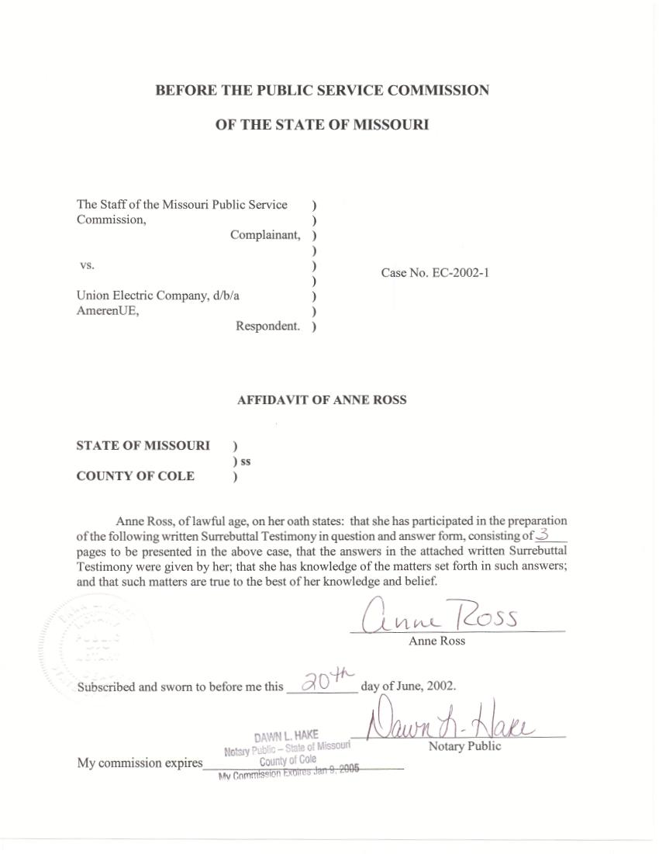
SURREBUTTAL TESTIMONY
OF
ANNE ROSS

UNION ELECTRIC COMPANY, d/b/a AMERENUE
CASE NO. EC-2002-001

Q. Please state your name and business address.
A. My name is Anne Ross and my business address is Missouri Public Service Commission, P.O. Box 360, Jefferson City, Missouri, 65102.
Q. What is your present position with the Missouri Public Service Commission?
A. I am a Regulatory Economist in the Energy Department of the Operations Division.
Q. Would you please review your educational background?
A. I have a Bachelor of Science in Business Administration and an M.B.A. from the University of Missouri - Columbia.
Q. Have you previously filed testimony before the Commission?
A. Yes. I joined the Staff of the Missouri Public Service Commission (Staff) in September, 1989. Since that time, I have filed testimony on class cost-of-service and rate design in a number of natural gas and electric cases.
Q. What is the purpose of your surrebuttal testimony?
A. The purpose of my testimony is to address the portion of Union Electric Company witness Warner L. Baxter’s rebuttal testimony on pages 21 and 22 that draws conclusions regarding the reasonableness of AmerenUE’s rates based on rate comparisons or statements of other individuals or entities. I will describe the preparation of an average revenue per kilowatt-hour comparison report that I compile annually and distribute to the Commissioners and Staff. Schedule 1-1 is the cover memorandum that I send out with this report and in particular it is the cover memorandum that I used for the most recent report on February 25, 2002.
Q. What is the purpose of this report?
A. This report summarizes dollars per kilowatt hour information for the electric and natural gas industries for the 50 states and the District of Columbia, and is intended to be used for informational purposes.
Q. What is the source of the information used in this report?
A. My report uses information published annually by the Energy Information Administration (EIA), Electric Power Division, Office of Coal, Nuclear, Electric and Alternate Fuels, U.S. Department of Energy. The EIA is identified in this publication as the independent statistical and analytical agency within the Department of Energy. For the most recent electric industry report that I compiled information for and sent to the Commissioners and Staff, I used the EIA publication Electric Sales and Revenue 2000, published January 2002.
Q. What Missouri information do you compile from this publication for the electric industry section of your report?
A. The report that I compiled contains Missouri-specific information on all investor-owned, cooperative, and municipal electric utilities in Missouri, including customer numbers, revenue, sales and dollars per kilowatt-hour. This information is grouped according to the broad Standard Industry Classification (SIC) code groupings of Residential, Commercial, and Industrial, as well as calculated for each utility in total. Schedule 1-7 is a representative page from the report that I distribute. Schedule 1-7, among other things, shows information respecting Missouri investor-owned electric utilities.
Q. Does the information that you compiled from the EIA publication differ from the conclusions stated in Mr. Baxter’s testimony?
A. I have provided this information to Staff witness Robert E. Schallenberg. He will address this question in his surrebuttal testimony.
Q. Does this conclude your surrebuttal testimony?
A. Yes, it does.
