Exhibit No.:
Issues: Class Cost of Service
Witness: Anne Ross
Sponsoring Party: MoPSC Staff
Type of Exhibit: Direct Testimony
Case No.: GR-2002-356
Date Testimony Prepared: June 26, 2002

MISSOURI PUBLIC SERVICE COMMISSION
UTILITY OPERATIONS DIVISION

direct TESTIMONY

OF
ANNE ROSS

LACLEDE GAS COMPANY
CASE NO. GR- 2002-356

Jefferson City, Missouri
June, 2002

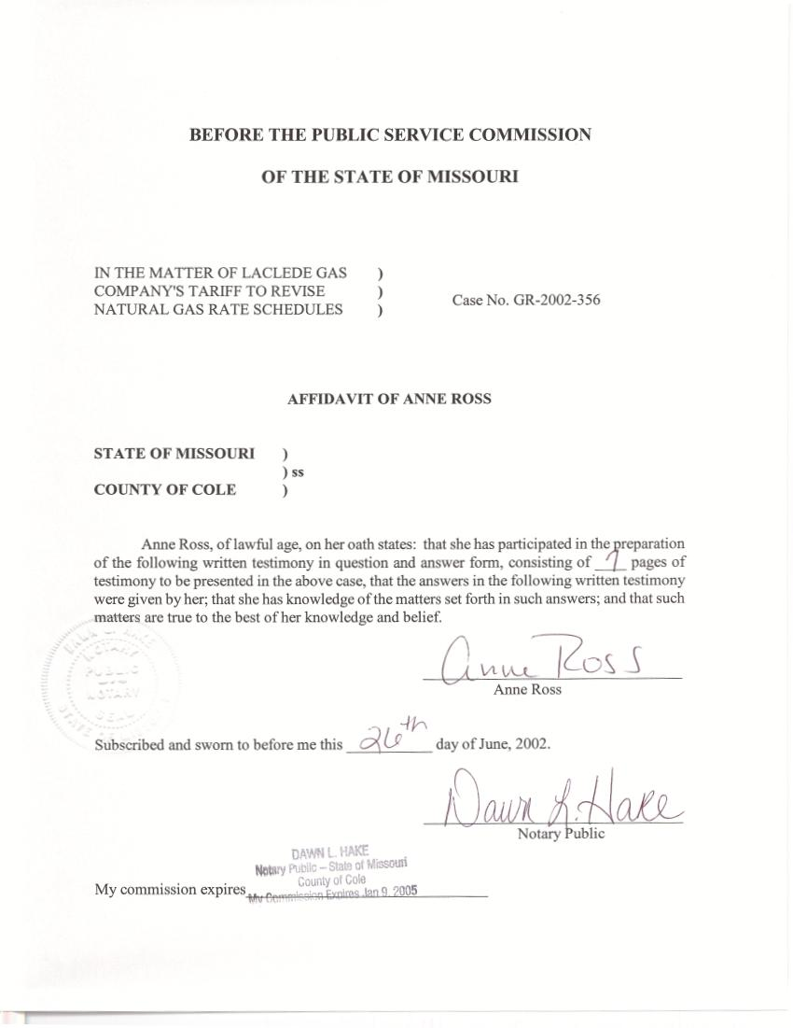

TABLE OF CONTENTS

Class Peak-Day Demand Estimates 1
Class Cost-of-Service 3
Billing Determinants 5

DIRECT TESTIMONY
OF

ANNE ROSS
LACLEDE GAS COMPANY
CASE NO. GR-2002-356

Q. Please state your name and business address.
A. My name is Anne Ross and my business address is P. O. Box 360, Jefferson City, Missouri 65102.
Q. Are you the same Anne Ross who has previously filed testimony in this case?
A. Yes, I am.
Q. What is the nature of your testimony as it relates to the rate increase being proposed by Laclede Gas Company (Laclede or Company) in Case No. GR-2002-356?
A. I will present testimony in regard to estimated class peak demands, class Cost-of-Service (C-O-S), and billing determinants.

Class Peak-Day Demand Estimates
Q. Did you develop class peak-day demand estimates for use in Staff’s class
C-O-S study?
A. Yes. I developed peak-day demand estimates for the General Service – Residential, General Service – Commercial and Industrial, Vehicular Fuel, and Unmetered Gas Light classes.
Q. How are class peak-day demand estimates used in Staff’s class C-O-S study?
A. Class peak-day demands are used to form allocation factors that reflect a realistic estimate of each C-O-S class’ contribution to the demand on the Laclede system on a system peak day
Q. Why are peak-day demands for these classes estimated rather than calculated directly from billing data?
A. Smaller customers, such as Residential customers, and those in the General Service – Commercial and Industrial rate classes, do not usually have the type of meter that is capable of measuring and recording a customer’s usage at a single point in time; rather, these meters keep a running total and are read on a monthly basis. Therefore, Staff must use the results of its weather normalization studies, and an average of the actual coldest day of each of the last 30 years, to estimate these smaller customers’ contribution to system usage on the coldest day of the year.
Q. How did you estimate peak-day demand for the General Service – Residential and General Service – Commercial and Industrial C-O-S classes?
A. For these two classes’ estimate of peak-day demand, I multiplied peak-day therm usage per customer, calculated by Staff witnesses Kim J. Elvington and James A. Gray, by the annual average number of customers in these classes.
Q. How did you estimate peak-day demands for the Vehicular Fuel and Unmetered Gas Light customer classes?
A. As these customers are not weather-sensitive, I estimated their peak-day usage by dividing their annual therm usage by 365.

Class Cost-of-Service
Q. Did you develop a class C-O-S study in Case No. GR-2002-356?
A. Yes. I updated the Staff class C-O-S study filed in October 2001 in Case No. GR-2001- 629.
Q. What is the purpose of a class C-O-S study?
A. A class C-O-S study estimates the revenue responsibilities of the various
C-O-S classes and estimates the average customer charges and average margin rates for each class.
Q. What C-O-S classes are used in Staff’s class C-O-S study?
A. Staff’s class C-O-S includes eight (8) classes. These classes are the: Residential, General Service - Commercial and Industrial, Liquid Propane, Large Volume, Interruptible, Firm Transportation, Basic Transportation, and Unmetered Gas Light Classes.
Q. Which customers are included in the Staff’s Residential C-O-S class?
A. This C-O-S class includes the Company’s General Service - Residential space heating and air conditioning customers.
Q. What customers are included in the Staff’s General Service – Commercial and Industrial C-O-S class?
A. This C-O-S class includes the Company’s General Service – Commercial and Industrial tariff class, which is composed of a diverse group of non-residential customers who take firm sales service, but are not large enough to benefit by taking service on the Large Volume Sales service rate. Vehicular Fuel customers are also included in this class in the Staff study.
Q. Which customers are included in the Staff’s other C-O-S classes?
A. The remaining C-O-S classes contain the customers in the corresponding tariff classes of the Company.
Q. Please describe how Staff’s class C-O-S study in Case No. GR-2001-629 was updated.
A. First, all costs were adjusted to reflect the values in Staff’s Accounting Schedules filed on June 20, 2002. Next, all customer numbers, volumes, and peak demands were modified to reflect the current values calculated by Staff.
Q. Are there any cost components that are not based upon the current Accounting Schedules?
A. No.
Q. Are there any revenue components that are not taken directly from the Staff’s Accounting schedules filed on June 20, 2002?
A. Yes. I developed class margin revenue estimates that approximate the revenue contribution of the classes. In total, these rate revenues are very similar to those filed by the Staff on June 20, 2002, but are categorized differently.
Q. Why did you develop class revenue estimates of current margin revenues, rather than using the revenue groupings filed by the Commission’s Accounting Staff on June 20, 2002?
A. While the Accounting Staff develops current revenues that are appropriate in total, these groupings cannot be used in the Staff class C-O-S study.
Q. Why are the revenues developed by the Staff Accounting Department unsuitable for use in determining an estimate of class revenue responsibility?
A. The revenue class groupings used by the Staff Accounting Department are not broken down into the same customer groupings that I am using in the Staff class C-O-S; therefore, they can’t be used to compare a C-O-S class’ current revenue with its estimated costs.
Q. You stated earlier that the total rate revenues you developed using the Staff’s normalized billing units are “very similar” to those developed by the Accounting Staff, filed on June 20, 2002. What do you mean by very similar?
A. The revenues developed by pricing out Staff’s normalized billing units do not exactly match the rate revenues contained in the filed Accounting schedules. The difference, however, represents less than 0.2% of the Company’s margin revenues.
Q. Can this difference be reconciled?
A. Yes, with the help of the Company. This difference must be reconciled in order to set rates to collect any revenue requirement ordered by the Commission in this case. It appears that Staff’s billing units are slightly low, and if rates are set using billing units that are too low, the resulting rates will be too high, and the Company will collect more than the Commission-ordered revenue requirement.
Q. What are the results of the Staff’s class cost-of-service study?
A. The results of Staff’s class C-O-S study are shown on Schedule 1.

Billing Determinants
Q. Are the Staff’s customer numbers used in developing allocation factors for this case appropriate to use as billing units when determining customer charges?
A. Yes.
Q. Once the revenue increase or decrease is decided by the Commission, are the therm volumes used in developing allocation factors for this case appropriate to use as billing units when designing volumetric rates?
A. Yes, as long as the volumes are reconciled with current revenues, as I discussed in the previous section.
Q. How are these billing determinants used to set rates?
A. If the Commission-orders a revenue increase in this case, the parties will work together to design initial rates that will collect each class’ revenue requirement. After doing this, the Company typically identifies any customer that, given their usage level and characteristics, might find it economically advantageous to switch to another rate class. Since this rate-switching would result in an undercollection of revenues for the Company, the parties would then perform an analysis that assumes that customers definitely will switch, and adjust the volumetric rates to insure that all of any Commission-ordered revenue requirement is collected.
Q. What if these customers do not realize that they could save money by switching to another rate, and, therefore, don’t switch?
A. In that case, the Company would collect more than the Commission-ordered revenue requirement. As a result of the Stipulation and Agreement in Case
No.GR-2001-629, the Company notified all customers identified in the rate-switching analysis that an analysis of their account had indicated that they might be able to save money by switching to another rate. Staff proposes that, as in the previous case, the Commission order the Company to notify all customers identified in the rate-switching analysis. Laclede provided Staff with a copy of the letter sent to those customers after the 2001 case, and it is attached as Schedule 2.
Q. Does this conclude your testimony?
A. Yes.
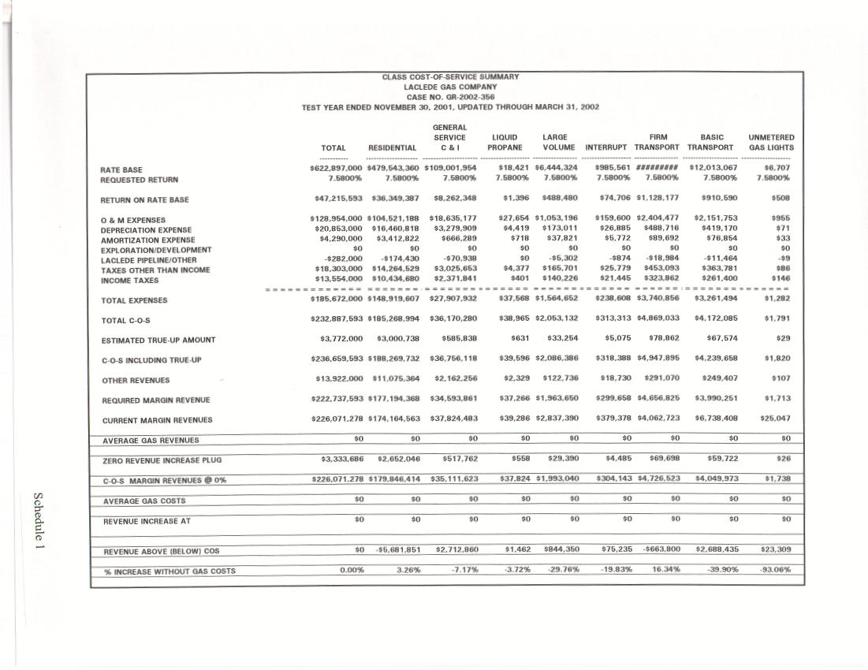
Schedule 1
