Exhibit No.:
Issues: Revenues
Witness: Anne Ross
Sponsoring Party: MoPSC Staff
Type of Exhibit: Direct Testimony
Case No.: GR-2002-356
Date Testimony Prepared: June 20, 2002

MISSOURI PUBLIC SERVICE COMMISSION

UTILITY OPERATIONS DIVISION

direct TESTIMONY

OF

ANNE ROSS

LACLEDE GAS COMPANY

CASE NO. GR-2002-356

Jefferson City, Missouri
June, 2002

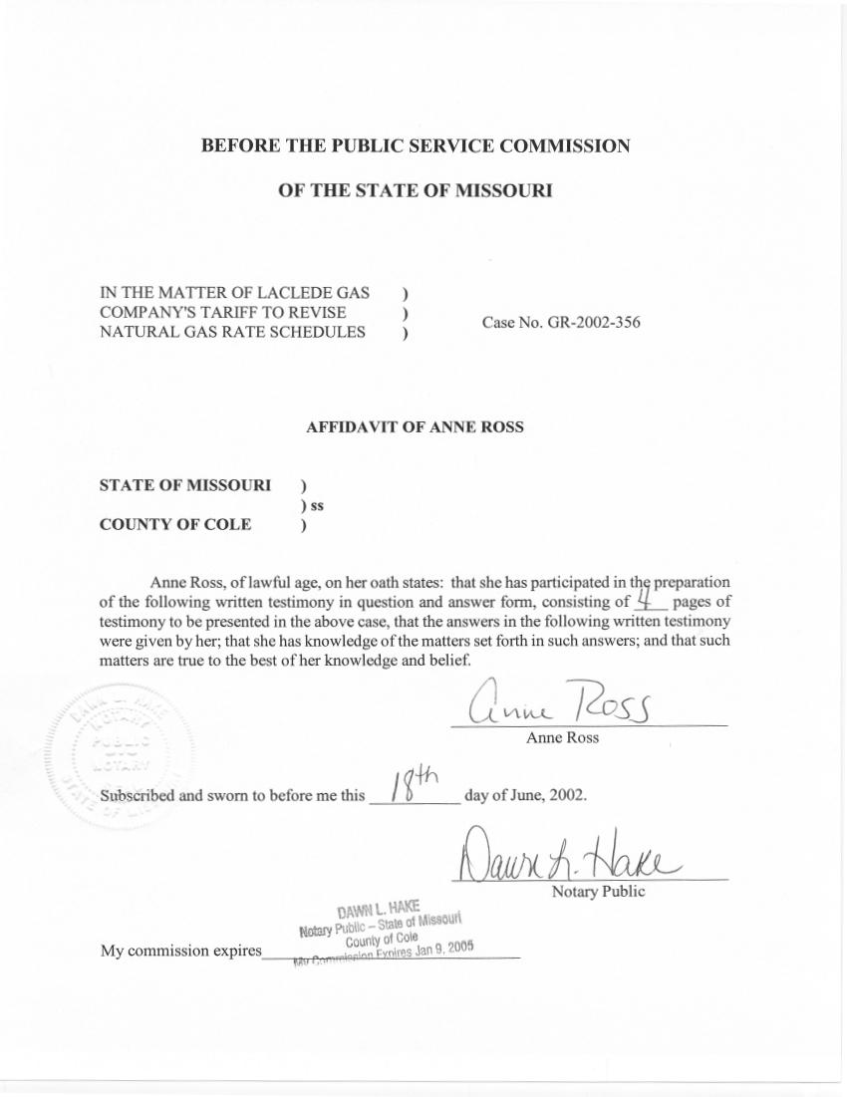

DIRECT TESTIMONY
OF
ANNE ROSS
Laclede Gas Company
CASE NO. GR-2002-356

Q. Please state your name and business address.
A. My name is Anne Ross and my business address is Missouri Public Service Commission, P.O. Box 360, Jefferson City, Missouri, 65102.
Q. What is your present position with the Missouri Public Service Commission?
A. I am a Regulatory Economist in the Energy Department of the Operations Division.
Q. Would you please review your educational background?
A. I have a Bachelor of Science in Business Administration and an M.B.A. from the University of Missouri - Columbia.
Q. Have you previously filed testimony before the Commission?
A. Yes. I joined the Staff of the Missouri Public Service Commission (Staff) in September, 1989. Since that time, I have filed testimony on class cost-of-service and rate design in a number of Natural Gas and Electric cases.
Q. What is the purpose of your direct testimony?
A. The purpose of my testimony is to describe adjustments to customer therm usage, customer numbers, and rate revenue for Laclede Gas Company (Laclede or Company) customers in the Large Volume Sales and Transportation Service (Firm Service and Basic Service), Large Volume Service, and Interruptible Service rate classes. These adjustments were made to recognize:
a. Rate-switching and customer load changes occurring through March 31, 2002.
b. Annualization of monthly billing demand to test year ending levels.
c. Restatement of Transportation class test year rate revenues to a level based on actual billing units and test year tariff rates.
These adjustments were provided to Staff witness John P. Cassidy.
Q. Please describe the “rate-switching” adjustment.
A. Customers who switched rate codes during the period December 1, 2000 – March 31, 2002 were identified by the Company in response to data requests. The test year volumes, customer numbers and revenues associated with the tariff class in which they were initially served were removed from the totals in that class. The volumes and customer numbers were then priced out at the rate in the customer’s new class, and these customer numbers, volumes, and dollars were added to those in the tariff class in which the customer was at the end of the March 31, 2002 update period.
Q. Please describe the adjustment made to demand therms and revenues.
A. Laclede’s tariffs use the maximum of a base level or the highest billing demand in the previous 11 months to calculate that component of customer bills. Therefore, to more accurately represent billing demand therm levels and revenues on a going-forward basis, I adjusted each customer’s actual test year monthly billing demand therm level to the test year ending level.
Q. Please explain the adjustment to the Large Volume Transportation and Sales Service (LVTSS) tariff class’ rate revenue.
A. In response to data requests, I received individual customer billing units for all customers who were served under the LVTSS tariff at any time during the test year. I reviewed each customer’s monthly usage, and in months where the usage appeared to be atypical for that customer, I asked for clarifying information from the Company. Using this information, I corrected billing units so that they more accurately reflected the customers’ actual monthly usages. I checked my resulting blocked usage numbers against information provided to the Staff accountants, and against the Company’s actual test year usage numbers in this case. Both sets of usage numbers were provided to Staff by the Company. The billing units I had developed tied closely to both sources.
I then priced out the billing units using the tariffed margin rates in effect during the test year. For one component of rate revenues – the Storage Charge of 2¢ per therm – the Company provided the dollar amount per a phone request. The calculated margin revenues for the LVTSS class produced an annual amount of $10,423,442, which is approximately $283,000 higher than the LVTSS revenues on the Company books. Therefore, I am sponsoring an adjustment to restate Transportation class test year revenues based on test year billing units and tariff rates.
Q. Have you made an attempt to verify your calculation?
A. Yes. I have performed checks to verify the billing units, the tariffs in effect at that time, and through conversations with the Company, I believe this calculation is appropriate.
Q. Are there additional volume and revenue adjustments being made to the customers in the Large Volume Sales and Transportation Service – Basic, Large Volume Sales and Transportation Service – Firm, Large Volume Sales Service, and Interruptible Sales Service rate classes in this case?
A. Yes. Staff Witness Daniel I. Beck is sponsoring additional adjustments to the revenues in these four classes. These adjustments will be discussed in his direct testimony.
Q. Does this conclude your direct testimony?
A. Yes, it does.

