BEFORE THE PUBLIC SERVICE COMMISSION

OF THE STATE OF MISSOURI

Before Commissioners: Jeff Davis. Chairman
Connie Murray, Commissioner
Steve Gaw, Commissioner
Robert Clayton III, Commissioner
Linward Appling, Commissioner

In the Matter of the Application of Kansas City )
Power & Light Company for Approval to Make ) CASE NO. ER-2006-0314
Certain Changes in its Charges for Electric Service )
To Begin the Implementation of Its Regulatory Plan )

W. BILL DIAS’ POST-HEARING BRIEF

November 17, 2006.

TABLE OF CONTENTS
I Introduction……………………………………………………………………………..…7
II Affidavit Rev. Daniel Childs Jr. ………………………………………………………..8-9
III Issue………………..….Honor Memorandum of Understanding………………………… 9
A. Should the Public Service Commission direct KCPL to honor the terms and conditions contained in the executed Memorandum of Understanding with
KCPL dated February 12, 2001?
a) Response…...………………………………………..……………9-10
b) Background ……………………………………..…………….10-11
c) Direct Testimony Related to This Issue Summary….…………… 12
d) Direct Testimony Transcript Related to This Issue…………… . 12-16
- Commissioner Clayton………………………………12-16
e) Conclusion to The Issue………...…………………….….…….. 17

IV Issue………………………… Delayed Due Dates………………………..………….…….17

B. Should the Public Service Commission direct KCPL to allow all of its customers that enroll in Dias' on-time bill payment program the flexibility to have “Delayed Due Dates” so they can participate in Alternative Credit Score?
a) Response……………………………………………...………...17-18
b) Background……………………………………... ………….…..19-20
c) Direct Testimony Related to This Issue Smmary...…………...…...19
d) Direct Testimony Transcript Related to This Issue…..…..…….12-16
- Commissioner Clayton………………...…….……..12-16
e) Conclusion to The Issue………………………….…….…….....….13

V Issue……….Alternative Credit Score Program………………………………….……..…18

C. Should the Public Service Commission direct KCPL to allow all of its customers that enroll in Dias’ on-time bill payment program the flexibility to participate in Alternative Credit Score Programs?
a) Response………………………………………..…………………18
b) Background……………………………………...……………..19-20
c) Direct Testimony Related to This Issue Summary ...……………...20
d) Direct Testimony Transcript Related to This Issue…...……….20-21
- Mr. Fischer………………………………..…….…20-21
- Mr. Dias…………………………………..………..21-24
- Commissioner Clayton…………………..…………….24
e) Conclusion to The Issue……………………………..……..…..23-24

VI Issue……….Expand Third-Party Payment Agent to Include Minority Pay Agents…….24
D. Should the Public Service Commission direct KCPL to expand its third-party payment agent vendors to include minority pay agents. Should the Commission direct KCPL to appoint DIAS "a minority owned company" as the first authorized thrid-party minority owned payment agent per the terms and conditions contained the February 12, 2001 and the June 5, 2006, Memorandum of Understandings that are in evidence in this case?
a) Response…………………………………………………………25
b) Background…………………………………………………........25 c) Direct Testimony Related to This Issue Summary…………….....26
d) Direct Testimony Transcript Related to This Issue..….……....26-33
- Mr. William Downy……..………………………..26-29
- Commissioner Clayton…………………….……...29-34
e) Conclusion to The Issue……………….………………………….34
VII Issue………..Participation in Energy Conservation Program…………………………...34
E. Should the Public Service Commission direct KCPL to participate in the Energy Conservation Program of DIAS” that will provide consultation, weatherization, materials, installation and On-time Bill Payment if the KCPL customer does not income quality for Low-Income help, if so, should the cost of the program to be underwritten by KCPL and charged back to the customer. Should this program be independent of the customer’s utility bill?
a) Response……………………………………………………...34-36 b) Background…………………………………………….…………36
- The repayment of these “Energy Conservation Loans"....……36
c) Direct Testimony Related to This Issue Summary ...………...36-37
d) Direct Testimony Transcript Related to This Issue………….…..37
- Mr. Fischer……………………………………………….37-38
- Mr. Mills………………………………………………….….38
- Mr. Finnegan……………………………………………..38-41
- Mr. Phillips……………………………………………….41-43
- Commissioner Clayton…………………….……………..43-52
- Mr. Dias………………………………………………….52-57
e) Conclusion to The Issue…………...…………………………57-58

VIII Issue……Combine Versions of Proposed Memorandum of Understanding……..…59-60

F. Should the Public Service Commission direct KCPL to execute a New Memorandum of Understanding that is a combination of all the versions proposed by Dias and as supported by the Urban Community. Should KCPL be required to pay DIAS as an authorized payment agent the transaction fee of $.75 per transaction as called for in the executed Memorandum of Understanding dated February 12, 2001?
a) Response…………………………………………………………58 b) Background………………………………………………………58 c) Direct Testimony Related to This Issue Summary………….……59
d) Direct Testimony Transcript Related to This Issue…………...59-61
- Commissioner Clayton…………………..………..............60-61
e) Conclusion to The Issue…………..….……….………………......61
IX Issue………..Expand Existing Tariff Program to Allow 50% Rate Reduction…….……60

G. Should the Public Service Commission direct KCPL to continue the existing tariff program that allows small churches to receive a 50% rate reduction. Also, the Commission should direct KCPL to expand this tariff program so that all churches working with DIAS' can receive this 50% rate reduction.
a) Response…………………………………………………....…61-62 b) Background…………………………………………….…….…....62 c) Direct Testimony Related to This Issue Summary ....….…………62 d) Direct Testimony Transcript Related to This Issue……..………...62
- No direct testimony on this issue offered
e) Conclusion to The Issue…………………………………….…62-63

X Issue……….Expand CPAG to Get Community Input on Issues………………….……..63
H. Should the Public Service Commission direct the KCPL to provide four (4) new paid seats to the “Customer Program Advisory Group (“CPAG”) to gather community input on all issues related to urban customers? Should Dias be given a paid permanent seat on this advisory group?
a) Response………………………………………………………63-64
b) Background……………………………………………………….64 c) Direct Testimony Related to This Issue Summary..………….…..65 d) Direct Testimony Transcript Related to This Issue……………….65
- Mr. Mills…………………………………………………..….65
- Mr.Conrad………………………………………………...65-66
- Commissioner Gaw………………………………………66-72
- Commissioner Appling……………………………….…..71-77
e) Conclusion to The Issue…………………………………….……77

XI Overall Conclusion Summary .……………………………………………………79

Exhibits Admitted Into Evidence

Dias No. 1301 Surrebuttal Testimony of W. Bill Dias
No. 2 Public Hearing Exhibit 8/24/06
Dias No. 1314 Hearing 10/27/06
“Memorandum of Understanding February 12, 2001”

No. 3 Public Hearing Exhibit 8/24/06
Dias No. 1310 Hearing 10/27/06
“Memorandum of Understanding, June 5, 2006”

OPC No. 218 Signed Urban Community Petition
To The Public Service Commission
“Ministers for Energy Conservation”

Dias No. 1304 Kansas City Call News Paper Article
“Baptist Ministers Union Negotiates with KCP&L
Officials to Assist Poor and Elderly”

Dias No. 1306 KCPL PowerPoint Presentation July 20, 2006
Baptist Ministers Union of Kansas City, Missouri

Dias No. 1309 John Marshall Hearing Testimony 10/27/06
Dias No. 1313 Rev. Mike Brooks Public Hearing Testimony Public Hearing 8/24/06
Dias No.1315 W. Bill Dias Public Hearing Testimony Public Hearing 8/24/06
Dias No.1317 KCPL Meeting Agenda Hearing 10/27/06
Dias No. 1318, Rev. Daniel Childs Public hearing Testimony
Public Hearing 8/24/06
I Introduction

Comes now W. Bill Dias submits its post-hearing brief; W. Bill Dias will limit its
requested relief to the issues on which KCPL has taken some position or on which was raised
in the direct testimony of Susan K. Natham, Anita Randolph, William Downy and John
Marshall.
The relief that Dias is requesting does not involve any Federal, State or Local funds;
for that reason it is not necessary to spend a lot of time on Susan Natham and Anita Randolph’s
testimony. The relief that Dias is requesting does not involve a breach of contract issue between
Dias and KCPL it is simply requesting the Commission to compel KCPL to do what is right by
the urban community as requested by the urban community through Dias.

The first element of Dias’ requested relief, as supported by the Urban Community and
direct testimony from the Hearing, would be from the Predatory Enabling Policies of
KCPL that require cash to pay utility bills at traditional pay stations, if a customer so chooses.

These policies allow the urban criminal element that stalk these KCPL authorized
pay stations; waiting for the opportunity to rob and murder urban residents. KCPL has rejected
all pleas from the urban core for the last 20 years to change the way they collect their payments,
however, KCPL has turned their backs on 1/3 of their customer base.

The second element of Dias’ requested relief, as supported by the Urban Community and
direct testimony from the Hearing, is to deny KCPL’s expansion of traditional pay stations in the
urban core. KCPL has testified that they plan to establish even more traditional pay stations in the
urban core, without having input from the leadership of the urban community. This action will get
even more urban residents robbed and murdered.

The third element of Dias’ requested relief, as supported by the Urban Community and
direct testimony from the Hearing, is to compel KCPL to authorized minority third-party
payment agents. To date, KCPL has refused to authorized a single minority third-party payment
agent; for more than 20 years even though their action is against both Federal and State Laws.

The fourth element of Dias’ requested relief, as supported by the Urban Community and
direct testimony from the Hearing, is to compel KCPL to change its overall treatment of urban
residents.
Currently KCPL takes a “Plantation Attitude” i.e. KCPL knows what is good for the
urban community and said so in the Kansas City Call Article that is in evidence in this case.
The testimony of Susan K. Nathan and Anita Randolph dealt with their opinions and interpretations of the “Energy Conservation Program” as envisioned by the leadership of the Urban Community of Greater Kansas City Missouri and Bill Dias. The testimony of William Downy dealt with the overall management philosophy that KCPL knows what is best for the urban community. The testimony of John Marshall dealt with the fictitious KCPL relationship with the Baptist Ministers Union.

Nathan and Randolph draw their interpretations from the “Energy Conservation Program envisioned by KCPL through the collaboration of a group of Interveners established and controlled by KCPL i.e.; Customer Programs Advisory Group better known as “CPAG”. CPAG’s vision of energy conservation can be found in Case No.EO-2005-0329, Appendix “B” entitled “Low Income Weatherization and High Efficiency Program”.

The description of CPAG’s energy conservation program simply deals with how to qualify low-income customers to get help managing their energy use and paying their KCPL bill. CPAG’s idea of low-income weatherization is to work directly with CAP agencies that already exist and provide weatherization services to low-income customers only, through the Department of Energy “DOE” and other federally funded agencies. KCPL provides funds to administer low-income weatherization measures.
This, low-income program, as envisioned by CPAG and administered by CAP agencies who (were previously selected by KCPL) follow the protocol under current federal and state guidelines. Participants can only come from KCPL owner-occupied residential customers and have an income that is up to 185% of the federal poverty guidelines. If a KCPL customer is a renter, they can only participate if the landlord pays 50% of the weatherization cost and agrees not to raise the rent for a pre-agreed period of time.

Direct testimony from the hearing shows that CPAG is controlled by KCPL and only works on issues put to them by KCPL. The direct testimony shows that at no time did KCPL nor CPAG seek the input of the urban community, nor did they seek input from the church even though John Marshall testified he knew how important there input is.
The Urban Community of Greater Kansas City has spoken loud and clear with one voice that has gone unheard for over twenty (20) years. For the first time through the Intervention of W. Bill Dias can this voice be heard because the interest of the urban community is the same as Dias’ interest.

Kansas City Power & Light is perpetrating a fraud when they continue to say that they are working with the Urban Community and that their involvement in the community meets the approval of their urban customers. Once again Dias can only say that there is a newspaper article from the Kansas City Call that was admitted into evidence as DIAS exhibit no. 1304; the reporter attended the meeting and heard John Marshall make these comments to the body of that meeting. The testimony of KCPL is not to be believed. KCPL is not to be trusted with the lives of urban residents whose only roll in this process is trying to pay a utility bill.

II Affidavit Rev. Daniel Childs Jr.
There is an affidavit that can be found in EFIS as a public comment of Rev. Daniel Childs, Jr., the tracking number is P200700795. Rev. Childs was first duly sworn and on his oath stated the following:

“My name is Rev. Daniel Childs, Jr. I am the administrative assistant of the Baptist Ministers Union of Kansas City Missouri.

I am a former president of the Baptist Ministers Union of Kansas City Missouri, and have been a member for over thirty years it is my sworn testimony that KCPL has made no attempts to include the Baptist Ministers Union in any decision making issues that relate to the Urban Community at large nor have they offered to provide a seat in the CPAG Organization that they profess to collaborate with.” Rev. Childs goes on to say “Not until we started working with W. Bill Dias did KCPL ever have any dialogue nor have they approached the Baptist Ministers Union to partner in any community related projects of any kind.

On July 25, 2006, it was reported to the body of the Baptist Ministers Union that negotiations with KCPL were going smoothly and that there were employment opportunities available and in order to determine if they were negotiating in good faith we should begin sending people to apply.

Rev. Childs further states “Upon that report I contacted the human resources department of KCPL and identified myself as a member of the Baptist Ministers Union seeking information on the process of application as to whether it needed to be in person or via the internet. I was told that the process of employment was through the Full Employment Counsel/FEC organization and that is based on income eligibility. The overall tone of the conversation indicated that there was no mechanism in place or willingness to provide employment for those who identified themselves from the Baptist Ministers Union.

Rev. Childs continues to state “The Executive Committee of the Baptist Ministers Union did help formulate the June 5, 2006 Memorandum of Understanding and support all the issues contained in this document.”

The Baptist Ministers Union states as the voice of over 160,000 church members that “The Baptist Ministers Union believes that the only way that the Urban Community at Large will get any help from KCPL will come only if the Public Service Commission of the State of Missouri compels them to do so.” “It is a consensus opinion that the Baptist Ministers Union request that the Public Service Commission should direct KCPL to implement all of the issues requested by W. Bill Dias”.

Rev. Childs ends his statement with these words “I have previously given sworn testimony on these matters at the public hearing held August 24, 2006 and my direct testimony is apart of these proceedings”.

III …… ISSUE…….Honor Memorandum of Understanding…..

A: Should the Public Service Commission direct KCPL to honor the terms and conditions contained in the executed Memorandum of Understanding with KCPL dated February 12, 2001?

Response: KCPL is directed to combine the February 12, 2001 Memorandum of Understanding agreement with the June 5, 2006 agreement and shall implement its terms and conditions.
It is clear that KCPL executed this Memorandum of Understanding in 2001 solely to hold down the anger of the urban community after several robberies and murders occurred at KCPL authorized pay stations.
From the testimony of John Marshall, KCPL plans to expand these traditional pay stations in the urban community which is unacceptable given the criminal element that stalks these pay stations.
KCPL choose not to honor this agreement as was testified to by William Downy in the Hearings pages 131-132. Once again it is clear that KCPL’s actions occurred only after they no longer felt pressure from the urban community and the anger over the robberies and murders calmed down.
KCPL had ample opportunity to dispute Mr. Dias’ claims during the Hearings, however they choose not to. It is so ordered.

Background: The Memorandum of Understanding executed on February 12, 2001, had its beginning in the spring of 2000. At that time KCPL was using check cashing, and pawn shops businesses as authorized pay station agents for the collection of their bills. The urban community was forced to go to these businesses to pay their utility bills if they did not want to pay by check or did not have a checking account. These pay stations operating under the Predatory Enabling Guidelines of KCPL required all collected funds due KCPL be in a separate bank account that will allow KCPL to transfer through electronic funds transfer at the end of each business day. If a check does not clear; that pay agent is still responsible for the funds until KCPL can settle with them, which could take several days. KCPL can draft this account anytime they so choose; which may cause an overdraft on the account and KCPL does not pay the overdraft fees. For that reason; pay stations in the urban community do not accept checks i.e. if you are going to pay your KCPL utility bill you have to have cash. This no check Predatory Enabling Policy is still the protocol to date.
In DIAS exhibit no. 1306, KCPL states that they have approximately 39 existing pay agents (non-minority owned) and are currently investigating adding more pay agents to increase accessibility for customers.

The Commission needs to know that due to KCPL’s Predatory Enabling Policy the criminal element in the urban core know that anyone going into these appointed pay stations have large sums of cash on them. The criminal element targets urban core KCPL customers. These pay stations are located in some of the worst areas in the urban core.

With that being said, a good example of KCPL’s Predatory Enabling Policy of locating pay stations in the worst areas in the urban core is as follows. This example profiles one urban customer that had no other option, but to go to KCPL’s authorized pay station located at 39th & Prospect which would prove to be a deadly selection.

Before this customer could get inside, to pay his KCPL bill, he was murdered and then robbed on the sidewalk in front of this pay station. This man left 5 children and a wife to make due as best as they could.
After this murder; the urban community demanded KCPL to change its Predatory Enabling Policy on having authorized KCPL pay agents located in pawn shops and check cashing business. KCPL would not act until Troy Nash; a member of the Kansas City Missouri City Counsel camped out side of the pay agent located at 39th & Prospect for weeks. KCPL finally got the message, and the pay station was closed and the building was demolished. The urban community also demanded that a debit card payment tool be developed with 1PayStation.com/Dias. This brought about the Memorandum of Understanding of February 12, 2001.

DIRECT TESTIMONY IN SUPPORT OF THE RESPONSE SUMMARY:
The testimony from the Hearing centered on KCPL’s creation of third- party pay agents that are forced to operate under predatory enabling policies that only enable the criminal element to prey on KCPL customers. (See Hearing Transcript pages 1526-1527)
Page 1526 | Direct Cross-Examination of W. Bill Dias by Commissioner Clayton
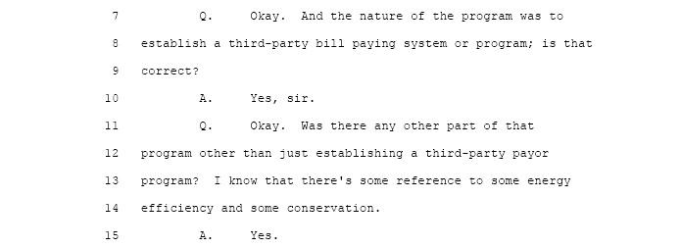
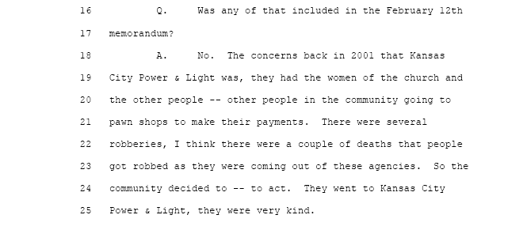

Page 1526 | Direct Cross-Examination of W. Bill Dias by Commissioner Clayton

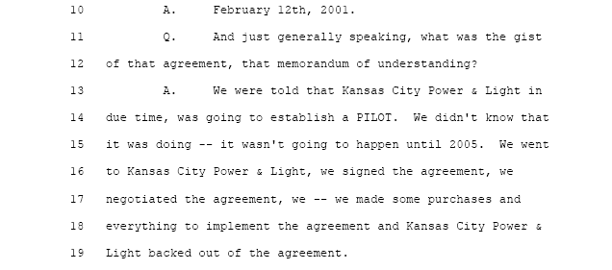
Page 1526 | Direct Cross-Examination of W. Bill Dias by Commissioner Clayton

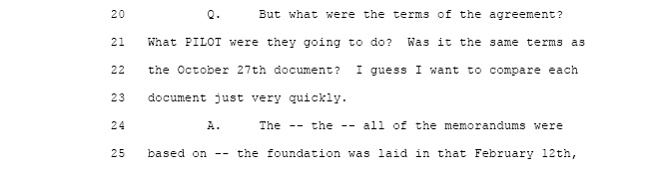
Page 1527 | Direct Cross-Examination of W. Bill Dias by Commissioner Clayton
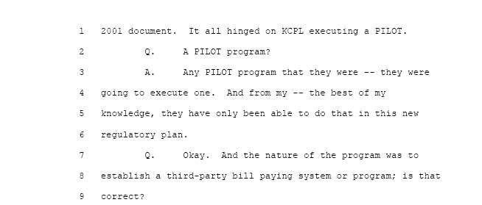

Page 1527 | Direct Cross-Examination of W. Bill Dias by Commissioner Clayton
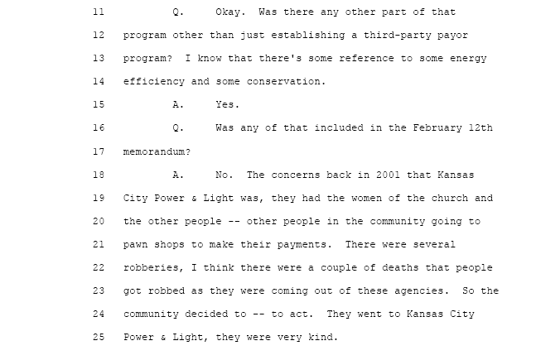

Page 1527 | Direct Cross-Examination of W. Bill Dias by Commissioner Clayton

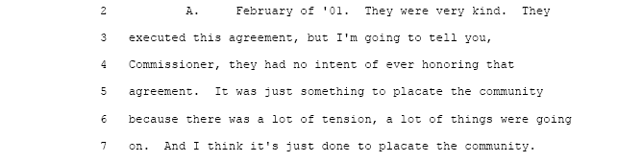

Page 1527 | Direct Cross-Examination of W. Bill Dias by Commissioner Clayton
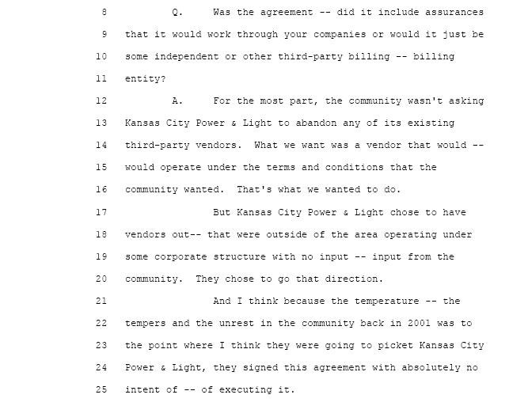

Page 1526 | Direct Cross-Examination of W. Bill Dias by Commissioner Clayton
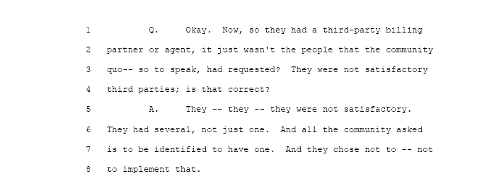
Conclusion to The Issue: KCPL has never denied that they executed the February 12, 2001 Memorandum of Understanding. KCPL has never accreted that they canceled this agreement even though they have had five years to do so. KCPL was given the chance to explain to the Commission any and all reasons during the Hearing, why they did not honor this executed agreement. Mr. Fischer and Mr. Blanc, counsel for KCPL had ample opportunity to cross-examine Dias or any other witness on the issue of the February 12, 2001 Memorandum of Understanding and choose not to. This was a clear indication that KCPL had no valid reason not honor this agreement other than they just did not want to.
The Urban Community wants the Commission to take note of the fact that KCPL has, not appointed a single minority owned third-party authorized pay agent for the past 20 years. The Commission should know that this act is deliberate, is illegal and needs to be corrected.

IV……………………….……Delayed Due Dates

B: Should the Public Service Commission direct KCPL to allow all of its customers that enroll in Dias' on-time bill payment program the flexibility to have “Delayed Due Dates” so they can participate in Alternative Credit Scoring?

Response: If a KCPL customer wants to arrange their financial affairs in such a manor through Dias which assures that KCPL’s utility bill will be paid on-time is not an unreasonable request. After all the, understanding, of the Commission, is that all utilities companies want their customers to pay on- time. Maybe KCPL wants the $5.00 dollar late fee. KCPL currently allows only those customers on fixed income to have the flexibility of “Delayed Due Dates”. If a KCPL customer wants to position them selves to take advantage of Alternative Credit Scoring, they must be permitted “Delayed Due Dates” which allows them to make on-time payments in such a manor that they can be reported to the four (4) major credit reporting agencies as “Paid as Agreed”.
Once again KCPL’s counsel, Mr. Fischer, has stated in the Hearing pages 68-69, that credit ratios are important to KCPL. The Commission would suggest that if credit ratios and credit scores are important to KCPL then KCPL customers should have the right to enroll in Dias’ program to establish Alternative Credit Scores because credit is important to them. IT IS SO ORDERED.

V………..………………...Alternative Credit Score Program

C: Should the Public Service Commission direct KCPL to allow all of its customers that enroll in Dias’ on-time bill payment program the flexibility to participate in Alternative Credit Score Programs?

Response: KCPL should not have the right to deny certain customers who feel they need Alternative Credit Score help to improve their financial position by paying their KCPL utility bill on-time and to have this on-time payment reported to the major credit reporting agencies.

The “Petition” marked “OPC exhibit no. 218”, is a direct appeal from the urban community of Greater Kansas City, Missouri asking the Public Service Commission to direct KCPL to participate in the Dias sponsored Alternative Credit Score Program and to allow its entire customer base the flexibility to have “Delayed Due Dates” The Commission believes this is a reasonable request. IT IS SO ORDERED.

Background: The “Delayed Due Dates” and Alternative Credit Scoring are both interdependent upon each other. Delayed Due Dates are required so that a KCPL customer can make an on-time utility payment at the same time that they receive their pay check. This on-time payment can then be reported to the major U.S credit bureaus as “Paid as Agreed”. This establishes an Alternative Credit Score that ranges from 300 to 850, the same as the traditional score.

The Kansas City, Missouri Urban Community; mainly minorities, young adults and women; who have thin or non-existent credit files which mean the big U.S credit bureaus don’t have enough information about their finances to assign them a traditional credit score, which is a figure generated via statistical models that examine outstanding borrowing, payment history and debt loads. Banks use credit scores to determine eligibility and pricing for mortgages, auto and other loans.

The primary reason that urban core residents, who use the authorized pay stations established by KCPL, can only pay their bill with cash is because KCPL does not want the expense of collecting bad checks. KCPL’s desire to have funds due them electronically deposited into their account at the close of each business day is not an unreasonable request, however, if a KCPL customer uses Dias’ debit card program; a payment can be made in the safety of the customers home.
To facilitate KCPL’s Predatory Enabling Policies and protocols that forces urban core residents to put their lives in danger simply to pay a utility when there is a better way is unreasonable. The major U.S credit bureaus can not track cash payments which results in thin or non-existent traditional credit files is also unreasonable and needs to be changed.

DIRECT TESTIMONY IN SUPPORT OF THE RESPONSE SUMMARY:

In Mr. Fischer’s Opening Statement he explains how important Credit ratios are to the financial health of KCPL. However, KCPL in their Pre- Hearing Brief, page 38, rejected the program that the urban community has asked DIAS to implement to help build there Alternative Credit Scores. Dias explains why the urban community wants KCPL to participate in Alternative Credit and why the Commission should compel KCPL to participate. KCPL’s predatory enabling policies are feeding “Predatory Lending” in the urban core. Community leaders have brought this fact up to KCPL in the past with not result.
Dias speaks to the promised programs of KCPL and states they will not happen unless the Commission compels KCPL to do so. (See Hearing Transcript pages 96-99).

Page 68 | Opening Statement Of Mr. Fischer

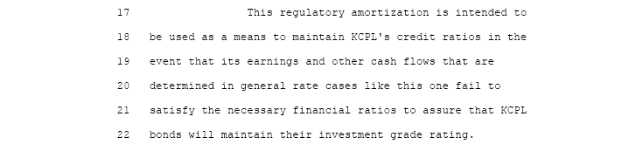

Page 69 | Opening Statement Of Mr. Fischer

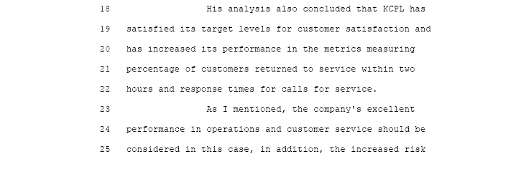

Page 99 | Dias Opening Statement On Alternative Credit And Delayed Due Dates

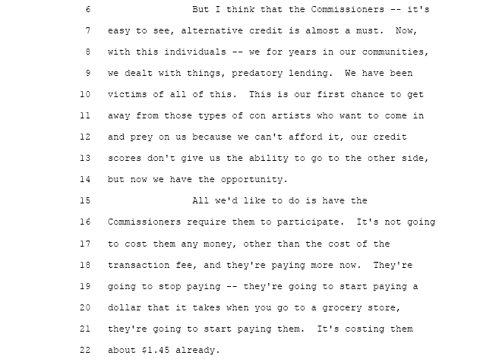

Page 96 | Dias Opening Statement On Alternative Credit And Delayed Due Dates
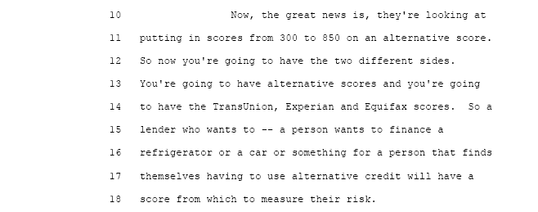

Page 97 | Dias Opening Statement On Alternative Credit And Delayed Due Dates
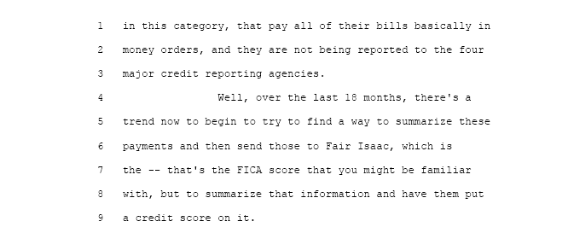

Page 98 | Dias Opening Statement On Alternative Credit And Delayed Due Dates
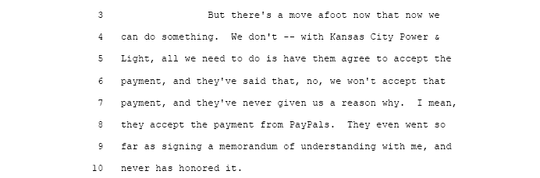

Page 98 | Dias Opening Statement On Alternative Credit And Delayed Due Dates

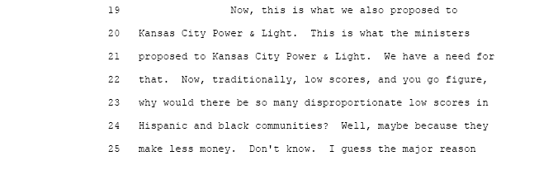

Page 98 | Dias Opening Statement on Alternative Credit and Delayed Due Dates
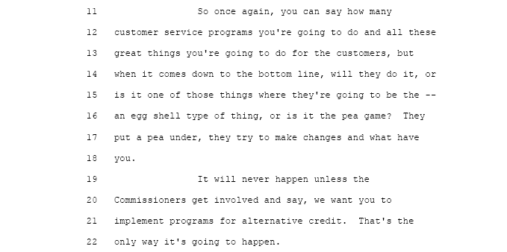

Conclusion to The Issue: The Commission has to here the voice of the Urban Community of Greater Kansas City, in its support for Dias, when they say, “no longer do we want to be targets of the criminal element at these KCPL authorized pay stations” because of the Predatory Enabling Policies and protocols of KCPL that makes urban core residents targets.

The Commission has to here the voice of the Urban Community of Greater Kansas City, in its support for Dias, when they say “we do not want to see another person robbed or murdered trying to pay a KCPL utility bill at an authorized pay station”.

The Commission has to here the voice of the Urban Community of Greater Kansas City, in its support for Dias, when they say “we helped Dias formulate the June 5, 2006 Memorandum of Understanding and the Commission should compel KCPL to combine the February 12, 2001 document with the June 5, 2006 document and implement all issues contained therein.

VI……Expand Third-Party Payment Agents to Include Minority Pay Agents

D. Should the Public Service Commission direct KCPL to expand its third-party payment agent vendors to include minority pay agents. Should the Commission direct KCPL to appoint DIAS "a minority owed company" as the first authorized thrid-party, (minority owned) payment agent per the terms and conditions contained in the February 12, 2001 and the June 5, 2006, Memorandum of Understanding that is in evidence in this case?

Response: KCPL has made certain decisions as it relates to the placement of pay stations in the Urban Community of Greater Kansas City. The community has had no input in where, who and how these pay stations are operated so as to protect urban residents from the criminal element that stalks these KCPL authorized pay stations; waiting for the chance to rob and murder its residents.

The Commission has realized that urban residents are suffering because of the decisions made by KCPL and its time for that suffering to stop.

The Urban community has requested the Commission to direct KCPL to appoint Dias as an authorized third-party pay agent under the terms and conditions contained in the February 12, 2001 and the June 5, 2006, Memorandum of Understanding as called for in the “Ministers for Energy Conservation Petition”, OPC Exhibit 218 in which 97 Ministers, deacons and lay persons called for the Public Service Commission to act is a reasonable request. IT IS SO ORDERED.

Background: For the last 20 years KCPL has ignored the requests of the Urban Community even in the face of robberies and murder of residents trying to pay their KCPL utility bill. This is the first time in the past 20 years that the Public Service Commission can see and hear issues that highlight the “Benign Neglect” and a clear picture of failed programs offered by KCPL are unacceptable. These failed programs are having a deadly impact on the Urban Community and it is clear that no matter how much community input given KCPL from the leadership of the urban community which is also unacceptable; KCPL has in the past and is likely going to continue to ignore any and all requests by the community for help is unacceptable. The Public Service Commission has to compel KCPL to act in a reasonable manor.

DIRECT TESTIMONY IN SUPPORT OF THE RESPONSE SUMMARY:

William Downy admits that KCPL is going to respond to the Urban Community in the same way that they have done over the past 20 years no matter how many urban residents get robbed and or MURDERED.
From his statement William Downy seems to be out of touch with the senior level representatives that have met with the urban community; which has requested action to be taken. From his statements, it seems that these senior level representatives report back to William Downy; this is what the community wants, however, we (KCPL) are going to continue with our plans even if they (the urban community) don’t like. It seems as if KCPL says; what can they do about it anyway. Without community input, how would KCPL meet the needs of the urban community without knowing what they want or need. This “Plantation Attitude” starts at the very top of the Management Team of KCPL; why would the urban community expect any different outcome on issues presented to KCPL than what has been shown; “Benign Neglect”. (See Hearing Transcript pages 131-133)

Page 131 | Cross-Examination of William Downy by W. Bill Dias

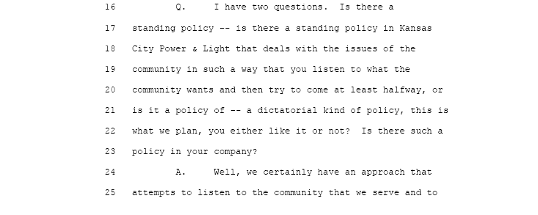

Page 132 | Cross-Examination of William Downy by W. Bill Dias

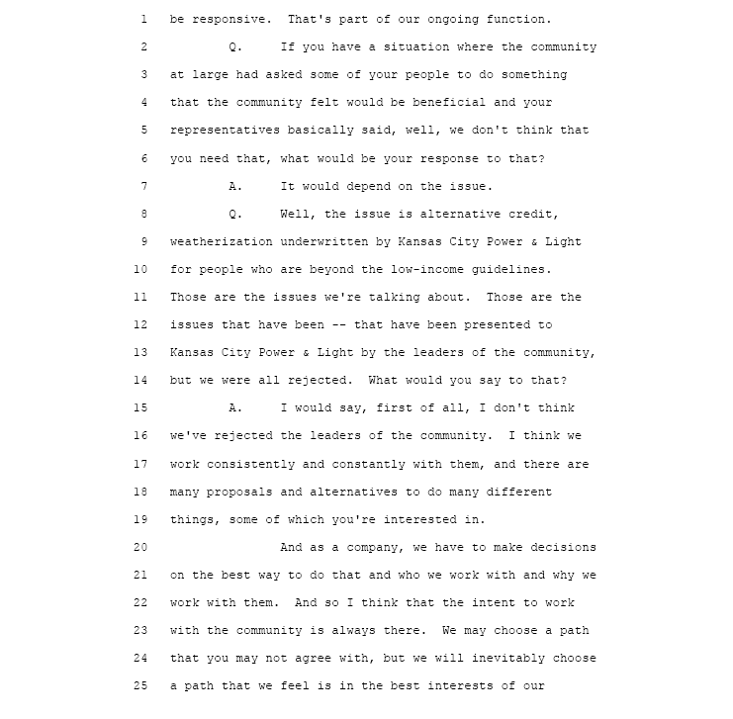
Page 133 | Cross-Examination of William Downy by W. Bill Dias

It is clear from William Downy’s testimony that KCPL is only going to do what is in the context of the stipulation filed in this rate case. The only help that KCPL customers can expect is if they are low-income; all other customers that fall outside of the low-income guidelines and their credit score will not allow these customers to get outside financing to get weatherization will get no help from KCPL.
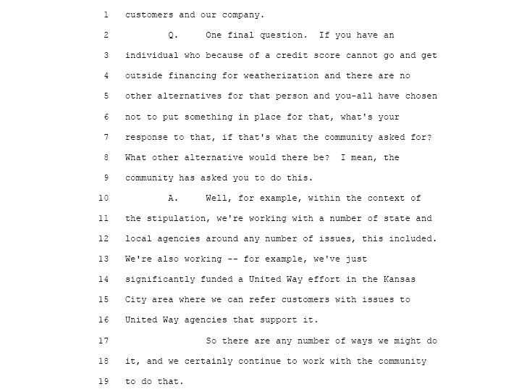
Page 133 | Cross-Examination of William Downy by W. Bill Dias

William Downy admits that even though they executed the February 12, 2001, Memorandum of Understanding he states “It was back in 2001 when we decided not to take the approach you were suggesting”. Once again it is clear; KCPL will sit down with community residents, make promises and even execute agreements with no intent of following through with the terms and conditions of such agreements.
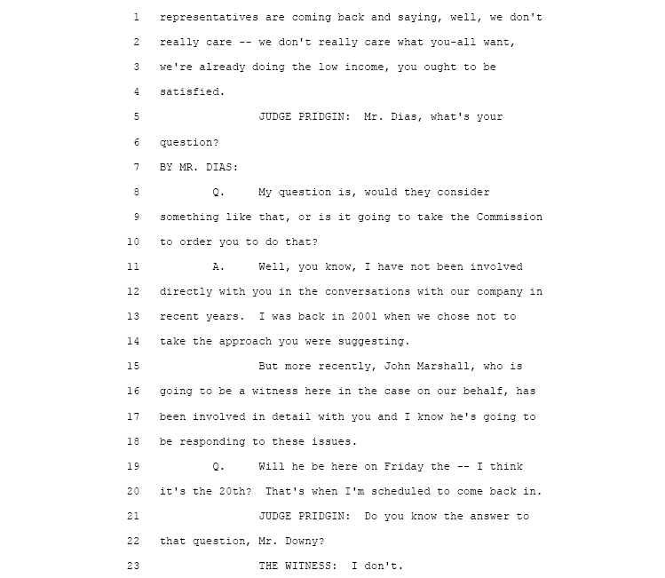

Page 1527 | Direct Cross-Examination of W. Bill Dias by Commissioner Clayton

Commissioner Clayton gets the details of what the urban community wants in an agreement to get minority third-party pay agents that will be responsive to community issues.

Page 1526 | Direct Cross-Examination of W. Bill Dias by Commissioner Clayton

Commissioner Clayton makes the point that the urban community wants authorized minority third-party pay agents that will be responsive to the needs of the community.

Page 1528 | Direct Cross-Examination of W. Bill Dias by Commissioner Clayton

The Memorandum of Understanding that the Urban Community wants is June 5, 2006.

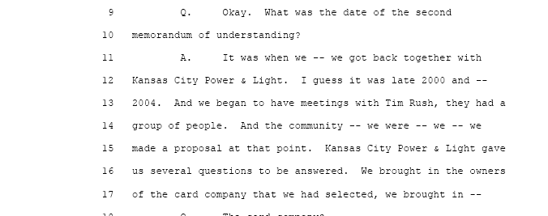

Page 1528 | Direct Cross-Examination of W. Bill Dias by Commissioner Clayton

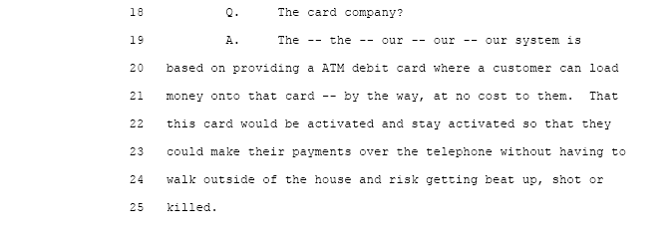

Page 1530 | Direct Cross-Examination of W. Bill Dias by Commissioner Clayton
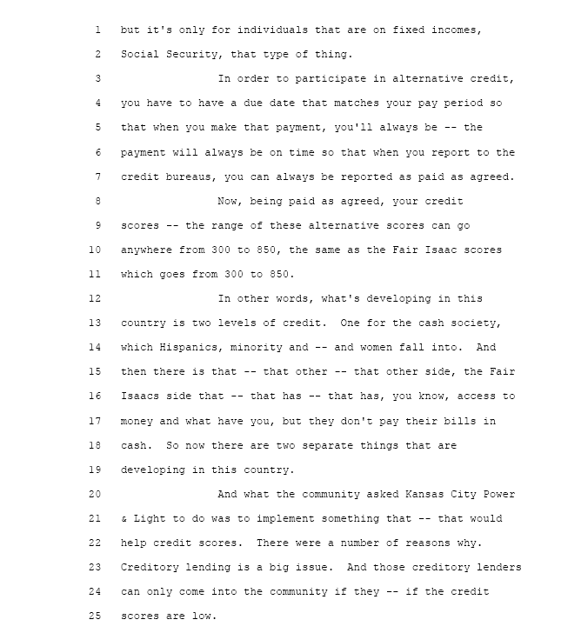

Page 1530 | Direct Cross-Examination of W. Bill Dias by Commissioner Clayton

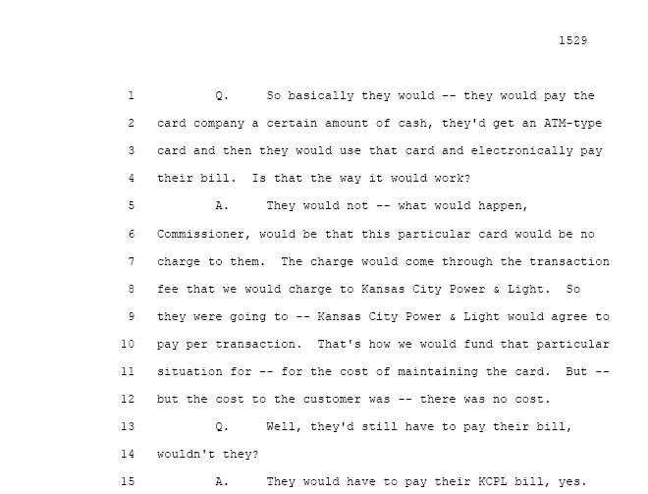

Page 1529 | Direct Cross-Examination of W. Bill Dias by Commissioner Clayton

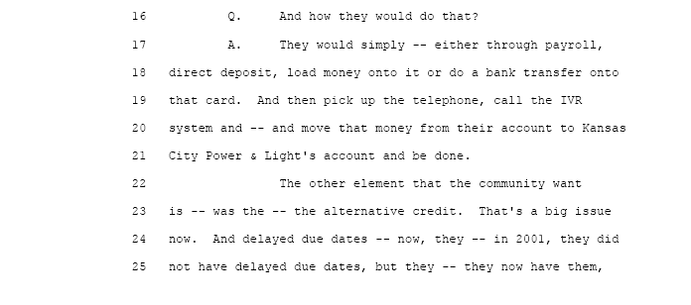
Conclusion to The Issue: The Urban Community believes that the latest debit card technology can be implemented in such a way as to allow payment of their KCPL utility bills without having to take cash to KCPL authorized pay agent locations. These KCPL pay stations are stalked by a criminal element that pray upon customers that are forced to bring cash to pay their KCPL utility bill.
No one should have to put their lives in danger just to pay a KCPL utility bill when a simple debit card program can be offered to the Urban Community that will eliminate the need to travel to these pay station locations.
The Commission has the power to compel KCPL to change their collection procedures in order to protect urban residents. The “Petition” OPC exhibit No. 218 urges the Commission to act in favor of the residents of the Urban Community of Greater Kansas City Missouri.

VII……………..Participation in Energy Conservation Program

E. Should the Public Service Commission direct KCPL to participate in the Energy Conservation Program of Dias” that will provide consultation, weatherization, materials, installation and On-time Bill Payment if the KCPL customer does not income quality for Low-Income help, if so, should the cost of the program be underwritten by KCPL and charged back to the customer. Should this program be independent of the customer’s utility bill?

Response: KCPL has gone on record in the Stipulation and Agreement in Case No. EO-2005-0329 that they plan to work with those agencies that the community feels would most benefit the urban residents. However, the truth is, when the community finds a company that can deliver the services they want; KCPL denies their request with no clear reason why they can’t do business with that company. KCPL has had the chance to explain why they (KCPL) do not want to use (Dias) the company that the community has selected even though KCPL has used trade secrets and technology disclosed to them by this company; Maybe the true reason is what John Marshall stated in our July 24, 2006 meeting, “That is just to much money for your company (a minority owned company) to make” KCPL did not select this company.

Which KCPL are we to believe; the one that presented the Stipulation and Agreement to the Commission in Case No. EO-2005-0329 (as shown in) (“Appendix B”). Should the Commission believe the testimonies of Susan K Nathan, William Downy are John Marshall; or should the Commission believe the sworn affidavit of Rev. Daniel Childs, Administrative Assistant of the Baptist Ministers Union of Kansas City Missouri; or should the Commission believe the signed “Petition” that was signed by 97 ministers and deacons representing a membership of thousands of urban residents?

It appears that KCPL says what is needed, at the time it is needed; whether they intend to operate in good faith or not. KCPL in the Stipulation and Agreement proposes to offer help to the low-income customer; the Urban Community of Kansas City believes that the Commission should compel KCPL to provide funds for families above the low-income guidelines so they can participate in Dias’ Energy Conservation Program.

The Commission should compel KCPL to help any customer that may not be low-income but has no other source to turn to for weatherization and energy conservation?
KCPL have had an average over earning of $34 million dollars each year for the past 20 years. KCPL has requested the Commission to grant a ROE that provides no risk to their creditors or their investors to implement their Regulatory Plan.
The Urban Community has asked the Commission to give those customers not qualified as low-income and or who can not get outside financing; to compel KCPL to provide and additional $5 million dollars for weatherization, consultation, materials, installation and on-time bill payment each year. This $5 million should come from KCPL shareholders earnings or as part of the ROE Calculations to cover the cost of weatherization, consultation, materials, installation and on-time bill payment each year as detailed in Dias’ Memorandum of Understanding.

Background: The households, in the urban community in most cases, are 50 years old and have little or no insulation. This rate increase and the subsequent rate increases will impact the urban community the most because their homes are not energy efficient.
The Urban Community wants the Commission to know that Weatherization and insulation of there urban homes is the only way to ease the financial burden of these forthcoming rate increases. The loans provided from this $5 million dollars will be repaid to KCPL; therefore, there is little or no real cost to KCPL shareholders to provide this requested “Energy Conservation” relief.
The repayment of these “Energy Conservation Loans:
The loans underwritten by KCPL should have an “Income Qualification Rider”. That is on a case-by-case bases the customers ability to repay should be calculated so that repayment could range from 100% to as little as 25%, all to be dependent on the customers income.

DIRECT TESTIMONY IN SUPPORT OF THE RESPONSE SUMMARY:

Mr. Fischer’s statements confirms that there is little drought KCPL will not have the additional $5 million dollars each year for “Non Low- Income Energy Conservation Assistance”.
There is some question as to whether KCPL really needed a “Regulatory Plan” to finance the construction of a new power plant. The testimony in the Hearing pointed out that in 1985 KCPL built the Wolf Creek Plant without help from the ratepayers.
With this ratepayer financed plant, KCPL will have more electrical energy to sell on the open market it is called “Off-System Sales”. KCPL makes 50% of its revenues from off-system sales which are unregulated.

The Commission has approved KCPL’s Regulatory Plan and there will be a rate increase. Past Commissioners, over the last 80 to 100 years of regulation has balanced the interest of the rate payers on one hand and the interest of KCPL stockholders on the other hand. However, in this rate case no ER-2006-0314 there’s a new party; the KCPL creditors. The Commission has the task of balancing these parties so that it is fair.

The Urban Community would like the Commission to consider this equation to achieve a fair balance between the parties that other past Commissions have always tried to obtain.

Balance = [KCPL stockholders + KCPL creditors] - minus [rate increases + urban community energy conservation + low-income help] = Balance

Page 68 | Opening Statement of Mr. Fischer

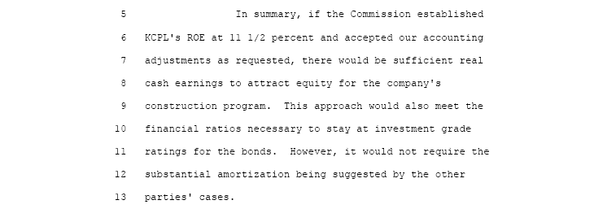

Page 67 | Opening Statement of Mr. Fischer

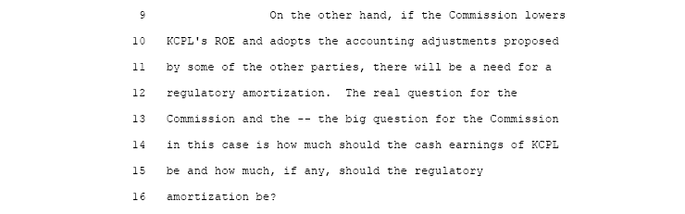
Page 65 | Opening Statement of Mr. Fischer

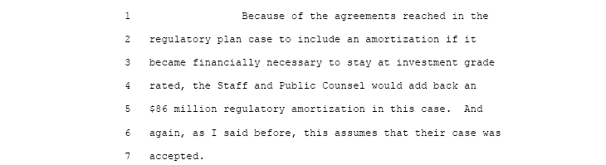

Page 80 | Opening Statement of Mr. Mills

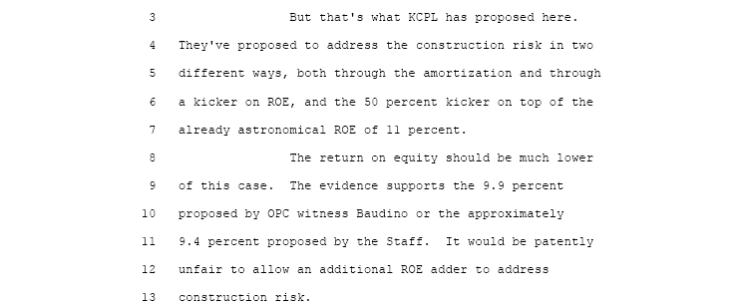

Page 85 | Opening Statement of Mr. Finnegan

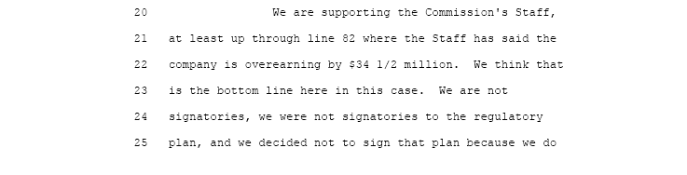

Page 68 | Opening Statement of Mr. Finnegan

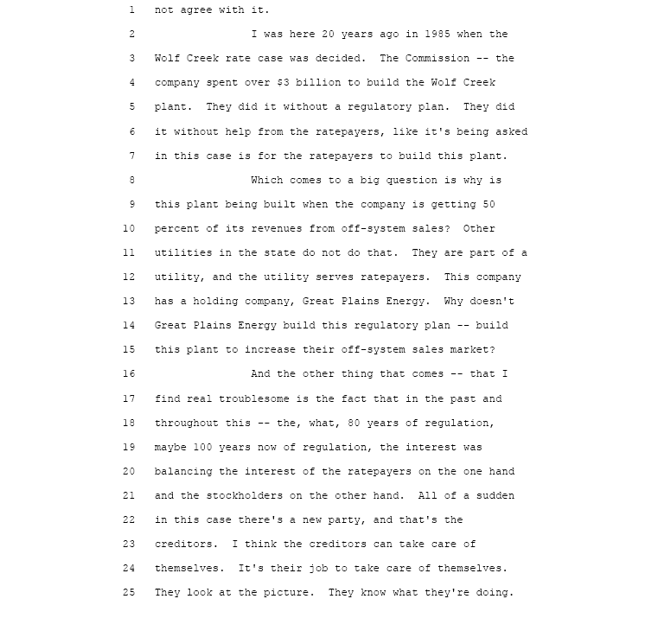

Page 68 | Opening Statement of Mr. Finnegan

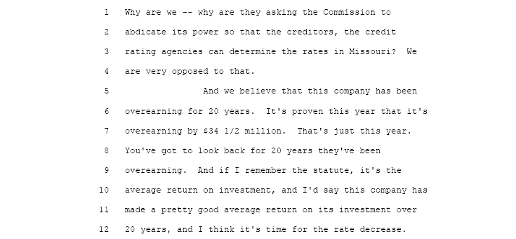
Page 110 | Opening Statement of Mr. Phillips

Page 111 | Opening Statement of Mr. Phillips
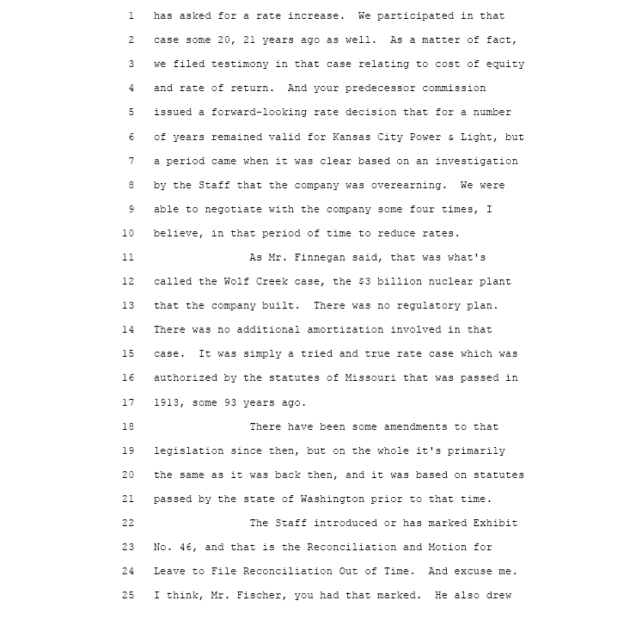

Page 112 | Opening Statement of Mr. Phillips
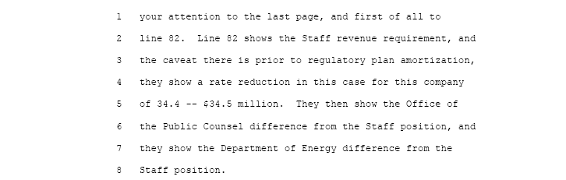

Page 1531 | Direct Cross-Examination of W. Bill Dias by Commissioner Clayton

Points of clarification, the two Memorandum of Understandings are February 12, 2001 and
June 5, 2006.
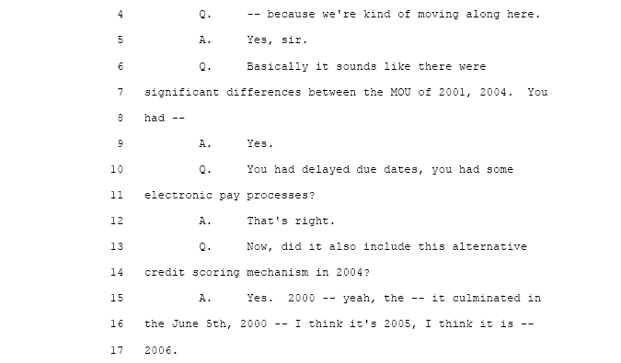

Page 1532 | Direct Cross-Examination of W. Bill Dias by Commissioner Clayton

Commissioner Clayton ask questions on the “On-Time bill payment program and how it relates to energy conservation and weatherization.
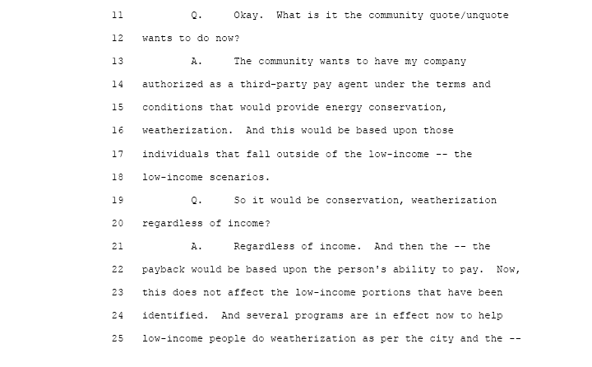
Page 1533 | Direct Cross-Examination of W. Bill Dias by Commissioner Clayton

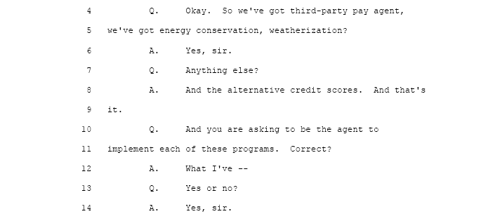

Page 1533 | Direct Cross-Examination of W. Bill Dias by Commissioner Clayton
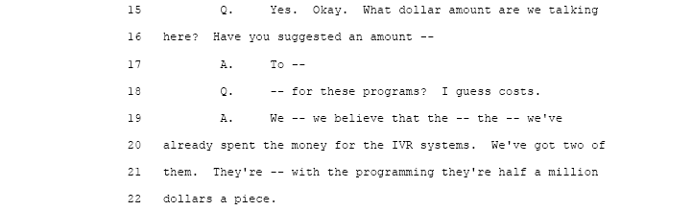

Page 1533 | Direct Cross-Examination of W. Bill Dias by Commissioner Clayton

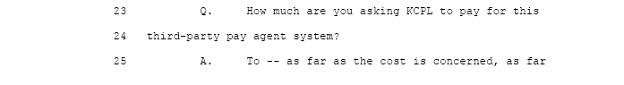

Page 1534 | Direct Cross-Examination of W. Bill Dias by Commissioner Clayton
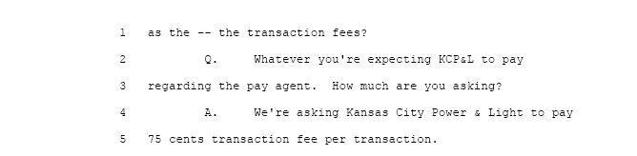

Page 1534 | Direct Cross-Examination of W. Bill Dias by Commissioner Clayton

Point of clarification, the number of transaction is 200,000 per month.

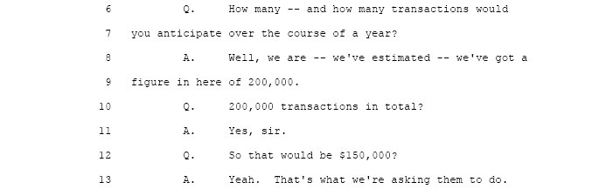

Page 1534 | Direct Cross-Examination of W. Bill Dias by Commissioner Clayton

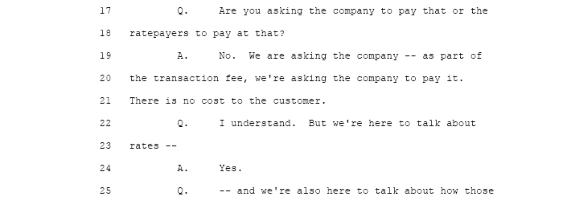

Page 1534 | Direct Cross-Examination of W. Bill Dias by Commissioner Clayton

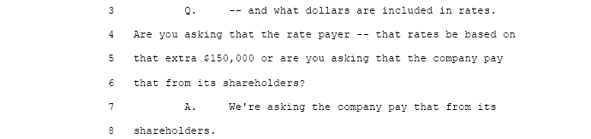

Page 1533 | Direct Cross-Examination of W. Bill Dias by Commissioner Clayton
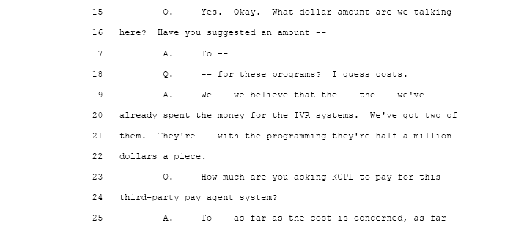

Page 1533 | Direct Cross-Examination of W. Bill Dias by Commissioner Clayton

A point of clarification: the answer given here should state 200,000 transactions per month is the requested guaranteed amount.
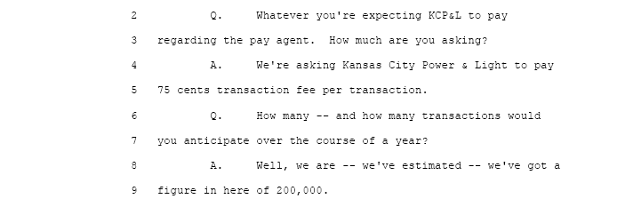

Page 1534 | Direct Cross-Examination of W. Bill Dias by Commissioner Clayton

A point of clarification; the number of transactions is based on 200,000 transaction per month would be guaranteed by KCPL.

Page 1534 | Direct Cross-Examination of W. Bill Dias by Commissioner Clayton

Commissioner Clayton changes his questions to focus on what the urban community wants the Commission to compel KCPL to do in Energy Conservation. and weatherization..

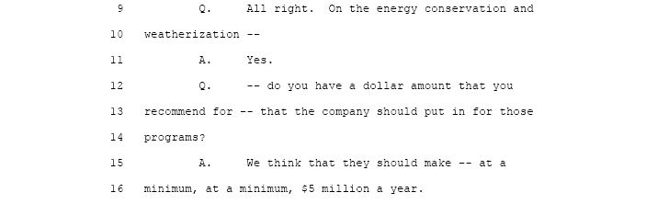
Page 1534 | Direct Cross-Examination of W. Bill Dias by Commissioner Clayton

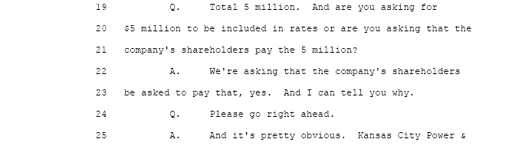

Page 1536 | Direct Cross-Examination of W. Bill Dias by Commissioner Clayton
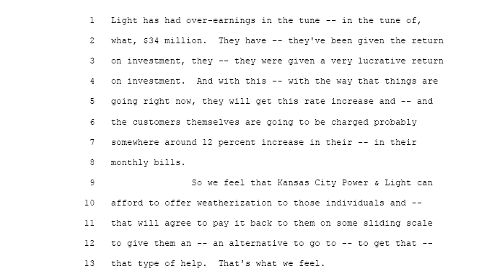

Page 1536 | Direct Cross-Examination of Mr. Blanc by Commissioner Clayton
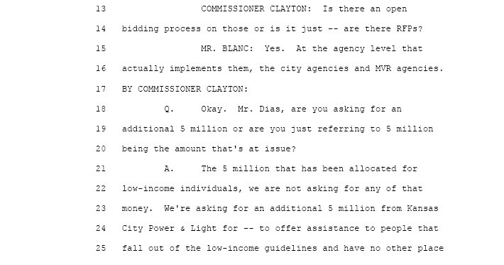

Page 1536 | Direct Cross-Examination of Mr. Blanc by Commissioner Clayton

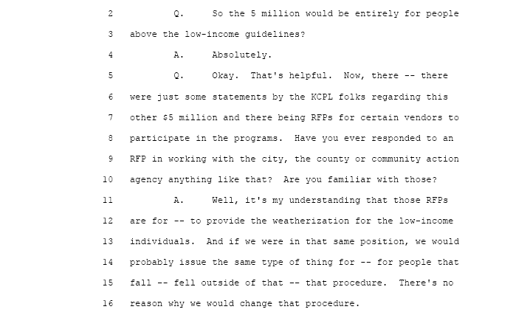

Page 1536 | Direct Cross-Examination of W. Bill Dias by Commissioner Clayton
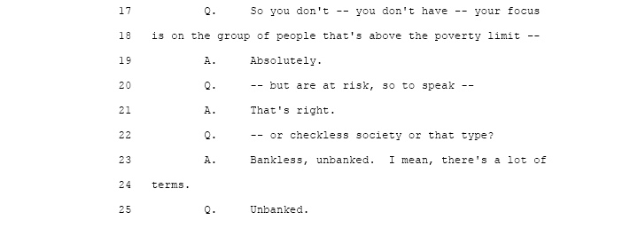

Page 1537 | Direct Cross-Examination of W. Bill Dias by Commissioner Clayton

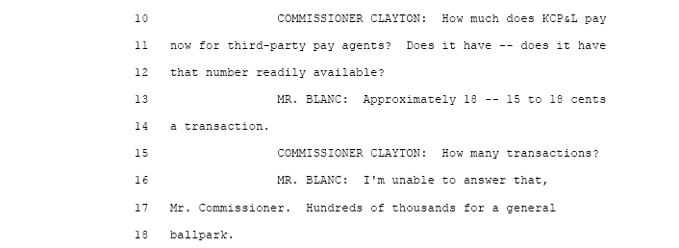

Page 1540 | Direct Cross-Examination of Mr. Blanc by Commissioner Clayton
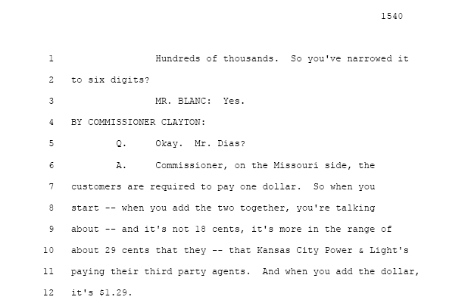

Page 1540 | Direct Cross-Examination of W. Bill Dias by Commissioner Clayton

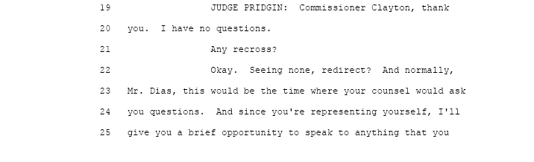

Page 1541 | Direct Cross-Examination of W. Bill Dias by Commissioner Clayton
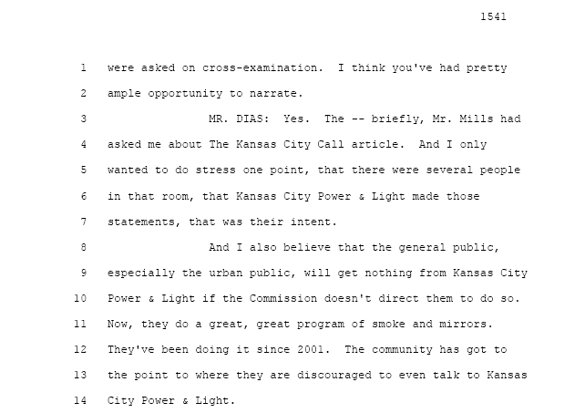

Page 1544 | Direct Cross-Examination of Anita Randolph by W. Bill Dias

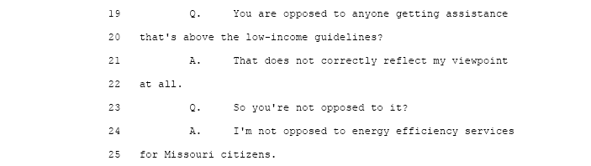

Page 1544 | Direct Cross-Examination of Anita Randolph by W. Bill Dias

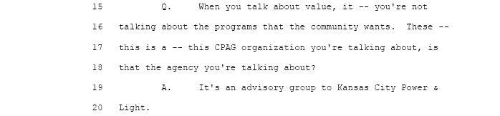

Page 1544 | Direct Cross-Examination of Anita Randolph by W. Bill Dias

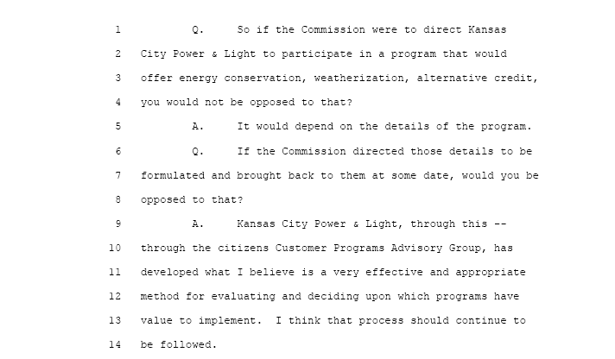

Page 1545 | Direct Cross-Examination of Anita Randolph by W. Bill Dias
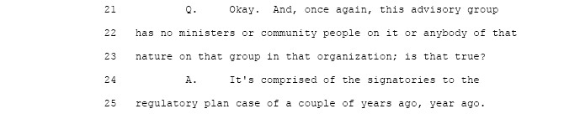

Page 1546 | Direct Cross-Examination of Anita Randolph by W. Bill Dias
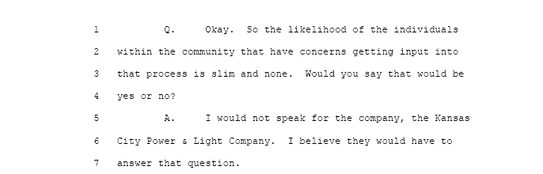

Page 1546 | Direct Cross-Examination of Anita Randolph by W. Bill Dias
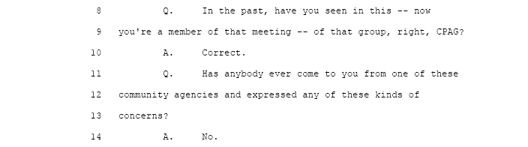
Page 1547 | Direct Cross-Examination of Anita Randolph by W. Bill Dias
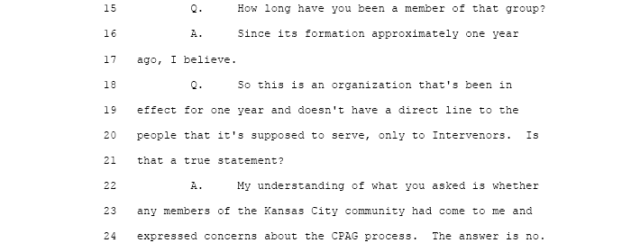
Page 1547 | Direct Cross-Examination of Anita Randolph by W. Bill Dias

Page 1547 | Direct Cross-Examination of Anita Randolph by W. Bill Dias

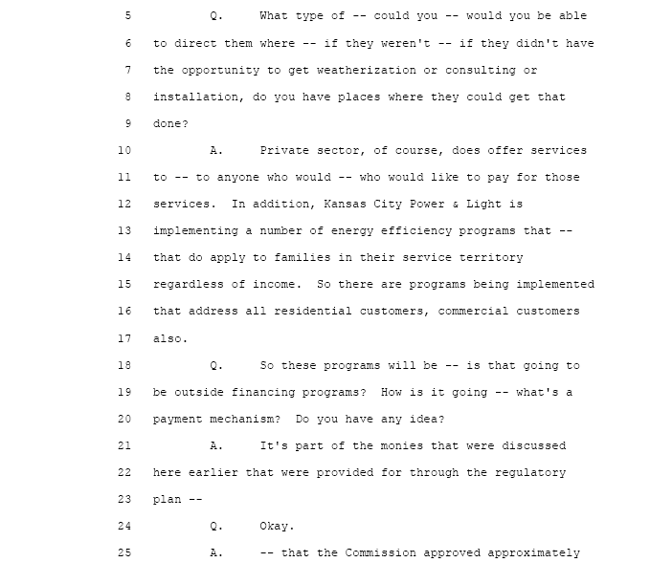

Page 1549 | Direct Cross-Examination of Anita Randolph by W. Bill Dias
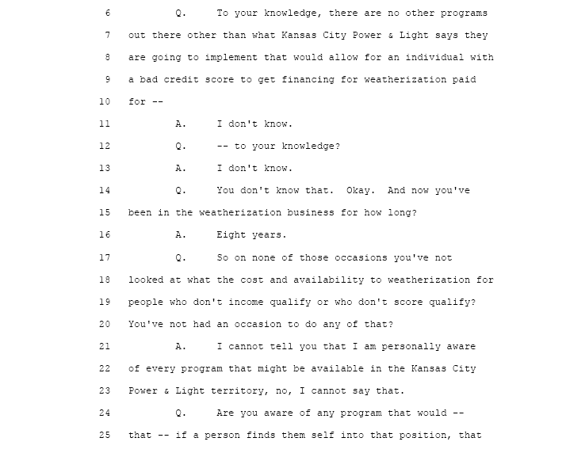
Page 1554 | Direct Cross-Examination of Anita Randolph by W. Bill Dias

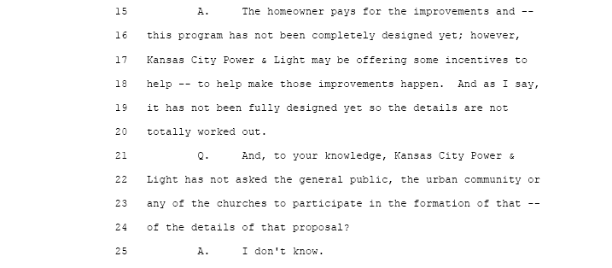

Page 1554 | Direct Cross-Examination of Anita Randolph by W. Bill Dias

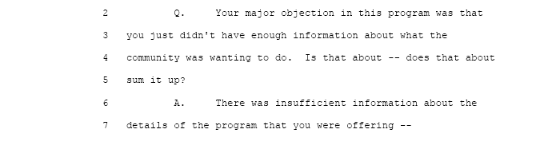
Page 1556 | Direct Cross-Examination of Anita Randolph by W. Bill Dias

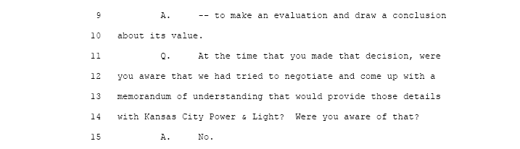
Page 1558 | Direct Cross-Examination of Anita Randolph by W. Bill Dias

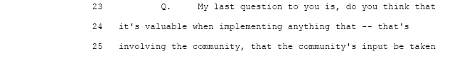

Page 1559 | Direct Cross-Examination of Anita Randolph by W. Bill Dias

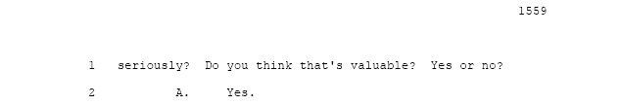

Conclusion to The Issue: The Regulatory Plan approved by the Commission clearly shows that this Regulatory Plan has no balance between the ratepayers and KCPL. The testimony shows ratepayers on one side of the equation and KCPL, their creditors and their investors are on the other side of the equation. There is no balance to this Regulatory Plan for the ratepayers. The testimony in this Hearing clearly shows that KCPL is non-responsive to the Urban Community of Kansas City Missouri so if balance is to be had the Commission has to act. This rate case needs balance restored to the ratepayers. One way to accomplished balance is to add the requested relief of Dias’ issues to the ratepayer side of the equation.
There are no significant differences in the proposed Memorandum of Understanding presented by Dias other that issues the urban community has asked to be included.
The Memorandums plans to enroll 200,000 KCPL customers in “Energy Conservation, Delayed Due Dates, On-time Bill Payment and Alternative Credit Reporting. The Memorandums call for a guaranteed 200,000 transactions per month at a cost of $.75 per transaction for those KCPL customers enrolled in Dias’ programs. For those KCPL customers wanting to enroll in Energy Conservation; the Memorandums call for KCPL to underwrite the cost of weatherization, insulation, consultation and on-time bill payment at a funding level of $5 million dollars each year. This will bring back balance to the approved Regulatory Plan and the forth coming rate increases.
The Commission is charged with the task of keeping the balance and to insure that all parties’ interests are protected. The Commission must restore the balance in this rate case that has been shifted to KCPL, their creditors and investors.

KCPL shareholders clearly have over earnings, and should not have a problem providing $5 million per year for the “Energy Conservation Program” that the urban community has asked Dias to implement. Once again there is a need to restore balance between the parties i.e.; KCPL shareholders, KCPL creditors; the ratepayers and energy conservation as proposed by Dias.
Mr. Phillips provides more history of KCPL over earning for the last 20 years. He makes it clear the Commission has to balance their decision to grant KCPL this Regulatory Plan with more help to the KCPL customers. Approval of Dias’ Energy Conservation Program would be a blessing to KCPL ratepayers and it would restore some balance.
VIII………..Combine Versions of Memorandum of Understanding

F. Should the Public Service Commission direct KCPL to execute a New Memorandum of Understanding that is a combination of all the versions proposed by the Urban Community and Dias. Should KCPL be required to pay DIAS as an authorized payment agent the transaction fee of $.75 per transaction as called for in the executed Memorandum of Understanding dated February 12, 2001?

Response: DIAS has been forwarding unauthorized utility bill payment for KCPL customers since 2003 through a network of pay stations in the Greater Kansas City Area. These are the same customers that have indicated that they would participate in Dias’ bill payment program with all of the benefits that come along with being a card member. It is not unreasonable to think that the biggest benefit to KCPL’s urban customers will be that they would no longer be subjected to the criminal element that hangs around these pay station locations. IT IS SO ORDERED

Background: KCPL executed this Memorandum of Understanding simply as a way to calm the anger of the Urban Community after several KCPL customers were robed and or killed trying to pay their utility bill at one of KCPL’s authorized pay stations

DIRECT TESTIMONY IN SUPPORT OF THE RESPONSE SUMMARY:

There is an abundance of testimony that supports a decision by the Commission to compel KCPL to execute an agreement with Dias. There is an executed agreement between the parties that calls for a transaction fee of $.75 with no limit to the number of transactions. There is a need to implement a debit card program that will eliminate the need to travel to one of KCPL’s pay stations and risk getting rob and or murdered. All of the agreements call for this to occur however, KCPL has rejected this idea in favor of putting more pay stations locations in the urban core regardless of the fact that these pay stations are a potential death sentence to those resident that are forced to use them.
Page 1526 | Direct Cross-Examination of W. Bill Dias by Commissioner Clayton

Page 1534 | Direct Cross-Examination of W. Bill Dias by Commissioner Clayton

The executed calls for a $.75 per transaction fee; we are asking KCPL to honor that part of the February 12, 2001, agreement.
Page 1534 | Direct Cross-Examination of W. Bill Dias by Commissioner Clayton

Conclusion to The Issue: The Commission can save many lives of urban residents by not allowing KCPL to put more pay station locations in the urban core. It has been proven that these pay stations attract a criminal element that prey on person going and coming to pay their KCPL utility bills. Dias has a better way for KCPL to get their payment on-time without endangering rate payers and is supported by the community at large. The Commission has to compel KCPL to do it is not an unreasonable request.

IX……….Expand Existing Tariff Program to Allow 50% Rate Reduction
G. Should the Public Service Commission direct KCPL to continue the existing tariff program that allows small churches to receive a 50% rate reduction. Also, should the Commission direct KCPL to expand this tariff program so that all churches can receive this 50% rate reduction.

Response: The church is the center of all activities in the minority community. The church is supported by limited financial gifts from its membership. The churches in the Greater Kansas City Area are open seven days a week providing services to the community that can not be gotten anywhere else i.e. feeding the poor; there is a move in the larger churches to partner with the Kansas City Missouri School District to provide after school tutoring in all subjects; there is counseling of all types going on in the urban church.

Those churches that are providing valuable services to the urban community should be given a 50% rate reduction so that this work can be expanded. The “Petition”; OPC’s exhibit No 218 clearly requests the Commission to compel KCPL to modify the existing tariff to allow a 50% rate reduction and then expand this modified tariff to allow all churches to receive this 50% rate reduction providing these churches are working with Dias and the Kansas City Missouri School District Tutoring Program.

This existing tariff has been eliminated from the current rate design by KCPL. The past Commissions felt that this tariff was of value to urban churches and the current Commission should no allow KCPL to eliminate this tariff. Once again; the Commission has to compel KCPL to modify this tariff and then expand it so that all churches that provide social services 7 days a week can get this 50% rate reduction.

Background: The Commission should know that currently there are 859 churches that will be grandfathered in, so they can keep this 50% rate reduction. The existing tariff is limited in its scope, however; there is a foundation that can be modified so that all churches can get a 50% reduction in their rate as long as these churches provide social services 7 days a week. These churches should have to become certified by the Kansas City Missouri School District and have to follow very strict tutoring guidelines.

The Staff of the Commission; the Office of the Public Counsel, Dias and KCPL should be directed to reinstate, modify and expand this tariff to allow for a 50% rate reduction.

DIRECT TESTIMONY IN SUPPORT OF THE RESPONSE: None has been offered

Conclusion to The Issue:
This is an issue that is only important to W. Bill Dias and his customers as an Intervener and some members of the Commission. Because W. Bill Dias was only granted his Intervener status September 19, 2006, a very limited list of community related issues are being presented to the Commission for consideration. The other Interveners do not have an interest in urban community matters and there is no direct testimony for the Commission to consider. This issue was raised in the conference call held by Staff however; it did not get any further than that.
I see no reason why the Commission should allow KCPL to terminate this tariff and I see no reason why the Commission should not compel KCPL to expand this tariff so that it would include all churches working with Dias and want to provide social services to the urban community.

X……………….Expand CPAG to Get Community Input on Issues

H. Should the Public Service Commission direct KCPL to provide four (4) new paid seats to the “Customer Program Advisory Group (“CPAG”) to gather community input on all issues related to urban customers? Should Dias be given a paid permanent seat on this advisory group?

Response: It is clear that the Urban Community of Greater Kansas City Missouri has no direct input into KCPL to help shape the programs that the Commission has approved in the Regulatory Plan. The Commission supports these low-income programs and they should be implemented with direct input from the urban community.
Direct testimony confirms that KCPL has no outreach program established to get urban community input on issues and programs that have a direct impact on the day-to-day lives of urban residents.
This advisory group is the only tool that KCPL is using at this time; however, this group only has Interveners as members, all controlled and appointed by KCPL.
For that reason, (CPAG) shall be expanded to provide four (4) new paid seats with W. Bill Dias having a permanent seat on this advisory group.
Background:
CPAG was established by KCPL as part of its Regulatory Plan in an effort to demonstrate to the Commission that KCPL has an outreach program to deal with community issues. The direct testimony from the Hearing clearly shows that this advisory group, in its current state and membership has no value and no mechanism in place to gather input from the rate payers in KCPL’s Kansas City Missouri Service Area.

DIRECT TESTIMONY IN SUPPORT OF THE RESPONSE SUMMARY:

Through the testimony of Anita Randolph it became clear that KCPL had set up a Puppet Advisory Group to gives the appearance of community input on issues that affect them the most. This CPAG was put together solely for the purpose of giving the Commission a false image of KCPL’s plans for its Urban Customers. This advisory group has failed to address one (1) single issue that was important to the urban community.
Had the Commission known that urban customers were dieing trying to pay their utility bills at KCPL authorized pay stations; it is hard to believe the Commission would have been approved KCPL’s Regulatory Plan in its current format.
It is my belief that this current Commission would not allow people to be murdered trying to pay a utility bill when there is a better way to pay KCPL only if they would listen.
It appears that the approved Regulatory Plan was built upon lies and half truths present by KCPL. They (KCPL) knew that the other Interveners’ Counsel only have their client’s interest to deal with and urban community issues would not be germane to clients. Dias interests which is a bill payment service that directly affect the KCPL customer runs parallel to that of the KCPL customer’s interest which is to be able to their utility without being robbed or murdered.

DIRECT TESTIMONY IN SUPPORT OF THE RESPONSE SUMMARY:

Commissioner Gaw’s cross-examination of Anita Randolph reveled that at no time has this group heard from a single State Representative; nor have the heard from a single community organization during the 18 months of there existence and in fact the public can not attend their meetings. KCPL sets their agenda and there in, is the problem.

Page 1567 | Recross-Examination of Anita Randolph by Mr. Mills
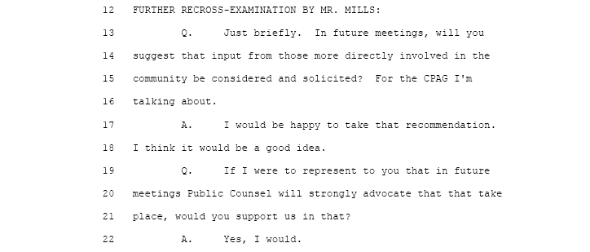

Page 1564 | Recross-Examination of Anita Randolph by Mr. Conrad

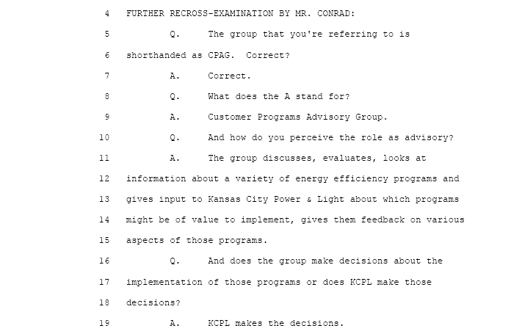

Page 1559 | Direct Cross-Examination of Anita Randolph by Commission Gaw
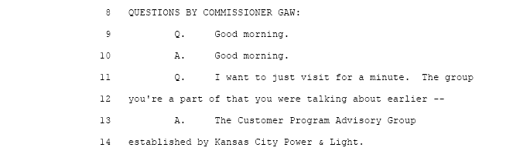
Page 1559 | Direct Cross-Examination of Anita Randolph by Commission Gaw

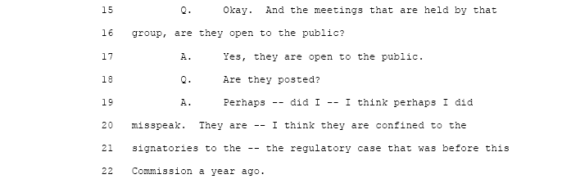


Page 1560 | Direct Cross-Examination of Anita Randolph by Commission Gaw
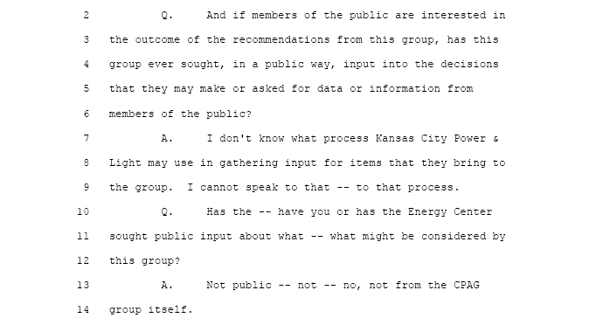
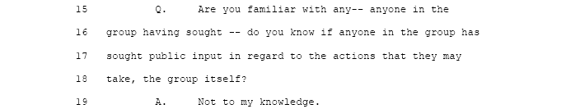
Page 1560 | Direct Cross-Examination of Anita Randolph by Commission Gaw

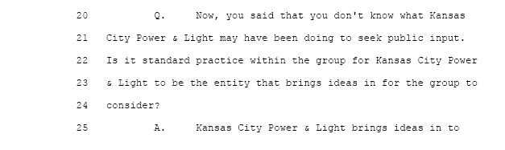

Page 1561 | Direct Cross-Examination of Anita Randolph by Commission Gaw

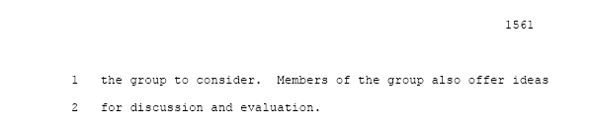
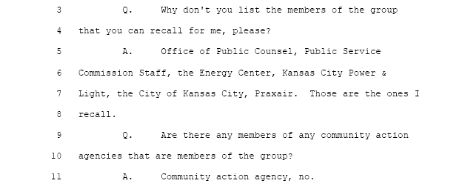
Page 1560 | Direct Cross-Examination of Anita Randolph by Commission Gaw
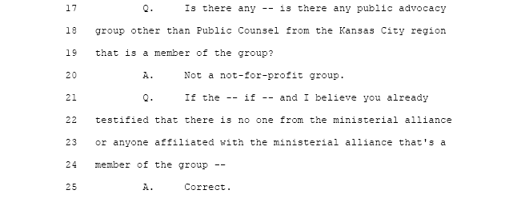
Page 1560 | Direct Cross-Examination of Anita Randolph by Commission Gaw
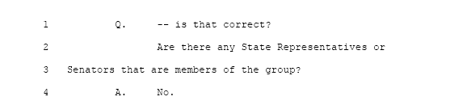
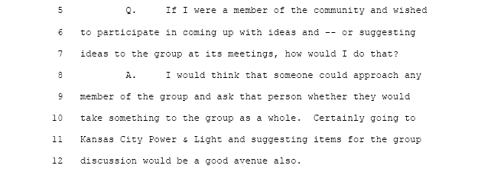

Page 1560 | Direct Cross-Examination of Anita Randolph by Commission Gaw
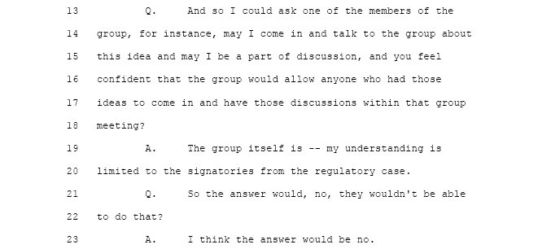
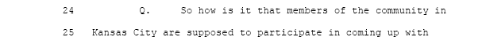
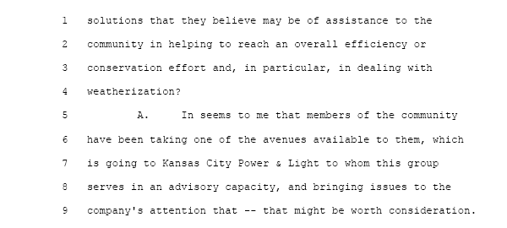

Page 1560 | Direct Cross-Examination of Anita Randolph by Commission Gaw

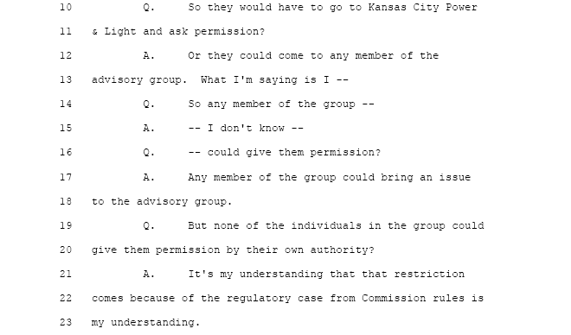

Page 1564 | Direct Cross-Examination of Anita Randolph by Commission Gaw
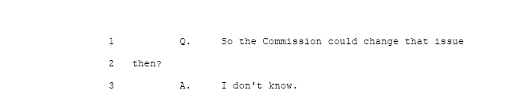

Page 1564 | Direct Cross-Examination of Anita Randolph by Commission Gaw
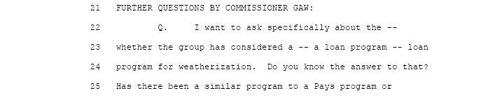

Page 1564 | Direct Cross-Examination of Anita Randolph by Commission Gaw

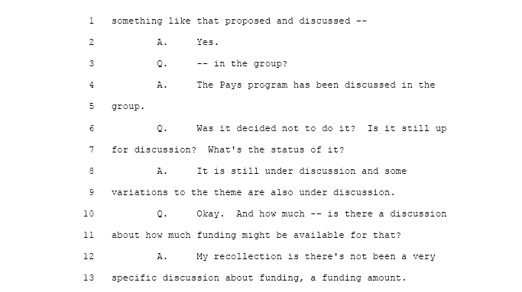

Page 1566 | Direct Cross-Examination of Anita Randolph by Commission Gaw

Page 1567 | Direct Cross-Examination of Anita Randolph by Commission Gaw

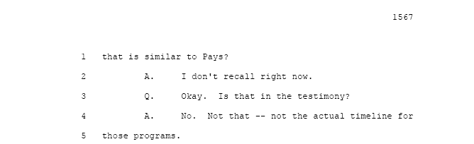

Page 410 | Direct Cross-Examination of John Marshall by Commissioner Appling

John Marshall admits to picking certain zip codes to get the concentration so that we see the load characteristics on the individual circuits.
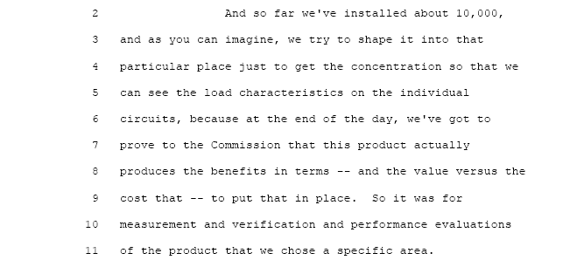

Page 401 | Direct Cross-Examination of John Marshall by Commissioner Appling

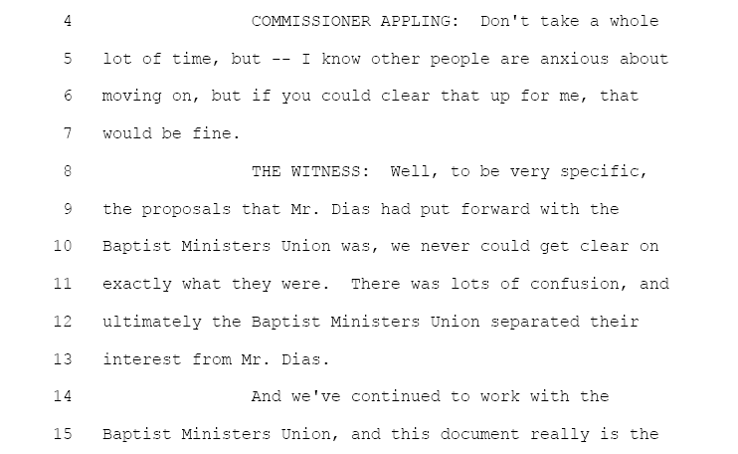

Page 402 | Direct Cross-Examination of John Marshall by Commissioner Appling

John Marshall speaks to research on community needs
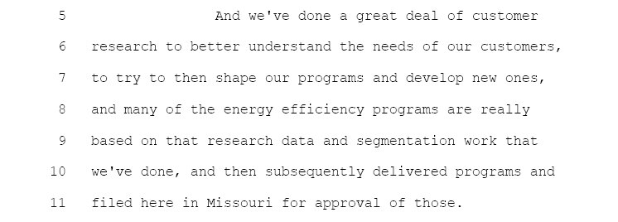

Page 405 | Direct Cross-Examination of John Marshall by Commissioner Appling

John Marshall speaks to outreach to the Baptist Ministers Union
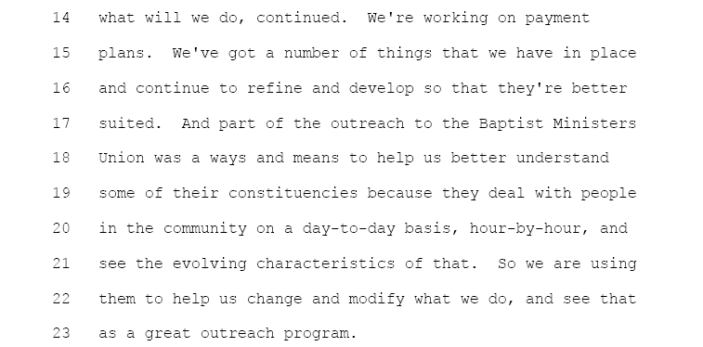

Page 406 | Direct Cross-Examination of John Marshall by Commissioner Appling

John Marshall speaks to the programs that KCPL has
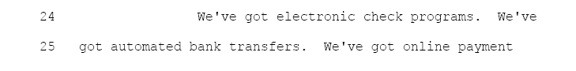

Page 406 | Direct Cross-Examination of John Marshall by Commissioner Appling

John Marshall speaks to credit/debit cards can help move customer to pay on-time.
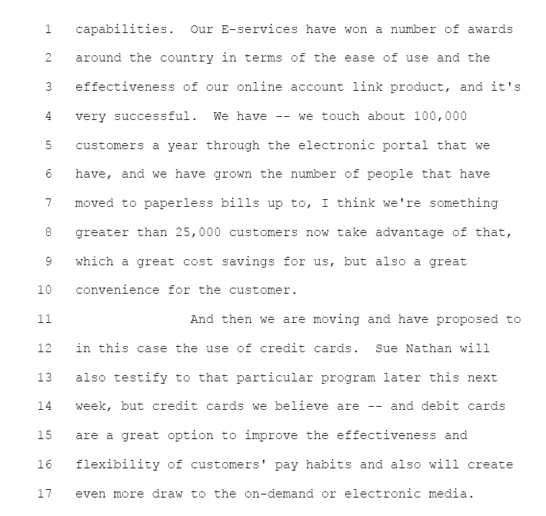

Page 401 | Direct Cross-Examination of John Marshall by Commissioner Appling

John Marshall speaks to adding new pay stations in the urban community.
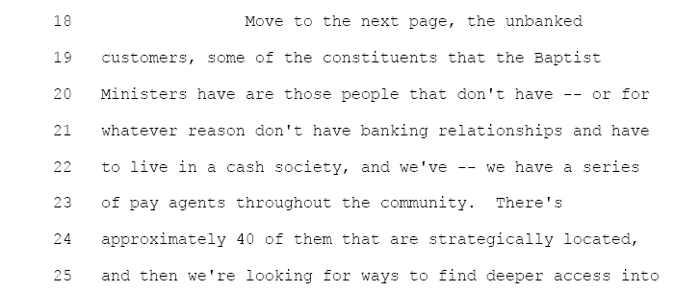

Page 406 | Direct Cross-Examination John Marshall by Commissioner Appling

John Marshall speaks to more pay stations
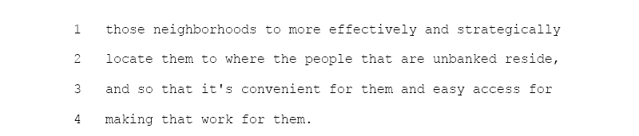

Page 407 | Direct Cross-Examination John Marshall by Commissioner Appling

John Marshall speaks to zip codes to effectively measure and verify the performance energy efficiency
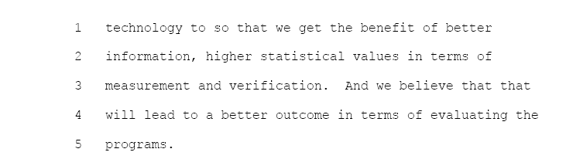

Page 407 | Direct Cross-Examination John Marshall by Commissioner Appling

John Marshall speaks to zip codes referenced in the Kansas City Call News Paper Article

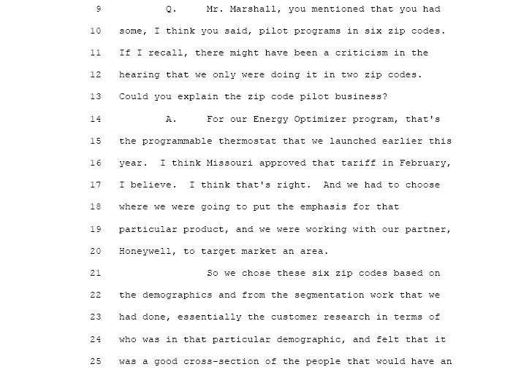
Page 410 | Direct Cross-Examination John Marshall by Commissioner Appling

Once again John Marshall admits that KCPL chose specific areas to measure, verification and performance evaluations of the product that we chose a specific area.
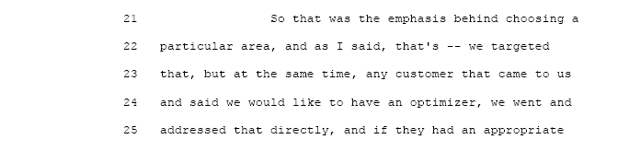
Conclusion to The Issue:
The testimony of Anita Randolph clearly shows that KCPL has put together a “Puppet Advisory Group” solely for the purpose of showing that their Stipulation and Agreement has community input. Commissioner Gaw’s cross-examination brings out the truth that this group is a smoke screen with no real programs that would offer any benefit to the urban community of Greater Kansas City Missouri.
It is even questionable if low-income customers are getting any lasting benefit from KCPL’s existing programs because the same customers come back for help year after year. The Commission has to change this now.

X Overall Conclusion Summary

KCPL has had a free and uncontrolled rule over the Urban Community of Greater Kansas City for over 20 years. In past Public Service Commissions, the past Commissioners, has not taken their guardianship over the urban customers of KCPL very seriously. Even though there have been several complaints against KCPL on their treatment of the Urban Community past Commissioners have not had a platform by which to take action until now.
The issues raised by W. Bill Dias would not have ever been raised if the current Commission had not granted Intervention through which the issues of the Urban Community could be heard for the first time. KCPL has failed to take action to provide relief. Which is not unlike how they (KCPL) has treated their minority employees with a “Plantation Attitude” i.e. they know what is best for the community; they (the Community) has to take what ever KCPL dishes out basically because there is no where to turn to get electrical energy. The Commission has to know that KCPL has lost several lawsuits that total millions of dollars yet KCPL has not changed their treatment of the Urban Community. From the testimony in this hearing, KCPL has no plans to change. The Commission has to act now.

Respectfully Submitted,

W Bill Dias
8358 Drury Circle
Kansas City, Missouri 64132
816-523-6614
816-554-7400 X 112 wbilldias@kc.rr.com, wbilldias@hotmail.com

Certificate of Service

I hereby certify that a true and correct copy of the above and foregoing document was sent via email on the 17 day of November 2006 to all parties of record.

