Exhibit No.:
Issue: Decommissioning
Witness: Rosella L. Schad, P.E.
Sponsoring Party: MoPSC Staff
Type of Exhibit: Rebuttal Testimony
Case No.: GR-2002-356
Date Testimony Prepared: August 2, 2002

MISSOURI PUBLIC SERVICE COMMISSION

UTILITY SERVICES DIVISION

REBUTTAL TESTIMONY

OF

ROSELLA L. SCHAD, P.E.

LACLEDE GAS COMPANY

CASE NO. GR-2002-356

Jefferson City, Missouri
August 2002

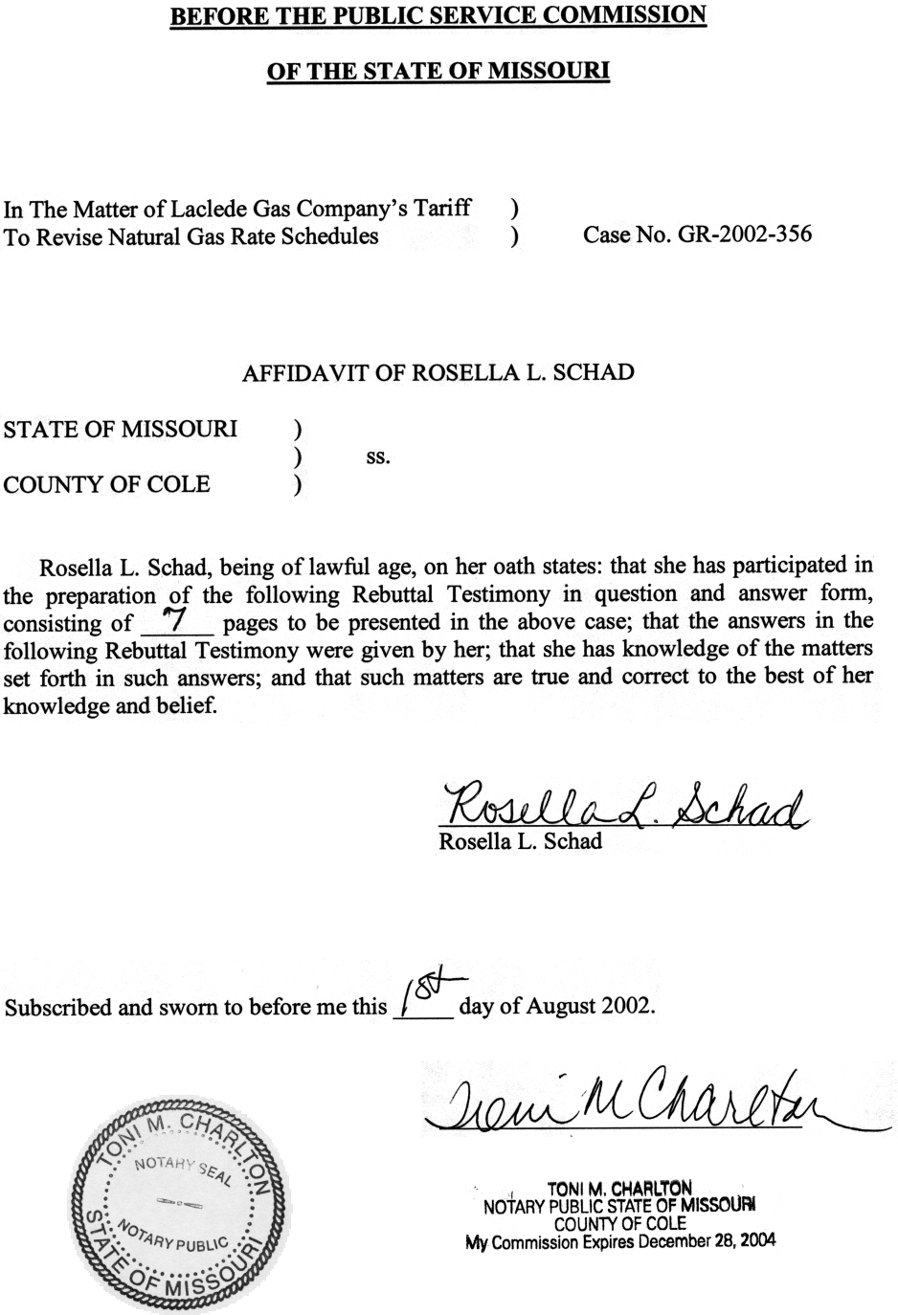
TABLE OF CONTENTS OF
REBUTTAL TESTIMONY OF
ROSELLA L. SCHAD, P. E.
CASE NO. GR-2002-356
Decommissioning 2
Gas Holders 2
Accured Reserve 6

REBUTTAL TESTIMONY
OF
ROSELLA L. SCHAD, P. E.
LACLEDE GAS COMPANY
CASE NO. GR-2002-356
Please state your name and business address.
Rosella L. Schad, P.O. Box 360, Jefferson City, MO 65102
By whom are you employed and in what capacity?
I am employed by the Missouri Public Service Commission (PSC or Commission) as an Engineer I in the Engineering and Management Services Department.
Are you the same Rosella L. Schad who filed direct testimony on behalf of the Staff of the Missouri Public Service Commission in this case?
Yes.
What is the purpose of your testimony in this case?
The purpose of my testimony in this case is to present Staff’s rebuttal position of Laclede Gas Company (Laclede or Company) witnesses Craig Hoeferlin, and R. Lawrence Sherwin.
What issue will you address?
I will address the final removal (decommissioning) costs of Laclede’s four gas holders.

Decommissioning

Gas Holders
Are final removal costs of the gas holders included with other net salvage costs by Staff?
No. Gas holders are considered a life span property, and as such, their final retirement costs are reviewed by Staff Engineers, as I explain later.
Has Staff previously identified its recommended treatment of final retirement of a life span property?
Yes. On page 6 of the direct testimony of Staff witness Paul W. Adam, P.E., in Case No. WR-2000-844, St. Louis County Water Company, he states,
“The final retirement of a life span property frequently includes a major demolition project and a rehabilitation of the site where the plant was located (greenfielding). These projects do not occur frequently and are normally after a long ‘in service’ period. For example, the Laclede Gas Company’s gas holders in St. Louis are in the range of 100 years old and are still in use. Their removal will be the final retirement of a life span property. The responsibility to determine this type of net salvage cost (life span “final retirement cost”) would remain with the depreciation engineers, due to the need to evaluate demolition and “greenfielding” projects.”
The decision to retire the gas holders, a life span property, includes engineering analyses of the gas holders’ operational function and economic alternatives available to the Company. Can you describe these analyses?
Yes. The first requirement of the engineering analyses is to evaluate whether the continued operation of the gas holders is required on Laclede’s system. If the Company’s engineers determine that current system design does not warrant use of the gas holders, their documentation provides the prerequisite to initiate the second requirement to retire the gas holders. The second requirement of the engineering analyses is an economic cost study evaluating whether the cost of removing the gas holders is justified when other alternatives, such as abandonment in place or sale to another entity, are considered. Risk assessments for all alternatives, including environmental concerns for the Company, its customers, and the public, need to be made and included in the analyses. If the Company’s studies show removal is the most prudent course of action, then the demolition, removal and greenfielding project can be developed in operational and economic detail. In summary, if the conclusions of the studies show the gas holders are not needed to operate the system or for reliability of the system during peak demand, and it is determined that retirement and removal is the most beneficial and cost-effective action for the Company to pursue, the Company needs to provide a signed authorization document that approves the decision to retire the gas holders. Prior to any demolition activity an appropriate entry should be made to the accounting ledger, retiring the gas holders and all associated equipment.
On page 7, line 22 of his direct testimony, Mr. Hoeferlin states, “Laclede has concluded that it is prudent to commence removal of the gas holders in the near future.” Has the Company provided any documentation of its analyses?
No. Notably absent are specific engineering and economic analyses by the Company to support removal of the gas holders at this time.
When is it appropriate to include final removal costs in a regulated utility’s customer rates?
It is Staff’s position that final removal costs should be included in a regulated utility’s customer rates when the final retirement date is certain and the costs are known and measurable.
On page 11, line 10 of his direct testimony, Mr. Hoeferlin states, “The best way to verify the cost is to proceed with bid specifications and to solicit firm proposals from contractors to remove the gas holders.” Has the Company initiated and/or completed this process?
No. The Company’s response to Staff’s Data Request No. 4601 is that they have neither solicited nor received bids for any such contracts, although preparations for doing so are ongoing. The Company’s response indicates that the dismantling of the gas holders is not imminent.
Since the Company’s plan to dismantle the gas holders is not imminent, do you believe the Company’s current estimate of $5,130,400 to remove the four gas holders, as given on Schedule 2 of Mr. Hoeferlin’s direct testimony, is a known and measurable cost that should be included in customer rates in this case?
No. When the costs to remove the four gas holders are known and measurable, they should be considered for inclusion in rates at that time.
Have the Company’s previous cost estimates to dismantle the four gas holders remained relatively constant?
No. On page 4, line 1 of the direct testimony of Company witness Harry R. Haury, III, P.E., in Case No. GR-96-193, he states, “Total Cost to remove them is estimated to be $8,723,900.” Three years later in Case No. GR-99-315, on Schedule 2 of the direct testimony of Company witness Richard A. Kottemann, Jr., the Total Decommissioning Cost is estimated at $4,779,700. The current estimate given by Company witness Mr. Hoeferlin is $5,130,400. In six years the cost estimates have had significant fluctuation.
On page 10, line 4 Mr. Hoeferlin states, “Furthermore, some of the gas holders are located near residential areas and there is growing public sentiment to eliminate them for aethetic reasons.” Has the Company made a commitment to these three communities to dismantle the gas holders?
At this time Staff is not aware of such a commitment nor has Staff seen any correspondence from local communities about the gas holders. Staff is currently waiting for responses from Laclede to two data requests related to both of these concerns. No individual or local government official has contacted Staff with concerns regarding the gas holders.
What criteria would Staff use to verify a commitment by the Company to dismantle the four gas holders?
The Company will need to submit a removal contract that includes, for example, a non-refundable payment by the Company to the contractor for removal of the gas holders and a penalty clause for failure of the contractor to complete the project by the date specified.
Would Staff Engineers evaluate the demolition and “greenfielding” project utilizing professional engineering judgment and provide a recommendation to the Commission?
Yes. Staff Engineers will review permits, contracts, and other associated documentation regarding the project for prudence. Staff Engineers will make on-site inspections throughout the duration of the project and will conduct any further evaluations as necessary.
On page 7, line 5 of his direct testimony, Mr. Sherwin states, “As shown on Schedule RLS-1, I propose to amortize the $5,130,400 estimated removal cost of the four gas holders over a five year period commencing with the effectiveness of gas rates resulting from this rate case. This results in an initial annual amortization amount of $1,026,080.” What is Staff’s recommendation regarding this proposal?
As I stated earlier, only at the time the Company’s costs to dismantle the four gas holders are known and measurable and their final removal date is certain, should costs be considered for inclusion in rates.

Accured Reserve
In the absence of a known and measurable final removal cost, a date certain for their final removal, and retirement of the gas holders (Account 362.00-$1,908,844) and compressor equipment (Account 363.30-$810,861) from the plant accounts and reserve, are there considerations that must be addressed prior to recovery of the gas holders’ final removal costs?
Yes. In past years, the “traditional whole life” depreciation rate determination was used by Laclede, allowing a reserve “build-up” for estimated future removal costs. The current reserve, which includes monies received by the Company from past ratepayers for future cost of removal expenditures, has an over-accrual of $141 million. Prior to recovery of additional monies for the gas holders’ final removal costs, a mechanism to reduce the Company’s over-accrued reserve should be initiated. Staff’s recommended negative annual amortization will reduce the Company’s
over-accrued reserve.
What are Staff’s recommendations concerning removal of the gas holders?
Staff’s recommendation in this case is that the Company’s decision to retire and remove the four gas holders is not adequately supported by the Company’s documentation or actions. Staff does not recommend the 5 year, $1,026,080 annual amortization be included in cost of service for this rate case. Staff recommends the Company provide engineering and economic analyses, a statement of authorization for retirement, and retirement of the assets associated with the gas holders before the Commission considers any rate recovery. Staff recommends the reduction of the over-accrued reserve be addressed in this case, facilitating the decisions to retire life span property in the future.
Does this conclude your testimony?
Yes.

Greenfielding refers to returning a site to the conditions that existed prior to the initial use of the site.

