Exhibit No.:
Issues: Rate Design

Witness: Anne Ross
Sponsoring Party: MO PSC Staff
Type of Exhibit: Surrebuttal Testimony
Case No.: GR-2002-356
Date Testimony Prepared: August 23, 2002

MISSOURI PUBLIC SERVICE COMMISSION

Utility Operations DIVISION

Surrebuttal Testimony

OF

Anne Ross

Laclede Gas Company

CASE NO. GR-2002-356

Jefferson City, Missouri
August, 2002
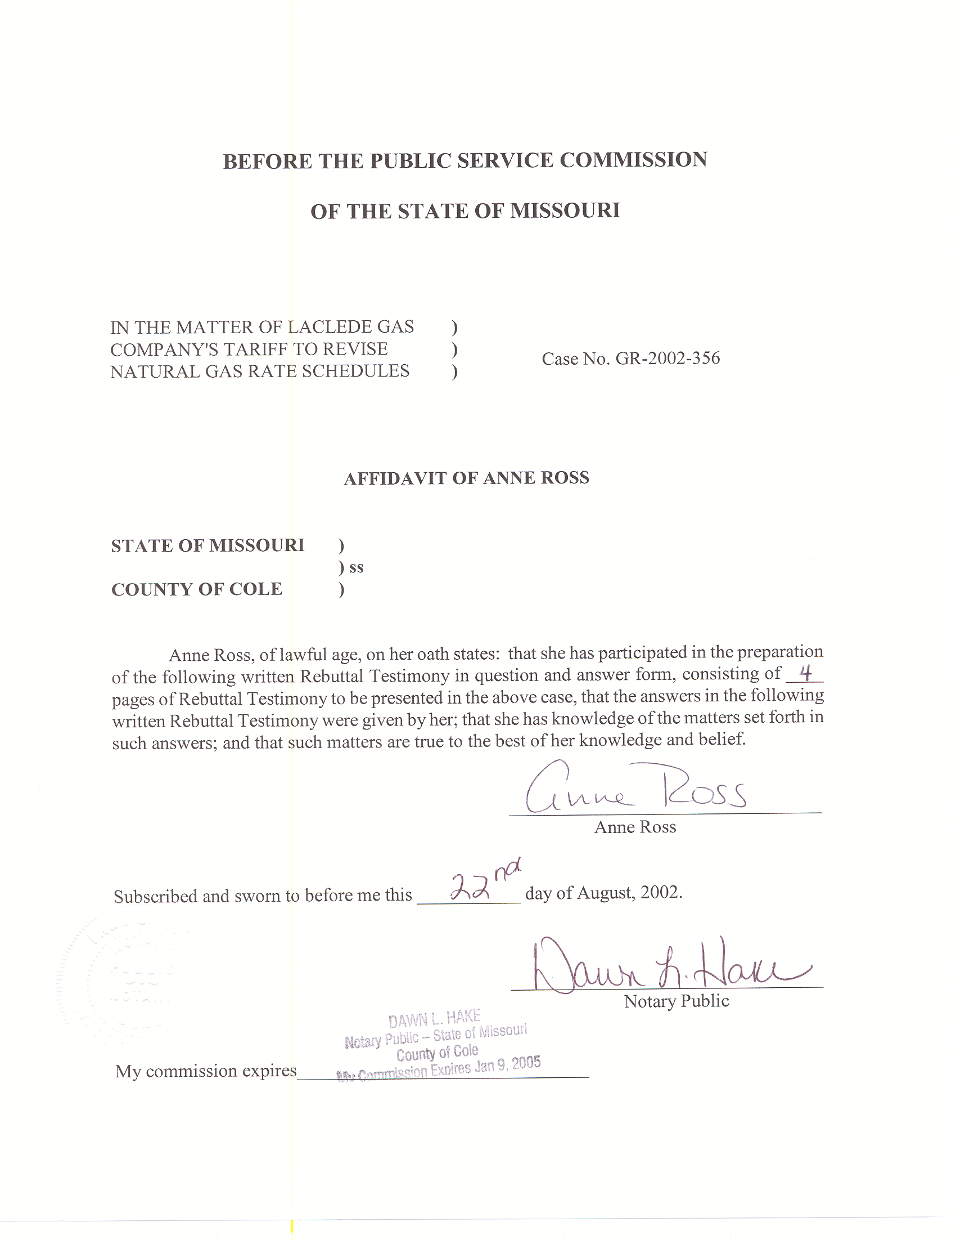
SURREBUTTAL TESTIMONY
OF
ANNE ROSS
LACLEDE GAS COMPANY
CASE NO. GR-2002-356

Q. Please state your name and business address.
A. My name is Anne Ross and my business address is P. O. Box 360, Jefferson City, Missouri 65102.
Q. Are you the same Anne Ross who has previously filed testimony in this case?
A. Yes, I am.
Q. What is the nature of your testimony as it relates to the rate increase being proposed by Laclede Gas Company (Laclede or Company) in Case No. GR-2002-356?
A. My Surrebuttal Testimony will address Company witness Michael T. Cline’s rate design proposal for separating the General Service – Commercial and Industrial class into three rate classes based on annual usage. Specifically, I will comment on my analysis of Mr. Cline’s rates in regard to rate continuity and impact on individual customers.
Q. What does the term rate continuity mean?
A. Rate continuity refers to the effect of the rate design upon a customer’s bill when the customer is very near the dividing point of two rate classes that differ only in usage requirements. In this specific case, I tested the effect on individual customers’ bills of being served under the various General Service classes for which they might qualify.
Q. What analysis have you done with regard to Mr. Cline’s proposal?
A. Using individual customer monthly usage records supplied by the Company, I identified a subset of customers whose annual usage was within two and one-half percent (2½ %) of the annual usage dividing points for each of Laclede’s proposed rate classes. I chose this criterion because I wanted to examine the individual customer impact of being served on one rate rather than the other. For example, a customer using around 5,000 therms per year might be classified as a Small General Service, or Medium General Service, customer, depending on their natural gas usage during the time period used to assign them to a tariff class. A customer using close to 50,000 therms annually might qualify for the Medium General Service, or Large General Service, rate.
From this subset, I further identified several customers whose load factors ranged from 18% - 87%. I priced each customer out on the two tariffed rates that they would potentially qualify for, and compared their bills.
Q. What did you find?
A. I found that, for the customers on the Small General Service/Medium General Service dividing point, the difference in every case was approximately $90 a year. For the customers on the Medium General Service/Large General Service dividing point, the difference was around $200 per year. This result of this comparison is shown on Schedule 1.
Q. What is your conclusion regarding the General Service – Commercial and Industrial rates proposed by Laclede in this proceeding?
A. For customers whose usage places them close to the annual usage requirement dividing points in Laclede’s proposed General Service classes, there is no substantial penalty for being classified in one group rather than another; thus, these rates are virtually continuous.
Q. What analysis did you do regarding the impact of Mr. Cline’s proposed rates on customers with varying load factors?
A. Using the same customers described previously, I priced these customers’ annual usage on the current General Service – Commercial and Industrial rate, and Laclede’s proposed General Service rates. Since these customers might potentially be served on one of two rates, to be conservative I chose the proposed rate that would result in the higher bill.
Q. What did your analysis show?
A. The results of my analysis are shown on Schedule 2, and show that, for the customers with usage around 5,000 therms per year, bills would increase $65 - $69 per year, or 2%; for the larger customers whose annual usage is around 50,000 therms, bills would increase about $275 per year, or 1%.
Q. Are the rates proposed by Laclede, and used in your analysis, the actual rates which will go into effect if the Commission orders this rate design?
A. No, they are not. As discussed in the Surrebuttal Testimony of Staff witness Dr. Michael S. Proctor, properly designed rates will be based on weather-normalized billing units for the test period, which is not the basis for these rates.
Q. Do you believe that rates designed using weather-normalized billing units will have the same characteristics regarding rate continuity and impact?
A. Yes, I do. These rates are designed in a manner that minimizes the rate impacts upon individual customers, and holds this class’ revenue requirement unchanged. If the Commission were to approve Mr. Cline’s rate design for the General Service – Commercial and Industrial customers, without a change in the Company’s allowed revenue requirement, and rates were designed in this fashion, I believe that they would have the same characteristics regarding rate continuity and rate impact. Of course, if the Company is allowed an increase in revenue requirement in this case, there will be impacts upon customer bills; however, that impact will not be caused by the rate design, but rather by the higher rates needed to collect a higher revenue requirement.
Q. Does this conclude your testimony?
A. Yes.

