Exhibit No.:
Issues: Other Telephone
Specific Issues
Sponsoring Party: Mo PSC Staff
Type of Exhibit: Additional Surrebuttal
Testimony
Case No.: TC-2002-57
Date Testimony Prepared: March 26, 2004

MISSOURI PUBLIC SERVICE COMMISSION

Utility Operations Division

Additional Surrebuttal Testimony

OF

Michael S. Scheperle

Northeast Missouri Rural Telephone Company
and Modern Telecommunications Company

CASE NO. TC-2002-57

Jefferson City, Missouri
March 2004

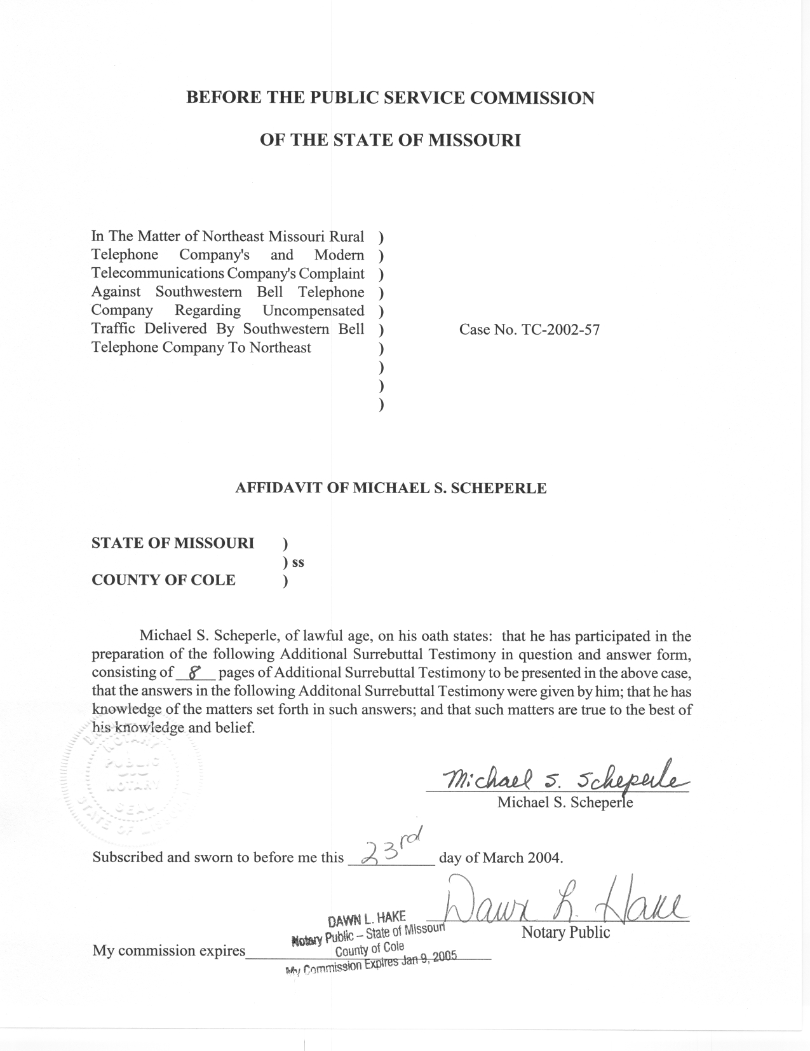

TABLE OF CONTENTS

InterMTA Factors Recommended By Sprint PCS 2
InterMTA Factors Recommended By US Cellular 3
Recommendation By Cingular To Dismiss The Case 5
Secondary Liability of SBC 6
Summary 7

ADDITIONAL SURREBUTTAL TESTIMONY
OF

MICHAEL S. SCHEPERLE
CASE NO. TC-2002-57

- Please state your name, employer and business address.
A. My name is Michael S. Scheperle and I am employed in the Telecommunications Department Staff (“Staff”) of the Missouri Public Service Commission (“Commission”). My business address is Post Office Box 360, Governor Office Building, Suite 500, 200 Madison Street, Jefferson City, Missouri 65102-0360.
Q. Are you the same Michael S. Scheperle who filed Rebuttal Testimony, Surrebuttal Testimony and Additional Rebuttal Testimony in this case on behalf of Staff?
A. Yes, I am.
Q. What is the purpose of your Additional Surrebuttal Testimony?
A. The purpose of my Additional Surrebuttal Testimony is to respond to the Rebuttal Testimonies of Angela Linares and Derek Canfield representing Sprint Spectrum LP d/b/a Sprint PCS (“Sprint PCS”), Jim Naumann representing United States Cellular (“US Cellular”), William Brown representing Cingular Southwestern Bell Wireless LLC (“Cingular”) and Alan Kern representing Southwestern Bell Telephone, L.P. d/b/a SBC Missouri (“SBC”).
Q. What issues will Staff address in its Additional Surrebuttal Testimony?
A. Through Additional Surrebuttal Testimony, Staff is addressing the following:
- InterMTA factors recommended by Sprint PCS.
- InterMTA factors recommended by US Cellular.
- Recommendation by Cingular to dismiss the case.
- Secondary liability of SBC.

InterMTA Factors Recommended By Sprint PCS
Q. Does Staff support the recommendations of Sprint PCS for interMTA factors for Alma, Choctaw, MoKan and Mid-Missouri?
A. Yes. According to Ms. Linares, Sprint PCS conducted individual traffic studies and reached agreement with Alma, Choctaw, MoKan and Mid-Missouri either on interMTA factors and/or in interconnection agreements between the parties. Staff supports the concept of parties negotiating and agreeing to interMTA factors or agreeing and filing interconnection agreements for Commission review.
Q. Does Staff oppose the recommendations by Sprint PCS for interMTA factors for Northeast and Chariton?
A. No. Sprint PCS has not been able to reach agreement with Northeast and Chariton concerning interMTA factors. However, Sprint PCS conducted a traffic study for Northeast and Chariton, as Staff discusses more fully below, that Staff believes represents a reasonable analysis of traffic originated by Sprint PCS transited to SBC and terminated to Northeast and Chariton. Sprint PCS traffic studies result in a recommendation of 11.9 % interMTA factor for Chariton and an 11.3 % interMTA factor for Northeast.
The traffic study results and details are outlined in Derek Canfield’s Rebuttal Testimony and attached Schedules (DAC – 1 through 7). Staff believes Mr. Canfield’s approach is realistic for the following reasons:
- The Sprint PCS traffic study identifies the initial cell site of a wireless-originated call and the terminating telephone number of each call, the traffic study then assigns MTA originating and terminating location as contemplated by the FCC in the First Report and Order.
- Sprint PCS was able to use the entire population of calls for a one week period. The minutes of use for the one-week period (September 7, 2003 through September 13, 2003) is a reasonable representative of the minutes of use generated by the CTUSR. The CTUSR is a monthly report generated by SBC for billing purposes for Northeast and Chariton and other ILECs.
- Sprint PCS studies summarize the raw data and assign calls as being intraMTA or interMTA.
- Sprint PCS has developed a methodology that may be used in future negotiation and cases based on FCC guidelines.
For all of the above-mentioned reasons, Staff does not oppose the recommendations by Sprint PCS.

InterMTA Factors Recommended By US Cellular
Q. Does Staff support the interMTA factors recommended by US Cellular for interMTA factors for Alma, Choctaw, MoKan and Mid-Missouri?
A. Yes. Jim Naumann representing US Cellular states that Alma, Choctaw and MoKan interMTA factors are unnecessary, for the purpose of this proceeding, because they have stipulated that the interMTA factor is 0 %. Also, interMTA factors for Mid-Missouri are unnecessary because US Cellular sends all the traffic via interexchange (“IXC”) carriers, thereby Mid-Missouri receives terminating switched access charges from the IXC provider. Staff agrees with this assessment based on the Notice filed by Alma, Choctaw and MoKan on January 9, 2004. Also, after reviewing the record and CTUSR, Staff agrees with Mr. Naumann’s assessment of the situation for Mid-Missouri.
Q. Does Staff oppose the recommendations by US Cellular for interMTA factors for Northeast and Chariton?
A. Yes. US Cellular has not been able to reach agreement with Northeast and Chariton concerning interMTA factors. However, Mr. Naumann recommended interMTA factors for both Northeast and Chariton of 12% because US Cellular has 13 cell sites outside the MTA and 94 cell sites within the MTA, so the interMTA factor would be 12%. Cell site information is helpful in understanding US Cellular’s system. However, at this time, Staff opposes the recommendation because it does not take into account the particular circumstances of Northeast and Chariton, as Northeast has access lines in three MTA areas and Chariton has access lines in two MTA areas (see Schedule 4, Additional Rebuttal Testimony of Scheperle for breakdown). If Northeast and Chariton had access lines in one MTA area, Staff may not oppose the proposed methodology by US Cellular. However, as a result of the MTA overlap in access lines for both Northeast and Chariton, Staff believes the percentage of interMTA factors as proposed by US Cellular is distorted.
Q. Did Staff make a recommendation for interMTA factors for traffic originated by US Cellular that terminates on the network of Northeast and Chariton?
A. Yes. In Staff’s Additional Rebuttal Testimony, Staff recommended that the interMTA factor for Northeast be 26% and the interMTA factor for Chariton be 33% (see Schedule 6, Scheperle Additional Rebuttal Testimony).

Recommendation By Cingular To Dismiss The Case
- What is Cingular’s recommendation?
- Mr. Brown, representing Cingular, states:
“While I understand the Commission’s interest in the actual breakdown on intraMTA and interMTA traffic for each of the wireless carriers in relation to each of the Complainants, I do not believe it is sufficient cause for the Commission to re-open this record. Rather, the absence of evidence on a critical issue in Complainants’ cases is cause to dismiss the cases because Complainants have failed to meet their burdens of proof” (William Brown, Rebuttal Testimony on Re-opening, page 3, lines 62-66).

Q. Does Staff agree with this assessment and recommendation by Mr. Brown?
A. No. Cingular is originating the traffic, delivering the traffic to SBC for transiting purposes, and then SBC is delivering the traffic to a Complainant’s network for termination. Staff opposes Mr. Brown’s recommendation for the following reasons:
- Cingular is delivering the traffic to SBC through an interconnection agreement between SBC and Cingular (Exhibit 38). In this agreement between Cingular and SBC, for traffic to third party providers (i.e., Complainants’ networks) Section 3.1.3 (page 16 of Exhibit 38) states that, “the Parties agree to enter into their own agreements with Third Party Providers. SWBT agrees that it will not block traffic involving Third Party Providers with whom Carrier has not reached agreement.” Staff interprets this to mean that Cingular is to enter into its own agreements with the Complainants. Also, SBC will not block the traffic originated by Cingular destined for a Complainant’s network. From Staff’s perspective, agreements have not occurred and it is Cingular’s responsibility to have an agreement.
- According to Staff’s understanding, at this point in time, neither the wireless providers, the transiting carrier or the Complainants create records to know the jurisdiction (interMTA or intraMTA) of the calls. The wireless providers are originating the call. However, the wireless providers are currently not creating call detail records to deliver to the transiting carrier or the Complainants. As a result, it is unclear how the Complainants, are to know whether a call is interMTA or intraMTA and have no way to determine how to divide the calls to recover charges from the parties responsible for paying those charges. Staff does not understand the rationale of asking the Commission to dismiss the case because the Complainants do not know the jurisdiction of the traffic.
- To date, Cingular has not completed any traffic studies.

- Staff is hopeful that since Sprint PCS created a program and methodology to ascertain the jurisdiction of wireless traffic based on cell site origination and terminating MTA location, other wireless providers, such as Cingular could also develop a program and methodology to obtain the jurisdiction of wireless traffic.

Secondary Liability of SBC
- Do you believe that SBC should be secondarily liable should a CMRS provider not pay a Complainant?
A. No. Mr. Alan Kern, representing SBC, reiterates that the Complainants asks the Commission that SBC pay the Complainants either under a primary or secondary liability for which the Complainants claim they have not been compensated.
In this situation, Staff recommends that the originating wireless provider is responsible for payment whether the traffic is interMTA or intraMTA. Staff agrees with Mr. Kern’s testimony where the “calling-party’s-network-pays” whether a LEC, IXC or CMRS provider (Kern, Rebuttal Testimony, pages 23 and 24, lines 18-24 and 1-11).
Staff recommends that in the situations of non-payment of traffic to a Complainant by a CMRS provider, traffic blocking is a preferable solution. Previous Commission decisions have allowed for traffic blocking (i.e., Case No. TC-2001-20 and TT-2001-139). In Case No. TC-2001-20, the Commission allowed for blocking of certain traffic to Mid-Missouri Telephone Company (a Complainant in this case). In Case No. TT-2001-139, the Commission allowed blocking of traffic by a small LEC should a wireless provider not pay (establishment of 29 wireless termination tariffs). Therefore, Staff recommends that SBC should not be secondarily liable for non-payment by a wireless provider to a Complainant.

Summary
Q. Please summarize your Additional Surrebuttal Testimony.
- Staff supports the recommendations of Sprint PCS for interMTA factors for Alma, Choctaw, MoKan and Mid-Missouri.
- Staff does not oppose the interMTA factors developed by Sprint PCS for Northeast and Chariton.
- Staff supports the assessment of US Cellular for interMTA factors for Alma, Choctaw, MoKan and Mid-Missouri.
- Staff does not agree with US Cellular’s recommendation of interMTA factors for Northeast and Chariton.

- Staff does not agree with Cingular’s recommendation that the Commission should dismiss the case because the Complainants have failed to meet their burdens of proof.
- Staff recommends that SBC is not secondarily liable should a CMRS provider not pay. Staff recommends that in the situation of non-payment of traffic to a Complainant by a CMRS provider, traffic blocking is a preferable solution.
- Does this conclude your Additional Surrebuttal Testimony?
A. Yes, it does.

