Exhibit No.:

Issues: Class Cost-of-Service
Witness: Anne Ross
Sponsoring Party: MoPSC Staff
Type of Exhibit: Rebuttal Testimony
Case No.: GR-2002-356
Date Testimony Prepared: August 2, 2002

MISSOURI PUBLIC SERVICE COMMISSION

Utility Operations DIVISION

REBUTTAL TESTIMONY

OF

ANNE ROSS

LACLEDE GAS COMPANY

CASE NO. GR-2002-356

Jefferson City, Missouri

August, 2002

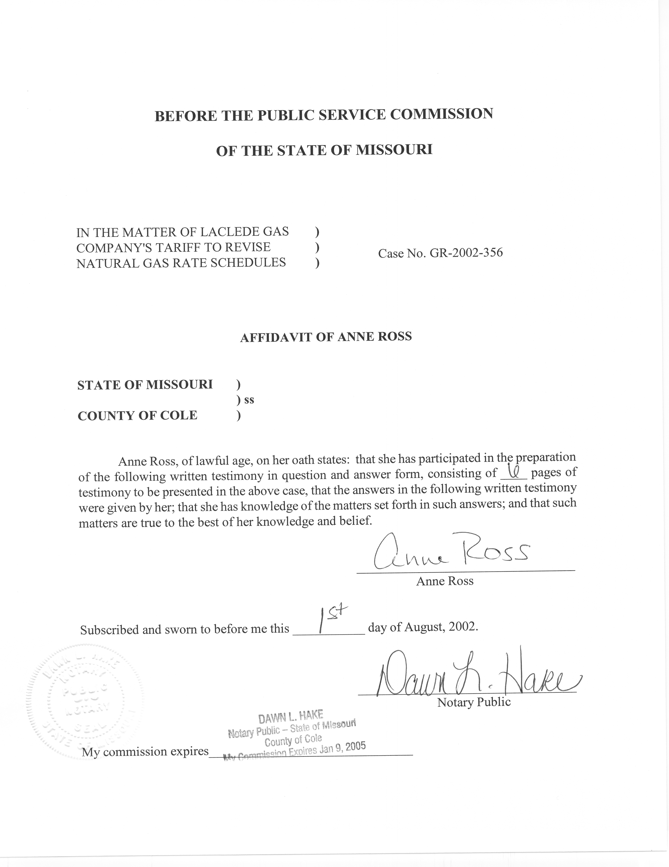

REBUTTAL TESTIMONY
OF

ANNE ROSS
LACLEDE GAS COMPANY
CASE NO. GR-2002-356

Q. Please state your name and business address.
A. My name is Anne Ross and my business address is P. O. Box 360, Jefferson City, Missouri 65102.
Q. Are you the same Anne Ross who filed direct testimony in this case?
A. Yes, I am.
Q. What is the nature of your testimony as it relates to the rate increase being proposed by Laclede Gas Company (Laclede or Company) in Case No. GR-2002-356?
A. First, I will describe changes made to the Staff’s Class Cost of Service study filed June 26, 2002. Next, my testimony will address Midwest Industrial Energy Consumer’s (MIEC’s) method of allocating Storage costs. My testimony also will address the Weighted Customer measure used by the Office of Public Counsel (OPC) and MIEC witnesses to allocate costs associated with billing customers.
Q. What changes have you made to the Staff’s class cost-of-service study since your direct filing of June 26, 2002?
A. I have made the following changes:
1. I changed the General Service bills and volumes to incorporate the customers in the Air Conditioning class. These were inadvertently left out in my direct filing.
2. I adjusted customer numbers and volumes to reflect customers who switched rates through March 31, 2002, which is the update period.
3. I adjusted Basic Transportation Unauthorized Overrun therms and revenues to reflect normalization of these units.
4. I revised my Winter Sales allocator to include all the months defined in the Laclede tariff as winter months – that is, November-April.
5. I corrected a mistake in my initial cost-of-service study, in which I had input the Firm and Basic Transportation customers’ coincident peak demands incorrectly.
6. I incorporated revisions to the Staff’s mains, meters, and regulators allocators. These revisions are discussed in the rebuttal testimony of Staff witness Daniel I Beck.
The Staff’s revised class cost-of-service study is attached as Schedule 1.

MIEC ALLOCATION OF STORAGE COSTS
- What are your concerns with the MIEC study?
A. The MIEC study does not differentiate between Production plant used for meeting peak day requirements, and Storage plant used year-round for balancing as well as meeting customer usage requirements. In the MIEC study, these costs are allocated in the same manner.
Additionally, the MIEC study does not allocate any Storage costs to the Basic Transportation customers, even though these customers bought gas from the company in every month of the test year, including the extremely cold winter months, meaning that transportation customers would have used gas from storage.
Further, the MIEC study does not allocate any Storage costs to the Basic Transportation customers, even though these customers are allowed to use Laclede’s storage for balancing purposes.
Q. How are Laclede’s Production and Storage facilities allocated in the MIEC study?
A. Production and Storage plant and expenses are lumped together under the label “Peaking,” and allocated using a coincident demand allocator.
Q. Do Production and Storage facilities serve the same purpose?
A. No, they do not. Production facilities are used for meeting peak day load. Storage facilities are used to provide sales gas during the winter months, as well as for balancing the deliveries and receipts of the Transportation customers year-round.
Q. What type of Production facilities does Laclede have?
A. Laclede has Manufactured Gas Production plant, whose costs are booked in the Federal Energy Regulatory Commission Uniform System of Accounts (FERC USOA) 304 – 311. These plant accounts, and the expenses associated with them, contain costs related to propane vaporization.
Q. For what purpose is this vaporized propane used?
A. In a February 18, 1997, Natural Gas Roundtable Discussion Group presentation given by Laclede Vice President Kenneth J. Neises titled “Overview of the History, Regulation, Structure and Operation of the Natural Gas Industry”, Mr. Neises stated that propane was mixed “directly with natural gas during peak periods to increase the overall heat content of the gas.”
Q. Are these facilities, then, used specifically for peaking purposes?
A. Yes, they are.
Q. How did the MIEC study allocate these costs to the customer classes?
A. Mr. Mallinckrodt used a peak day demand allocator to allocate these costs to the customer classes.

Q. Do you believe that a peak day demand allocator is the correct way to allocate these costs to the customer classes?
A. Yes, I do.
Q. What is the major type of Storage facility that Laclede has?
A. Laclede has a large Underground Gas Storage facility.
Q. What is the function of Laclede’s Underground Gas Storage?
A. Laclede’s Underground Gas Storage, whose costs are booked in FERC USOA 350-357, consists of approximately 9,000 acres of land near Florissant, and, according to the talk Mr. Neises gave in 1997, is used “to meet winter demands for gas, and balance the receipts and deliveries of gas for all of our customers.”
Q. How did Mr. Mallinckrodt allocate these costs in the MIEC study?
A. Mr. Mallinckrodt did not differentiate between these costs and the Manufactured Gas Production (propane peaking) costs discussed previously, so in the MIEC study these costs were allocated using a peak day demand allocator.
Q. Is Laclede’s Underground Storage used only on the system peak day or days?
A. No. Laclede’s Underground Storage is used throughout the year for balancing of Transportation customer receipts and deliveries, as well as during the winter heating season, which is a period of months, not days.
Q. Do you believe that the Basic Transportation and Sales Service customers use Laclede’s underground storage facilities?
A. Absolutely. These customers bought sales gas from the Company in every month of the test year. One of the ways in which Laclede supplies sales gas to its customers in the winter is by utilizing its underground storage; for that reason I believe that all Transportation customers should be allocated a portion of Laclede’s Underground Storage costs.
Q. Is winter the only time Transportation customers use Laclede’s Underground Storage facilities?
A. No. Transportation customers use Laclede’s storage year-round for balancing purposes. In fact, the Transportation tariff contains a 2¢/therm charge for providing storage services when the quantity of gas delivered to the customer exceeds a tolerance band of 5% less than the quantity received by the Company for the customer. During the test year, the Company reported $225,000 in revenue for this service. A simple calculation ($225,000/$0.02) shows that 11,250,000 therms were assessed this charge. Consequently, the Basic Transport customers should share the cost of the Storage facilities necessary to provide these services to them.
Q. How did Staff allocate Storage costs in this case?
A. In order to properly reflect the fact that the Company uses its Storage facilities throughout the heating season, I used Winter Therm Sales for each class to allocate these costs.

ALLOCATION OF CUSTOMER ACCOUNTING EXPENSES
Q. How did OPC and MIEC allocate Account 903 – Customer Records and Collections?
A. Both parties allocated the costs in this account using a density-weighted customer measure.
Q. What is a density-weighted customer measure?
A. A density-weighted customer measure is developed by taking customer numbers, then weighting the customer numbers by the average size of the parcel or plot on which the customer’s home or business sits. This type of measure is appropriate to use when allocating costs such as meter-reading, which is obviously affected by the size of the customer’s parcel.
Q. Do you believe that this is a reasonable way to allocate these customer billing costs?
A. No, I do not. The costs in this account are largely related to preparing and mailing bills, investigating credit, and maintaining records. I do not believe that the average parcel size strongly impacts these costs. For instance, both studies have a weight for General Service – Residential customers of 1, and a weight for General Service – Commercial and Industrial customers of 3.42. These classes have an identical rate structure – a customer charge and blocked commodity rate, and both receive postcard bills. I do not believe that it is reasonable to claim that it would cost 3.42 times as much to render a postcard bill to a GS – C&I customer as to a GS – Res customer. Schedule 2 shows a Laclede Residential customer’s actual bill, as well as a Laclede General Service – Commercial customer’s actual bill. As you can see, the two bills are identical in terms of rate structure and format.
Q. Does this conclude your testimony?
A. Yes.
