Exhibit No.:
Issues: Tariff Filing
Implementing Deposit Requirements

Witness: John Van Eschen Sponsoring Party: MO PSC Staff
Type of Exhibit: Rebuttal Testimony
Case No.: TT-2003-0043
Date Testimony Prepared: November 5, 2002

MISSOURI PUBLIC SERVICE COMMISSION

Utility Operations DIVISION

Rebuttal testimony

OF

JOHN VAN ESCHEN

Spectra communications group, llc

CASE NO. TT-2003-0043

Jefferson City, Missouri
November 2002

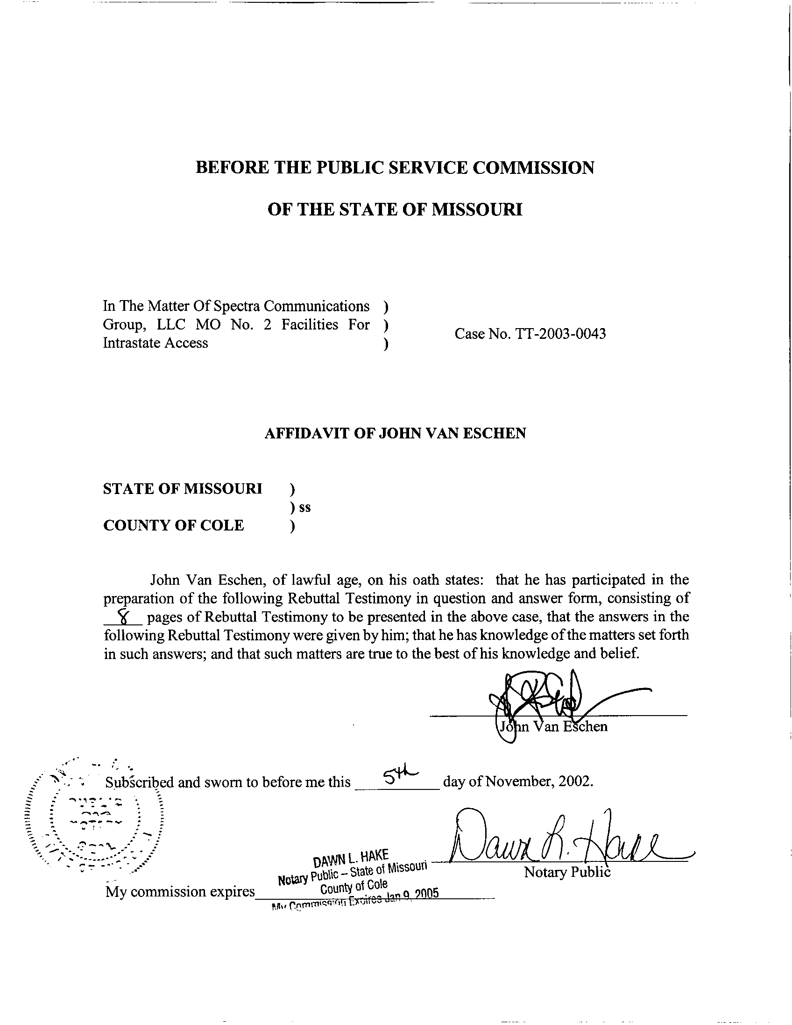
REBUTTAL TESTIMONY
OF
JOHN VAN ESCHEN
CASE NO. TT-2003-0043

Q. Please state your name, employer, and business address.
A. My name is John Van Eschen. I am the Manager of the Telecommunications Department at the Missouri Public Service Commission. My business address is 200 Madison Street, Jefferson City, Missouri, 65102.
Q. Please describe your educational background and work experience.
A. I have a Masters of Arts degree in Economics from Kansas State University. I have been employed by the Commission in various capacities since 1984 and since 1995, I have been the Manager of the Telecommunications Department.
Q. What is the purpose of your testimony?
A. The purpose of my testimony in this proceeding is to respond to the proposed tariff sheets filed by Spectra Communications Group, LLC d/b/a CenturyTel (Spectra) concerning the establishment of additional deposit requirements for switched access subscribers.
Q. Please explain your understanding of the proposed tariff.
A. The proposed tariff would essentially expand Spectra’s ability to request a deposit from switched access subscribers. Specifically, if a switched access subscriber’s credit rating falls below a BBB rating then the proposed tariff, if approved, would allow Spectra to request a deposit from the subscriber. The deposit amount would not exceed total rates and charges for two months of the customer’s actual billing.
Q. Does Spectra’s existing tariff already permit Spectra to request a deposit from switched access subscribers?
A. Yes. Spectra’s existing tariff permits Spectra to request a deposit if a customer has a proven history of late payments to the company or does not have established credit. Such a deposit would not exceed the actual or estimated rates and charges for the switched access subscriber for a two month time period.
Q. Do other incumbent local exchange companies (ILECs) currently have deposit requirements for switched access subscribers?
A. Yes. Most, if not all, of the ILECs have some form of deposit requirement. Schedules 1, 2 and 3 are the relevant existing tariff pages from the respective switched access tariffs of Southwestern Bell, Sprint and Oregon Farmers Mutual Telephone Company. Oregon Farmer’s tariff applies to most of the small ILECs operating in Missouri. In my opinion, Sprint’s and Oregon Farmer’s tariffs are similar to Spectra’s existing deposit requirement in the sense that the company can request a deposit if the switched access subscriber has a proven history of late payments to the company or the customer does not have established credit. Southwestern Bell’s tariff does not identify specific criteria for requesting a deposit. Instead, Southwestern Bell’s tariff states, “the Telephone Company may, in order to safeguard its interests, require an IC to make a deposit prior to or at any time after the provision of a service to the IC…”
Q. Does the Federal Communications Commission allow local exchange companies to apply deposits to switched access subscribers?
A. Yes. The FCC has allowed local exchange companies to require deposits from carriers if the carrier has a proven history of late payments to the local exchange company and if the carrier has no established credit. The FCC has allowed such deposits to not exceed the actual or estimated rates and charges for service for a two-month period. Although I will discuss it more later, the FCC currently has a pending proposal from Southwestern Bell to establish deposit requirements for carriers with an impairment of credit worthiness.
Q. What is your reaction to Spectra’s proposal to establish deposit requirements for carriers whose creditworthiness has fallen below commercially acceptable levels?
A. In general, I support the concept. Existing deposit requirements allow local exchange companies to request a deposit if the switched access carrier fails to pay its bill in a timely manner. Unfortunately, such deposit requirements may not be enough to sufficiently protect a company from incurring losses. For example, Spectra witness Arthur Martinez stated that the bankruptcies of WorldCom and Global Crossing produced losses that amounted to a significant portion of Spectra’s 2002 capital budget. A switched access subscriber may be paying its bills in a timely manner but suddenly file for bankruptcy. In my opinion, allowing a local exchange carrier to request a deposit from a financially risky carrier is a reasonable expectation especially for carriers of last resort where the company is expected to maintain the capability to offer basic local telecommunications service to anyone within its service territory.
Q. Has there been increased attention to the number of telecommunications carriers filing for bankruptcy?
A. Yes. As noted in the August 15, 2002, Order Establishing Case for Case No. TW-2003-0063, In The Matter Of An Investigation Into The Effects Of The Bankruptcy Of Telecommunications Carriers In The State Of Missouri, the Missouri Commission stated, “The Missouri Public Service Commission is aware of an increasing number of bankruptcy filings by certificated telecommunications carriers operating in the state of Missouri….” The Commission went on to say, “...The telecommunications bankruptcies referred to above raise questions as to the ability of these carriers to continue to provide safe, adequate and nondiscriminatory services to customers at just and reasonable rates and as to the impact upon other telecommunications carriers operating in Missouri….” In that same case, the Commission instructed Staff to compile a list of telecommunications carriers operating in Missouri that are currently in bankruptcy. Staff’s report, filed on September 13, 2002, identified 66 telecommunications carriers. While the impact of these bankruptcies is still being evaluated, there is an increased sensitivity to the number of telecommunications companies filing for bankruptcy.
Q. Is Spectra’s proposal reasonable in terms of identifying carriers presenting a financial risk?
A. Yes. Mr. Martinez articulated the role that the relative bond rating agencies play in assessing the risk of default for publicly traded commercial paper on pages 6 and 7 of his Direct Testimony. Mr. Martinez also gave an accurate overview of the relative bond ratings and their relationship to one another. Attached as Schedule 4 to my testimony are two pages from Standard and Poor’s (S&P’s) Corporate Ratings Criteria publication that clearly explains the rating process and expand upon the relative rating criteria. Staff believes it is important to note that a bond rating might be accompanied by a “+” or “-.” These symbols, as reflected in Schedule 4, only indicate a carrier’s relative ranking within a particular category, instead of indicating that a bond is rated at a different rating level. For instance, Staff interprets the tariff sheets to means that if a carrier is rated as a “BBB-” by S&P then the deposit would not apply, as the bond’s rating is still “BBB” just relatively positioned towards the lower end of the group of bonds rated “BBB”.
Q. Has the Commission previously allowed a telecommunications company to identify financially risky customers though some form of credit rating?
A. Yes. Sprint Missouri, Inc. d/b/a Sprint has an existing tariff for residential customers that allow the company to request a deposit based on an applicant’s credit rating from a nationally recognized credit bureau. For instance, if the applicant has an unsatisfactory credit rating or has insufficient prior credit history upon which a credit rating may be based, Sprint may request a deposit from the customer. In my opinion, such a practice might be considered similar to Spectra’s proposal in the sense that Spectra proposes to request a deposit if the switched access customer has a credit rating that falls below a BBB rating.
Q. Have you attempted to determine how many interexchange carriers currently have a credit rating of less than BBB?
A. Staff analyzed the credit ratings of the 29 largest interexchange carriers in Missouri, based on revenues. Staff found two carriers with a credit rating of less than BBB. The analysis shows six other carriers are currently in bankruptcy. I should point out that we were unable to identify bond ratings for eight carriers.
Q. Do you believe Spectra’s proposed two-month deposit amount is reasonable if a carrier is unable to maintain a BBB or equivalent rating?
A. No. Staff would prefer to see a smaller deposit amount than Spectra’s proposed amount. In my opinion, a maximum deposit of one month is more reasonable, plus interexchange carriers should be allowed to provide the deposit in four equal monthly installments. If the interexchange carrier becomes delinquent at any time after the one-month deposit has been requested, then Spectra should be permitted to increase the deposit amount to two month’s worth of charges. Such a proposal would attempt to balance the interests of both Spectra and interexchange carriers. In this regard, this Staff proposal would be less of a burden on interexchange carriers but still provide significant additional protection to Spectra. This proposal represents a modification to Staff’s original support of the filing.
Q. Do you have any other recommended changes to Spectra’s proposed tariff filing?
A. Yes. I recommend if Spectra retains a deposit of $10,000 or more, then the deposit be held in escrow. Such deposits should be retained to minimize losses that Spectra may incur if an interexchange carrier fails to pay its bill. Spectra should not be able to use a deposit for any other purpose. Holding significant deposit amounts in escrow ensures deposits will be retained for their intended purpose.
Mr. Martinez’s direct testimony indicated he would be willing to make a clarification. Specifically, he indicated Spectra is willing to clarify that an interexchange carrier will be considered to have a history of late payments if the carrier is delinquent in two or more payments during a 12-month time period. In my opinion, such a clarification would be beneficial in the tariff. I recommend Spectra make such a clarification in its tariff.
Q. You previously mentioned the FCC is studying a deposit proposal at the interstate level. Please describe your understanding of this proposal.
A. The FCC released an Order on October 10, 2002, outlining a procedure to address Southwestern Bell tariff filings made on August 2, 2002. In my opinion, the SBC tariff filings are slightly more complicated than Spectra’s proposed tariff filing. These SBC tariff filings would allow a one-month deposit to be requested if there is an impairment of credit worthiness. The proposed tariffs attempt to define impairment of credit worthiness if any of the following situations exist: (1) If any debt securities of a customer or its parent are below investment grade, as defined by the Securities and Exchange Commission; (2) if any debt securities of a customer or its parent are rated the lowest investment grade by a nationally recognized credit rating organization and are put on review by the rating organization for a possible downgrade; or (3) if the customer does not have outstanding securities rated by credit rating agencies, e.g., Standard and Poor’s and the customer is rated (a) “fair” or below in a composite credit appraisal published by Dun and Bradstreet, or (b) “high risk” in Paydex score as published by Dun and Bradstreet; (4) if the customer or its parent informs SBC or publicly states that it is unable to pay its debts; or (5) if the customer or its parent has commenced a voluntary receivership or bankruptcy proceedings or had one initiated against it. SBC may seek a deposit or prepayment from a customer with impaired credit worthiness only if the customer’s most recent interstate access bills from “the SBC Telephone Companies” total (including any outstanding balances) $1 million dollars or more.
Q. What sort of procedure has the FCC established?
A. The FCC requested SBC to respond by October 31, 2002 to numerous questions presented in the FCC’s order. Oppositions to SBC’s direct case are due by November 14, 2002, with SBC’s rebuttal due by November 21, 2002. The FCC has suspended SBC’s proposed tariff for five months on August 16, 2002.
Q. In summary, what is your recommendation to the Commission?
A. I recommend the Commission reject Spectra’s tariff filing but clarify the Commission would approve the tariff filing with the following modifications: (1) The deposit amount associated with a carrier who fails to maintain a BBB rating or higher should be limited to a maximum of one-month’s worth of charges. (2) The interexchange carrier should be permitted to provide the deposit in four equal monthly installments. (3) Spectra should be allowed to increase the deposit request to two month’s worth of charges if the carrier becomes delinquent at any time. (4) Deposits should be held in escrow for deposit amounts of $10,000 or more that are collected based on a carrier’s inability to maintain a BBB rating or higher. (5) Spectra should clarify its tariff that Spectra will use the standard of two or more late payments during a 12 month time period to establish whether an IXC has a history of late payments.
Q. Does this conclude your testimony?
A. Yes, it does.

