Exhibit No.:
Issues: Property Taxes; Injuries and Damages; Insurance; Laclede’s Affiliated Operations; Appliance Repair
Witness: Leasha S. Teel
Sponsoring Party: MoPSC Staff
Type of Exhibit: Direct Testimony

Case No.: GR-2002-356
Date Testimony Prepared: June 20, 2002

MISSOURI PUBLIC SERVICE COMMISSION

UTILITY SERVICES DIVISION

DIRECT TESTIMONY

OF

LEASHA S. TEEL

LACLEDE GAS COMPANY

CASE NO. GR-2002-356

Jefferson City, Missouri
June 2002
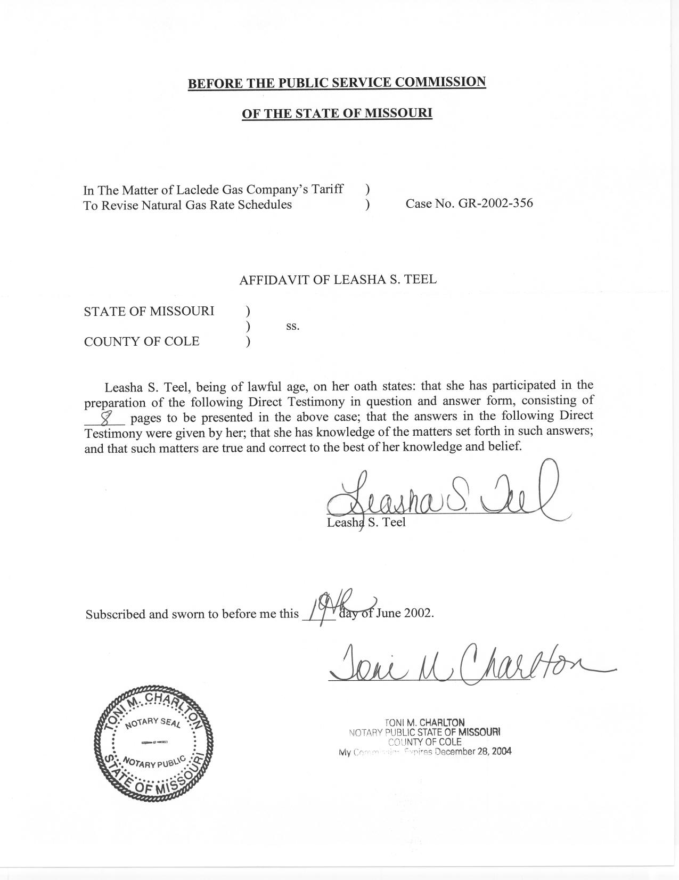

TABLE OF CONTENTS
LEASHA S. TEEL

LACLEDE GAS COMPANY

CASE NO. GR-2002-356

ACCOUNTING SCHEDULES 2
PROPERTY TAXES 2
INSURANCE 3
INJURIES AND DAMAGES 3
LACLEDE’S AFFILIATED OPERATIONS 4
APPLIANCE REPAIRS 7

DIRECT TESTIMONY
OF

LEASHA S. TEEL
LACLEDE GAS COMPANY
CASE NO. GR-2002-356

Please state your name and business address.
Leasha S. Teel, 815 Charter Commons, Suite 100B, Chesterfield, Mo. 63017.
By whom are you employed and in what capacity?
I am a Regulatory Auditor II for the Missouri Public Service Commission (MoPSC or Commission).
Please describe your educational background.
I graduated from Webster University in December 1998 with a Bachelor’s degree in Accounting.
Have you previously filed testimony before this Commission?
Yes. I previously filed testimony in AmerenUE Case No. EC-2002-01 and Laclede Gas Company Case No. GR-2001-629.
Have you made an investigation or study of the books and records of Laclede (Laclede or Company) in Case No. GR-2002-356?
Yes, in conjunction with other members of the Commission Staff (Staff).
Please identify what Accounting Schedules and Adjustments to the Income Statement you are sponsoring.
I am sponsoring Accounting Schedule 1, Accounting Schedule 9, and Accounting Schedule 10; which are the Revenue Requirement, Income Statement and Adjustments To Income Statement, respectively. I am also sponsoring the following adjustments in Accounting Schedule 10, Adjustments To Income Statement:
    - Property Tax S-18.2
    - Insurance S-15.10
    - Affiliated Operations S-15.22
    - Laclede Pipeline S-19.1

ACCOUNTING SCHEDULES
Please describe the accounting schedules you are sponsoring.
Accounting Schedule 1, Revenue Requirement, is the Staff’s calculation of the Revenue Requirement based on the rates of return sponsored by Staff witness Roberta A. McKiddy of the Financial Analysis Department.
Accounting Schedule 9 is the Income Statement for the test year ending November 30, 2001, updated through March 31, 2002. Each adjustment reflected in Column C on the income statement is a summary of the adjustments proposed by the Staff and is itemized on Accounting Schedule 10, Adjustments to Income Statement.

PROPERTY TAXES
Please describe adjustment S-18.2 for property tax.
Adjustment S-18.2 annualizes property tax expense. As of the filing date in this case, the actual 2002 assessed values were not available. Thus the Staff used the actual 2001 property tax payment made in December of 2001 as its annualized level. The Staff will re-examine this item during its true-up audit to consider any 2002 actual assessment values and/or effective tax rates that become available.

INSURANCE
Please explain your adjustment to Insurance.
Adjustment S-15.10 was made to annualize the Company’s cost of insurance, which is charged to the Federal Energy Regulatory Commission (FERC), Uniform System of Accounts Nos. 924 and 925. Included in this annualization were the following types of insurance: excess liability, director’s and officer’s liability, general liability, fiduciary liability, punitive liability, primary and excess property insurance, worker’s compensation, executive life insurance, blanket crime insurance, travel insurance and self insurer’s tax.
How did Staff determine the level of insurance premiums to include in its annualization?
The Staff based its annualization of the cost of insurance on current insurance premiums. This annualization is representative of the new insurance premiums that took effect on October 1, 2001. The new insurance premiums reflect an increase in the company’s deductible per incident. The test year level is only representative of two months of the new premiums. Therefore, Staff’s annualization reflects the new premiums the remaining ten months of the test year.

INJURIES AND DAMAGES
Please explain why you did not make an adjustment to injuries and damages.
As explained earlier in my testimony, several of the Company’s insurance premiums, including injuries and damages, increased significantly. To minimize the increase in costs, the Company increased the $200,000 deductible to $750,000 per incident. Based on Staff’s analysis of previous years’ cash payments, a multi-year average would be appropriate. However, Staff concluded that the test year provision was an appropriate level for ongoing injuries and damages.

LACLEDE’S AFFILIATED OPERATIONS
Q. Can you provide a description of Laclede’s affiliated operations?
Yes. Beginning September 1, 2001, Laclede and its former subsidiaries were reorganized under a holding company structure. Under this new structure Laclede, as well as its former subsidiaries, became subsidiaries of The Laclede Group. The following is a description of the subsidiaries, other than Laclede:
Laclede Investment Corporation invests in other enterprises and has made loans to several joint ventures engaged in real estate development.
Laclede Energy Resources, Inc., a wholly owned subsidiary of Laclede Investment Corporation, engages in non-utility efforts to market natural gas.
Laclede Gas Family Services, Inc., a wholly owned subsidiary of Laclede Energy Resources, Inc., provides legal services, and dental services in which Laclede Gas Family Services, Inc acts solely as an agent through GE Financial Assurance for the services provided.
Laclede Pipeline Company (LPC), a wholly owned subsidiary of the Laclede Group, owns and operates a pipeline for transporting liquid propane gas, purchased by Laclede from its suppliers, to a Company owned storage cavern. Laclede maintains an inventory of liquid propane gas at an underground storage site in St. Louis County for use during peak periods and sale to customers.
Laclede Development Company, a wholly owned subsidiary of the Laclede Group, participates in real estate development, primarily through joint ventures.
Laclede Venture Corporation, a wholly owned subsidiary of Laclede Development Company, has a 28.5% interest in the LBP Partnership, a general partnership which previously engaged in research and development of light beam profiling technology. Laclede Venture Corporation also offers services for the compression of natural gas to third parties who desire to use or sell compressed natural gas for use in vehicles.
Laclede Energy Services, Laclede has informed Staff that they intend to form a new subsidiary which acts as an agent and service provider for Laclede Gas Company, Laclede Energy Resources, and other third parties, assisting in planning, nominations, scheduling, gas accounting, spot purchasing, transportation and risk management.

SM&P is also a wholly owned subsidiary of the Laclede Group, which is an underground facilities locating company.
In addition, Laclede has retail sales of gas appliances (e.g., water heaters, dryers, gas grills), which are recorded on the Company’s books as miscellaneous income below the line.
What was the purpose of your examination of the Company’s affiliated operations?
The purpose was to determine if Laclede’s cost of service included any costs related to non-utility operations. If Laclede’s cost of service included any non-utility costs, then the Company’s utility ratepayers would be subsidizing these non-utility subsidiary operations.
What were the results of your review?
I found that Laclede’s utility operating books and records included non-utility costs. As a result, I have proposed adjustment S-15.22 to address this problem.
Why has the Staff proposed this adjustment?
During the course of this and previous audits, the Staff spoke with various Company employees to gather information about the Company’s non-utility operations. Through these interviews, data requests and other information received from the Company, Staff found several instances where costs that are included in Laclede’s cost of service should be assigned to non-utility operations.
For purposes of this case, the Company has started to allocate employee time through timesheets to the various subsidiaries. The Company annually allocates money to the non-utility affiliates for annual report and 10-K preparation, administrative expense and merchandise bill allocation. Monthly allocations are also distributed to the non-utility operations for payroll, payroll tax, group insurance, pension expense, auto distribution, information systems expense, insurance expense, stationary expense and rent expense.
Please explain adjustment S-15.22.
The Staff believes that there are additional expenses that are appropriately chargeable to affiliate operations. There are Laclede employees that perform services for the newly acquired SM&P and the Laclede Group, Inc. whose payroll and related costs must be allocated to these entities. A portion of their time is recorded currently on the books of Laclede Gas Company. However, the Company has indicated that it will update their allocations before the end of their fiscal year, ending September 30, 2002.
Is the Company generating any reports to address these concerns?
Yes. The Company is currently developing a Cost Allocation Manual (CAM). The purpose of the CAM would lessen the possibility of cross-subsidization of expenses and employee time betweens affiliates. The CAM is still in its initial stages, as the Company is still developing methodologies and policies to properly allocate employee time and other expenses.
Please describe adjustment S-19.1.
Adjustment S-19.1 moves the test year net income of LPC above the line. As previously discussed, LPC sells propane to Laclede Gas Company. Laclede Gas Company expenses include the markup from LPC. Adjustment S-19.1 eliminates the impact of any LPC mark-up built into Laclede Gas Company’s cost of service.

APPLIANCE REPAIRS
Q. Please describe the Company’s appliance repair function.
A. Appliance repairs are performed by the Company’s Service and Installation Department and are booked above the line. The Commission does not tariff the prices charged for appliance repair.
Q. Does the Staff have any concerns regarding appliance repairs?
A. Yes. The Staff believes that the Company does not track the costs adequately associated with this function. As a result the Company has failed to accurately capture the entire appliance repair expenses. Staff has no way of knowing whether the revenue from the appliance repair function is sufficient to cover its cost or if the ratepayers are subsidizing the appliance repair operations. The Staff believes the Company must begin to properly track and allocate appliance expenses if these costs are to be properly allocated in future cases. The Staff would suggest that appliance repair be a component of the Company’s CAM.
Q. Does this conclude your direct testimony?
A. Yes, it does.

