Exhibit No.:
Issue: Injuries and Damages Expense
Witness: Leasha S. Teel
Sponsoring Party: MoPSC Staff
Type of Exhibit: Rebuttal Testimony

Case No.: GR-2002-356
Date Testimony Prepared: August 2, 2002

MISSOURI PUBLIC SERVICE COMMISSION

UTILITY SERVICES DIVISION

REBUTTAL TESTIMONY

OF

LEASHA S. TEEL

LACLEDE GAS COMPANY

CASE NO. GR-2002-356

Jefferson City, Missouri

August 2002

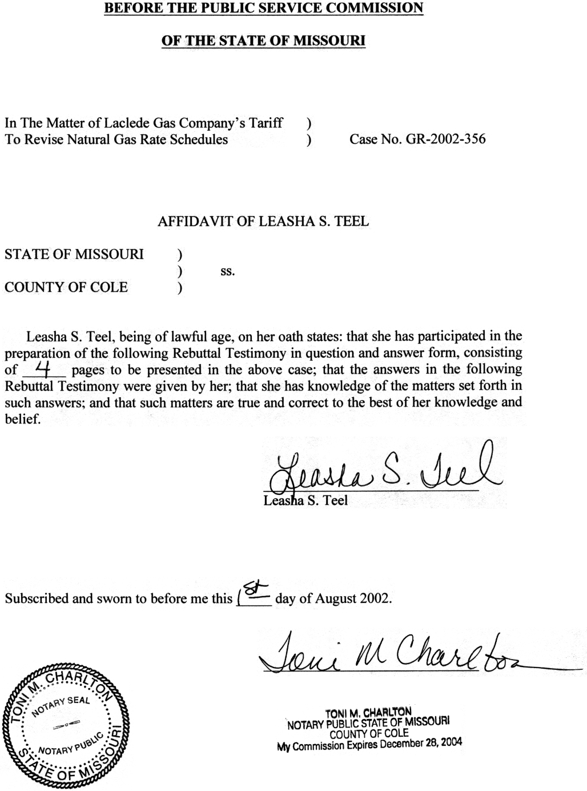

REBUTTAL TESTIMONY

OF

LEASHA S. TEEL
LACLEDE GAS COMPANY

CASE NO. GR-2002-356
Q. Please state your name and business address.
A. Leasha S. Teel, 815 Charter Commons, Suite 100B, Chesterfield, Mo. 63017.
Q. Are you the same Leasha S. Teel who filed direct testimony in this proceeding?
A. Yes.
Q. What is the purpose of your rebuttal testimony?
A. My rebuttal testimony will address the direct testimony of Laclede Gas Company (Company or Laclede) witness Glenn Buck regarding injuries and damages expense.
Q. What is the Company’s position regarding injuries and damages expense?
A. On page 13 of his direct testimony, Mr. Buck discusses the Company’s position. The first component of the Company’s calculation of its annualized/normalized level for injuries and damages is an adjustment to decrease the test-year expense to the three-year average of the actual payments related to injuries and damages expense for the twelve months ending November 30, 1999, 2000, and 2001. These payments are related to claims, which exceeded the Company’s historical deductible of $200,000 per incident. As a result of new insurance policies that went into effect October 1, 2001, the Company’s deductible increased from $200,000 to $750,000. The second component of the Company’s calculation increases test-year expense to account for the increase in the amount of the deductible for the new insurance policies.
Q. Does Staff agree with the Company’s position regarding the increased premium expense associated with the new insurance policies?
A. Yes. The Staff has reflected these increased costs in premiums in the Staff’s cost of service calculation.
Q. Does the Staff agree with the Company’s position related to the forecasted increase in expense associated with the larger deductible required by the new insurance policies?
A. No. As discussed in my direct testimony, the Staff concluded that the test-year amount was an appropriate level to include in the cost of service because it reflected the ongoing actual payments for injuries and damages expense. Staff’s position was based on its examination of the historical actual cash payments made for injuries and damages expense during the last five years.
The Company calculated its adjustment based on an examination of the payments for claims which occurred over the last eleven years that exceeded the $200,000 deductible. The Company determined that if the deductible had been $750,000, at the time it incurred these claims, the additional average annual payments that Laclede would have made, on an annual basis, would have increased by $553,605. The Staff disagrees with this adjustment because of the limited frequency of historical claims in excess of $200,000 and the fact that safety programs have been undertaken by the Company, which should reduce future claims.
Q. Please discuss the frequency of historical claims over $200,000.
A. The Company provided data in their filing, and through Staff Data Request No. 172 that listed the dollars paid and the description of each claim. During the eleven-year span from 1991 through 2001, thirteen claims exceeded the Company’s $200,000 deductible. Of the thirteen claims, two claims were undisclosed, three claims were for injuries and damages, and eight claims were the result of gas explosions. (The Company has not provided information pertaining to the undisclosed claims.) The Company did not have any claims that exceeded their deductible for the entire 2001 calendar year.
Q. Has the Company initiated any programs to address these historical claims?
A. Yes. The Company currently has ongoing replacement programs to address some of the causes of gas explosions. These programs call for the replacement of steel mains and the replacement and survey of copper service lines. As a result of these programs, the number of future incidents that have caused a majority of the Company’s cash payments for injuries and damages expense should be reduced. Therefore, the Staff does not believe that the eleven-year history of the cash payments should be used as a predictor for future levels.
Q. Did the Staff use an examination of historical payments to evaluate the level it recommends for the ongoing level of injuries and damages expense?
A. Yes. Due to the replacement programs previously discussed, the historical level is probably overstated. The Staff’s believes its position is conservative due to the fact that the Staff proposed no adjustment for injuries and damages expense incurred by the Company during the test-year.
Q. Has the Company been provided non-traditional regulatory treatment to address the cost of these programs?
A. Yes. The Company has been given Accounting Authority Orders (AAOs) to address the cost associated with these replacement programs. The programs and the associated AAOs are further discussed in the testimony of Staff witness Stephen M. Rackers.
Q. Do you have any outstanding data requests from the Company at this time?
A. Yes. I have requested an update to Staff Data Request No. 172. The Company’s response to Staff Data Request No. 172, lists each claim charged against the injuries and damages reserve in twelve-month increments and describes the circumstances of the claim. At the time of this testimony, the Staff has not received the update to this request.
Q. Does this conclude your testimony?
A. Yes, it does.

