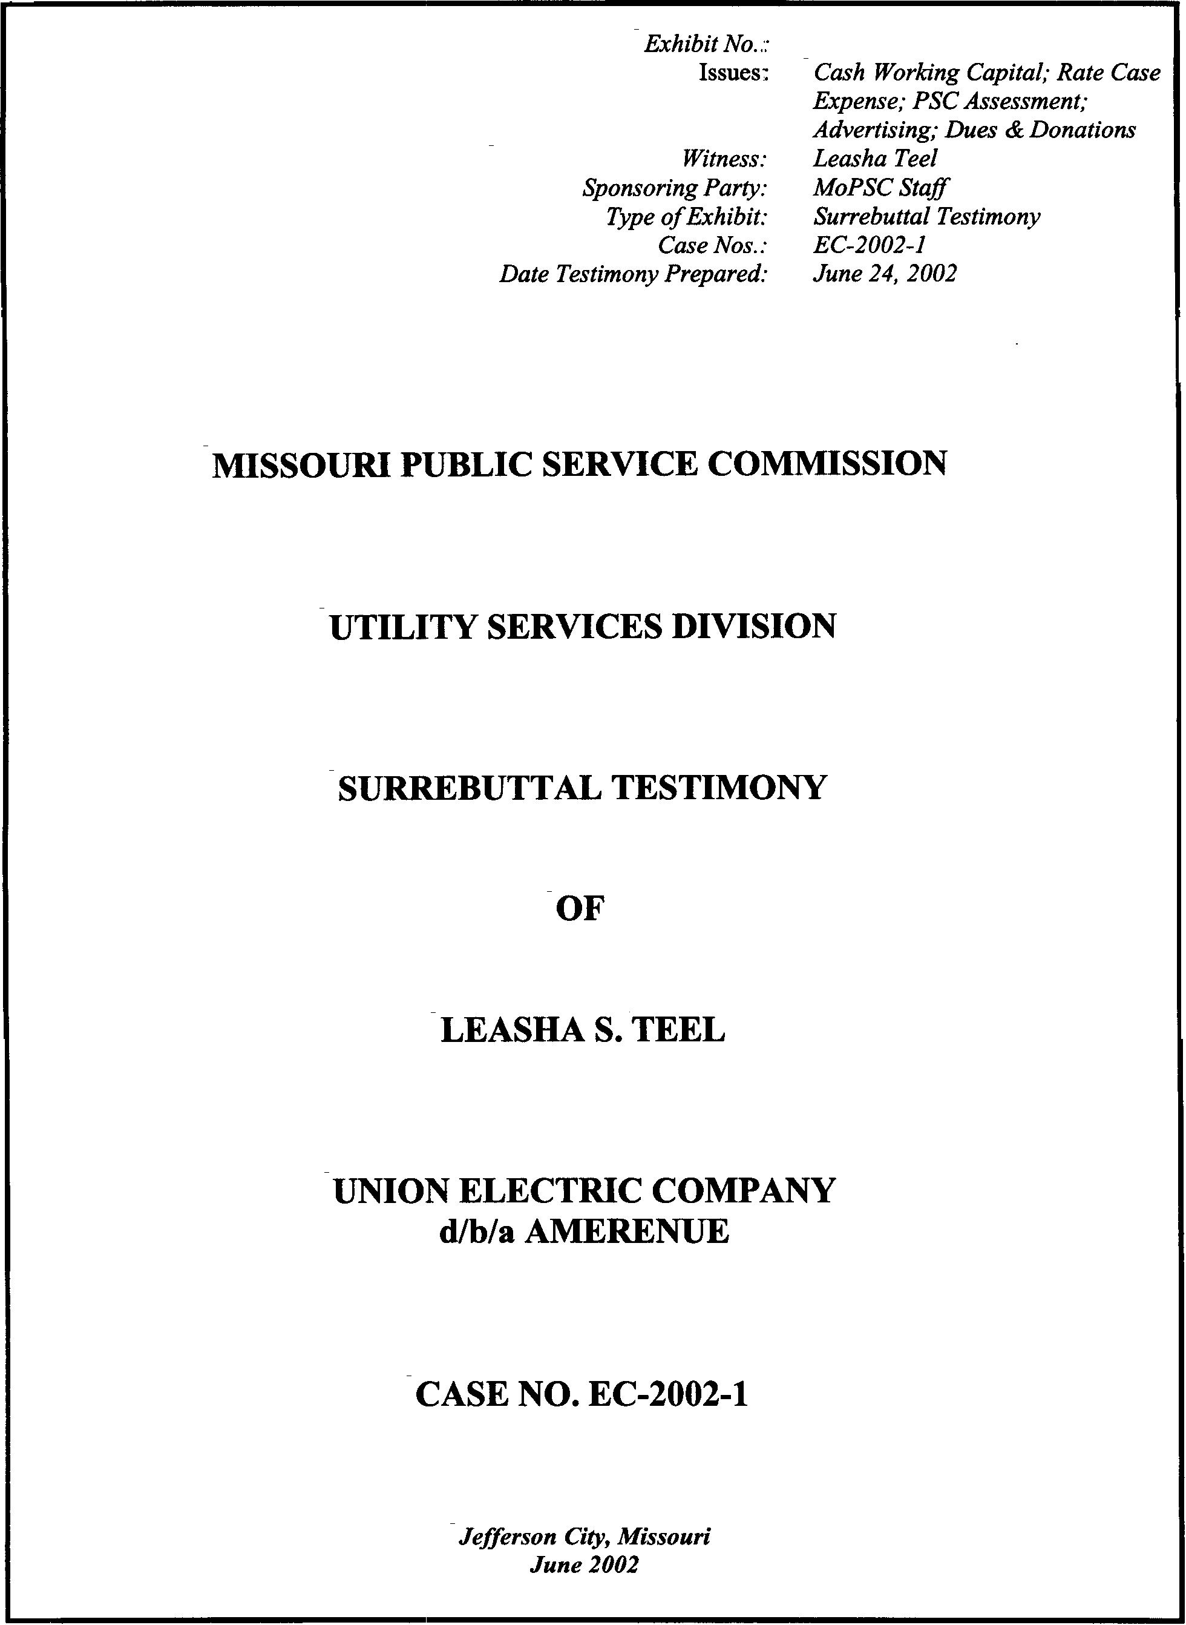
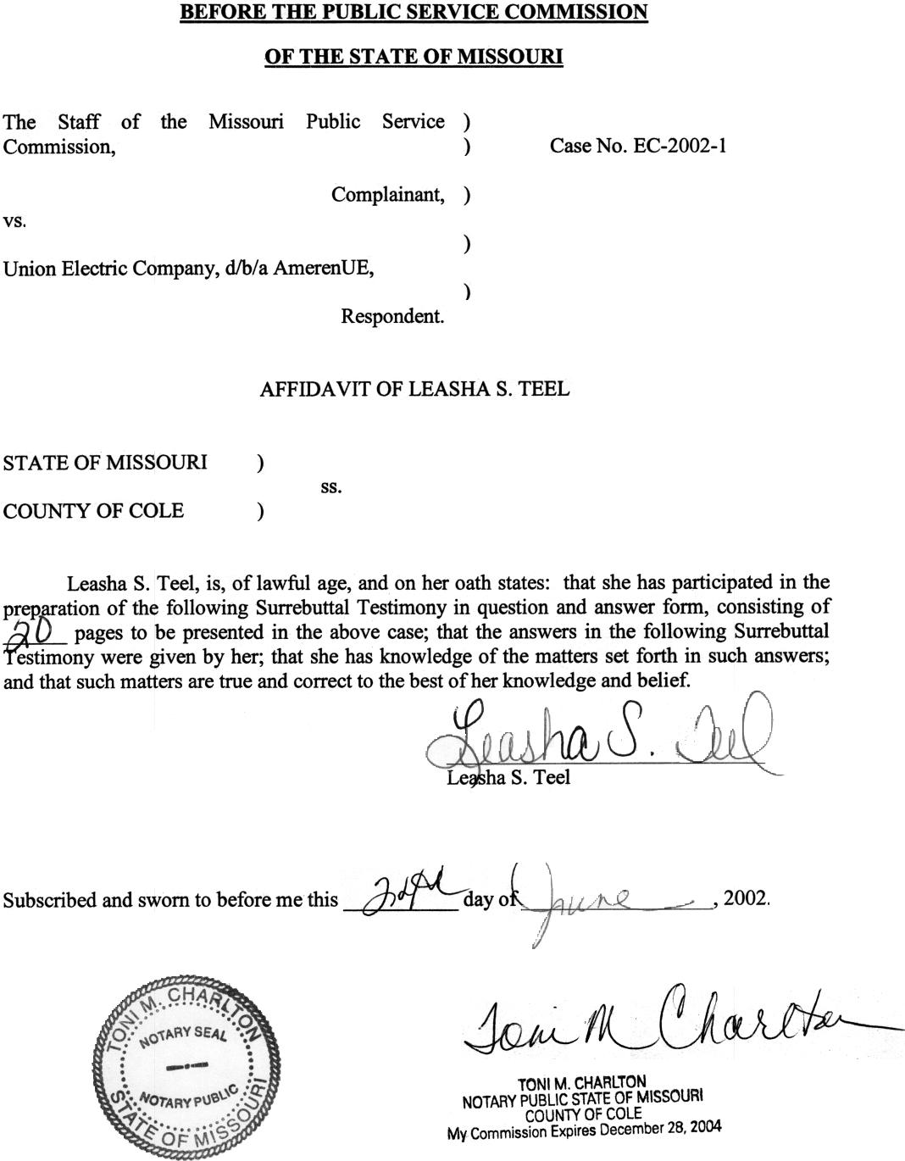

TABLE OF CONTENTS

SURREBUTTAL TESTIMONY OF
LEASHA S. TEEL
UNION ELECTRIC COMPANY
d/b/a AMERENUE

CASE NO. EC-2002-1

ADVERTISING 1
RATE CASE EXPENSE 4
DUES AND DONATIONS 6
MPSC ASSESSMENT 8
CASH WORKING CAPITAL 8
VACATION PAYROLL 9
REVENUE LAG 11
FUEL LAG 14
PURCHASE POWER 15
PREPAYMENTS 16
TAXES 16
INTEREST EXPENSE 17
GROSS RECEIPTS TAX 18
CASH VOUCHER LAG 18
ANNUALIZED EXPENSES 19

SURREBUTTAL TESTIMONY
OF
LEASHA S. TEEL
UNION ELECTRIC COMPANY
d/b/a AMERENUE
CASE NO. EC-2002-1

Please state your name and business address.
Leasha S. Teel, 815 Charter Commons, Suite 100B, Chesterfield, Mo. 63017.
Are you the same Leasha S. Teel who previously filed direct testimony in this proceeding?
Yes.
What is the purpose of your surrebuttal testimony?
My surrebuttal testimony will address the rebuttal testimony of AmerenUE (Company) witnesses Martin Lyons regarding Advertising, Dues and Donations, PSC Assessment and Rate Case Expense; and Michael Adams regarding Cash Working Capital (CWC).

ADVERTISING
Mr. Lyons states in his rebuttal testimony on page 28, lines 4-5, that the SmartLight advertisement “Slide” should be classified as a promotional or general advertisement. Do you agree with this statement?
No, I do not. The only information the “Slide” SmartLights advertisement provides is the name of the program and the phrase, “helping communities improve public lighting.” This advertisement primarily seeks to enhance the Company’s image and is, therefore, properly classified as institutional.
Did you classify other SmartLight advertisements as informational?
Yes. Each of the SmartLight advertisements referenced by Mr. Lyons is attached as a schedule to my March 2002 direct testimony (Schedule 4-3 for the television transcript, Schedules 4-16 and 4-17 for the radio advertisement, and Schedule 4-22 for the print advertisement). The radio and print advertisements are very informative about the groups that can participate in the SmartLights program, give examples of the types of property that can obtain lighting through the program, provide a phone number for further information and indicate that a grant is available. The print advertisement also contains the deadline to apply for the grant, provides more phone numbers and a website address. In contrast, the television advertisement provides none of the information discussed above.
Why did Mr. Lyons classify the “Slide” advertisement as promotional?
He states on page 29, lines 6-8, “The message and intent of those (SmartLight) advertisements are the same as the message and intent of the SmartLights-“Slide” television ad in that they all encourage and facilitate the installation of public lighting and thereby promote the used of off-peak electricity.
Does Mr. Lyons quantify the alleged SmartLight revenue benefit in his rebuttal testimony regarding the “Slide” advertisements?
Yes. In his rebuttal testimony on page 28, lines 14-18 Mr. Lyons states:
For cost/benefit analysis reasons, the Company does not specifically track increased revenue resulting from any of its SmartLights programs. However, the Company estimates that during calendar 2001 it granted approximately $148,000 toward specific lighting projects and estimates that the incremental off-peak electric revenues from those projects will approximate $26,000 annually.
Mr. Lyons then says on page 28, lines 19-21:
Clearly, those incremental off-peak revenues are causally connected to the SmartLights program. Furthermore, since the estimated, incremental off-peak electric revenues will allow the Company to recover its investment in less than six years, the benefits of the SmartLights program exceed its costs.
What problems do you have with this valuation?
Mr. Lyons has failed to consider the cost of the advertisements. This advertisement cost $206,000 annually. When added to the $148,000 AmerenUE spent on the specific lighting projects, AmerenUE has a total outlay of $354,000. A comparison of the revenues associated with the advertisement, (an estimated $26,000 annually) against the related cost ($354,000 annually), fails any reasonable cost/benefit test. Even these numbers understate the costs that should be examined, because ideally the cost of all SmartLight advertisements should be compared to Mr. Lyon’s $26,000 estimate of incremental revenue benefits. In addition, Mr. Lyons fails to include the fuel necessary to generate the electricity to provide the lighting.
Mr. Lyons states in his rebuttal testimony that the advertisement “Jane and Fred” (attached as Schedule 4-18 to my March 2002 direct testimony) should be classified as a general advertisement. Do you agree with this statement?
No. On page 29, lines 14-16 of his rebuttal testimony, Mr. Lyons states, “I believe this advertisement should be classified as general and fully included in cost of service because its primary messages are to provide information on becoming a direct pay customer, and to encourage the customer’s switch thereto.” However, this advertisement’s basic message is to improve AmerenUE’s public image and is therefore properly classified as institutional. This particular advertisement basically tells the listener that AmerenUE can create more time in their customers’ lives by signing up for Direct Pay. This advertisement contains more information about Jane and Fred’s personal life than a description of the actual direct pay service. The advertisement also mentions a donation that AmerenUE will make to the Salvation Army Tree of Lights, if customers sign up before a particular date. This donation aspect only reinforces the classification of this advertisement as an attempt to improve AmerenUE’s public image. Only one part of one sentence in the 60-second spot directly describes the service: “paid directly from your checking or savings account.” Therefore, the Staff continues to recommend this advertisement be disallowed.

RATE CASE EXPENSE
Have you read AmerenUE’s rebuttal testimony on the issue of rate case expense?
Yes, I have read Mr. Lyon’s testimony on this issue at, pages 30-32 of his rebuttal testimony.
Did you use an arbitrary number or method in determining the Company’s rate case expense?
No. I strongly disagree with Mr. Lyons’ arbitrary adjustment accusation. Mr. Lyons states at page 31, lines 7-11 of his rebuttal testimony that:
The Company has had the burden of substantiating its rate case expense, which it has done it its response to Data Request No. 17. Rate case expenses should not be disallowed unless the Staff can cite specific items that are unknown, not measurable, reasonable, unnecessary or not prudently incurred.
The Staff does not believe that the use of several outside consultants for issues that are traditionally performed by in-house Company personnel is reasonable. Nor are the costs associated with outside consultants measurable at this time. Staff Data Request No. 150 requested copies of invoices detailing the cost and work performed by these consultants. However, AmerenUE has objected to the data request on the grounds that the information requested is protected by attorney-client privilege and attorney work product doctrine and has not provided this information. The Company did respond to Staff Data Request No. 17, where Staff requested the vendor name, the issue assigned and the dollar amount incurred by the vendor by month. However, this information is not sufficient for Staff to verify some of the Company’s expenses. Additionally, in its response to Staff Data Request No. 92, the Company provided invoices from the law firm Cooper, Carvin & Rosenthal/Cooper & Kirk. However, much of the description in the invoices could not be read, due to the fact that there was an extreme amount of redaction of the information contained in the invoices. The Staff was not able to verify that the work performed was for this case. As a result, the Staff believes that the rate case expense associated with this proceeding is not known or measurable under these circumstances.
Has Staff researched the cost of rate case expense in previous cases for other utilities?
The Staff has performed some research to compare AmerenUE’s rate case expense with that of other Missouri Commission regulated companies. The Staff has found that the largest rate case expense was a Missouri Gas & Electric Case No. GR-98-140 in which $900,000, was amortized over two years. AmerenUE is requesting this amount for just one year’s rate case expense. The total amount the Company is requesting is $2.7 million, amortized over three years.
Does the Staff believe the amount charged to rate case expense by the Company to be excessive?
Yes. The Staff believes that at this time $300,000 is sufficient due to the inadequate documentation provided by the Company to support its position and the Staff’s position that the amount of costs incurred by the Company for outside consultants is unmeasurable.

DUES AND DONATIONS
Have you read AmerenUE’s rebuttal testimony on the issue of dues and donations?
Yes, I have read Mr. Lyons’ testimony, pages 32-36 pertaining to dues and donations.
Do you agree with Mr. Lyons’ contention that 40% of Edison Electric Institute (EEI) dues represent non-lobbying expense and should be included in the cost of service?
No. Mr. Lyons’ statement is based on the Audit Report of the Expenditures of the Edison Electric Institute, issued by the National Association of Regulatory Utility Commissioners (NARUC) in June 2001.
Can the Staff accept the conclusions contained with this audit report?
No. The Staff does not believe it is appropriate to rely on a third party audit to determine rate treatment of utility expenses. The Commission Staff did not perform this audit. NARUC is comprised of public utility commission personnel, and the regulatory agencies that employ them are not bound to follow identical ratemaking practices.
If it is true that 40% of EEI’s dues are related to non-lobbying activities, does the Company make an adjustment to disallow the other 60% of EEI dues?
No. In its case, the Company does not make an adjustment to disallow the other 60% of EEI dues, which, by its own admission, would pertain to lobbying expenses at least in part.
Mr. Lyons’ discusses certain benefits that he and other AmerenUE employees obtain from attending EEI seminars. Please comment.
At page 35, lines 14-17, Mr. Lyons’ discusses the benefits of EEI meetings he has attended. However, it is the Staff’s understanding that the cost of attending these seminars is not related to the EEI membership fee or cost of joining EEI.
Has AmerenUE met the Commission’s test for inclusion of EEI dues in rates?
No. In my direct testimony I have stated the past precedent in which the Commission requires electric utilities to provide a quantification of benefits from EEI membership, with the benefits allocated between the ratepayer and shareholder. Mr. Lyons in his testimony on page 33, lines 2-6 states:
I recognize that the Commission has historically excluded dues and donations on the basis that they generally benefit shareholders rather than ratepayers. However, I strongly believe that dues paid to EEI should be fully included in cost of service. To a large extent they represent non-lobbying activities and provide significant benefits to ratepayers and therefore should be included in cost of service.
Mr. Lyons again states on page 34, lines 6-9, “I recognize that the Commission has historically disallowed EEI dues absent a showing of direct, quantified benefits allocated between ratepayers and shareholders.” Mr. Lyons plainly admits that EEI dues have been disallowed in previous years because of lack of proof of how these dues benefit the ratepayers. The Staff believes that the entire amount of EEI dues included above the line should be removed from the cost of service as AmerenUE has not provided a comprehensive list of benefits from EEI membership, and has not allocated those benefits between its shareholders and customers. Accordingly, the Company has not met the Commission’s test for inclusion of dues in rates.

MPSC ASSESSMENT
Have you read AmerenUE’s rebuttal testimony on the issue of MPSC Assessment?
Yes, I have read Mr. Lyon’s testimony on this issue, pages 36-38 pertaining to MPSC Assessment.
Do you agree with Mr. Lyons’ statement that the Staff’s annualization of MPSC Assessment is inconsistent with the test year concept?
No. The MPSC Assessment is an annualized figure. The Staff based its allowable MPSC Assessment on a known quarterly payment, and multiplied it by four to obtain a yearly amount. I annualized AmerenUE’s payment for the period of July 1, 2001 through September 30, 2001, which is completely within the test year update period for this proceeding.
Do you believe that the Staff should have normalized the PSC Assessment?
No, I do not. The MPSC Assessment for AmerenUE has trended downward for the past two years, and the Staff believes that trend is likely to continue. The current MPSC Assessment is a known quantity on a going-forward basis; there is no need to use an average for this item.

CASH WORKING CAPITAL
Have you reviewed the Company’s cash working capital calculation (CWC) as presented by Company witness Adams as well as his rebuttal testimony on this issue?
Yes, I have.
Do you have any opinions as to the accuracy of that study?
Based upon my review, I have found Mr. Adams’ study to be flawed in the following areas: vacation payroll lag, billing lag, revenue lag, fuel lags, federal/state income tax lag, interest expense lag, gross receipts lag and other O & M expense lag. Furthermore, Mr. Adams’ has based his opinion of my study on the unsubstantiated claims that I have erroneously calculated federal/state income tax lags, included non-cash items in my study, and included employee benefits in the cash voucher lag that should have been included as a separate line item. Each of these areas will be discussed in my surrebuttal testimony.
What sources of material did you consider when you calculated cash working capital?
I consulted the Staff’s CWC position paper. I also consulted with senior Staff on several issues regarding how I should analyze certain areas of CWC. I also consulted other Staff members’ workpapers from AmerenUE gas cases to examine how they performed their analysis in previous cases. Also as discussed in my direct testimony, was, the Staff met with the Company to determine what lags should be re-calculated for purposes of this case.

VACATION PAYROLL
Are there non-cash factors included in your analysis of CWC?
No. This portion of my April 2002 deposition, which was cited by Mr. Adams, has been addressed in an errata sheet. This errata contains a notation in which I clearly state how I misspoke during my April deposition and I list the questions regarding non-cash items to be removed. In that deposition, I misspoke and stated that CWC contained a non-cash item, vacation accrual. The addendum to the errata sheet also discusses the Company and Staff’s miscommunication involving the words “Vacation Accrual” and “Vacation Payroll” and their inclusion in the Staff’s CWC study.
Do you agree with the response to Mr. Adams’ question on page 5, lines 9-10 of his rebuttal testimony?
Yes. In Mr. Adams’ rebuttal testimony on page 5, lines 11-22, and page 6, lines 1-2, he correctly states the Staff’s position regarding non-cash items. However, he is incorrect in stating that Staff has performed an “apparent about face” by including non-cash items from CWC, when in fact the Staff’s position has not changed on this matter.
What does the vacation payroll in the Staff’s CWC study represent?
Vacation payroll is wages paid to employees for service provided and earned during a previous year. These wages are paid annually when an employee takes vacation or at the end of employment.
Why is it appropriate to include vacation payroll in the CWC analysis?
It is appropriate to include vacation payroll in the CWC analysis because the vacation earned by an employee is expensed and accounted for as a liability and eventually paid out as a cash disbursement to the employee when the vacation is taken. According to Financial Accounting Standards Board Statement of Standards No. 43, “Accounting for Compensated Absences”: “The Board has considered those alternative accounting practices and concluded that a liability for employees’ rights to receive compensation for future absences should be accrued as specified by this Statement.”
Why is the Staff’s vacation payroll lag 365 days?
The Staff has assumed that vacation time is earned evenly throughout the year and taken evenly throughout the following year. Without obtaining more detailed records of when AmerenUE employees take vacation, this assumption is reasonable. Staff’s understanding of the Company’s vacation policy is that an employee must work for one year before vacation can be taken.

REVENUE LAG
Do you agree with the retail revenue lags proposed by Company witness Adams in this case?
No. On page 21, lines 8-11, of his rebuttal testimony Mr. Adams’ states that; “The Company’s retail revenue lag was analyzed in five distinct steps: 1) Meter Reading Lag; 2) Billing Lag; 3) Collections (Account Receivable) Lag; 4) Payment Lag; and 5) Bank Float on collections from customers.”
What are the differences between the Staff’s retail revenue lag and the Company’s retail revenue lag?
The Staff has calculated the overall revenue lag using three components: a usage lag, billing lag, and collection lag. Although Mr. Adams uses different names for the components, the difference lies in his inclusion of a payment lag and a bank float. The payment lag is designed to measure the time between the Company’s receipt of the customer’s payment and its transmittal to its bank for collection from the customer’s account. Bank float is designed to measure the time between the Company’s deposit of the customer’s check and the time the Company has access to the cash.
Does the Staff include the payment lag in the retail revenue lag?
The Staff has captured the payment lag in its calculation of the collection lag; through its use of the cash lag report supplied by the Company. This report captures the lag from when the bill is mailed until the time the Company has received the payment. The cash lag report captures the handling time that occurs with different methods of payment. The Staff believes that the additional time Mr. Adams is including in his revenue lag through the payment lag component is duplicative and represents handling time after the bill is received and payment is credited.
Why does the Staff not include bank float CWC?
The Commission traditionally has not included bank float in CWC associated with receipts from customers or payments to vendors. This treatment implicitly assumes that the Company’s payment checks clear the bank at the same rate as customer payment checks.
Has bank float been an issue in CWC in previous cases?
A. Yes. In Case Nos. ER-80-48 and ER-81-42, both Kansas City Power & Light Company (KCPL) rate case proceedings, the Staff attempted to include a bank float component in its cash working capital analysis. In these cases, KCPL sought CWC treatment for their minimum and compensating bank balances. In response the Staff advocated inclusion of bank float as a similar concept, if the bank balances treatment advocated by KCPL was accepted in CWC. In each case, the Staff lost this issue. In Case No. ER-80-48, the Commission stated, “Furthermore, the Commission cannot accept the Staff’s utilization of float, at this time.”
Did the Staff correctly calculate the billing lag in this proceeding?
Yes. While Mr. Adams’ definition of how a billing lag should be calculated is in agreement with the Staff, his methodology of calculating his billing lag is incorrect. In response to Staff Data Request No. 181, Mr. Weiss confirmed how the automated meter reading system worked and how it influenced the billing process. The data request states AmerenUE still has 21 billing cycles, as they did before introduction of the automated meter reading system. The Company maintains billing cycles because only a certain number of bills can be processed in a given day. The data request response states that information from Cellnet, the automated meter-reading vendor, is read automatically. The billing department must make some adjustments and do additional work before the information from Cellnet can be processed into a bill. Bills are printed out in the evening, and mailed the next day. The Staff believes that the time it takes the meter to be read is included in the Staff’s usage lag, and that the time the Company takes to bill the customer and mail the bill is encompassed in the Staff’s billing lag. Mr. Adams agrees with this concept on page 7, lines 3-9 of his rebuttal testimony..
Is that the only reason the billing lag decreased from 2.8 to 1.9 days in the last AmerenUE gas case, is because of the implementation of automated meter reading?
No. The Staff merely assumed efficiency would be gained regarding the billing lag due to the full implementation of the automated meter reading system. I also consulted with senior Staff and used the meter reading report I was given by the Company in response to Data Request No. 176R. After reviewing the Company’s rebuttal testimony, and after submitting Data Request No. 181, I spoke with Company witness Weiss and asked for a copy of the credit and collection report for both the 12 months ending July 31, 2000 and July 31, 2001. This report is used by the Company to calculate the billing lag. After calculating a billing lag based on this new report, the Staff still has a difference between its lag and the lag the Company has calculated in its CWC.
Do you have an explanation for the one-day difference between this calculation of the billing lag and the Company’s billing lag?
Calculating the billing lag using the credit and collection report, resulted in measurement of the lag between the meter read date to the mail date of 1.90 days. When I measured the lag from the meter read date to the day the bill was mailed, I came up with 2.90 days, the result of the Company’s billing lag analysis. The Staff believes that this discrepancy comes from the Company measuring the billing lag from the time the meter is read to the time the bill is mailed. This approach means that there is a day being double-counted in the usage lag and the billing lag. The usage lag includes the day on which the meter is read. The billing lag begins on the next day, the day the bill is produced. Therefore, the Staff is now recommending that the Commission adopt its revised billing calculation of 1.90 days.

FUEL LAG
Do you have any concerns regarding Mr. Adams’ calculation of the fuel expense lags in the Company’s presentation of CWC?
Yes. Based upon the fuel expense lag workpapers of Mr. Adams and his rebuttal testimony, I have serious concerns that he has miscalculated the fuel lags. On page 20, lines 3-6 of Mr. Adams’ rebuttal testimony, he states;
A lead lag study analyzes the lag between the date customers receive service and the date that customers’ payments are available to the Company. This lag is offset by a lead-time during which the company receives goods and services, but pays for them at a later date.
What are your concerns with Mr. Adams’ calculation of the fuel lag?
Mr. Adams’ rebuttal testimony on page 28, lines 20-22 states that the Company “paid its major vendors of nuclear fuel and fuel related products and services 29.18 days after receipt of invoices for the twelve months ended September 30, 2001.” Again on page 29, lines 3-5 Mr. Adams states that AmerenUE, “paid its vendors of coal, freight services, and tires approximately 13.94 days after receipt of invoices for the twelve months ended September 30, 2001.” Also on page 29, lines 10-11 Mr. Adams states the Company, “paid its oil vendors 13.48 days after receipt of invoices for the twelve months ended September 30, 2001.” Lastly on page 29, lines 15-17, Mr. Adams states again that the Company, “paid its vendors of natural gas approximately 10.53 days after receipt of invoices for the twelve months ended September 30, 2001.”
Every instance listed above references to lag days starting after the receipt of invoices. This is contrary to Mr. Adams’ definition of “lag” on page 15. The lag should be measured from the date or average date service was received. This may or may not be the date the invoice was received. Therefore, Mr. Adams’ calculation of the fuel lags are understated.

PURCHASE POWER
Has Mr. Adams criticized the Staff’s handling of purchase power expenses in its CWC analysis?
Yes. Mr. Adams; states that purchase power expenses should be treated as a separate line item of CWC.
Q. Do you agree?
No. The Staff has treated purchase power expense as a component of the cash voucher lag. For purposes of the calculation of the cash voucher lag. I requested a report specifying all vouchers above the $50,000 threshold for the 500 and 900 accounts. I have determined there were no purchase power vouchers included in that listing. However, the annualized amount of purchased power is included in the cash working capital study in Staff’s Accounting Schedule 8, column B, annualized expense. The Staff believes this treatment of purchase power is appropriate.

PREPAYMENTS
Is the Staff’s treatment of prepayments appropriate in the context of CWC?
Yes. I have sampled vouchers for the items Staff Accounting witness Paul Harrison has excluded from the prepayments rate base line item. These vouchers were included in the amount assigned to the cash voucher; coal fuel and gross receipts tax lags in the Staff’s CWC analysis. An explanation of this approach was previously provided to AmerenUE in response to Company Data Request JJC-54.

TAXES
Is St. Louis Earnings Tax included in the Staff’s CWC calculation?
Yes. On page 15, lines 5-7, Mr. Adams’ rebuttal testimony states, “First, Staff witness Teel does not consider the lead times associated with the Company’s payments of Saint Louis Corporate Earnings in her calculation.” The lag and cash working capital requirement for city earnings tax, (otherwise referred to St. Louis Corporate Earning tax,) is located on Staff Accounting Schedule 2-Rate Base and is shown as an offset.
Why did you lump the state unemployment taxes with the federal unemployment taxes annual test year amounts in the CWC study?
I consulted with senior Staff in coming to the conclusion that, due to the immateriality of these amounts, the Illinois and Iowa state unemployment dollars should be included with the federal unemployment amount. A workpaper was supplied to the Company illustrating this approach. The Company’s CWC requirement for state unemployment is $593.
Do you agree with Mr. Adams’ presentation of the lead times associated with Missouri state or federal income taxes?
No. Mr. Adams’ lags assume that each quarter in which a tax payment is made is “service period”, for which the lag should be measured beginning at the midpoint of the quarter. This is not consistent with the Staff’s methodology. The Staff believes that federal and state taxes are based on annual income, not quarterly. That is why the midpoint of the Staff’s service period is 182.5 days, which represents the midpoint of a year. See Schedule 1, attached to my surrebutal testimony, to illustrate the difference between the Staff’s and the Company’s methodologies for calculation of income tax lags. Are state and federal income taxes paid on the same schedule?
No. There is one additional payment for state income tax on April 15 of the following tax year. Mr. Adams’ rebuttal testimony states on page 15, lines 22-23, “According to her testimony, Staff witness Teel assumes that State Income Taxes are paid on the same schedule as Federal Income Taxes.”
These lags are calculated separately and, by viewing the Staff’s workpapers, it should be immediately apparent that the state income taxes and the federal taxes are paid differently as I have discussed above.

INTEREST EXPENSE
Has Company witness Adams calculated the interest payment lag appropriately?
No. Company witness Adams’ cites a lead-time for interest payments of 36.17 days. A review of Mr. Adams’ workpapers show that he is using a calendar year for the service period regardless of when the bond was issued. This approach will lead to the conclusion that some interest payments are “prepayments” by the Company; i.e., that interest payments on average are made by the Company before the amounts are collected from customers in rates. This is not correct.
What is Staff’s methodology for calculating the interest expense lag?
The payments to bondholders occur every six months, and the midpoint of those six months is 91.25 days. The Company collects the interest in rates for six months prior to the interest payment date. The Staff has taken the payments for various types of long-term debt and notes payable and weighted them together to derive a lag of 89.02 days.

GROSS RECEIPTS TAX
Has Mr. Adams correctly calculated his gross receipt tax lag?
A. No. According to his rebuttal testimony on page 33, lines 14-15, Mr. Adams’ states, “ The Company typically pays these taxes between the 25th and 27th of the month in which the taxes are due.” This sentence leads me to believe that Mr. Adams’ applied the same lag to all municipalities, regardless if they were paid monthly or not.
How did the Staff calculate the gross receipts tax lag?
A. I obtained a schedule showing when each municipality was paid gross receipts taxes (quarterly, monthly, semi-annually or annually), and calculated the lag based on the schedule provided by the Company. I then weighted the lags to the dollars paid based on information from the Company.

CASH VOUCHER LAG
Is there a concern regarding the other O&M (operation and maintenance) expenses lag calculated by the Company?
Yes. The other O&M expense lag is the counterpart to the Staff’s cash voucher lag. The Staff has reviewed Mr. Adams’ workpapers and found instances of double counting the payments of various expense items in his CWC study. An example of this would be gross receipt taxes and fuel. Gross receipt taxes and fuel are analyzed separately in the CWC accounting schedule. Double counting the payments and/or vouchers of various expense items in the O & M expense lag skews the results of the CWC analysis.
How did the Staff calculate the cash voucher lag in its analysis?
Staff obtained a report from the Company listing vouchers in excess of $50,000 for the 500 and 900 accounts. I obtained copies of these vouchers from the Company and calculated a lag based on this information. I eliminated any vouchers associated with items I analyzed separately, like fuel, or disallowed, like advertising. This approach prevented double counting or influencing the analysis by considering disallowed items.

ANNUALIZED EXPENSES
How are the amounts in Accounting Schedule 8-CWC, column B, determined?
The Staff uses the annualized amounts in the CWC analysis. However, the Company has used per book numbers in its study. This is inappropriate as a CWC analysis should determine the cash requirement associated with the Company’s annualized and normalized expense levels.
What is your recommendation to the Commission regarding Company witness Adams’ CWC study?
The Staff recommends to the Commission that it adopt the Staff’s CWC analysis. AmerenUE witness, Mr. Adams has several inconsistencies in his definition and methodologies. Mr. Adams has not calculated a vacation payroll lag, or included it in his analysis. The lags for fuel, federal income tax, state income tax, and gross receipts taxes are calculated incorrectly and inconsistently compared with past Commission-accepted methods. Mr. Adams’ determination of the revenue lag double counted one whole day, the meter read date, and included this day in the usage lag and the billing date. Due to all of the problems and inaccuracies within Mr. Adams’ work in the CWC area, the Staff’s recommends that the Commission disregard AmerenUE’s CWC study.
Does this conclude your surrebuttal testimony?
Yes, it does.

