Exhibit No.:
Issue: Rate Design

Witness: Henry E. Warren
Sponsoring Party: Mo PSC Staff
Type of Exhibit: Rebuttal Testimony
Case No.: GR-2004-0209
Date Testimony Prepared: May 21, 2004

MISSOURI PUBLIC SERVICE COMMISSION

Utility Operations DIVISION

REBUTTAL TESTIMONY

OF

Henry E. Warren, PhD

MISSOURI GAS ENERGY

CASE NO. GR-2004-0209

Jefferson City, Missouri
May 2004

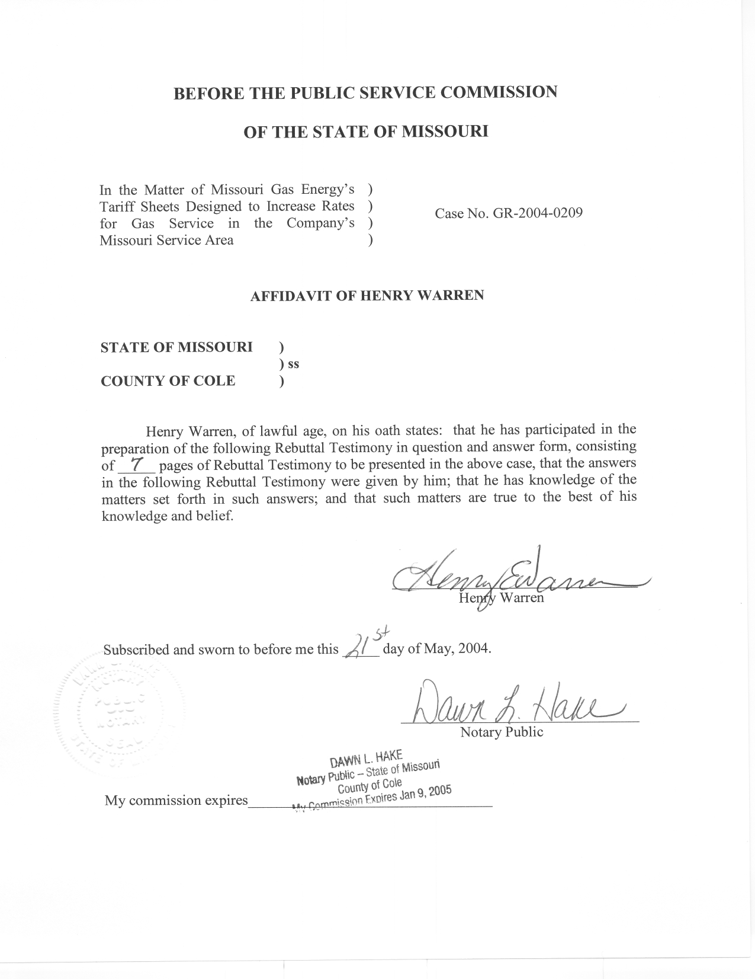
REBUTTAL TESTIMONY
OF
HENRY E. WARREN, PhD
MISSOURI GAS ENERGY
CASE NO. GR-2004-0209

Q. Please state your name and business address.
A. My name is Henry E. Warren and my business address is P. O. Box 360, Jefferson City, Missouri, 65102.
Q. By whom are you employed and in what capacity?
A. I am employed by the Missouri Public Service Commission (PSC or Commission) as a Regulatory Economist in the Energy Department of the Utility Operations Division.
Q. How long have you been employed by the Commission?
A. I have worked at the Commission 11 years.
Q. What is your educational and professional background?
A. I received my Bachelor of Arts and my Master of Arts in Economics from the University of Missouri-Columbia, and a Doctor of Philosophy (PhD) in Economics from Texas A&M University. Prior to joining the PSC Staff (Staff), I was an Economist with the U.S. National Oceanic and Atmospheric Administration (NOAA). At NOAA I conducted research on the economic impact of climate and weather. I began my employment at the Commission on October 1, 1992, as a Research Economist in the Economic Analysis Department. My duties consisted of calculating adjustments to test-year energy use based on test-year weather and normal weather, and I also assisted in the review of Electric Resource Plans for investor owned utilities in Missouri. From December 1, 1997, until May 2001, I was a Regulatory Economist II in the Commission’s Gas Department where my duties still included analysis of issues in natural gas rate cases and were expanded to include reviewing tariff filings, applications and various other matters relating to jurisdictional gas utilities in Missouri. On June 1, 2001, the Commission organized an Energy Department and I was assigned to this Department. My duties in the Energy Department are similar to my duties in the Gas Department.
Q. Are you a member of any professional organizations?
A. Yes, I am a member of the International Association for Energy Economics and the Western Economics Association.
Q. Have you previously filed testimony before the Commission?
A. Yes, I have filed testimony in the cases listed in Schedule 1 attached to this testimony.
Q. What is the purpose of your Rebuttal Testimony?
A. My Rebuttal Testimony covers the Pay As You Save (PAYS®) system described in the Direct Testimony of Ms, Barbara A. Meisenheimer, The Office of Public Counsel. This system is described by Ms. Meisenheimer as a financially self-sufficient program that would assist moderate and middle-income households in making energy bills more affordable without requiring ongoing contributions from Missouri Gas Energy (MGE or Company) or its customers for the program.
Q. How would you describe the basic concept of the PAYS®?
A. I have read some documents and references furnished by Ms. Meisenheimer in her Data Request Responses from PAYS America, including the paper, Pay-As-You-Save Energy Efficiency Products, Restructuring Energy Efficiency, Paul A. Cillo and Harlan Lachman, National Association of Regulatory Utility Commissioners, December 1999. The PAYS® system is offered through PAYS America, a non-profit organization providing research and education about PAYS®. According to the information, PAYS® would offer homeowners, landlords and tenants a method to improve the energy efficiency of residences or buildings with retrofitting and more energy efficient appliances and equipment with a long-term low-interest payback without requiring a conventional loan, up-front payment, or debt obligation. The participating customers, who benefit from the approved efficiency measures (measures), pay for these measures through a tariffed charge on their utility bill, but only for as long as they occupy the location where the measures were installed. The monthly charge is always lower than the measure’s estimated savings and it remains on the bill for that location until all costs are recovered. Like a loan, PAYS® allows for payment over time, but unlike a loan the PAYS® obligation ends for a particular customer when occupancy ends or the measure fails to perform as specified. The PAYS® system proposes eliminating the existing market barriers to the implementation of energy efficiency in households by offering measures that are more financially attractive to utility customers.
Q. What are some of the basic elements of a PAYS® system?
A. Under the PAYS® model, described in the Cillo and Lachman paper above, a fund would be created that would finance the purchase of measures from vendors. Payments for the cost of the measures would be collected through the MGE bill over time using a PAYS® tariff. The program is designed so that utility savings exceed payments for the measures in the near term and through the payment period, with the additional requirement that the measure will be effective one-third longer than the payment period. So, the customer’s bill is actually lower than it would have been absent installation of the measures. The measures for a particular residence or building would be determined by an energy audit and subsequently an independent certification of PAYS® measures so that the measures actually generate annual savings sufficient to cover their annual payments and the term of the payments is for only three-quarters of the estimated measure life. Longer term, higher cost retrofitting such as insulation would also be included with payments running with the meter, i.e. if the occupant or owner of the property receiving the measure changed, the monthly charge for the measure would transfer to the successor utility customer.
Q. What is your evaluation of Ms. Meisenheimer’s discussion of the benefits of a system such as PAYS®?
A. I concur that the PAYS® system could benefit participating ratepayers by providing a means for them to afford the set of PAYS® measures. If the PAYS® system can be designed and implemented as described in the information provided by PAYS America, a result could be the same level of comfort for the participating ratepayer with a lower level of energy consumption, which should mean a comparable decrease in their utility bills. A PAYS® system could also benefit all ratepayers and MGE by helping utility bills become more affordable to the participating ratepayers. A program such as the PAYS® system may need to be implemented in the context of resource planning incentives for the regulated utilities so that the paradox of energy conservation under regulation is avoided, i.e. shrinking usage due to conservation leads to lower revenues for the regulated utility, subsequently higher per unit rates are requested to maintain the revenues needed to provide a specified rate of return, so the customer’s costs for the utility service do not decline as much as anticipated with decreased usage.
As Ms. Meisenheimer states, the PAYS® system is purported to be self-sustaining. Once funding is available, the participant’s payments through their bills are intended to replenish the program funds. Consequently, the PAYS® system should be a benefit to all ratepayers and not be an ongoing expense item. Although a limit may be set on the amount of PAYS® funding to an individual customer, the program may be more successful without a means test for participation as suggested by Ms. Meisenheimer.
Q. What is the extent and success of previous PAYS® systems that have been implemented?
A. According to information provided by Mr. Cillo and Mr. Lachman, PAYS America, one version of the PAYS® system was implemented by the Public Service of New Hampshire (PSNH), an investor owned electric utility, for their municipal customers and another version of the PAYS® system was implemented by the New Hampshire Electric Cooperative (NHEC), a rural electric cooperative. The limited implementation of PAYS® by PSNH may have been due to their existing programs for residential and commercial/industrial customers including Energy Star® Homes and Appliances and other incentives for energy efficiency including rebate programs. NHEC measures included in their PAYS® program were weatherization, Energy Star® Lighting, Lighting Controls and a Heat Pump Water Heater. A evaluation from PAYS America indicates that all measures installed thus far for which data are available have met the criteria for saving more on a monthly basis than the monthly charge for the measure.
Q. What differences between the MGE service area and the New Hampshire Utility service areas where PAYS® has been implemented would cause the proposed PAYS® system to be different?
A. Differences in the PAYS® system would occur due to differences in the climate, and by the cost of natural gas, electricity, and water. The per unit cost of natural gas is about 15% lower in Missouri and the per unit cost of electricity is about 30% lower, which will change the measure’s savings. Also, the willingness of customers to encumber their utility bills with ongoing charges might be different.
Q. Is a PAYS® system being considered by any other utilities in Missouri?
A. Yes, I am aware of one other Missouri utility that is evaluating a proposal for a PAYS® system.
Q. What is the effect of the PAYS® system being resource blind in its implementation?
A. This type of PAYS® system would allow for measures without respect to the type of energy that is conserved. So, the program would include high efficiency gas water heaters and furnaces, it would also include compact florescent lights (CFL) and low flow showerheads that would conserve electricity and water. A resource blind PAYS® system would provide a broader spectrum of measures that could be implemented than if measures are evaluated in terms of a single type of energy.
Q. Do you concur with Ms. Meisenheimer’s proposed funding for limited pilot PAYS® system?
A. I agree with the proposal for a pilot PAYS® program, and for the need for continued work on the program to determine how it could be effectively implemented. Staff considered the funding of a PAYS® system along with the Company’s current low-income weatherization program and the current Experimental Low-Income Rate (ELIR) program. Staff proposes a monthly adder of $0.018 per residential customer which would provide approximately $100,000 annually for two years for a PAYS® system. This amount is lower than the $126,156 proposed by Ms. Meisenheimer, but Staff’s recommendation was arrived at with the concurrent consideration of the low-income weatherization and ELIR programs, which are addressed by Staff Witness Ms. Anne Ross in her Rebuttal Testimony.
Q. Does this conclude your Rebuttal Testimony?
A. Yes, it does.
MISSOURI GAS ENERGY

CASE NO. GR-2004-0209

Previous Cases in which Prepared Testimony Was Presented by:

Henry E. Warren, PhD

Company Name Case Number
St. Joseph Light and Power Company GR-93-042
Laclede Gas Co. GR-93-149
Missouri Public Service GR-93-172¹
Western Resources GR-93-240¹
Laclede Gas Co. GR-94-220¹
United Cities Gas Co. GR-95-160¹
The Empire District Electric Co. ER-95-279¹
Laclede Gas Co. GR-96-193¹
Missouri Gas Energy GR-96-285¹
The Empire District Electric Co. ER-97-081¹
Union Electric Co. GR-97-393¹
Missouri Gas Energy GR-98-140¹
Laclede Gas Co. GR-98-374¹
St. Joseph Light & Power Company GR-99-246¹
Laclede Gas Co. GR-99-315¹
Union Electric Company (d/b/a AmerenUE) GR-2000-512¹
Missouri Gas Energy GR-2001-292¹
Laclede Gas Co. GR-2001-629¹
Laclede Gas Co. GR-2002-0356¹
Laclede Gas Co. GT-2003-0117
Aquila Networks (MPS and L&P) GR-2004-0072¹

Testimony includes computations to adjust test year volumes, therms, or kWh to normal weather.

